Hybrid split-arc partial-field volumetric modulated arc therapy: an improved beam arrangement for linear accelerator-based hippocampal-avoidance whole brain radiation therapy

Supplementary File

Table S1. Dose criteria of RTOG 0933 protocol
RTOG 0933 protocol | Per protocol | Acceptable variation | Unacceptable deviation
Whole brain PTV | D_{2%} < 37.5 Gy | D_{2%} = 37.5 Gy | D_{2%} > 40 Gy
 | D_{98%} > 25 Gy | D_{98%} < 25 Gy | V₃₀ < 90%
Hippocampus | D_{100%} < 9 Gy | D_{100%} = 10 Gy | D_{100%} > 10 Gy
 | D_{max} < 16 Gy | D_{max} = 17 Gy | D_{max} > 17 Gy
Optic nerves and optic chiasm | D_{max} < 37.5 Gy | D_{max} = 37.5 Gy | D_{max} > 37.5 Gy

Figure S1. Delineation of the hippocampus made on T1-weighted MRI axial sequence images with reference to the RTOG 0933 guidelines. A. Delineation of hippocampus begins at the inferior extent of the crescentic-shaped floor of the temporal horn of the lateral ventricle. The low-density grey matter was contoured on the low signals of the cerebrospinal fluid (CSF); B. Avoid delineating the grey matter (amygdaloid nucleus and hamulus) in the fimbriae that are located superomedial to the hippocampus; C. The anterior boundary of the hippocampus is defined by the anterior edge of the temporal horn, to distinguish the hippocampus from the T1-hypointense gray matter of the amygdala, lying anterior and superior to the hippocampus. The medial boundary of the hippocampus is defined by the “boomerang-shaped” uncus; D. The uncal recess of the temporal horn defines the anterior boundary of the hippocampus. The medial boundary of the hippocampus becomes defined by the medial edge of the uncal recess; E. Postero-cranially, the medial boundary of the hippocampus is defined by the lateral edge of the quadrageminal cistern; F. The hippocampus remains medial to the temporal horn of the lateral ventricle throughout its extent; G. The hippocampal tail remains posterior to the thalamus as it curves medially toward the splenium of the corpus callosum. The hippocampus is medially located relative to the lateral ventricle; H. The postero-cranial extent of the hippocampal tail is located antero-medially to the atrium of the lateral ventricle
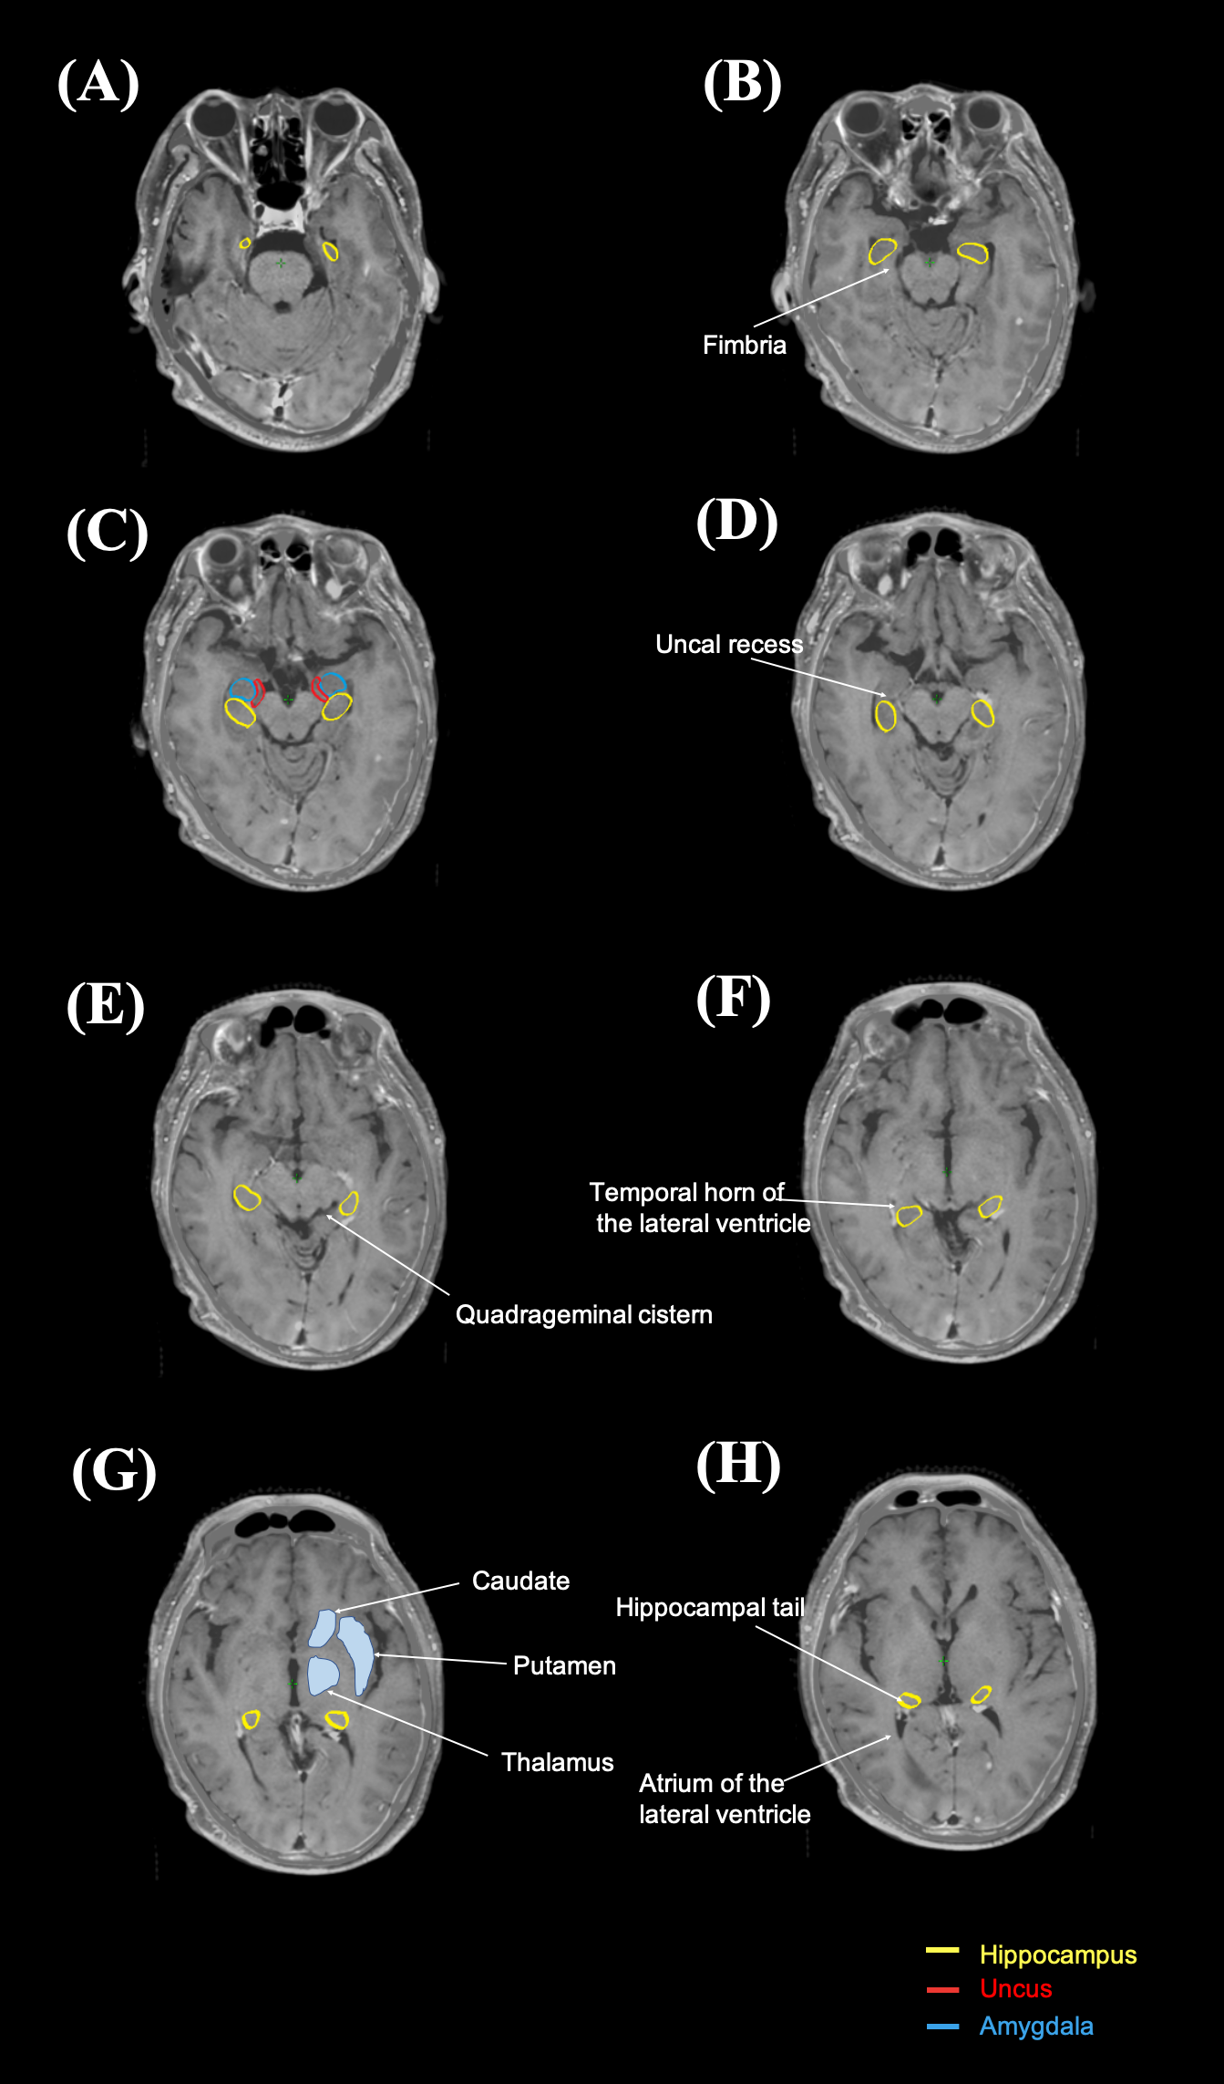

Table S2. Optimization objectives of major structures used in sapf-VMAT and Hsapf-VMAT

Structures | Limit | Volume (%) | Dose [cGy] | Priority
Whole brain PTV | Upper | 0 | 3300 | 80
 | Upper | 1 | 3150 | 80
 | Upper | 2 | 3120 | 80
 | Lower | 99 | 3030 | 100
Hippocampus | Mean | - | 800 | 80
 | Upper | 0 | 850 | 80
 | Upper | 0 | 900 | 80
 | Upper | 0 | 1350 | 80
 | Upper | 0 | 1360 | 80
 | Upper | 0 | 1370 | 80
 | Upper | 0 | 1380 | 80
 | Upper | 0 | 1390 | 80
Left eye | Upper | 1 | 1380 | 80
 | Upper | 2.5 | 1345 | 80
Right eye | Upper | 1 | 1400 | 80
 | Upper | 2.5 | 1360 | 80
Left lens | Upper | 0 | 600 | 80
 | Upper | 0.1 | 540 | 80
Right lens | Upper | 0 | 600 | 80
 | Upper | 0.1 | 540 | 80
Left optic nerve | Upper | 0.5 | 2970 | 80
 | Upper | 1.5 | 2940 | 80
Right optic nerve | Upper | 1 | 3050 | 80
 | Upper | 2 | 3020 | 80
Optic chiasm | Upper | 0 | 3180 | 80
 | Upper | 1.5 | 3165 | 80

Figure S1. Beam arrangement of (A) sapf-VMAT and (B) Hsapf-VMAT. CCW — counterclockwise; CW — clockwise
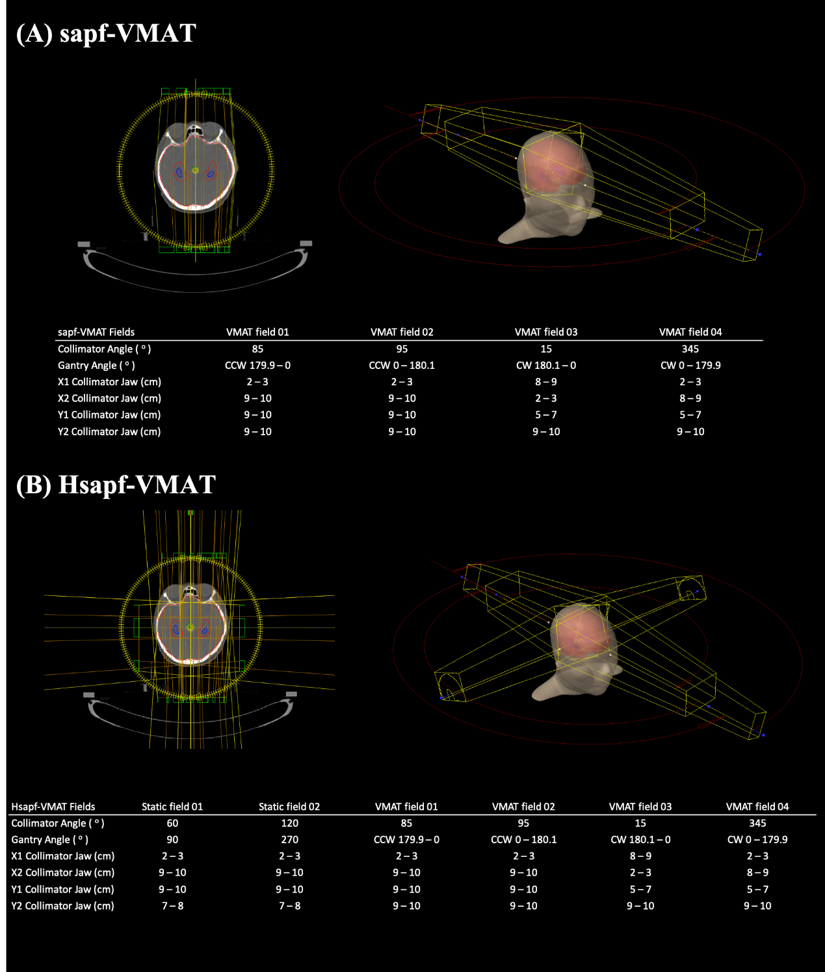

Figure S3. Left (A) and (B) right static fields have been employed in Hsapf-VMAT. The eyes and lenses were shielded by the X1 collimator jaw
