Hypofractionated radiotherapy in breast cancer: a 10-year single institution experience
Supplementary File
Figure S1. Local recurrences (A) and overall survival (B) related to the number of radiotherapy fractions

A
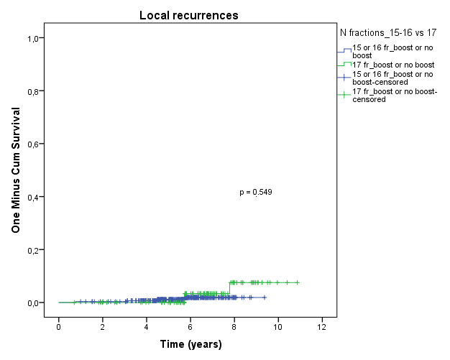
B
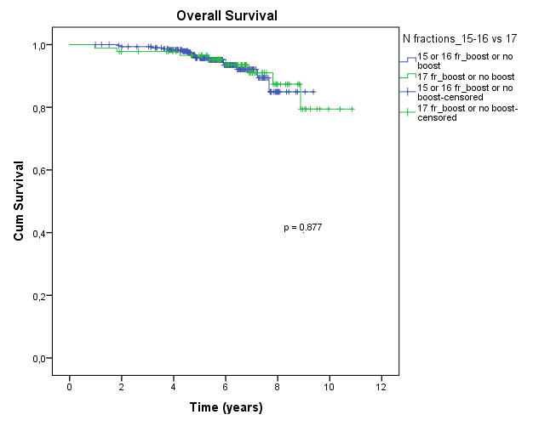

Figure S2. Local recurrences (A) and overall survival (B) related to the delivery of boost
A

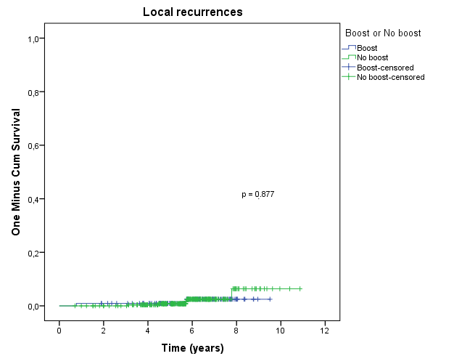

B
