**The early onset of sero-negative polyarthritis juvenile idiopathic arthritis in female patient - a case report**

**The early onset of sero-negative polyarthritis JIA in female patient**

**Keywords**: Juvenile idiopathic arthritis, MRI, Adalimumab, Musculoskeletal system

**Declarations:**

**Ethics approval and consent to participate:** Not applicable

**Consent for publication:** Not applicable

**Availability of data and materials:** Not applicable

**Competing interests:** The authors declare that they have no competing interests.

**Funding:** The authors declare that they have no funding.

**Authors' contributions:** All authors took part in writing the review article.

**Acknowledgements:** Not applicable.

**Abstract:**

**Introduction:** Juvenile idiopathic arthritis (JIA) is a chronic inflammatory joint disease with a complex etiology, characterised by symptoms such as swelling, exudates, soreness and reduced mobility. Early diagnosis and treatment are crucial to improve long-term prognosis and prevent complications.

**Case report:** A 5-year-old girl with polyarticular sero-negative, HLA-B27-positive JIA previously under the care of another medical centre was admitted for evaluation of disease activity and possible reintroduction of treatment. The patient's history began at the age of 14 months, when symptoms of inflammation of the small joints of the hands appeared.  
  
On physical examination pain and swelling of the proximal interphalangeal joints of the hands were detected. Laboratory tests revealed low inflammatory indices. Rheumatoid factor, anti-citrullinated protein antibodies and genetic test for HLA-Cw6 were negative. An ultrasound of the hands confirmed the presence of arthritis. Furthermore, a magnetic resonance imaging (MRI) scan and a computed tomography (CT) scan were performed revealing sacroiliitis. The treatment initially included two disease-modifying drugs - methotrexate and sulphasalazine with folic acid shielding. Subsequently, due to the poor response to treatment, the child was qualified for biological treatment with adalimumab, achieving a significant improvement in clinical condition and imaging findings. Follow-up hospital admissions confirmed the stabilisation of the patient's condition and the absence of disease progression.  
  
**Conclusion:** This case emphasises the importance of early diagnosis and an individualised therapeutic approach in the treatment of JIA. Biological therapy with adalimumab combined with conventional drugs, proved effective in controlling symptoms of the disease and improving the patient's quality of life.

**Introduction**

Juvenile Idiopathic Arthritis (JIA) is the most common rheumatic disease in the pediatric population [1], with estimated prevalence at about 1 per 1,000 children, and the incidence that ranges from 2 to 28 per 100,000 pediatric population - nearly 10 per 100,000 pediatric population in Poland [2]. It is a heterogeneous group of idiopathic inflammatory arthritis, differing in etiopathogenesis and clinical presentation. There is a significant disparity between the genders within JIA patients, with women developing the disease more often than men (female to male ratio of 1:0.57) [3].

The common feature and basic diagnostic according to The International League of Associations for Rheumatology (ILAR) criterion [4] of JIA is arthritis of an unexplained etiology that occurred before the age of 16, with symptoms such as swelling, exudates, soreness and reduced mobility present for a minimum of six weeks. The diagnosis is to be made only after excluding other causes of arthritis from the so-called "exclusion list" consisting of infectious, reactive, allergic and toxic arthritis, proliferative diseases, other inflammatory connective tissue diseases, arthropathies of blood and metabolic diseases, systemic non-inflammatory connective tissue diseases, arthropathies of immune diseases, psychogenic gout and fibromyalgia [5]. There are seven JIA subtypes: oligoarthritis, sero-positive polyarthritis, sero-negative polyarthritis, systemic arthritis, enthesitis—related arthritis, juvenile psoriatic arthritis and undifferentiated [4]. The laboratory blood tests are not intended to provide a diagnosis of JIA, but to exclude potential other medical conditions. These may also be valuable for determining the type of JIA and monitoring its course. The most commonly determined parameters are inflammatory markers such as white blood cell count (WBC), C-reactive protein (CRP) and erythrocyte sedimentation rate (ESR). The immunological tests commonly performed include antinuclear antibodies (ANA), rheumatoid factor (RF) and antibodies to cyclic citrullinated peptide (anti-CCP) [6]. The determination of RF separately 2 times at least 3 months apart indicates whether a person is seropositive or seronegative. Around 85% of polyarthritis patients are RF-negative [7]. Imaging techniques such as ultrasound (USG), X-ray, computed-tomography (CT) and magnetic resonance imaging (MRI) are applicable in the diagnosis and monitoring of JIA [8-9].

Treatment of JIA is complex and requires a comprehensive multifaceted approach to effectively control symptoms, prevent joint damage and improve patients' quality of life. Current pharmacotherapy should be guided by the 2019 ACR recommendations [10]. According to which, patients with active polyarticular JIA should be treated with disease-modifying antirheumatic drugs (DMARDs) from the beginning, instead of non-steroidal anti-inflammatory drugs (NSAIDs) as in the past. The preferred drug is methotrexate (MTX). Systemically administered glucocorticosteroids (GCs) can only be used as bridging therapy for no longer than 3 months, until the full effect of MTX becomes apparent in patients with high disease activity. Subsequently, in the case of low disease activity, treatment can be escalated by delivering injections of GCs, increasing the dose of the DMARD, or switching it to MTX if it has not been administered before. In the case of high or moderate JIA activity, a biologic drug should be included.

Despite treatment development observed in recent years, JIA still reduces the quality of life of patients and only around 20-25% of them will experience full remission. The prognosis depends on the activity of the disease and also differs for the different subtypes. In about half of the patients, the disease remains active into early adulthood and as many as 30% face disability [11].

**Case report**

In September 2021, a European, white girl aged 5 years and 2 months with a diagnosis of polyarticular juvenile idiopathic arthritis (seronegative form), Human Leukocyte Antigen-B27 (HLA-B27) positive, was admitted to the Clinical Department of Pediatrics and Rheumatology at the St. Louis Regional Specialized Children's Hospital in Krakow for disease monitoring and possible initiation of treatment. The child had previously been treated in another clinical center. At the time of admission, the patient did not receive any medications - the mother reported that she had independently withdrawn MTX due to the child's abdominal complaints of nausea and vomiting.

In medical history, the first symptoms of the disease were observed at the age of 14 months consisting of widening of the outline of the interphalangeal joints of fingers II-IV of the right hand and I-IV of the left hand, normal mobility. An USG of the right hand performed during the patient’s hospitalisation in November 2017, showed metacarpophalangeal (MCP) joints III and IV, proximal interphalangeal (PIP) joints II and III, and flexor tendon sheaths of fingers III and IV. In the left hand, effusion in the interphalangeal (IP) joint of the thumb, MCP joint II and distal interphalangeal (DIP) joint IV was visible. Due to the confirmation of arthritis of the small joints of the hands with involvement of the tendon sheaths, the first-line treatment of JIA [12] -NSAIDs and prednisone at a dose of 5 mg - was applied, concomitantly, MTX was included at a dose of 2.5 mg twice a week with folic acid protection. During follow-up at the Rheumatology Clinic in May 2018, prednisone was discontinued and chloroquine was included due to the lack of clinical improvement.

In order to assess the effectiveness of treatment and to determine further management, the child was consecutively hospitalised in July 2018. Physical examination on admission revealed, swelling and limitation of mobility of the right wrist, slight swelling of the left wrist, swelling and flexion contracture of the PIP II-IV joints of the right hand, swelling and flexion contracture of the PIP I and III and DIP III joints of the left hand. On the USG of the right hand, there was an exudate in the PIP II-IV joint cavities and a moderately thickened synovial membrane without features of excessive vascularisation. Thickened synovial membrane of the flexor tendon sheath of finger IV was noticable. The USG of the left hand showed exudate, moderately thickened synovial membrane in the IP joint cavity of the thumb, without features of increased vascularisation, as well as thickened synovial membrane of the flexor tendon sheaths of fingers I and III. X-ray of the hands was also performed, which showed the presence of a geode in the hook bone of the right wrist and marked periosteal build-up in the proximal phalanx of the proximal phalanges of the third and fourth fingers of the right hand and the third finger of the left hand. In laboratory tests performed, inflammatory parameters were low (WBC 8.99 thousand//μl [4.86-18.18], ESR 4mm/h [<12], CRP 5 mg/l [1-10]), blood count, liver and renal parameters were normal. The presence of HLA-B27 antigen and anti-nuclear antibodies with homogeneous luminescent type in low titer (1:160) was detected, and RF was absent. Concomitant HCV (Hepatitis C Virus) infection was excluded. In the absence of the expected improvement, treatment was intensified - the dose of MTX was increased to 10 mg once a week, systemic steroids were reintegrated - prednisone at a dose of 5mg for 2 weeks with a planned dose reduction. In August 2018, due to the ineffectiveness of the previous treatment, the patient was qualified for biologic treatment with tocilizumab at a dose adjusted to the child's weight.  
  
In view of the lack of clinical improvement after 6 months of tocilizumab therapy and the persistence of high disease activity, the biologic drug was changed to adalimumab at a dose of 20 mg. Treatment was continued until February 2021, with initially observed improvement.

On physical examination on admission to the Clinical Department of Pediatrics and Rheumatology at the St. Louis Regional Specialized Children's Hospital in Krakow in September 2021, pain and swelling of the PIP II and III joint of the right hand and the PIP of the left hand were found, other joint contours were not enlarged, active and passive mobility was preserved, strength and muscle tone were normal. A family history consisted of psoriasis in mother, mother's sister and mother's father. No significant abnormalities were found in laboratory tests performed during the hospitalisation, low inflammatory indices (WBC 10.34 tys/μl [4.86-13.18], CRP <5 mg/l [0-10], ESR 8mm/h [<12], RF, anti-CCP and genetic test for HLA-Cw6 were negative. Insufficient vitamin D level (23.2ng/ml). Densitometry results were within reference values for the patient's sex and age. An electrocardiogram (ECG) recording , chest X-ray and abdominal USG proved to be normal. Patient was consulted ophthalmologically - uveitis was excluded. USG of hip, knee and foot joints did not reveal pathology. The USG of the hand joints on the left side revealed trace effusion in DIP I, synovial membrane and flow normal, and MCP II, synovial membrane and grade I trough. A performed whole-body MRI detected an irregular zone of bone marrow edema located in the sacrum on the left side, adjacent to the sacroiliac joint crevice - the image suggested the presence of an active inflammatory process. In addition, an enhancing foci of inflammatory granuloma character is symmetrically distinguished on the right side. The imaging diagnosis was extended by performing a CT scan of the sacroiliac joints with contrast (Figure 1).

Due to the active inflammatory process in the sacroiliac and hand joints, it was decided to restart two DMARDs - MTX at a dose of 15 mg per week and sulphasalazine at a dose of 500mg per day with folic acid shielding, with good tolerance. Re-hospitalisation has been scheduled for October 2021.

On admission, the child was then presented with pain and swelling of the PIP II and III joints of the right hand and the PIP of the left hand. In September 2021, due to an exacerbation of the disease process, the girl was qualified on an outpatient basis to resumption of biological treatment. In laboratory tests there were no abnormalities. During hospitalisation, the first dose of the biological drug, adalimumab, was administered without complications. The treatment of MTX at a dose of 15 mg per week and sulfasalazine at a dose of 500mg per day with folic acid shielding was maintained.

The patient was hospitalised again in March 2022 to assess the effectiveness of the biological treatment. The mother reported pain in the toes during gait and at rest, gait disturbance especially in the morning and child’s limp since 01.2022. On physical examination, the contours of the left thumb and fingers II-IV of both hands were widened, painless, active and passive mobility was preserved, the contours of the other joints not widened. Painfulness of fingers and V toe of both lower limbs was reported, strength and muscle tone was normal. Walking abnormalities were present - wide-base walking and limping. In laboratory tests performed during hospitalisation, inflammatory indices were low (CRP 5 mg/l [0-10], ESR 7 mm/h, WBC 7.13 thousand/ul [4.86-13.18]), low vitamin D3 level (26.4 ng/dl), liver and renal parameters normal. The USG of the hip and knee joints showed no abnormalities. USG of the joints of the hands presented a small effusion with low inflammatory activity (first stage flow) in the DIP I of the left hand and a persistent thickening of the sheath of finger III on the left side without effusion (first stage flow). In view of the results obtained and the child's clinical condition, the disease activity was assessed as low and the effectiveness of the treatment administered was confirmed. Continuation of current pharmacotherapy and rehabilitation was recommended.

In February 2024 child was administered to our department for follow-up examinations and a planned MRI of the sacroiliac joints. The girl is taking MTX 15 mg once a week in folic acid shielding, fluoxetine 10 mg daily, vitamin D 3000 IU per day. Also treated with adalimumab 40mg every 2 weeks. Outpatient sulfasalazine was withdrawn in 2023. On physical exam, on admission, the contours of the left thumb and fingers III-IV were widened, in the right II, III, IV fingers were widened, no pain, active and passive mobility was preserved, otherwise joint contours were not widened, full prone, incomplete squat, strength and muscle tone were normal, walking on a wide base. In laboratory tests, low inflammatory markers (CRP 2.5 mg/l [0-5], WBC 7.26 thousand/ul [4270-1140]) and insufficient vitamin D3 levels (27.8 ng/ml). A follow-up MRI of the sacroiliac joints showed no areas of significant marrow edema, sclerosis or fatty remodeling in the subchondral layers of the joints (Figure 2). The clinical picture and findings indicate a stationary disease state, and therefore treatment was not modified.

**Discussion**

The patient presented in this case report meets the criteria for RF-negative polyarticular JIA according to the ILAR classification. This is evidenced by an onset of disease involving seven joints of the hands lasting more than 6 months, with persistent RF negativity. Gender, age of onset and symmetrical involvement of the small joints of the hands are also characteristic of this disease subtype [13]. In the clinical picture, no general symptoms such as fever, hepato- and/or splenomegaly, lymphadenopathy, respiratory, gastrointestinal or circulatory system involvement were observed.

Clinically, the child presented with typical symptoms of arthritis such as swelling, pain, restricted mobility and a tendency to flexion contracture. A range of laboratory tests and imaging techniques were used in the diagnostic process. Regular assessment of inflammatory parameters such as ESR, CRP and WBC were performed, which remained low throughout the disease course, which is characteristic for seronegative polyarticular JIA. Immunological tests such as RF, ANA and anti-CCP were also performed and remained negative. Determination of these antibodies can be crucial in the diagnostic process, in the classification of the JIA subtype and in the assessment of the patient's prognosis [11].

General urinalysis, assessment of liver and renal function were also performed periodically for possible detection of amyloidosis secondary to JIA [14]. In the present child, these parameters tended to be within the normal range. Genetic tests for HLA-B27 (positive) and for HLA-Cw6 (negative) were also performed due to a family history of psoriasis [15]. In terms of diagnostic imaging, regular USG assessment of the joints was provided. USG makes it possible to visualise thickening of the synovial membrane and tendon sheaths, increased blood flow due to hypervascularisation, as well as exudate in the joint cavity, tendon sheath and synovial bursae. This allows non-invasive, rapid and low-cost verification of the presence of joint inflammation without requiring general anaesthesia, which is particularly important in younger children. This makes USG a valuable tool not only to aid diagnosis, but also to assess the risk of disease relapse and to monitor the effectiveness of treatment [16]. As the aforementioned changes suggestive of inflammation in the joints of the patient's hand persisted, the decision was made to extend the diagnostics with whole-body MRI to assess the activity of the disease and to detect possible inflammatory lesions in other joints, with particular emphasis on joints that could not be assessed by USG. Due to the presence of marrow edema in the sacroiliac joints, the assessment was expanded with a scan aimed at exclusively imaging these joints. Both CT and MRI are crucial in the diagnosis and monitoring of sacroiliitis in children. CT is useful for detecting structural changes such as erosions and bone remodelling [17]. MRI is the preferred modality considering its lack of radiation, high sensitivity in detecting early inflammatory changes and its ability to accurately assess soft tissues such as synovial membrane and ligaments. However, taking into account the better availability than MRI at the clinic where the child was hospitalized, the decision to perform a contrast-enhanced CT scan was made, confirming the sacroiliitis. During the course of treatment, MRI scans of the sacroiliac joints were performed to monitor its efficacy and thus disease activity in this area, where features of acute inflammation were no longer observed. MRI offers high-resolution imaging of soft tissues, enabling the detection of early inflammatory changes and their accurate assessment, as well as the evaluation of disease activity without exposure to ionising radiation [17]. With these features, MRI allows accurate and safe tracking of therapy effects [18].

The treatment in the presented case was initiated with MTX at the dose of 2.5 mg twice a week, NSAIDs and bridging therapy with systemic GCs due to the high disease activity. Subsequently, a second DMARD, chloroquine, was added due to lack of improvement. After nine months, due to the persistent poor response, the therapy was escalated by increasing the dose of MTX to 10 mg once a week, chloroquine was discontinued, prednisone was restarted as bridging therapy and the patient was qualified for biologic therapy with the IL-6 (Interleukin 6) antagonist - tocilizumab, next, due to the lack of efficacy, the drug was changed to TNFi (tumor necrosis factor inhibitor), but after two years the therapy was discontinued for 6 months. The resumption of treatment began with the reintroduction of two DMARDs - MTX and sulfasalazine, after which the child was again qualified for the inclusion of biological treatment - adalimumab. Treatment was managed with significant improvement observed and the disease transitioned to a stationary state.

Attention should also be drawn to the necessity of multi-specialist care in children with JIA. Besides the pediatricians‘ and rheumatologists’ care, ophthalmological care is equally important. Within the group of children with JIA, uveitis is the most common extra-articular manifestation of the disease. The incidence reaches 5-10% of those with polyarthritis [19].

**Conclusion:**

The early diagnosis and appropriate treatment of JIA are essential to improve a patient's prognosis. An individualised therapeutic approach, supported by a multidisciplinary team, ensures optimal disease management. Advanced diagnostic modalities, such as MRI, CT and USG, allow a precise assessment of the inflammation, enabling proper diagnosis and optimal treatment monitoring.

**References:**

1. Long AM, Marston B. Juvenile Idiopathic Arthritis. Pediatr Rev. 2023 Oct 1;44(10):565-577. doi: 10.1542/pir.2022-005623. PMID: 37777651.
2. Żuber Z, Kania U, Krol-Zdechlikiewicz A, et al. Analysis of Clinical Symptoms and Laboratory Profiles in Children with Juvenile Idiopathic Arthritis in Malopolska Region (Poland) in the Years 2007-2010. Open Access Macedonian Journal of Medical Sciences. 2014;2(1):56-61. doi:10.3889/oamjms.2014.010

McCurdy D, Parsa MF. Updates in Juvenile Idiopathic Arthritis. Adv Pediatr. 2021 Aug;68:143-170. doi: 10.1016/j.yapd.2021.05.014. PMID: 34243850

1. Palman J, Shoop-Worrall S, Hyrich K, McDonagh JE. Update on the epidemiology, risk factors and disease outcomes of Juvenile idiopathic arthritis. Best Pract Res Clin Rheumatol. 2018 Apr;32(2):206-222. doi: 10.1016/j.berh.2018.10.004. Epub 2018 Nov 19. PMID: 30527427.
2. Petty RE, Southwood TR, Manners P, Baum J, Glass DN, Goldenberg J, He X, Maldonado-Cocco J, Orozco-Alcala J, Prieur AM, Suarez-Almazor ME, Woo P; International League of Associations for Rheumatology. International League of Associations for Rheumatology classification of juvenile idiopathic arthritis: second revision, Edmonton, 2001. J Rheumatol. 2004 Feb;31(2):390-2. PMID: 14760812.
3. Giancane G, Consolaro A, Lanni S, Davì S, Schiappapietra B, Ravelli A. Juvenile Idiopathic Arthritis: Diagnosis and Treatment. Rheumatol Ther. 2016 Dec;3(2):187-207. doi: 10.1007/s40744-016-0040-4. Epub 2016 Aug 12. PMID: 27747582; PMCID: PMC5127964.
4. Thatayatikom A, Modica R, De Leucio A. Juvenile Idiopathic Arthritis. 2023 Jan 16. In: StatPearls [Internet]. Treasure Island (FL): StatPearls Publishing; 2024 Jan–. PMID: 32119492.
5. Courtney B. Crayne, Timothy Beukelman, Juvenile Idiopathic Arthritis: Oligoarthritis and Polyarthritis, Pediatric Clinics of North America, Volume 65, Issue 4, 2018, Pages 657-674, ISSN 0031-3955, ISBN 9780323641692, <https://doi.org/10.1016/j.pcl.2018.03.005.(https://www.sciencedirect.com/science/article/pii/S0031395518300385)>
6. Sudoł-Szopińska I, Grochowska E, Gietka P, Płaza M, Pracoń G, Saied F, Walentowska-Janowicz M. Imaging of juvenile idiopathic arthritis. Part II: Ultrasonography and MRI. J Ultrason. 2016 Sep;16(66):237-51. doi: 10.15557/JoU.2016.0024. Epub 2016 Sep 7. PMID: 27679727; PMCID: PMC5034018.
7. Sudoł-Szopińska I, Matuszewska G, Gietka P, Płaza M, Walentowska-Janowicz M. Imaging of juvenile idiopathic arthritis. Part I: Clinical classifications and radiographs. J Ultrason. 2016 Sep;16(66):225-36. doi: 10.15557/JoU.2016.0023. Epub 2016 Sep 7. PMID: 27679726; PMCID: PMC5034017.
8. Ringold S, Angeles-Han ST, Beukelman T, Lovell D, Cuello CA, Becker ML, Colbert RA, Feldman BM, Ferguson PJ, Gewanter H, Guzman J, Horonjeff J, Nigrovic PA, Ombrello MJ, Passo MH, Stoll ML, Rabinovich CE, Schneider R, Halyabar O, Hays K, Shah AA, Sullivan N, Szymanski AM, Turgunbaev M, Turner A, Reston J. 2019 American College of Rheumatology/Arthritis Foundation Guideline for the Treatment of Juvenile Idiopathic Arthritis: Therapeutic Approaches for Non-Systemic Polyarthritis, Sacroiliitis, and Enthesitis. Arthritis Care Res (Hoboken). 2019 Jun;71(6):717-734. doi: 10.1002/acr.23870. Epub 2019 Apr 25. PMID: 31021516; PMCID: PMC6561125.
9. Zaripova LN, Midgley A, Christmas SE, Beresford MW, Baildam EM, Oldershaw RA. Juvenile idiopathic arthritis: from aetiopathogenesis to therapeutic approaches. Pediatr Rheumatol Online J. 2021 Aug 23;19(1):135. doi: 10.1186/s12969-021-00629-8. PMID: 34425842; PMCID: PMC8383464.
10. Ringold S, Weiss PF, Beukelman T, Dewitt EM, Ilowite NT, Kimura Y, Laxer RM, Lovell DJ, Nigrovic PA, Robinson AB, Vehe RK; American College of Rheumatology. 2013 update of the 2011 American College of Rheumatology recommendations for the treatment of juvenile idiopathic arthritis: recommendations for the medical therapy of children with systemic juvenile idiopathic arthritis and tuberculosis screening among children receiving biologic medications. Arthritis Care Res (Hoboken). 2013 Oct;65(10):1551-63. doi: 10.1002/acr.22087. PMID: 24078300; PMCID: PMC5408573.
11. Macaubas, C., Nguyen, K., Milojevic, D. et al. Oligoarticular and polyarticular JIA: epidemiology and pathogenesis. Nat Rev Rheumatol 5, 616–626 (2009). <https://doi.org/10.1038/nrrheum.2009.209>
12. Papa, R., & Lachmann, H. J. (2018). Secondary, AA, Amyloidosis. Rheumatic Disease Clinics of North America. doi:10.1016/j.rdc.2018.06.004
13. Chen, L., & Tsai, T.-F. (2018). HLA-Cw6 and psoriasis. British Journal of Dermatology, 178(4), 854–862. doi:10.1111/bjd.16083
14. Borocco C, Anselmi F, Rossi-Semerano L. Contribution of Ultrasound in Current Practice for Managing Juvenile Idiopathic Arthritis. J Clin Med. 2022 Dec 22;12(1):91. doi: 10.3390/jcm12010091. PMID: 36614888; PMCID: PMC9821589.
15. Sudoł-Szopińska I, Herregods N, Zejden A, Jans L, Giraudo C, Boesen M, Becce F, Bazzocchi A, Simoni P, Aparisi Gómez MP, Jaremko J, Maas M, Teh J, Hermann KG, Menegotto F, Isaac A, Reijnierse M, Shah A, Rennie W, Jurik AG. Current Role of Conventional Radiography of Sacroiliac Joints in Adults and Juveniles with Suspected Axial Spondyloarthritis: Opinion from the ESSR Arthritis and Pediatric Subcommittees. Semin Musculoskelet Radiol. 2023 Oct;27(5):588-595. doi: 10.1055/s-0043-1772169. Epub 2023 Oct 10. Erratum in: Semin Musculoskelet Radiol. 2023 Oct;27(5):e1. PMID: 37816367.
16. Malattia, C., Tolend, M., Mazzoni, M., Panwar, J., Zlotnik, M., Otobo, T., … Doria, A. S. (2020). Current status of MR imaging of juvenile idiopathic arthritis. Best Practice & Research Clinical Rheumatology, 34(6), 101629. doi:10.1016/j.berh.2020.101629
17. Heiligenhaus A, Minden K, Föll D, Pleyer U. Uveitis in juvenile idiopathic arthritis. Dtsch Arztebl Int. 2015 Feb 6;112(6):92-100, i. doi: 10.3238/arztebl.2015.0092. PMID: 25721436; PMCID: PMC4349966.

Figures:

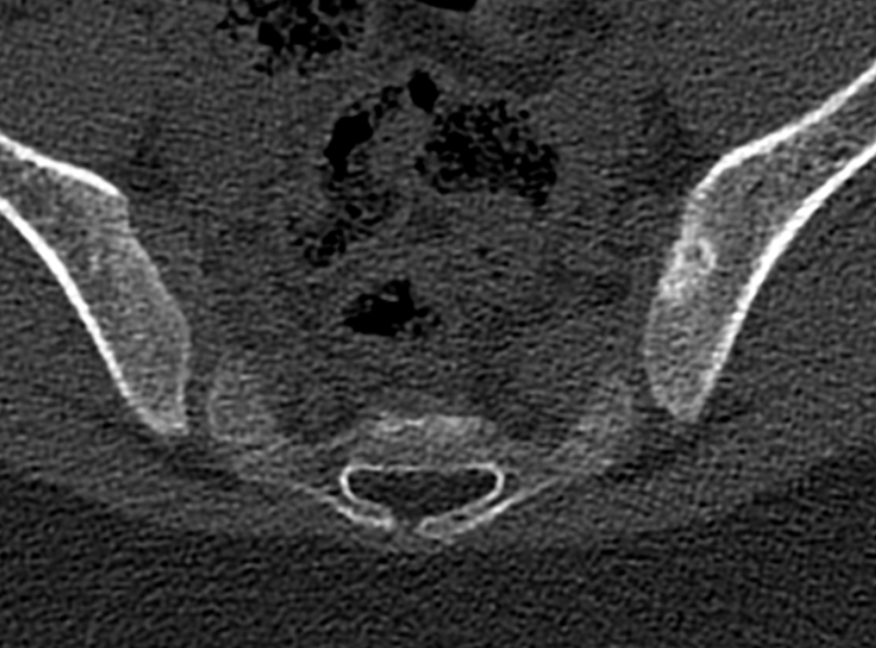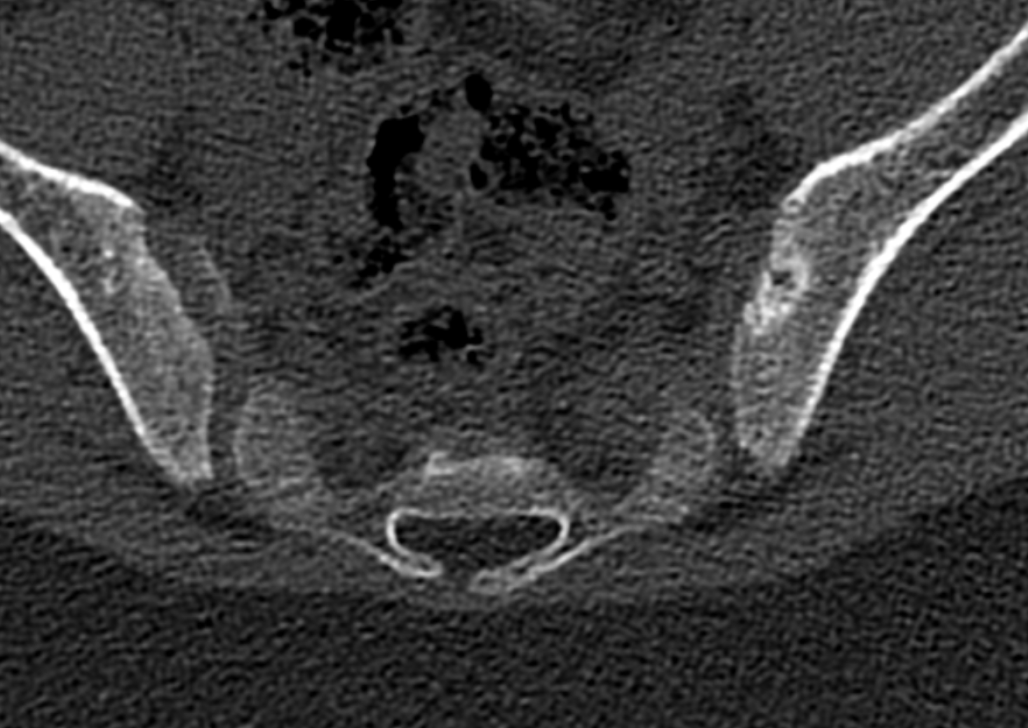

*Figure 1*

*Computed tomography (CT) of the sacroiliac joints showing symmetrical bilateral lesions of acute inflammation (sacroiliitis) and chronic lesions in the form of erosions in the anteroinferior parts of the joints.*

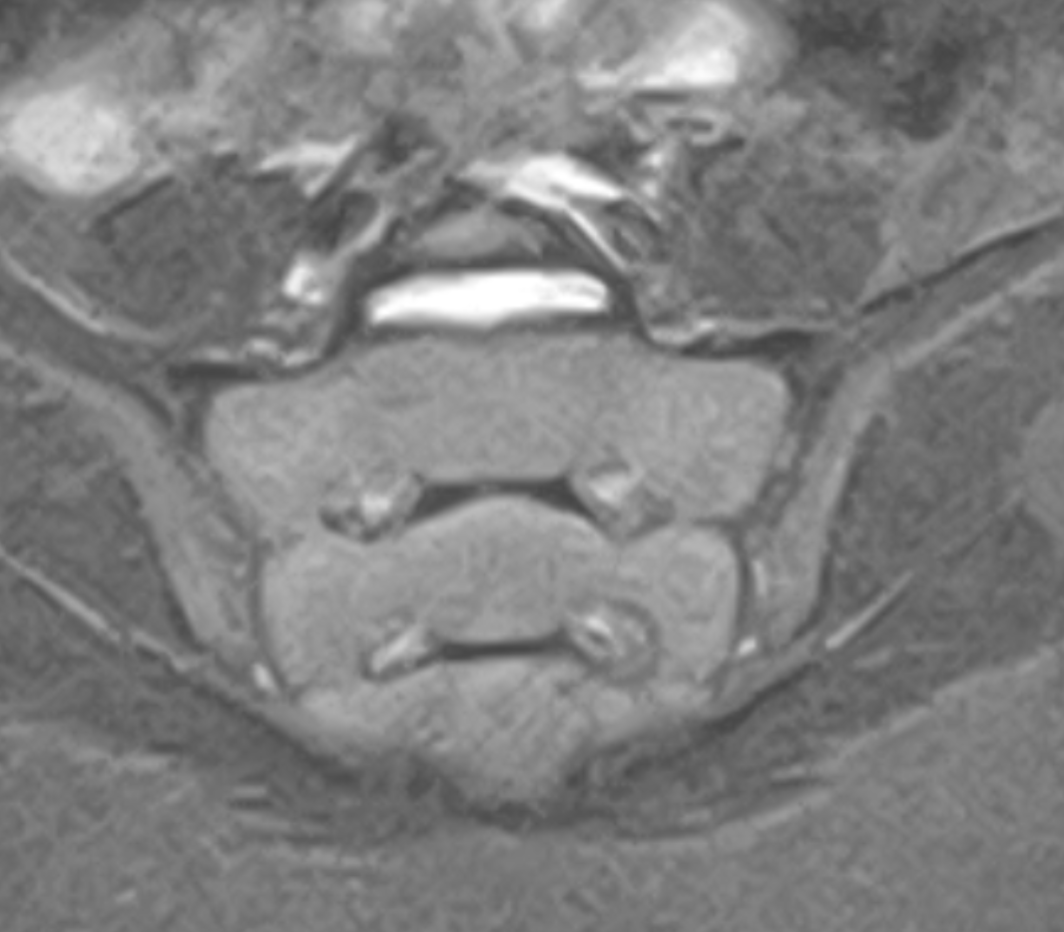

*Figure 2*

*MRI of the sacroiliac joints in STIR-sequence showing no signs of sacroiliitis.*