Cover Letter

Manuscript Title: Affective temperaments and risk of non-adherence to medications in patients with hypertension
Names of authors: Sanaz Mortazian, Alireza Shamsi, Mohamad Esmail Gheydari
Name and address of Corresponding Author: Alireza Shamsi, Shahid Beheshti University of Medical Sciences, Tehran, Iran

To: Editor-in-Chief of Psychiatria Journal
Dear Editor
I, as the main corresponding author of the mentioned manuscript, would like to submit a research article entitled “Affective temperaments and risk of non-adherence to medications in patients with hypertension” for consideration for publication in Psychiatria Journal.
I believe that the findings of this study are relevant to the scope of your journal and will be of interest to its readership.
I, as the author, by signing the below letter declare that:
- The manuscript is the original work of authors. All data, tables, figures, etc. used in the manuscript are prepared originally by authors, otherwise the sources are cited, and reprint permission is attached.
- The manuscript has not been and will not be published elsewhere or submitted elsewhere for publication.
- The authors mention that there is no conflict of interest in this study.
- The paper, the final version of which I enclose, is not substantially the same as any that I/we have already published elsewhere.
- No more changes in the authors or main results are accepted from my side after submitting to the journal.
If you have any further questions, feel free to contact me. Thank you for your attention.
Yours Sincerely,
Alireza Shamsi, M.D., Assistant Professor of Psychiatry
Shahid Beheshti University of Medical Sciences, Tehran, Iran
Email: ar.shamsi@sbmu.ac.ir

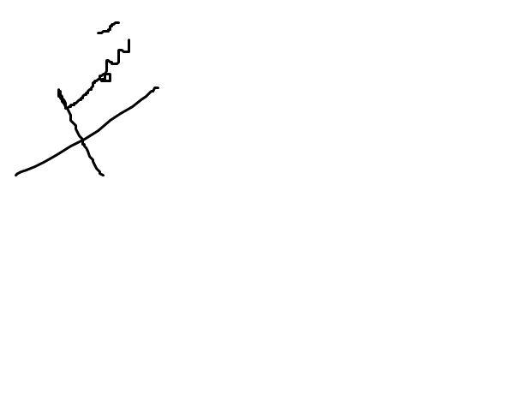
10/27/2023

