Supplementary Figure S1. Indications for transvenous lead removal in the study group (a) and in the control group (b).
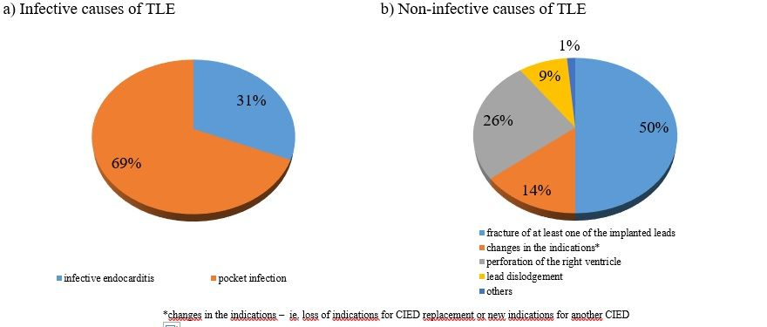

Supplementary Table S1. Clinical characteristics of patients, in whom transvenous lead extraction (TLE) was performed due to infective (study group) or non-infective (control group) causes.
 | Study group  (n = 51) | Control group  (n = 70) | p
Age [years] | 69±18 | 65±16 | 0.1
Sex  Male (n,%)  Female (n,%) | 31 (61)  20 (39) | 40 (57)  30 (43) | 0.7  0.8
Concomitant disease
Diabetes (n,%) | 9 (18) | 12 (17) | 1.0
Chronic kidney disease (n,%) | 11 (22) | 8 (11) | 0.3
Chronic obstructive pulmonary disease (n,%) | 4 (8) | 3 (4) | 0.7
Malignancy (n,%) | 4 (8) | 5 (7) | 09
Chronic heart failure (n,%) | 24 (47) | 42 (60) | 0.2
NYHA class  I  II  III  IV | 17 (33)  27 (53)  6 (12)  1 (2) | 31 (45)  26 (38)  12 (17)  0 (0) | 0.9  0.3  0.8  0.6
Dilated cardiomyopathy (n,%) | 18 (35) | 22 (31) | 0.7
Hypertrophic cardiomyopathy (n,%) | 1 (2) | 0 (0) | 0.8
Ischemic heart disease (n,%) | 26 (51) | 26 (37) | 0.2
Hypertension (n,%) | 29 (57) | 40 (57) | 1.0
Chronic atrial fibrillation (n,%) | 16 (31) | 10 (14) | 0.02
Paroxysmal atrial fibrillation (n,%) | 10 (20) | 18 (26) | 0.6
2nd/3rd degree atrioventricular block (n,%) | 22 (43) | 20 (29) | 0.2
Sick sinus syndrome (n,%) | 15 (29) | 19 (27) | 0.9
Dual nodal disease (n,%) | 5 (10) | 2 (3) | 0.5
History of infective endocarditis (n,%) | 1 (2) | 0 (0) | 0.8
Type of the last procedure preceding TLE
Hospitalization duration (mean ± SD) [days] | 7±13 | 11±12 | <0.01
De novo implantation (n,%) | 23 (46) | 46 (66) | 0.02
CIED exchange (n,%) | 14 (27) | 15 (21) | 0.6
CIED upgrade (n,%) | 14 (27) | 9 (13) | 0.2
Type of the device implanted during the last procedure preceding TLE
Pacemaker (n,%) | 27 (53) | 29 (41) | 0.2
AAI (n,%) | 2 (4) | 1 (1) | 0.8
VVI (n,%) | 5 (10) | 4 (6) | 0.7
DDD (n,%) | 20 (39) | 23 (33) | 0.5
CRT-P (n,%) | 0 (0) | 1 (1) | 0.9
ICD (n,%) | 24 (47) | 41 (59) | 0.2
VR (n,%) | 12 (23) | 14 (20) | 0.7
DR (n,%) | 9 (18) | 21 (30) | 0.2
CRT-D (n,%) | 3 (6) | 6 (9) | 0.8
Number of implanted leads  0 (n,%)  1 (n,%)  2 (n,%)  3 (n,%) | 19 (38)  18 (35)  13 (25)  1 (2) | 17 (24)  21 (30)  30 (43)  2 (3) | 0.4  0.8  0.3  0.9
Temporary transvenous pacing during the last procedure preceding TLE (n,%) | 3 (6) | 5 (7) | 0.9
Hospitalization within 6 months before the last procedure preceding TLE (n,%) | 18 (35) | 12 (17) | 0.005
History of CIED exchange (n,%) | 9 (18) | 12 (17) | 1.0
History of CIED revision (evacuation of pocket hematoma, pocket plasty (n,%) | 5 (10) | 2 (3) | 0.5
History of CIED upgrade (n,%) | 4 (8) | 4 (6) | 0.8

CIED – cardiac implantable electronic device, ICD – implantable cardioverter-defibrillator

Supplementary Table S2. Results of laboratory tests at the time of the procedure preceding TLE in both groups of patients.
 | Study group  (n=51) | Control group  (n=70) | p
CRP [mg/l] | 14.3 ± 29.11  (n=13; 25%) | 6.3 ± 8.6  (n=32; 46%) | 1.0
White blood cell count [x10³/µl] | 6.6 ± 1.8  (n=28; 55%) | 7.3 ± 3.9  (n=50; 71%) | 0.8
Neutrophil count [x10³/µl] | 4.2 ± 1.8  (n=21; 41%) | 3.9 ± 1.8  (n=42; 60%) | 0.4
Hemoglobin [g/dl] | 13.6 ± 1.8  (n=28; 55%) | 13.1 ± 1.7  (n=50; 71%) | 0.2
Creatinine [mg/dl] | 1.1 ± 0.5  (n=27; 53%) | 0.9 ± 0.3  (n=49; 70%) | 0.2
Procalcitonin [ng/ml] | 0.2 ± 0.1  (n=3; 6%) | 0.1 ± 0.1  (n=10; 14%) | 0.2
BNP [pg/ml] | 1345 ± 1175  (n=6; 12%) | 317 ± 371  (n=11; 16%) | 0.09

CRP – C-reactive protein, BNP – brain natriuretic peptide

Supplementary Table S3. Risk factors of infective complications leading to transvenous lead extraction (TLE).
 | Univariate analysis |  |  | Multivariate analysis
Variable | OR | 95% CI | p | OR | 95% CI | p
Hospitalization during 6 months before the last procedure preceding TLE | 3.62 | 1.44-9.11 | 0.01 | 1.32 | 0.39-4.50 | 0.6
Chronic atrial fibrillation | 2.78 | 1.13-6.8 | 0.02 | 1.20 | 0.27-5.37 | 0.8
Bridge therapy with LMWH | 3.11 | 1.19-8.13 | 0.02 | 7.57 | 1.94-29.5 | 0.004
Concomitant antiplatelet and anticoagulation therapy | 3.41 | 0.8-14.53 | 0.09 | 0.45 | 0.03-7.75 | 0.6
Cerebrovascular disease | 2.81 | 0.88-8.98 | 0.07 | 3.09 | 0.53-18.17 | 0.2
History of CIED upgrade | 2.32 | 0.9-5.94 | 0.08 | 4.22 | 1.23-14.44 | 0.02
Pacemaker implantation | 1,.5 | 0.84-3.68 | 0.02 | 4.12 | 1.27-13.4 | 0.02
History of CIED revision | 3.64 | 0.68-19.58 | 0.1 | 3.91 | 0.45-34.12 | 0.2
Coronary artery disease | 1.79 | 0.86-3.75 | 0.1 | 1.86 | 0.56-6.23 | 0.3

CIED – cardiac implantable electronic device, LMWH – low molecular weight heparin

