Figure 1. The mutation rate of the EGFR gene and its subgroups

Figure 1 presents the EGFR gene mutation rate and the rate of mutation subgroups. The EGFR mutation rate is 41.9%, of which Exon 19 and L858R exon 21 deletion mutations account for the majority.

Figure 2. ROC curve analyses: Sensitivity and Specificity of CEA value for predicting the presence of EGFR mutations in patients with NSCLC
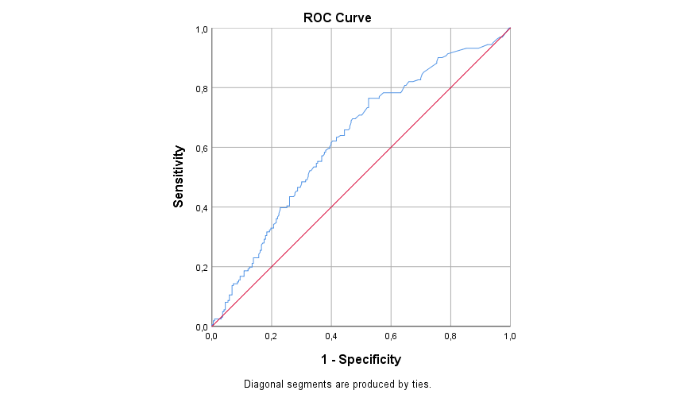
A ROC curve was analyzed to select a cut-off value for the CEA level, which could be used to identify patients with an increased risk of EGFR mutations. A cut-off value of 8.95 was determined and ROC analysis of CEA levels indicated a sensitivity of 76.4 %, a specificity of 47.5%, and an area under the curve (AUC) of 0.627 (95% CI, 0.571–0.683).

