**Figures**

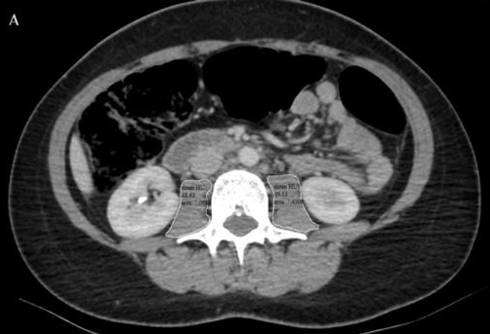

Figure 1. Abdominalaxial CT images. A. At thelevel of thirdlombervertebra, outerboundaries of psoasmusclesweredrawnmanually (whitelines) andpsoasmusclecrosssectionalarea (cm2) andattenuation (HounsfieldUnit, HU) weremeasured on bothsides

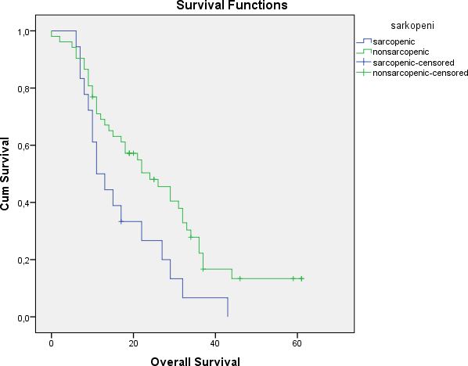

Figure 2. Survival time for sarcopenic and non-sarcopenic patients

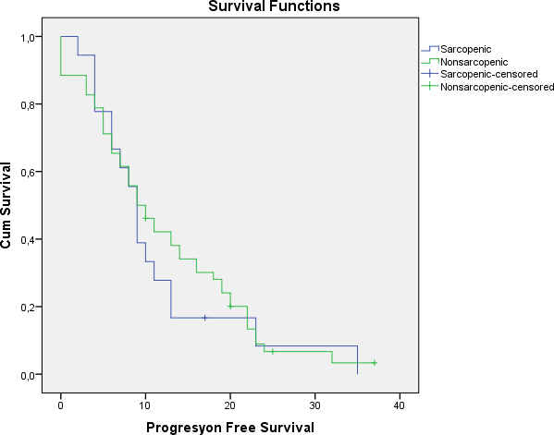

Figure3. Progression-free survival for sarcopenic and non-sarcopenic patients