**von Hippel-Lindau syndrome  - of the urologist and oncologist perspective; literature review**

**Krzysztof Kowalik1, Paweł Narożnicki2,Katarzyna Hetman3, Artur Smogór4, Katarzyna Kołaczyk5, Krystian Kasperowicz6,Anna Gruszczyńska7 Grażyna Dutkiewicz8, Andrzej Modrzejewski1**

1 Clinical Department of General Surgery of the Pomeranian Medical University, Szczecin, Poland  
Head: prof. Andrzej Modrzejewski, MD, PhD

2Medical Faculty, Collegium of Military Medicine, Faculty of Medicine, Medical University of Łódź, Poland

3Department of Clinical Oncology West Pomeranian Oncology Center, Szczecin, Poland  
Head: Roman Dubiański, MD, PhD  
  
4Medical offices "ARTIMED" Szczecin

5Department of Imaging Diagnostics and Interventional Radiology, University Clinical Hospital No. 1 of the Pomeranian Medical University, Szczecin, Poland  
Head: Prof. Wojciech Poncyljusz, MD, PhD

6Faculty of Health and Life Sciences, Northumbria University, Newcastle upon Tyne, UK

7Department of Forensic Medicine of the Pomeranian Medical University, Szczecin, Poland

8Department of Nephrology, Transplantology, and Internal Medicine, University Clinical Hospital No. 2 of the Pomeranian Medical University, Szczecin, Poland  
Head: Prof. Kazimierz Ciechanowski, MD, PhD

**Address for correspondence:**

Krzysztof Kowalik, MD  
Clinical Department of General Surgery,  
Pomeranian Medical University  
Piotra Skargi St., 9–11, 70–965  
Szczecin, Poland  
e-mail: [krzysztof.kowalik.uro@gmail.com](mailto:krzysztof.kowalik.uro@gmail.com)

**Abstract**

Von Hippel-Lindau (VHL) syndrome is a rare genetic disorder characterized by multipleretinal and cerebellar hemangioblastomas that tend to occur in a familial setting. The pattern of inheritence is autosomal dominant. Patients with VHL syndrome have an increased risk of clear cell renal cell carcinoma (ccRCC) as well as pancreatic and testicular cysts and cystadenomas. Tumours associated with VHL syndrome manifest at a young age.

This article presents diagnostic methods and discusses the treatment approaches for this syndrome based on a review of the global literature.

**Keywords**: von Hippel-Lindau syndrome, familiar angiomatosis of the retina and cerebellum,

clear cell renal cell carcinoma, polycystic kidney disease

**Introduction**  
Von Hippel-Lindau (VHL) syndrome is a rare genetic disorder characterized by familial cerebellar and retinal angiomatosis. This syndrome is an example of an autosomal dominant disease, with an estimated occurrence rate ranging from 1:36,000 to 1:100,000 [1,2]. There are two types of this syndrome: Type 1 VHL without a pheochromocytoma and type 2 with a pheochromocytoma [3-6]. The clinical manifestations are linked to mutations in the VHL gene located on the short arm of the third chromosome (3p25-26) [1]. The tumor suppressor gene VHL encodes a protein that, through the action of E3 ubiquitin ligase, leads to the degradation of HIF factors. Under normal conditions, HIF (Hypoxia Inducible Factor), which are activated by hypoxia, induce the expression of genes including VEGF (Vascular Endothelial Growth Factor), EPO (Erythropoietin), TGF (Transforming Growth Factor), EPOR (Erythropoietin Receptor), angiopoietin 1, and transferrin, thereby helping to reduce hypoxia. During normoxia, HIF are degraded by the VHL protein. In patients with VHL disease, the VHL protein loses its function, which leads to uncontrolled activation of HIF and the expression of the aforementioned genes, causing phenomena such as angiogenesis and erythropoiesis. These processes lead to the development of symptoms of von Hippel-Lindau syndrome, including hemangioblastomas in the central nervous system, clear cell renal cell carcinoma, retinal hemangioblastomas, pancreatic neuroendocrine tumors, polycystic kidneys, and cysts in the pancreas and epididymis. About 80% of VHL gene mutations occur as a familial trait, and in 20% of patients, they occur de novo. In Denmark, a study of 34 families with a VHL gene mutation found that the most common types of mutations are missense mutations, deletions or insertions within the reading frame, and nonsense mutations. [7]

The disease is characterised by an increased predisposition to develop hemangioblastomas in71 the central nervous system (most commonly in the cerebellum and spinal cord), occurring in 60-80% of cases. Other conditions associated with this syndrome include clear cell renal cell carcinoma, retinal hemangioblastomas, pancreatic neuroendocrine tumours, polycystic kidneys, and cysts in the pancreas and epididymis. The syndrome typically presents multifocally, bilaterally, and at a young age, with anaverage77 onset at 30 [8-25].

The average life expectancy of patients with VHL disease is 49 years, the most common causes of death being clear cell renal carcinoma and hemangioblastoma. [26].Cases of VHL syndrome in children have also been described in the literature [8-20]. Diagnosis relies on genetic testing and clinical imaging.

**Components of VHL type 1**

The first type of the disease is characterised by predominant deletion mutations. Moreover, in this type, there is an absence of the development of pheochromocytoma. Typically, patients without the development of pheochromocytoma in VHL syndrome experience complete remission of tumour lesions, with the tumours exhibiting low malignancy [3-6].

**Components of VHL type 2**

In the second type of VHL syndrome, there is a significant risk (40-60%) of developing pheochromocytoma and clear cell renal cell carcinoma (ccRCC) [3-6,21]. Additionally, within type 2, three subtypes are distinguished - 2A, 2B, and 2C. [27]

They are categorized based on the occurrence of hemangioblastomas and clear cell renal cell carcinoma [27].

Hemangioblastoma can be observed in subtypes 2A and 2B. RCC is typically found in patients with subtype 2B. [27] Subtype 2C is rare and involves RCC or papillary cell carcinoma (PCC).

[28,29] Point mutations such as transversion type, are specific for VHL Type 2 [8-20].

Such mutations are additionally nonsense mutations leading to the formation of an abnormal protein structure. The studied gene is a tumour suppressor gene; therefore, mutations in it contribute to the development of tumours.

**Diagnosis**

In the diagnosis of VHL disease, medical history (including a detailed family history), physical examination, imaging studies (such as magnetic resonance imaging, computed tomography, and ultrasonography), and genetic testing are utilized.

The physical examination may reveal various neurological disturbances, such as problems with motor coordination, balance; vision and hearing impairments, muscle weakness, palpable abdominal mass, and feelings of fatigue and weakness.

VHL diagnosis is basen on genetic tests to confirm or rule out mutations in the VHL gene of potentially affected individuals and the family genetic line.

Patients should be referred for VHL gene testing if the individual's medical history reports either retinal hemangioblastomas (RH), central nervous system hemangioblastomas, pheochromocytomas (PCC), endolymphatic sac tumours (ELST), or RCC with atypical features, including people aged below 46, bilateral or multifocal tumours, and other family members with RCC cases. [30]. In some patients, the diagnosis of VHL is made based on clinical symptoms. For individuals with a family history of VHL disease, the presence of one characteristic symptom of VHL disease is sufficient, whereas in the absence of a family history, two symptoms of the VHL syndrome are necessary for diagnosis, one of which must be a hemangioma. It is recommended that the diagnosis and further treatment be conducted by a multidisciplinary team, which includes a clinical geneticist, neurosurgeon, endocrinologist, urologist, ophthalmologist, and oncologist [7].

Specific diagnostic criteria for VHL were constructed   
(Table 1).

**Table 1,** Danish and international criteria for diagnosing VHL [31-35].  
  
In patients with VHL, computed tomography (CT) and ultrasonography (US) typically reveal numerous, often bilateral kidney cysts and kidney tumours corresponding to ccRCC. ccRCCs usually coexist with other changes in the central nervous system or cysts in the pancreas and epididymis. MRI (Magnetic Resonance Imaging) allows for the visualization of changes in the central nervous system. (CT scans presented changes occurring in patients with von Hippel-Lindau syndrome, in fairly common locations **(Fig. 1-4a).**

**Fig. 1. Cystic hemangioblastoma. Enhanced coronal T1-weighted MR image depicts a cystic mass with a strongly enhancing mural nodule (arrow) in the cerebellum.**

**Fig. 2. Coronal contrast-enhanced CT scan shows right adrenal gland pheochromocytoma with homogeneous, vivid enhancement (arrow).**

**Fig. 2a. Same patient as in Fig.2. Axial contrast-enhanced CT image depicts multiple cystic lesions (arrows) scattered within the body and tail of pancreas.**

**Fig. 3. Coronal contrast-enhanced CT scan shows left renal solid mass (arrow) showing strong arterial enhancement typical for clear cell renal cell carcinoma.**

**Fig. 3a. Same patient as in Fig.3. Coronal contrast-enhanced CT scan depicts left adrenal mass showing heterogeneous enhancement suggestive of pheochromocytoma.**

**Fig. 3b. Same patient as in Fig 3 and 3a. Axial contrast-enhanced CT image demonstrates a small well-defined hyperenhancing mass (arrow) located in the pancreatic uncinate process. CT appearance of the lesion is considered suggestive of neuroendocrine tumor (NET).**

**Fig. 4. Axial contrast-enhanced CT image shows complex cystic left renal mass (large arrow) and multiple simple renal cysts (small arrow).**

**Fig 4a. Axial contrast-enhanced CT image in the same patient as in Fig. 4. The arrows show multiple, hypodense cystic lesions within the pancreatic tail.**

**Treatment**

The treatment of patients with VHL syndrome depends on the manifestations and clinical symptoms. However, the cornerstone of management is surgical treatment with a multidisciplinary team of specialists.

Radical nephrectomy (RN) or sparing surgery nephrectomy (NSS) for patients with kidney tumors depends on the clinical advancement of the tumour. Currently, according to the latest EAU guidelines, if possible, the NSS is the preferred treatment for patientswith kidney tumors. However, in the case of VHL syndrome patients, the literature does not adopt a position.

NSS is recommended primarily for patients with ccRCC at stage T1. According to the EAU guidelines, NSS better preserves overall kidney function compared to RN. However, due to incompatibile results, the beneficial effect of NSS on overall survival, suggested in some studies, remains unconfirmed. Thus, in the case of VHL syndrome, this method is not preferred because new tumors may rapidly develop from the remaining kidney tissue. Nevertheless, it is recommended to treat tumors smaller than 4 cm with NSS while preserving kidney tissue [36].

Another cited study state that in patients after NSS, the risk of developing new tumours in the same kidney within five years and the overall risk of reoperation is respectively 50% and 25%.

However, the treatment strategy adopted by these authors using NSS and strict observation maintained proper kidney function without an increased risk of metastasis [37].

On the other hand, RN usually applies to tumours staged T2 and higher. Currently, the laparoscopic RN is recommended for T2 tumours. Compared to open RN, laparoscopic RN is characterised by decreased blood loss, shorter hospitalisation time, and patients

report less postoperative pain, returning to daily activities quicker.

Open RN is considered the standard procedure for T3 and T4 advanced tumours [38].

An increasing number of medical centres have access to the da Vinci robot. Patients eligible for RN or NSS can also be considered for robot-assisted surgery. However, compared to laparoscopic methods, no significant benefits for patient recovery have been demonstrated

with robot-assisted surgery. Moreover, robot-assisted RN (RARN) increases treatment costs [38]. In the treatment of patients with VHL, a HIF2a inhibitor (hypoxia-inducible factor) is also used. Under normal conditions, HIF2a, activated by hypoxia, causes the expression of genes, including VEGF, EPO, TGF, EPOR, angiopoietin 1, and transferrin, thereby contributing to the reduction of hypoxia. During normoxia, HIF2a is degraded by the VHL protein. In patients with VHL, the VHL protein loses its function, leading to uncontrolled activation of HIF2a and the expression of the aforementioned genes, causing phenomena such as angiogenesis and erythropoiesis. These processes lead to the development of symptoms of von Hippel-Lindau syndrome. The HIF2a inhibitor prevents the action of HIF2a, which inhibits the development of VHL syndrome. The HIF2a inhibitor plays a significant role in the treatment of patients with von Hippel-Lindau syndrome and RCC, as the HIF2a factor in this cancer is treated as an oncogene. [39] HIF2a is expressed in various cell types, including endothelial cells of blood vessels, renal glomeruli, cardiomyocytes, and hepatocytes. [40] The second generation of HIF2a inhibitors includes NKT2152, DFF332, and belzutifan. During clinical trials, it has been reported that the most common side effects that may occur during treatment are anemia, weakness and fatigue, shortness of breath, and nausea. [41] The LITESPARK-004 study (a phase II clinical trial) evaluated the efficacy of belzutifan treatment in patients with RCC and VHL disease. The dosage of the drug was 120 mg per day. Treatment was discontinued in the event of disease progression or the occurrence of unacceptable side effects. The study involved 61 patients, with a median duration of 8.2 months. The objective response rate was assessed at 49% (95% CI 36-62). In 30 patients, the disease remained stable after drug application. The following side effects occurred during the study: anemia, weakness and fatigue, as well as pain and dizziness. To treat anemia, packed red blood cell transfusions and/or erythropoiesis-stimulating agents were used. In August 2021, the FDA approved belzutifan for the treatment of adult patients with VHL disease who have RCC, CNS hemangiomas, or pancreatic neuroendocrine tumors that do not require immediate surgical treatment. [42]

Phase III clinical trials are also ongoing for the combination of belzutifan with cabozantinib. The results from earlier studies involving this combination of drugs are promising. [43]

**Necessity of lymphadenectomy and metastasectomy in case of distant metastasis**

Lymphadenectomy in patients with ccRCC does not improve long-term survival rates.

In patients with lymph node metastasis, regardless of the disease stage, the 3-year survival rate after nephrectomy is 20-30% [44]. However, in patients with isolated distant metastasis resistant to systemic treatment, performing metastasectomy is recommended. Randomised studies cited here have demonstrated that metastasectomy can improve the survival rates in patients who respond to systemic treatment, patients with metachronous lung metastasis or metastasis that appeared 2 years after the primary disease diagnosis [45].

**Risk of Recurrence**

The majority of patients with VHL syndrome experience local recurrence (83.7% after 10 years), with an average recurrence-free period of 53 months. Patients treated with NSS should be informed about strict monitoring and the likelihood of future reoperation [37].

**Palliative treatment**

Currently, significant advancements in the treatment of metastatic ccRCC involve various therapies targeting cellular signalling pathways. The standard approach for metastatic RCC includes agents targeting the VEGF, PDGFR, or mTOR signalling pathways.

Tyrosine kinase inhibitors (TKIs) are effective in treating advanced ccRCC, serving as both, firstand second-line treatment options. Agents used for advanced ccRCC treatment include inhibitors such as pazopanib, cabozantinib, axitinib, sorafenib, and sunitinib [46]. Another

class of drugs includes mTOR inhibitors like everolimus and temsirolimus [46].

Bevacizumab, a monoclonal anti-VEGF antibody, has been approved for treating advanced ccRCC in combination with interferon-alpha. Currently, there is the possibility of utilising

immunotherapy as monotherapy. Combined therapy for treating advanced ccRCC can be used [46].

Regarding radiotherapy, ccRCC was generally considered resistant to this type of treatment.

However, recent studies demonstrate that high-dose stereotactic radiotherapy (SRT) shows some effectiveness in treating metastatic and advanced ccRCC, particularly in cases of oligometastatic disease [47].

**Treatment of Central Nervous System Lesions**

Microsurgical resection remains the treatment of choice for vascular lesions of the Central Nervous System (CNS)[48].

In cases where patients are not fit enough to meet the requirements for surgical intervention, stereotactic radiation or craniospinal radiation is used.

However, long-term studies show that vascular lesions treated with radiation grow similarly to their natural history [49].

Prophylactic irradiation is not recommended for patients with VHL-associated vascular lesions as they exhibit unpredictable growth patterns [48].

The primary surgical methods used for treating retinal hemangioblastomas (RH) include laser photocoagulation and cryotherapy. They can be used alone or in combination [50]. For small RH lesions near the optic nerve, non-surgical methods include intravitreal injections of anti-VEGF agents [51].

Complete surgical resection is a preferred treatment option for endolymphatic sac tumours [52].

**FOLLOW UP PROTOCOLS**

All patients with VHL disease are predisposed to the development of benign or malignant lesions. Even if asymptomatic, such patients should be followed to detect new lesions and to monitor the progression of known lesions. Follow-up evaluations focus on hemangioblastomas (including retinal hemangioblastomas), endolymphatic sac tumors, pheochromocytomas, clear cell renal carcinomas, and pancreatic cystadenomas, as well as lesions of the epididymis and broad ligament of the uterus, and can be tailored to individual patient needs (Tab.2)

**Tabele 2. Follow-up evaluations recommended for patients with VHL disease [53,54].**

|  |  |  |  |
| --- | --- | --- | --- |
| **Follow-up evaluation** | **Initial age** | **Frequency** | **Comments** |
| Retinal assessment | < 1 year, | Every 6-12 months, | Annually, before age 30 |
| Anamnesis and physical examination by a specialist | 1 year | Yearly |  |
| Blood pressure and heart rate | 2 years | Yearly |  |
| Determination of metanephrine levels | 5 years | Yearly | Measurement in plasma preferred, but fractionated metanephrines may be measured in 24-h urine samples |
| MRI of the neuraxis (brain and spinal cord) | 11 years | Every 2 years | Performed with and without contrast (no contrast during pregnancy); can be coordinated with MRI of the abdomen; thin slices in the posterior fossa and temporal bone; single MRI of the inner ear canal at 15 years of age |
| Audiometry | 11 years | Every 2 years |  |
| MRI of the abdomen | 15 years | Every 2 years | Performed with and without contrast (no contrast during pregnancy); assess kidneys, pancreas, and adrenal glands; can be coordinated with MRI of the neuraxis |

**Summary**

Von Hippel-Lindau syndrome is a condition that increases the risk of developing multiple tumours, especially at a young age.

It is a rare autosomal recessive genetic disease. Its symptoms are nonspecific. However, genetic testing is critical in confirming or ruling out the diagnosis.

Early detection of VHL syndrome allows planning treatment, which extends and improves the patient's quality of life.

Treatment requires specialists from various medical fields, such as urology, oncology, endocrinology, and radiation oncology. Treatment methods depend on the timing and the patient's condition at the time of

diagnosis.

**Conclusions:**

1. Early diagnosis of VHL syndrome allows for proper treatment planning, enhancing patient comfort and lifespan.

2. In VHL syndrome patients with tumours up to 4 cm, NSS is the preferred treatment method.

3. Close monitoring of patients after NSS helps maintain kidney function and does not increase the risk of metastasis.

4. NSS compared to RN leads to better preservation of overall kidney function.

5. Management of VHL syndrome should involve a multidisciplinary team of specialists.

6. Since 2021, belzutifan, which is a HIF2a inhibitor, has been approved for treating patients with VHL disease and RCC.

**Początek formularza**

**References:**

[1]. Campbell-Walsh, et al.: Urology. 10th ed. International Edition, Elsevier 2012.

[2]. Martins R, João Bugalho M: Paragangliomas/pheochromocytomas: clinically oriented genetic testing. Int J Endocrinol 2014;2014:1-14.

[3].Ang SO, Chen H, Hirota K, Gordeuk VR, Jelinek J, Guan Y, Liu E, Sergueeva AI, Miasnikova GY, Mole D, Maxwell PH, Stockon DW, Semenza GL, Prchal JT: Disruption of oxygen homeostasis underlies congenital Chuvash polycythemia. Nat Genet 2002;32:614-621.

[4]. Maher ER, Neumann HPH, Richard S: von Hippel-Lindau disease: a clinical and scientific review. Eur J Hum Genet 2011;19:617-623

[5]. Lonser RR, Glenn GM, Walther M, Chew EY, Libutti SK, Linehan WM, Oldfield EH: von Hippel-Lindau disease. Lancet 2003;361:2059-2067.

[6]. Bender BU, Eng C, Olschewski M, Berger DP, Laubenberger J, Altehöfer C, Kirste G, Orszagh M, van Velthoven V, Miosczka H, Schmidt D, Neumann HPH: VHL c.505T>C mutation confers a high age-related penetrance but no increased overall mortality. J Med Genet 2001;38:508-514.

[7] Marie Louise M Binderup, Maja Smerdel, Line Borgwadt, Signe Sparre Beck Nielsen, Mia Gebauer Madsen, Hans Ulrik Møller, Jens Folke Kiilgaard, Lennart Friis-Hansen, Vibeke Harbud, Søren Cortnum, Hanne Owen, Steen Gimsing, Henning Anker Friis Juhl, Sune Munthe, Marianne Geilswijk, Åse Krogh Rasmussen, Ulla Møldrup, Ole Graumann, Frede Donskov, Henning Grønbæk, Brian Stausbøl-Grøn, Ove Schaffalitzky de Muckadell, Ulrich Knigge, Gitte Dam, Karin AW. Wadt, Lars Bøgeskov, Per Bagi, Lars Lund, Kirstine Stochholm, Lilian Bomme Ousager, Lone Sunde, von Hippel-Lindau disease: Updated guideline for diagnosis and surveillance, European Journal of Medical Genetics, Volume 65, Issue 8, 2022, 104538, ISSN 1769-7212, https://doi.org/10.1016/j.ejmg.2022.104538.

[8]. Pastore Y., Jedlickova K., Prchal J.T.: Mutations of von Hippel-Lidau tumor suppressor gene and congenital polycythemia. Am. J. Hum. Genet., 2004; 74 (3): 598

[9]. Lorenzo F.R., Yang C., Prchal J.T.: A Novel EPAS1/HIF2A germline mutation in Congenital Polycythemia with Paraganglioma. J. Mol. Med., 2013; 91 (4): 507–512

[10]. Maher E.R., Neumann H.P., Richard S.: Von Hippel-Lindau disease: a clinical and scientific review. Eur. J. Hum. Genet., 2011; 19: 617–623

[11]. Lenders J.W.M., Eisenhofer G., Manneli M., Pacak K.: Pheochromocytoma. Lancet, 2005; 366: 665–675

[12]. Andersen K.F., Altaf R., Krarup-Hansen A., Hendel H.W., et al.: Malignant pheochromocytomas and paragangliomas – the importance of a multidisciplinary approach. Cancer Treat. Rev., 2011; 37: 111–119

[13]. Parenti G., Zampetti B., Rapizzi E., Mannell M.: Update and new perspectives on diagnosis, prognosis and therapy of malignant pheochromocytoma/ paraganglioma. J. Oncol., 2012; doi: 10.1155/2012/872 713

[14]. Gimm O., DeMicco C., Perren A., Brunaud L., et al.: Malignant pheochromocytoma and paragangliomas: a diagnostic challenge. Langenbecks Arch. Surg., 2012; 397: 155–177

[15]. Neumann H.P., Berger D.P., Sigmund G., Blum U., et al.: Pheochromocytomas, multiple endocrine neoplasia and von Hippel-Lindau disease. N. Engl. J. Med., 1993; 329: 1531–1538

[16]. Beitner M.M., Winship I., Drummond K.J.: Neurosurgical considerations in von Hippel-Lindau disease. J. Clin. Neurosci., 2011; 18: 171–180

[17]. Bartontini M., Dahia P.: VHL disease. Best Pract. Res. Clin. Endocrinol. Metab., 2010; 24: 401–413

[18]. Richard S., Gardie B., Couve S., Gad S.: Von Hippel-Lindau: how rare disease illuminates cancer biology. Semin. Cancer Biol., 2013; 23 (1): 26–37

[19]. Bader H.L., Hsu T.: Systemic VHL gene functions and the VHL disease. FEBS Letters, 2012; 586: 1562–1569

[20]. Jilg C.A., Neumann H.P., Glasker S., Schultze-Seemann W.: Growth kinetics in von Hippel-Lindau-associated renal cell carcinoma. Urol. Int., 2012; 88: 71–78

[21]. Shuin T, Yamasaki I, Tamura K, Okuda H, Furihata M, Ashida S: Von Hippel-Lindau disease: molecular pathological basis, clinical criteria, genetic testing, clinical features of tumors and treatment. Jpn J Clin Oncol 2006;36:337-343.

[22]. Beck O, Fassbender WJ, Beyer P, Kriener S, Neumann HP, Klingebiel T, Lehrnbecher T: Pheochromocytoma in childhood: implication for further diagnostic procedures. Acta Paediatr 2004;93:1630-1634.

[23].Vaganovs P, Bokums K, Miklaševics E, Plonis J, Zarina L, Geldners I, Gardovskis J, Vjaters E: Von Hippel-Lindau syndrome: diagnosis and management of hemangioblastoma and pheochromocytoma. Case Rep Urol 2013;2013:624096.

[24]. Hasani-Ranjbar S, Amoli MM, Ebrahim-Habibi A, Haghpanah V, Hejazi M, Soltani A, Larijani B: Mutation screening of VHL gene in a family with malignant bilateral pheochromocytoma: from isolated familial pheochromocytoma to von Hippel-Lindau disease. Fam Cancer 2009;8:465-471.

[25]. Toote A, Hasani- Ranjbar S: Von Hippel-Lindau Disease: a new approach to an old problem. Int J Endocrinol Metab 2012;10:619-624.

[26]. Leung RS, Biswas SV, Duncan M, Rankin S. Imaging features of von Hippel-Lindau disease. Radiographics. 2008 Jan-Feb;28(1):65-79; quiz 323. doi: 10.1148/rg.281075052. PMID: 18203931.

[27].Ong, K.R.; Woodward, E.R.; Killick, P.; Lim, C.; Macdonald, F.; Maher, E.R. Genotype-phenotype correlations in von HippelLindau disease. Hum. Mutat. 2007, 28, 143–149.

[28]. Chou, A.; Toon, C.; Pickett, J.; Gill, A.J. von Hippel-Lindau syndrome. Front. Horm. Res. 2013, 41, 30–49.

[29]. Zhou, B.; Wang, J.; Liu, S.; Peng, X.; Hong, B.; Zhou, J.; Ma, K.; Zhang, J.; Cai, L.; Gong, K. Hemangioblastoma Instead of Renal Cell Carcinoma Plays a Major Role in the Unfavorable Overall Survival of Von Hippel-Lindau Disease Patients. Front. Oncol. 2019, 9, 1037

[30] Hampel H, Bennett RL, Buchanan A, et al. A practice guideline from the American College of Medical Genetics and Genomics and the National Society of Genetic Counselors: referral indications for cancer predisposition assessment. Genet Med 2015;17:70–87

[31]. Binderup ML, Bisgaard ML, Harbud V, Moller HU, Gimsing S, Friis-Hansen L, Hansen T, Bagi P, Knigge U, Kosteljanetz M, Bogeskov L, Thomsen C, Gerdes AM, Ousager LB, Sunde L. Von Hippel-Lindau disease (vHL). National clinical guideline for diagnosis and surveillance in Denmark. 3rd edition. Dan Med J 2013;60(12):B4763.

[32] MELMON KL, ROSEN SW. LINDAU'S DISEASE. REVIEW OF THE LITERATURE AND STUDY OF A LARGE KINDRED. Am J Med 1964;36:595-617.

[33] Maher ER, Neumann HP, Richard S. von Hippel-Lindau disease: A clinical and scientific review. Eur J Hum Genet 2011.

[34] Nordstrom-O'Brien M, van der Luijt RB, van RE, van den Ouweland AM, Majoor-Krakauer DF, Lolkema MP, van BA, Voest EE, Giles RH. Genetic analysis of von Hippel-Lindau disease. Hum Mutat 2010;31(5):521-37.

[35] Choyke PL, Glenn GM, Walther MM, Patronas NJ, Linehan WM, Zbar B. von Hippel-Lindau disease: genetic, clinical, and imaging features. Radiology 1995;194(3):629-42.

[36]. Ljungberg B, Albiges L, Abu-Ghanem Y, Bedke J, Capitanio U, Dabestani S, Fernández-Pello S, Giles RH, Hofmann F, Hora M, Klatte T, Kuusk T, Lam TB, Marconi L, Powles T, Tahbaz R, Volpe A, Bex A. European Association of Urology Guidelines on Renal Cell Carcinoma: The 2022 Update. Eur Urol. 2022 Oct;82(4):399-410. doi: 10.1016/j.eururo.2022.03.006. Epub 2022 Mar 26. PMID: 35346519.

[37]. Ploussard, G., Droupy, S., Ferlicot, S., Ples, R., Rocher, L., Richard, S., & Benoit, G. (2007). *Local Recurrence After Nephron-Sparing Surgery in von Hippel-Lindau Disease. Urology, 70(3), 435–439.* doi:10.1016/j.urology.2007.04.040

[38]. Kunath F, Schmidt S, Krabbe LM, et al. Partial nephrectomy versus radical nephrectomy for clinical localised renal masses. Cochrane Database Syst Rev. 2017(5). <https://doi.org/10.1002/14651858.CD012045.pub2>

[39] Metelo AM, Noonan H, Iliopoulos O. HIF2a inhibitors for the treatment of VHL disease. Oncotarget. 2015 Sep 15;6(27):23036-7. doi: 10.18632/oncotarget.4564. PMID: 26325097; PMCID: PMC4695098.

[40] Watts D., Gaete D., Rodriguez D., Hoogewijs D., Rauner M., Sormendi S., Wielockx B. Hypoxia pathway proteins are master regulators of erythropoiesis. Int. J. Mol. Sci. 2020;21:8131. doi: 10.3390/ijms21218131. [PMC free article] [PubMed] [CrossRef] [Google Scholar] [Ref list]

[41] Suárez C, Vieito M, Valdivia A, González M, Carles J. Selective HIF2A Inhibitors in the Management of Clear Cell Renal Cancer and Von Hippel-Lindau-Disease-Associated Tumors. Med Sci (Basel). 2023 Jun 30;11(3):46. doi: 10.3390/medsci11030046. PMID: 37489462; PMCID: PMC10366718.

[42] Jonasch E., Iliopoulos O., Rathmell W.K., Narayan V., Maughan B.L., Oudard S., Else T., Maranchie J.K., Welsh S.J., Bundsbæk Bøndergaard Iversen A., et al. LITESPARK-004 (MK-6482-004) phase 2 study of belzutifan, an oral hypoxia-inducible factor 2α inhibitor (HIF-2α), for von Hippel-Lindau (VHL) disease: Update with more than two years of follow-up data. J. Clin. Oncol. 2022;40:4546. doi: 10.1200/JCO.2022.40.16_suppl.4546. [CrossRef] [Google Scholar] [Ref list]

[43] McDermott D.F., Choueiri T.K., Bauer T.M., Arrowsmith E., Roy A., Perini R., Vickery D., Tykodi S.S. 656MO Phase II study of belzutifan (MK-6482), an oral hypoxia-inducible factor 2α (HIF-2α) inhibitor, plus cabozantinib for treatment of advanced clear cell renal cell carcinoma (ccRCC) Ann. Oncol. 2021;32:S681. doi: 10.1016/j.annonc.2021.08.052. [CrossRef] [Google Scholar] [Ref list]

[44]. Weight CJ, Mulders PF, Pantuck AJ, Thompson RH. The role of adrenalectomy in renal cancer. Eur Urol Focus. 2016; 1(3):251-7. <https://doi.org/10.1016/j.euf.2015.09.005>

[45]. Umbreit EC, McIntosh AG, Suk-Ouichai C, Karam JA, Wood CG. The current role of cytoreductive nephrectomy for metastatic renal cell carcinoma. Indian J Urol. 2021; 37(1):13. <https://pubmed.ncbi.nlm.nih.gov/33850351/>

[46]. Hsieh JJ, Purdue MP, Signoretti S, et al. Renal cell carcinoma. Nat Rev Dis Primers. 2017; 3(1):1-19. https://doi.org/10.1038/nrdp.2017.9

[47]. Spyropoulou D, Tsiganos P, Dimitrakopoulos F-I, et al. Radiotherapy and Renal Cell Carcinoma: A Continuing Saga. in vivo. 2021; 35(3):1365-77. https://doi.org/10.21873/invivo.12389

[48] Surgical management of spinal cord hemangioblastomas in patients with von Hippel—Lindau disease Russell R. Lonser M.D., Robert J. Weil M.D., John E. Wanebo M.D., Hetty L. Devroom R.N., and Edward H. Oldfield M.D.

[49]Chang SD, Meisel JA, Hancock SL et al. (1998). Treatment of hemangioblastomas in von Hippel–Lindau disease with linear accelerator-based radiosurgery. Neurosurgery 43: 28–34, discussion 34–25.

[50] Singh AD, Nouri M, Shields CL et al. (2002). Treatment of retinal Capillary hemangioma. Ophthalmology 109: 1799-1806.

[51] Wong WT, Liang KJ, Hammel K et al. (2008b). Intravitreal ranibizumab therapy for retinal capillary hemangioblastoma related to von Hippel-Lindau disease. Ophthalmology 115:1957-1964.

[52] Kim HJ, Hagan M, Butman JA et al, (2013). Surgical resection of endolymphatic sac tumors in von Hippel-Lindau disease: findings, results, and indications. Laryngoscope 123: 477-483.

[53]. Adapted from the VHL Family Alliance - VHL handbook(9 Alliance VHL. The VHL handbook - What you need to know about VHL. 6th. Boston, MA: VHL Alliance; 2020. International edition.

[54]. Mourão JLV, et al. Imaging manifestations of von Hippel-Lindau disease: an illustrated guide focusing on the central nervous system. Radiol Bras. 2022 May-Jun;55(3):188-192.

**Table 1. Danish and international criteria for diagnosing VHL** [30-34].

|  |  |  |
| --- | --- | --- |
|  | **International criteria** | **Danish criteria** |
| Confirmation of mutation in the family/VHL mutation | Symptom associated with VHL syndrome | Symptom associated with VHL syndrome |
| Associated with VHL  Symptoms included  in the criteria | * Retinal hemangioblastoma * CNS hemangioblastoma * RCC * Primitive Neuroectodermal Tumor (PNET) * Endolymphatic sac tumor (ELST) * Pancreatic cysts * Epididymal cystadenomas * Pheochromocytoma | * Retinal hemangioblastoma * Hemangioblastoma in the cerebellum, brainstem, or spinal cord * Primitive Neuroectodermal Tumor (PNET) and/or multiple * Pancreatic cysts * Endolymphatic sac tumor (ELST) * RCC * Pheochromocytoma, paraganglioma, and/or glioma |
| Exclusion of the disease within the family | Hemangioblastoma (CNS or retina) or at least one hemangioblastoma (retina and/or CNS) and other organ damage | At least 2 symptoms associated with VHL syndrome |

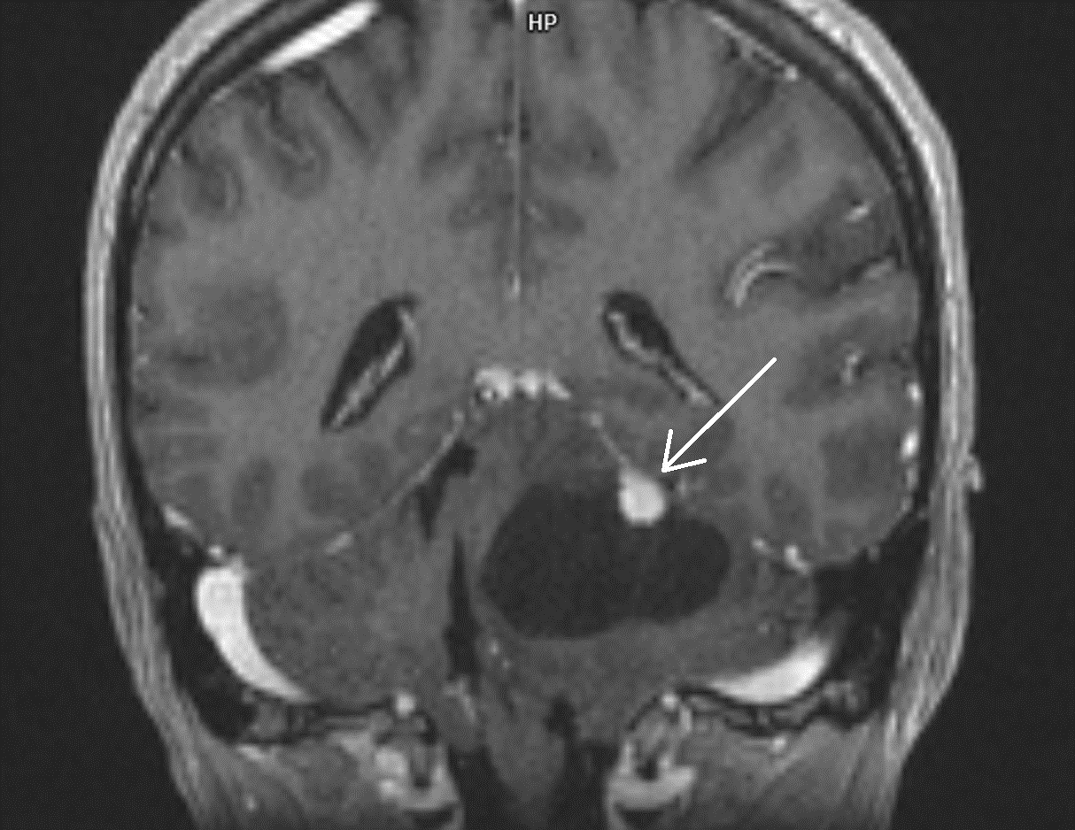

Fig. 1. Cystic hemangioblastoma. Enhanced coronal T1-weighted MR image depicts a cystic mass with a strongly enhancing mural nodule (arrow) in the cerebellum

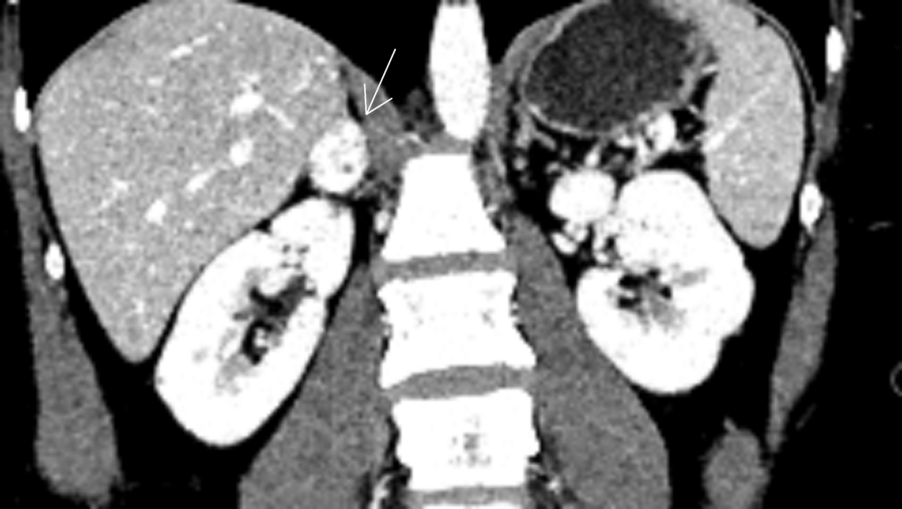

Fig. 2. Coronal contrast-enhanced CT scan shows right adrenal gland pheochromocytoma with homogeneous, vivid enhancement (arrow).

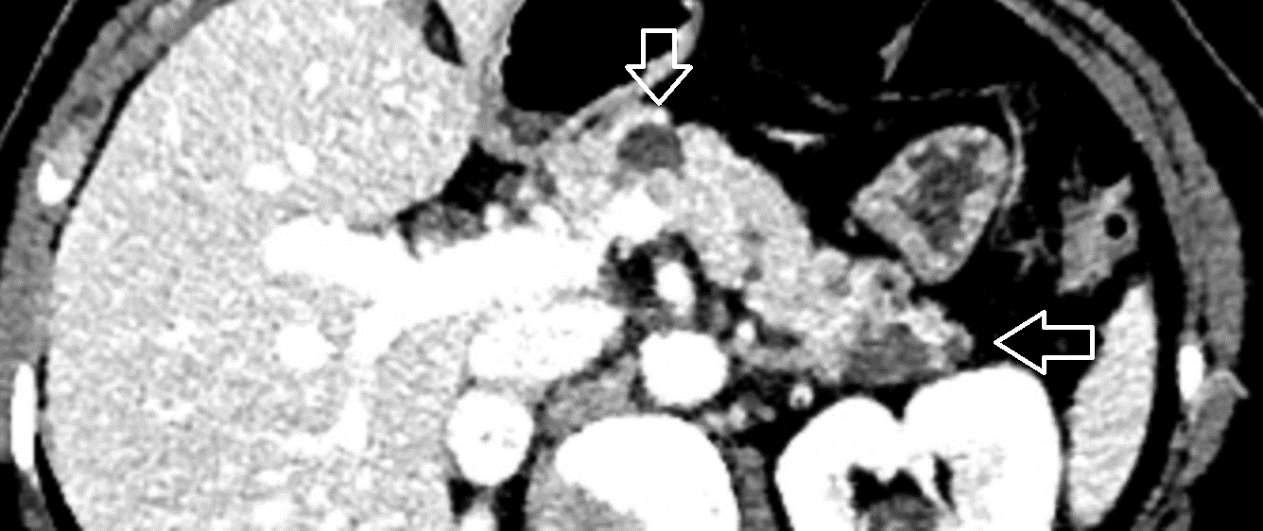

Fig. 2a. Same patient as in Fig.2. Axial contrast-enhanced CT image depicts multiple cystic lesions (arrows) scattered within the body and tail of pancreas.

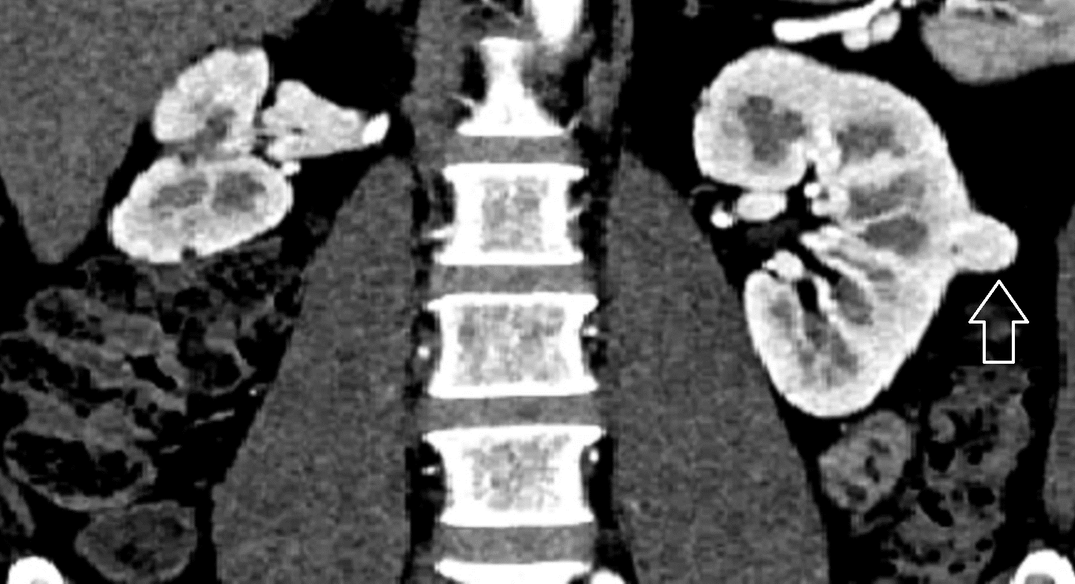

Fig. 3. Coronal contrast-enhanced CT scan shows left renal solid mass (arrow) showing strong arterial enhancement typical for clear cell renal cell carcinoma.

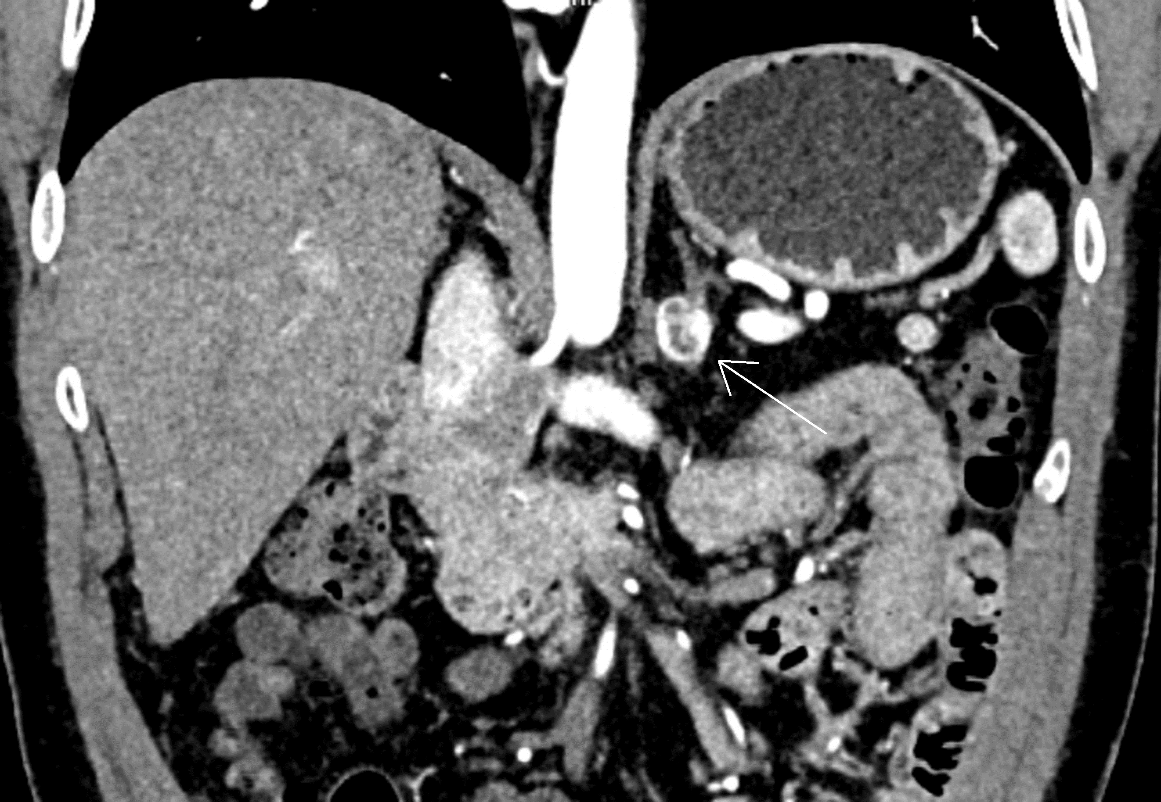

Fig. 3a. Same patient as in Fig.3. Coronal contrast-enhanced CT scan depicts left adrenal mass showing heterogeneous enhancement suggestive of pheochromocytoma.

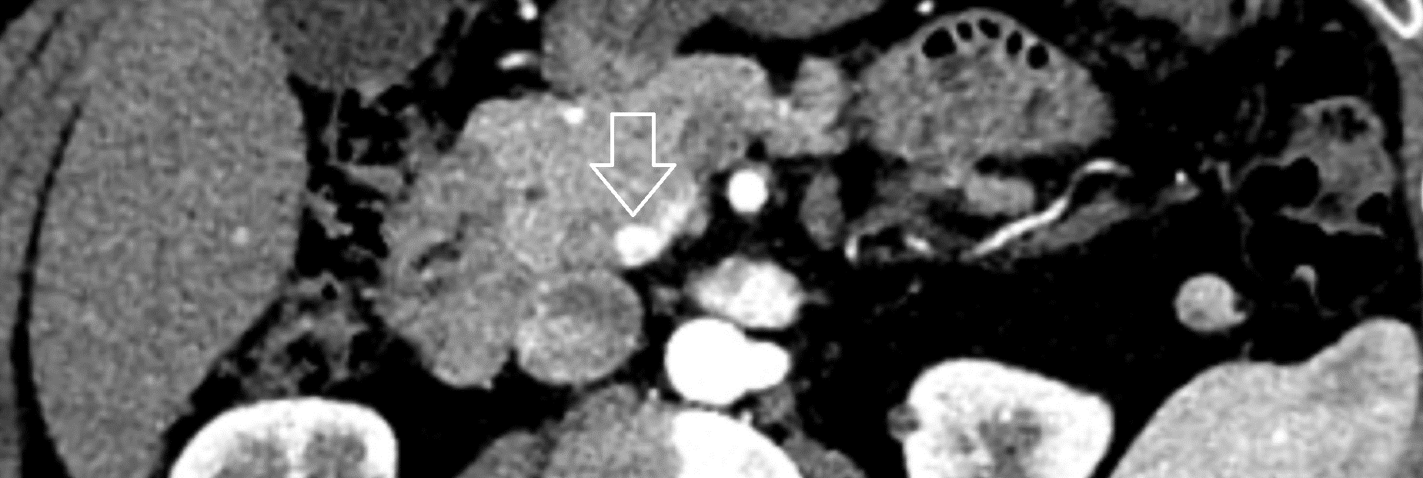

Fig. 3b. Same patient as in Fig 3 and 3a. Axial contrast-enhanced CT image demonstrates a small well-defined hyperenhancing mass (arrow) located in the pancreatic uncinate process. CT appearance of the lesion is considered suggestive of neuroendocrine tumor (NET).

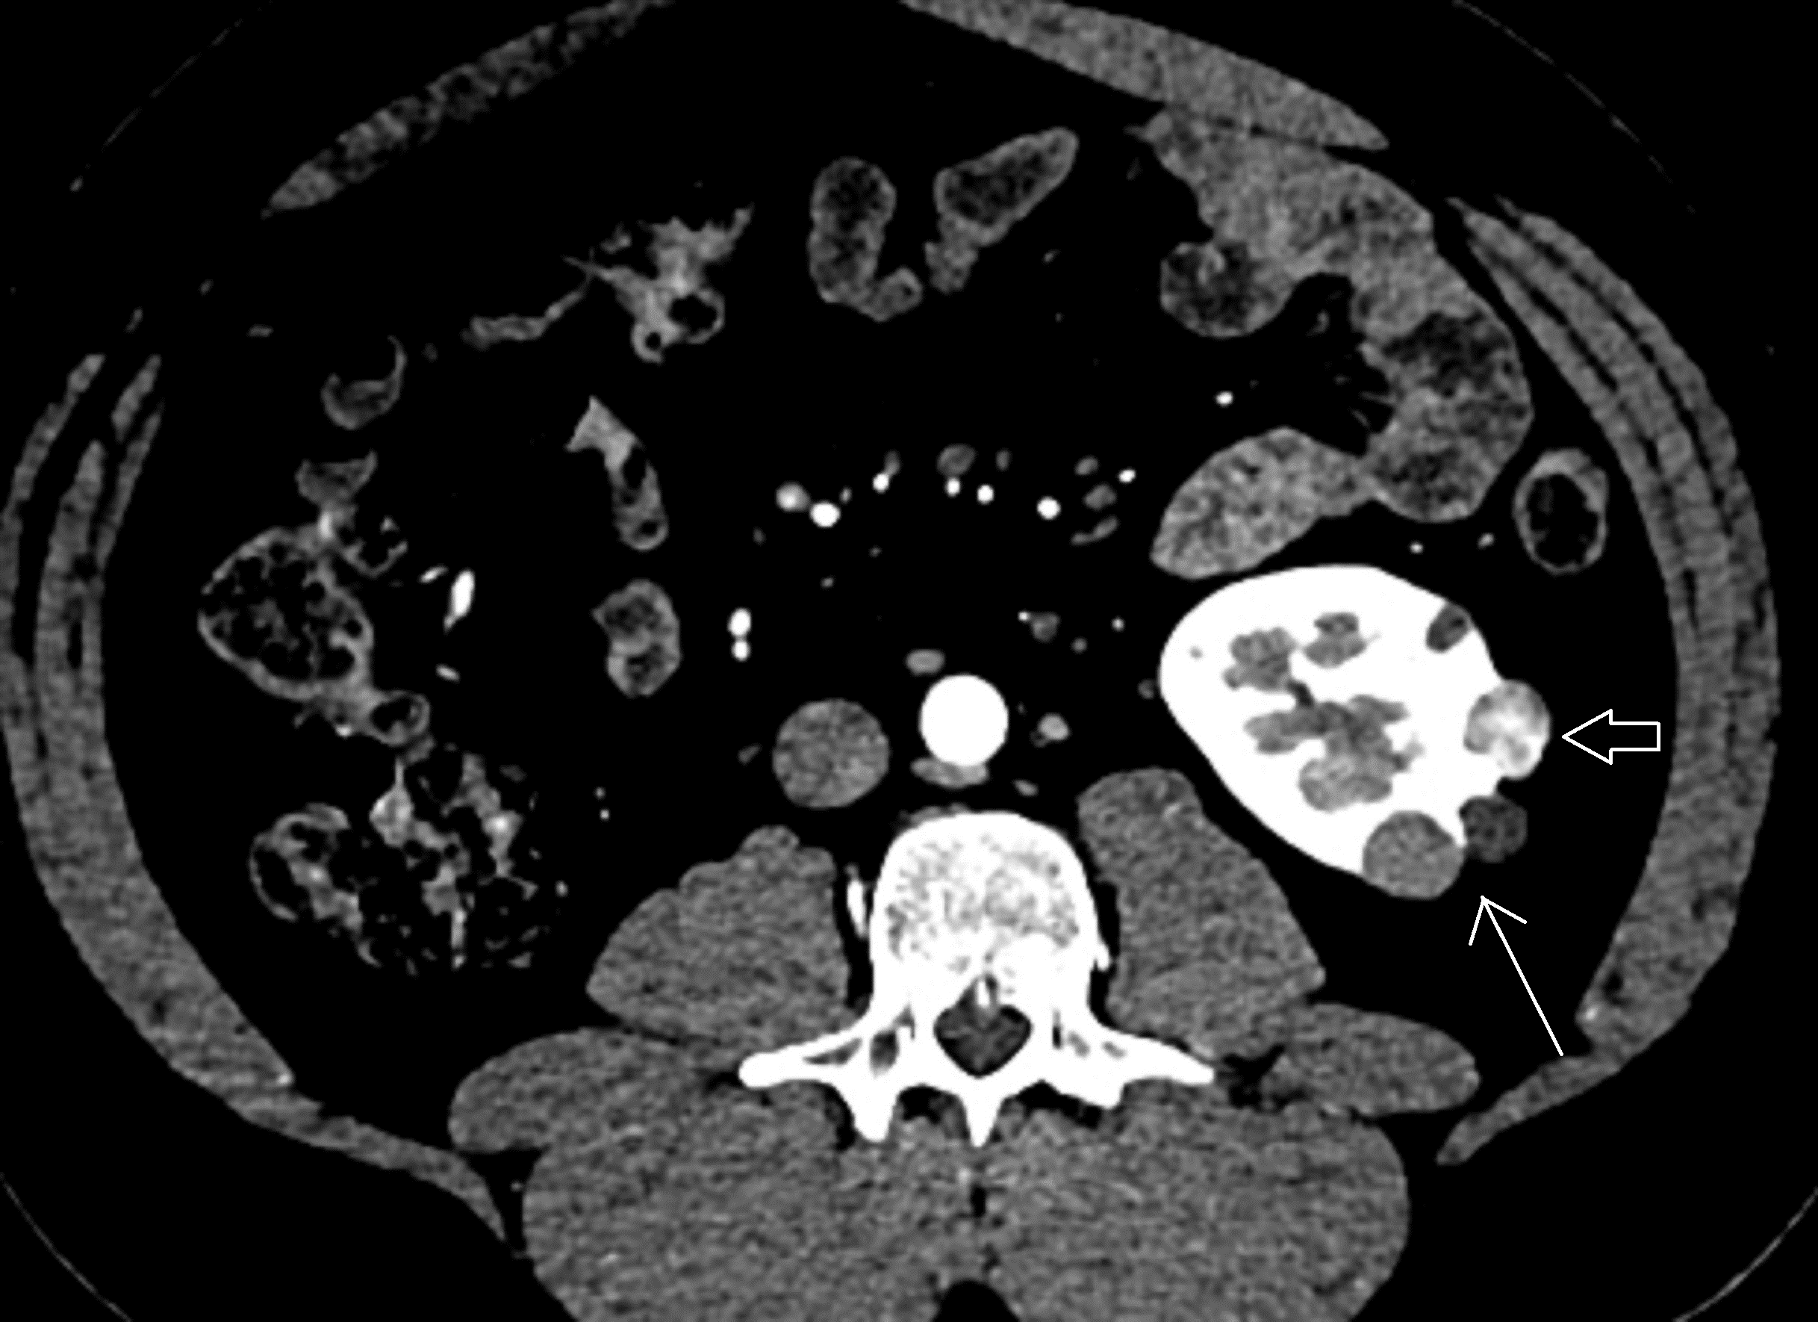

Fig. 4. Axial contrast-enhanced CT image shows complex cystic left renal mass (large arrow) and multiple simple renal cysts (small arrow).

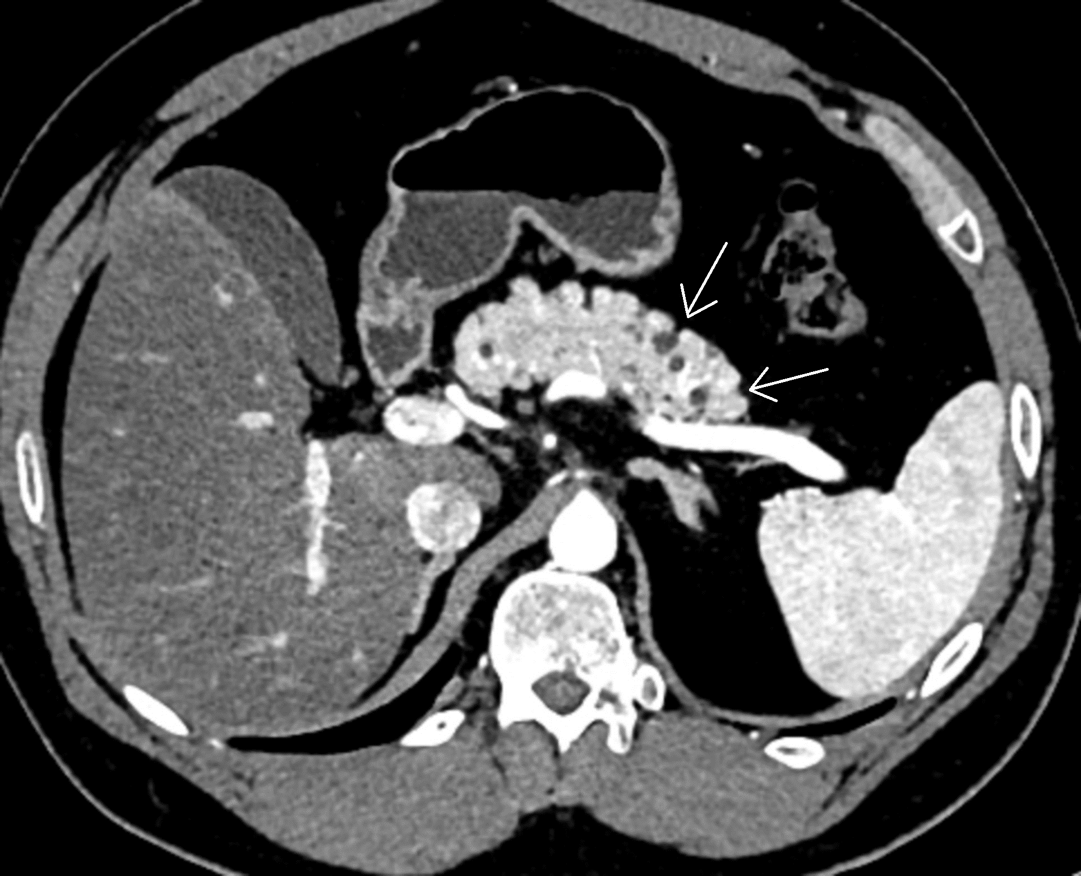

Fig. 4a. Axial contrast-enhanced CT image in the same patient as in Fig. 4. The arrows show multiple, hypodense cystic lesions within the pancreatic tail.