Supplemental Figure 1. Flow diagram of patient progress

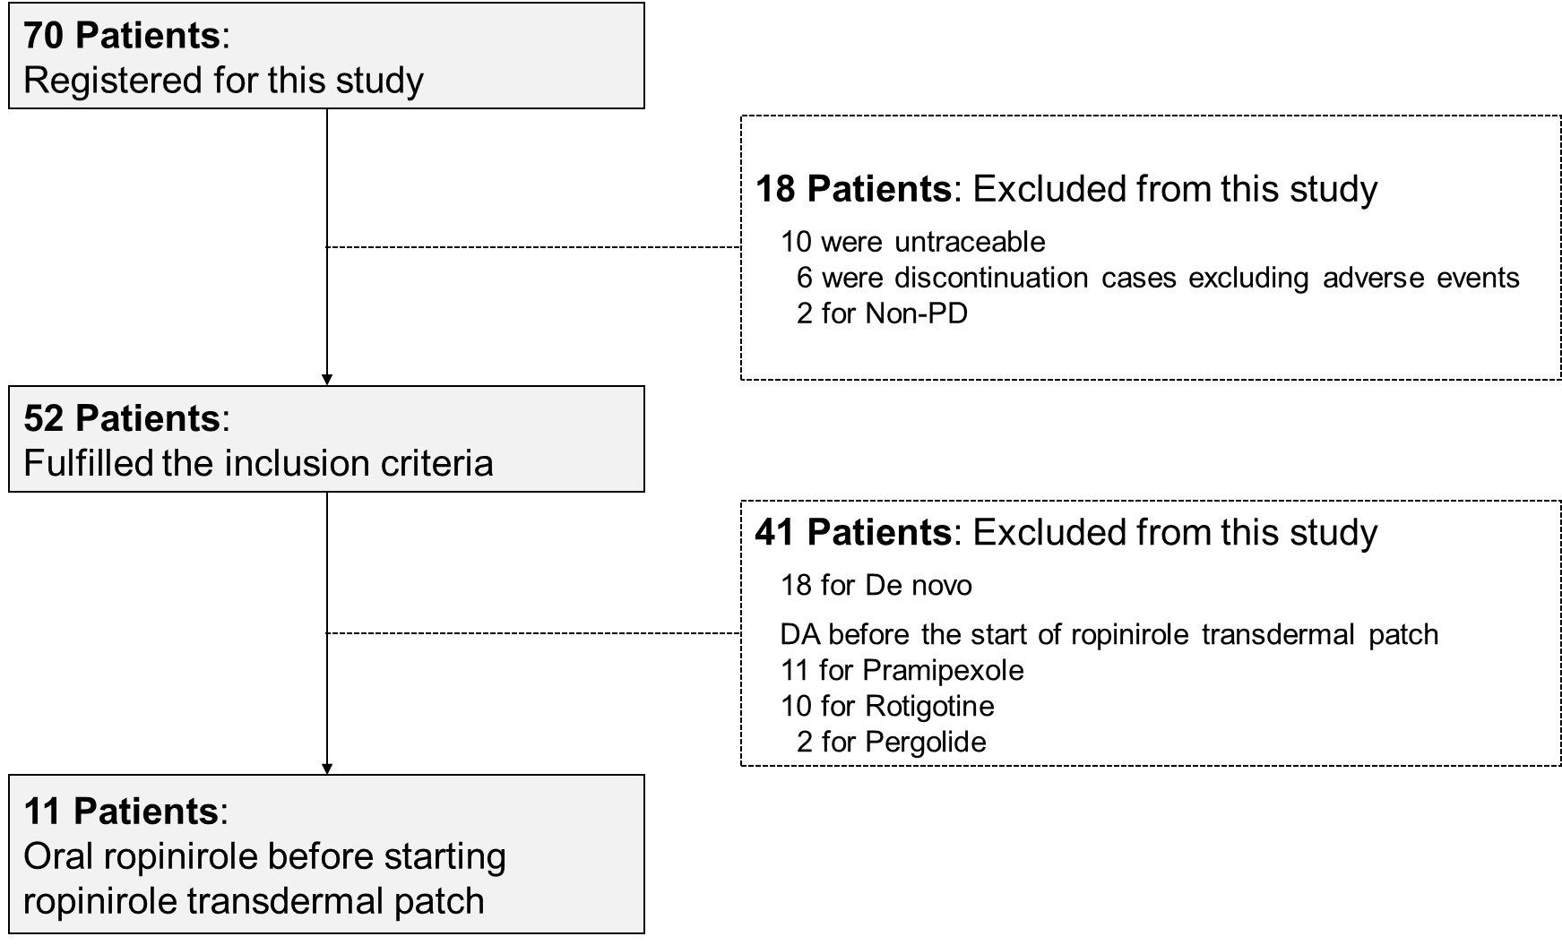

Supplemental Table 1. Conversion dose for switching from oral ropinirole to ropinirole transdermal patch

Ropinirole dosage form |  |  |  | Dose (mg/day)
Immediate-release tablet | ～2.25 | 3～4.5 | 6 | 7.5～9 | 10.5 | 12 | 13.5 | 15
Controlled-release tablet | 2 | 4 | 6 | 8 | 10 | 12 | 14 | 16
 | ↓ | ↓ | ↓ | ↓ | ↓ | ↓ | ↓ | ↓
Transdermal patch | 8 | 16 | 24 | 32 | 40 | 48 | 56 | 64

