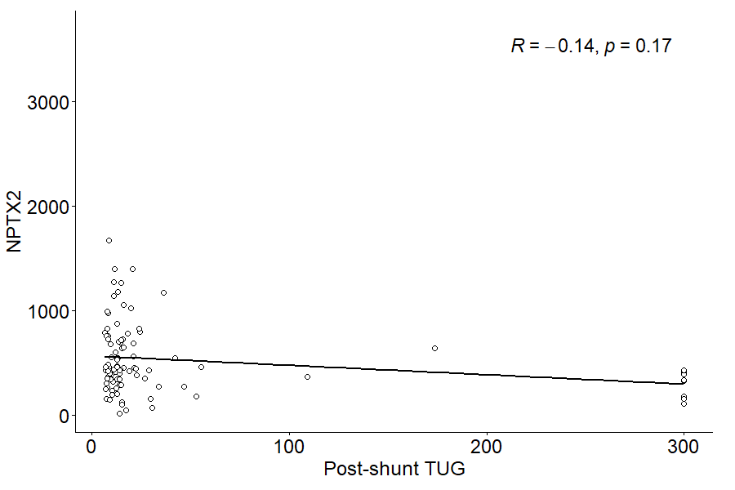
Figure 6. Correlation between CSF NPTX2 concentration and post-shunt surgery TUG score.

