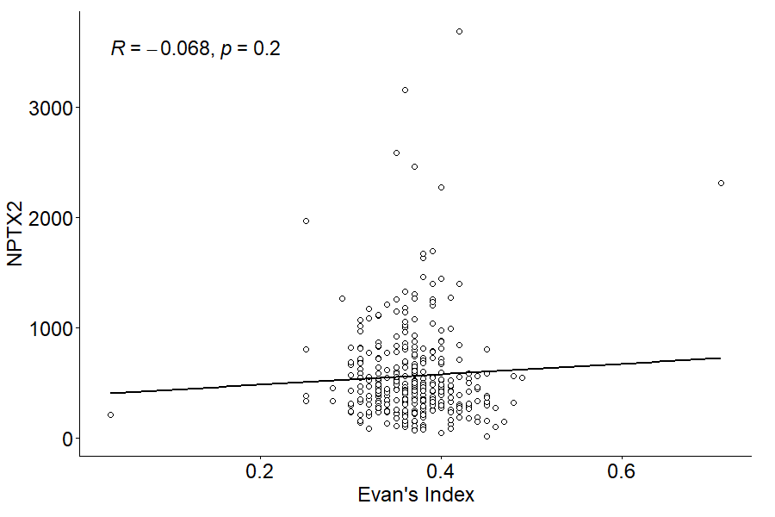
Figure 5. Correlation between CSF NPTX2 concentration and Evans Index.

