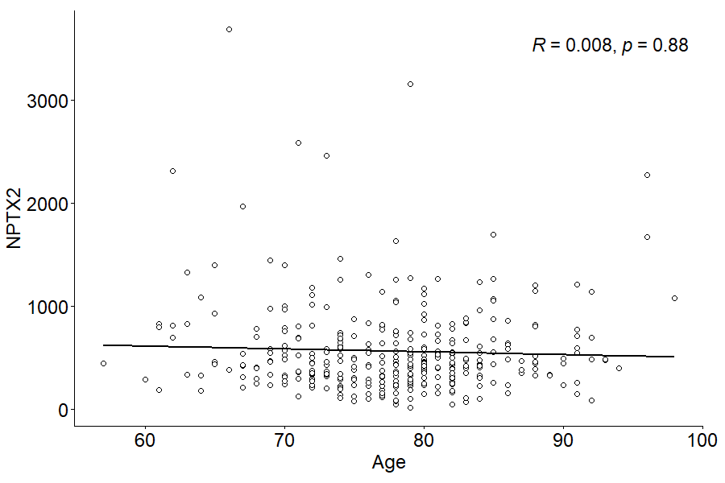

Figure 4. Correlation between CSF NPTX2 concentration and age.

