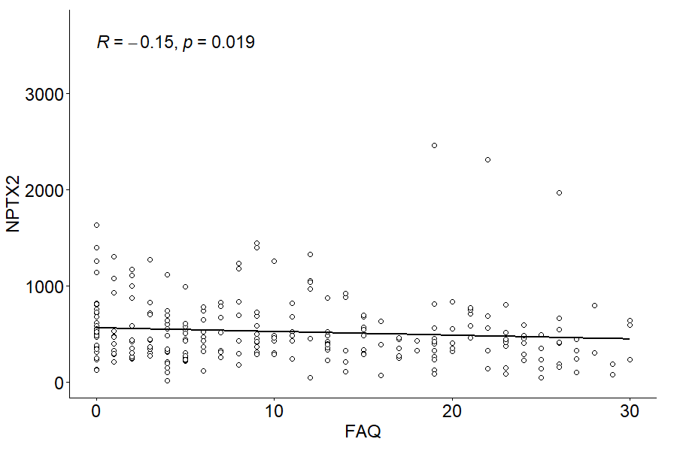
Figure 3. Correlation between CSF NPTX2 concentration and FAQ score.

