

**CENTRE FOR STATISTICAL ANALYSIS**

Prepared by: Krzysztof Leki

for: dr hab. Paweł Sokal, prof. UMK

ANALYSIS RAPORT PART 2

# effect of hospitalization

## age

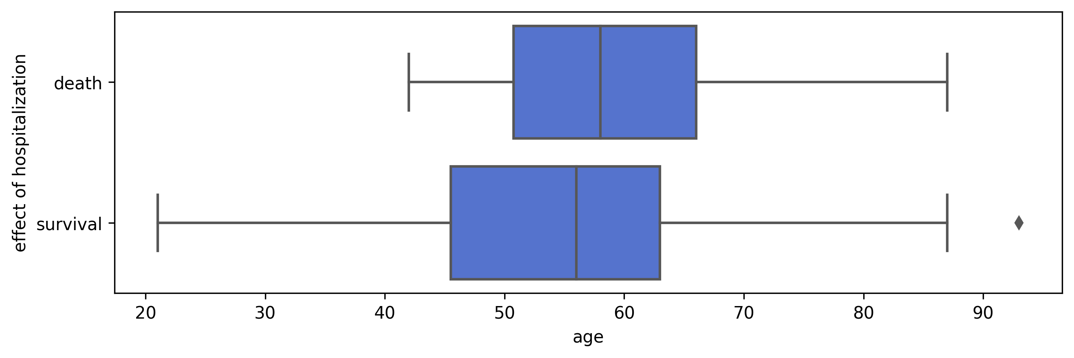

**Welch’s test**

|  | **T** | **dof** | **p-val** | **cohen-d** |
| --- | --- | --- | --- | --- |
| **T-test** | -2.494822 | 57.814018 | 0.015481 | 0.371555 |

## gender

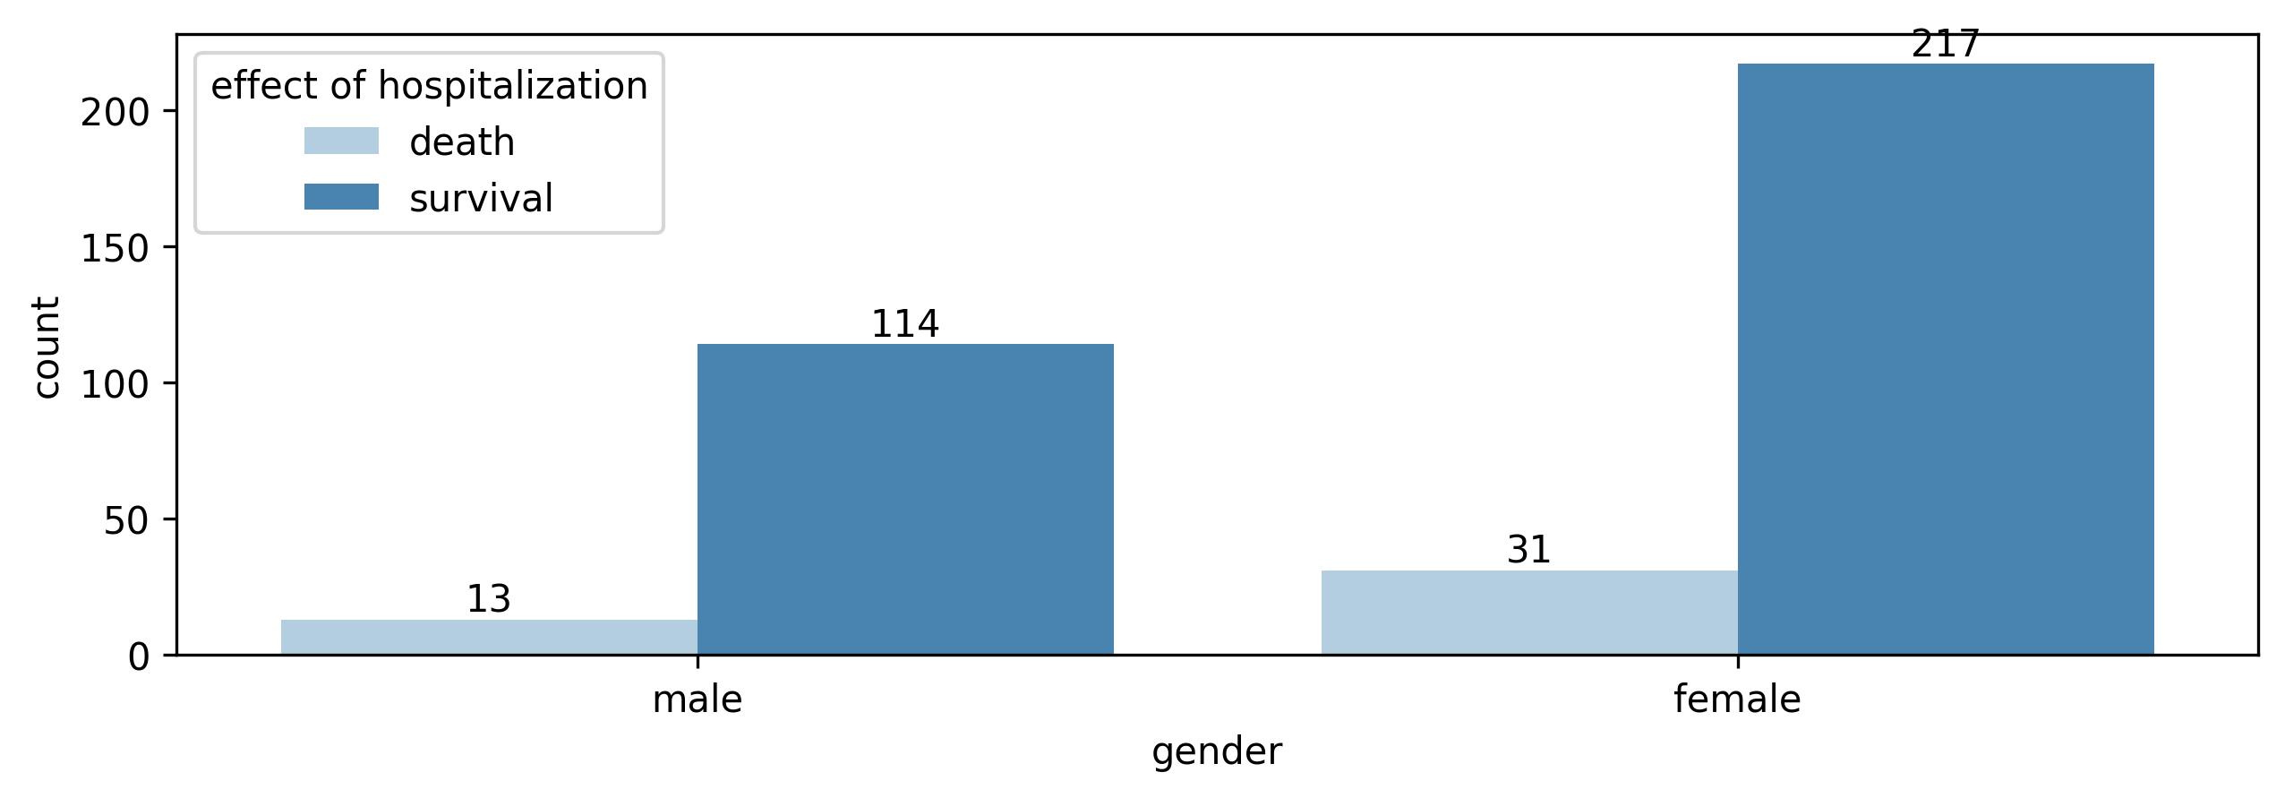

| **gender** | **male** | **female** |
| --- | --- | --- |
| **effect of hospitalization** |  |  |
| **death** | 13 (10.24%) | 31 (12.50%) |
| **survival** | 114 (89.76%) | 217 (87.50%) |

**Tabela krzyżowa do testu**

| **effect of hospitalization** | **death** | **survival** |
| --- | --- | --- |
| **gender** |  |  |
| **male** | 13.500000 | 113.500000 |
| **female** | 30.500000 | 217.500000 |

**Test G niezależności**

|  | **chi2** | **dof** | **pval** | **cramer** |
| --- | --- | --- | --- | --- |
| **log-likelihood** | 0.228982 | 1.000000 | 0.632279 | 0.024711 |

## localization of ruptured aneurysms

**Wykres słupkowy**

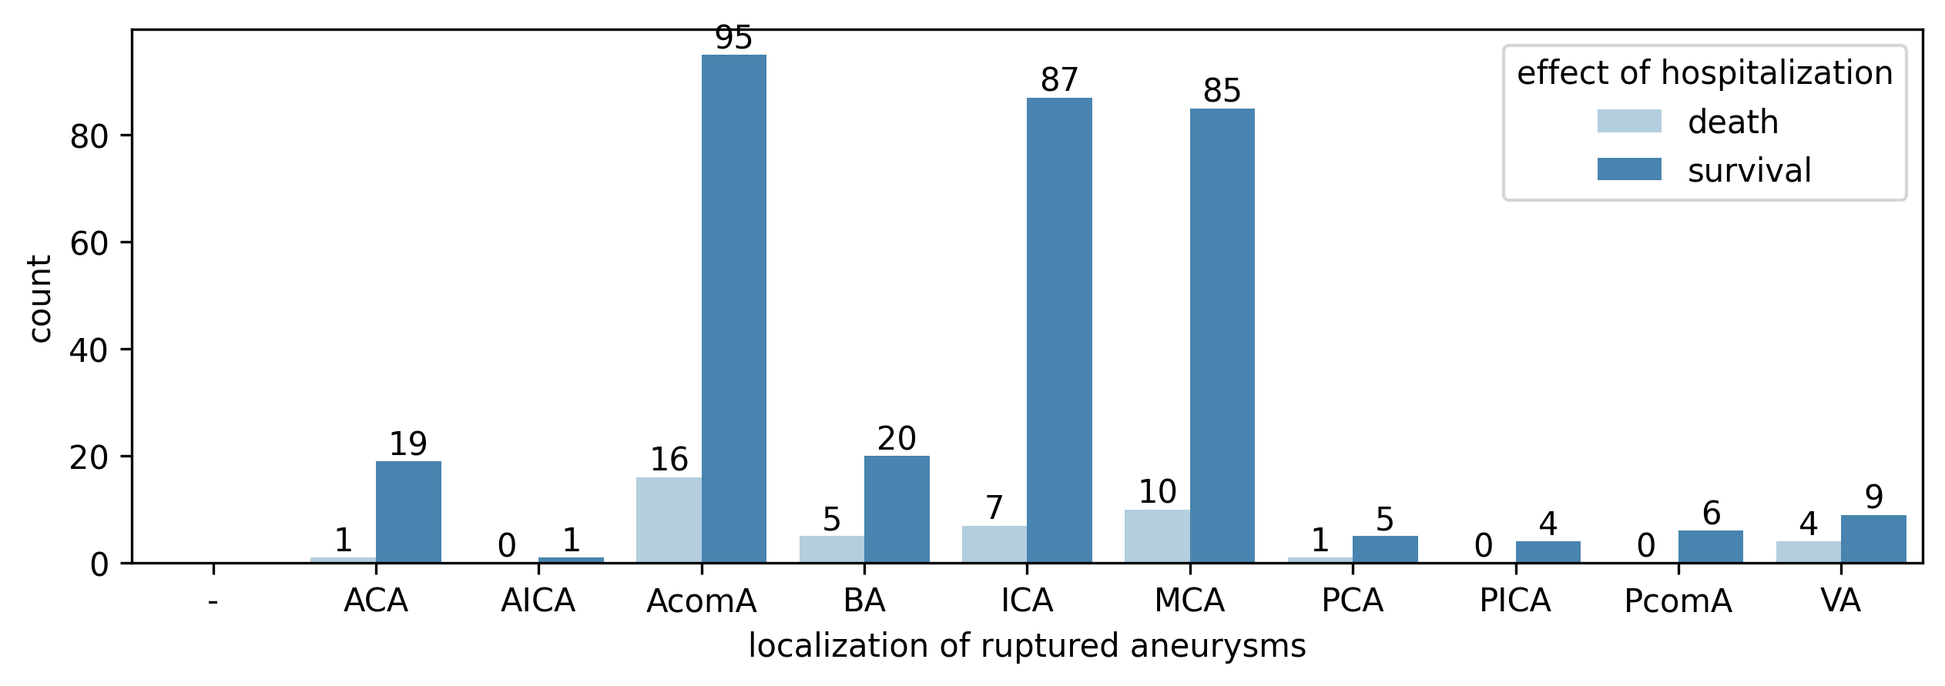

**Tabela krzyżowa**

| **localization of ruptured aneurysms** | **ACA** | **AICA** | **AcomA** | **BA** | **ICA** | **MCA** | **PCA** | **PICA** | **PcomA** | **VA** |
| --- | --- | --- | --- | --- | --- | --- | --- | --- | --- | --- |
| **effect of hospitalization** |  |  |  |  |  |  |  |  |  |  |
| **death** | 1 (5.00%) | 0 (0.00%) | 16 (14.41%) | 5 (20.00%) | 7 (7.45%) | 10 (10.53%) | 1 (16.67%) | 0 (0.00%) | 0 (0.00%) | 4 (30.77%) |
| **survival** | 19 (95.00%) | 1 (100.00%) | 95 (85.59%) | 20 (80.00%) | 87 (92.55%) | 85 (89.47%) | 5 (83.33%) | 4 (100.00%) | 6 (100.00%) | 9 (69.23%) |

**Tabela krzyżowa do testu**

| **effect of hospitalization** | **death** | **survival** |
| --- | --- | --- |
| **localization of ruptured aneurysms** |  |  |
| **AcomA** | 16 | 95 |
| **ICA** | 7 | 87 |
| **MCA** | 10 | 85 |

**Test G**

|  | **chi2** | **dof** | **pval** | **cramer** |
| --- | --- | --- | --- | --- |
| **log-likelihood** | 2.590088 | 2.000000 | 0.273886 | 0.092917 |

## multiple aneurysms

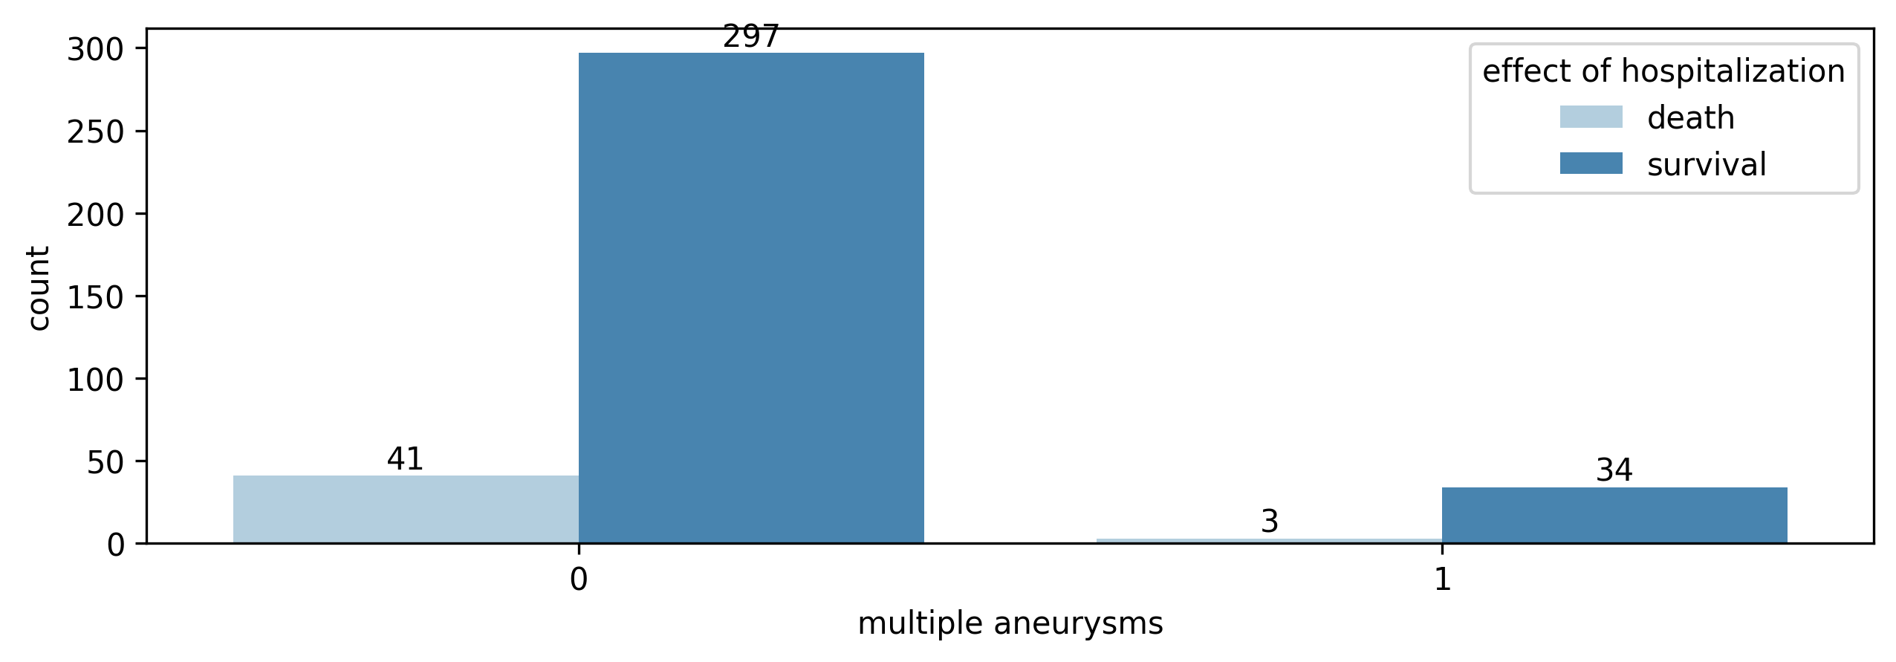

| **multiple aneurysms** | **0** | **1** |
| --- | --- | --- |
| **effect of hospitalization** |  |  |
| **death** | 41 (12.13%) | 3 (8.11%) |
| **survival** | 297 (87.87%) | 34 (91.89%) |

**Tabela krzyżowa do testu**

| **effect of hospitalization** | **death** | **survival** |
| --- | --- | --- |
| **multiple aneurysms** |  |  |
| **0** | 40.500000 | 297.500000 |
| **1** | 3.500000 | 33.500000 |

**Test G**

|  | **chi2** | **dof** | **pval** | **cramer** |
| --- | --- | --- | --- | --- |
| **log-likelihood** | 0.216325 | 1.000000 | 0.641854 | 0.024018 |

## GCS admission

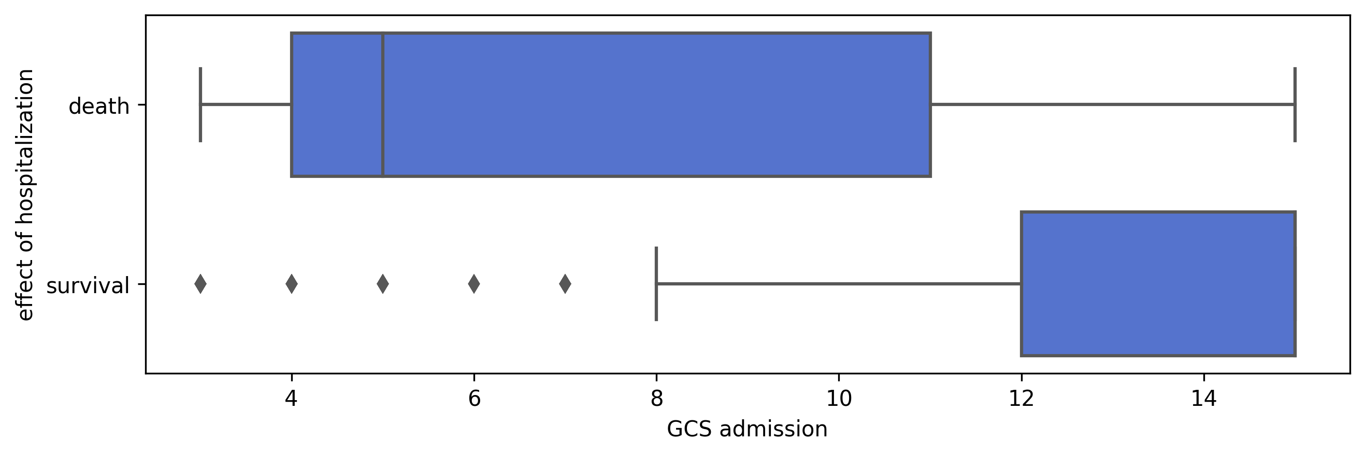

**Welch’s Test**

|  | **T** | **dof** | **p-val** | **cohen-d** |
| --- | --- | --- | --- | --- |
| **T-test** | 7.895634 | 51.625536 | 0.000000 | 1.432749 |

## Rankin on the day of admission

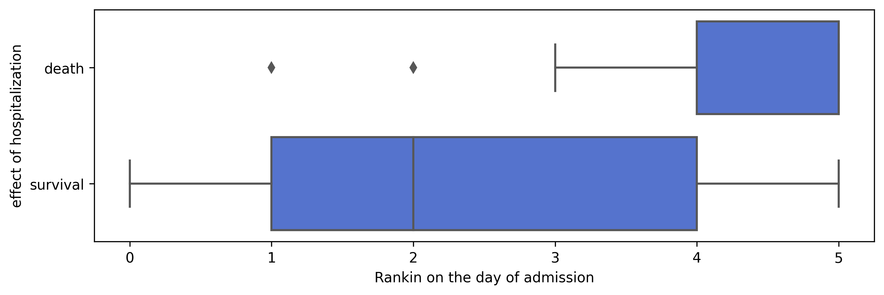

**Welch’s test**

|  | **T** | **dof** | **p-val** | **cohen-d** |
| --- | --- | --- | --- | --- |
| **T-test** | -9.359803 | 69.029316 | 0.000000 | 1.145068 |

## Hunt Hess scale - admission

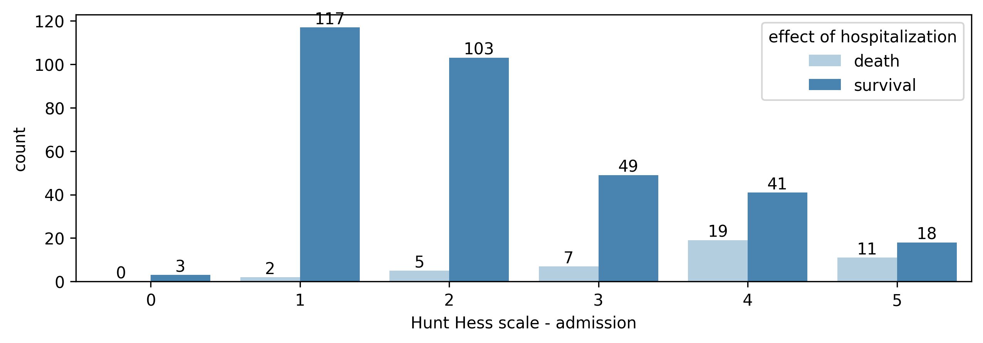

| **Hunt Hess scale - admission** | **1** | **2** | **3** | **4** | **5** |
| --- | --- | --- | --- | --- | --- |
| **effect of hospitalization** |  |  |  |  |  |
| **death** | 2 (1.64%) | 5 (4.63%) | 7 (12.50%) | 19 (31.67%) | 11 (37.93%) |
| **survival** | 120 (98.36%) | 103 (95.37%) | 49 (87.50%) | 41 (68.33%) | 18 (62.07%) |

| **effect of hospitalization** | **death** | **survival** |
| --- | --- | --- |
| **Hunt Hess scale - admission** |  |  |
| **1** | 2 | 120 |
| **2** | 5 | 103 |
| **3** | 7 | 49 |
| **4** | 19 | 41 |
| **5** | 11 | 18 |

**Test G**

|  | **chi2** | **dof** | **pval** | **cramer** |
| --- | --- | --- | --- | --- |
| **log-likelihood** | 39.318852 | 3.000000 | 0.000000 | 0.338574 |

## size of the aneurysm ≥7mm

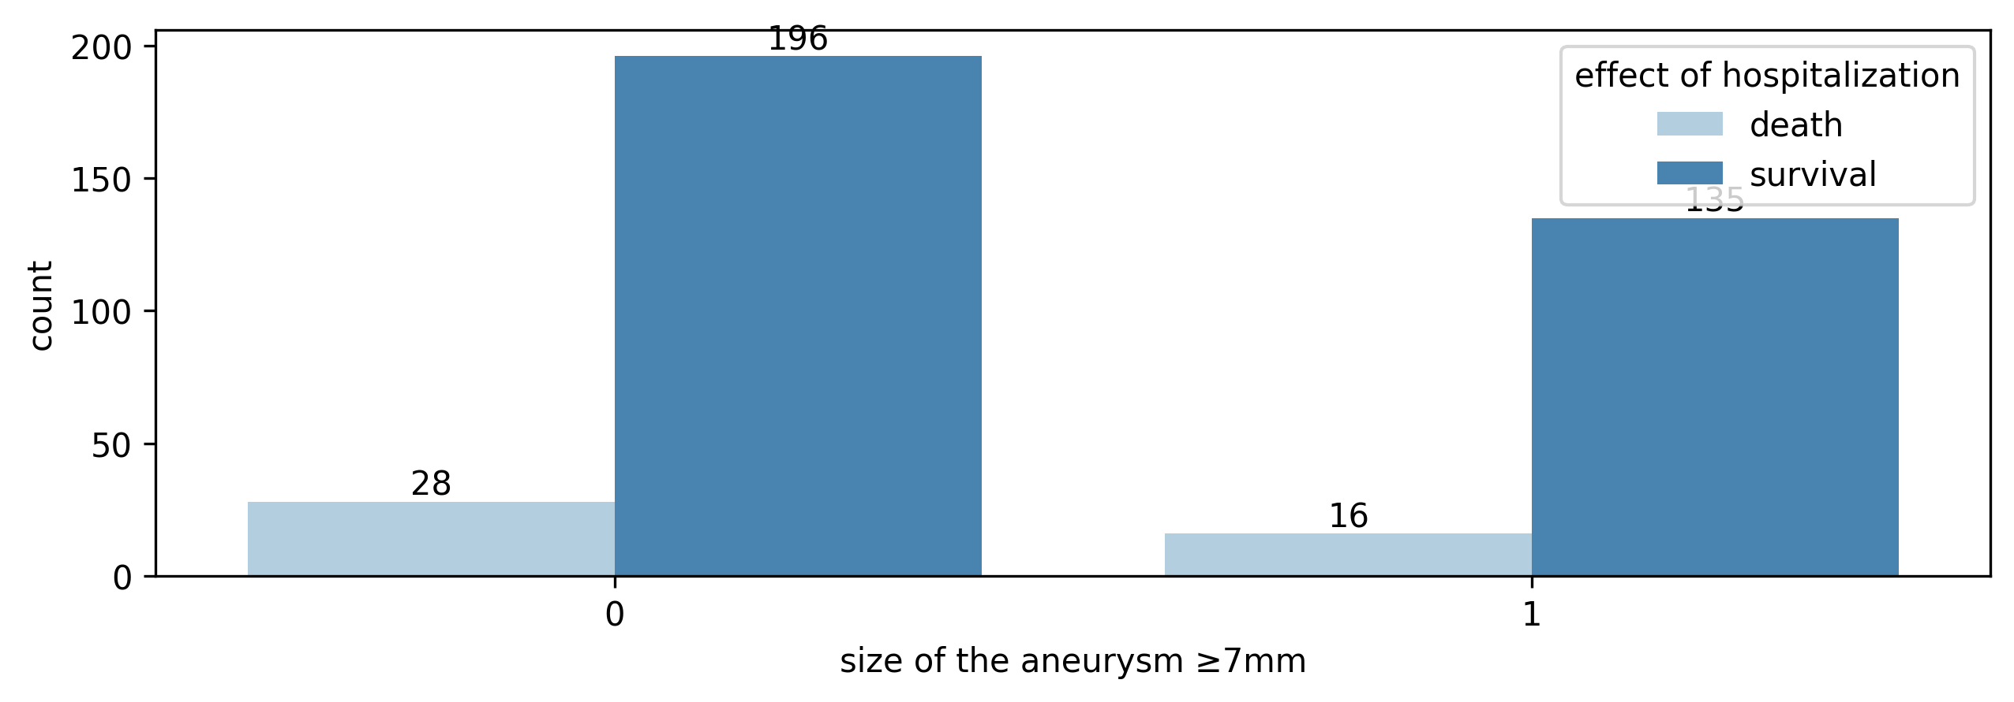

| **size of the aneurysm ≥7mm** | **0** | **1** |
| --- | --- | --- |
| **effect of hospitalization** |  |  |
| **death** | 28 (12.50%) | 16 (10.60%) |
| **survival** | 196 (87.50%) | 135 (89.40%) |

| **effect of hospitalization** | **death** | **survival** |
| --- | --- | --- |
| **size of the aneurysm ≥7mm** |  |  |
| **0** | 27.500000 | 196.500000 |
| **1** | 16.500000 | 134.500000 |

**Test G**

|  | **chi2** | **dof** | **pval** | **cramer** |
| --- | --- | --- | --- | --- |
| **log-likelihood** | 0.159753 | 1.000000 | 0.689384 | 0.020640 |

## size of the aneurysm 5≤7mm

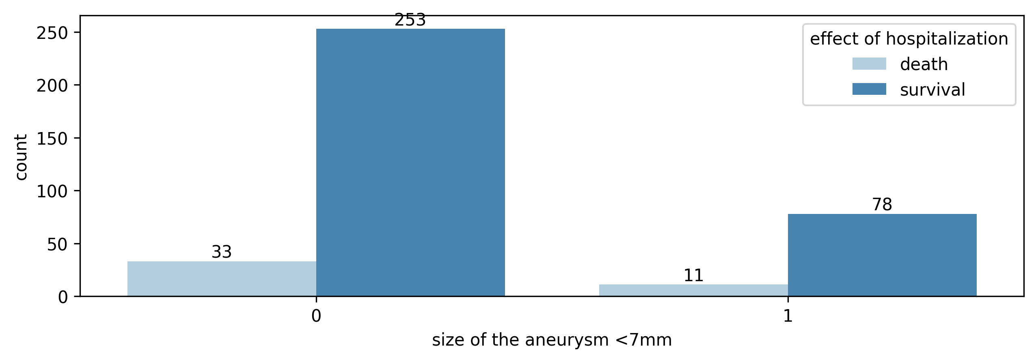

| **size of the aneurysm <7mm** | **0** | **1** |
| --- | --- | --- |
| **effect of hospitalization** |  |  |
| **death** | 33 (11.54%) | 11 (12.36%) |
| **survival** | 253 (88.46%) | 78 (87.64%) |

| **effect of hospitalization** | **death** | **survival** |
| --- | --- | --- |
| **size of the aneurysm <7mm** |  |  |
| **0** | 33.500000 | 252.500000 |
| **1** | 10.500000 | 78.500000 |

**Test G**

|  | **chi2** | **dof** | **pval** | **cramer** |
| --- | --- | --- | --- | --- |
| **log-likelihood** | 0.000467 | 1.000000 | 0.982757 | 0.001116 |

## size of the aneurysm <5mm

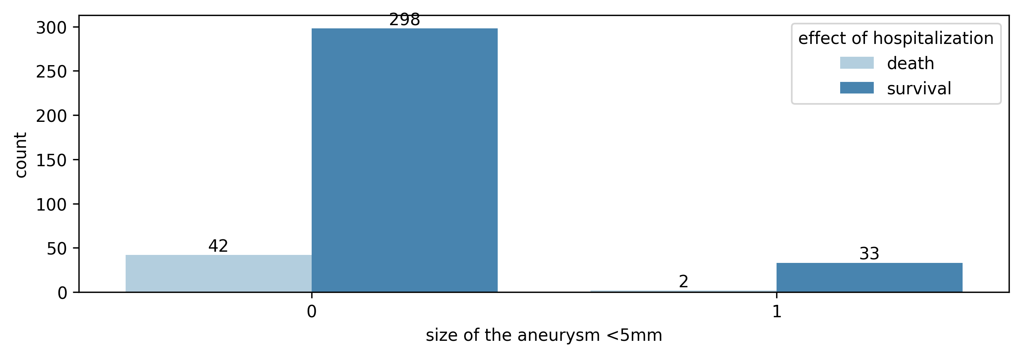

| **size of the aneurysm <5mm** | **0** | **1** |
| --- | --- | --- |
| **effect of hospitalization** |  |  |
| **death** | 42 (12.35%) | 2 (5.71%) |
| **survival** | 298 (87.65%) | 33 (94.29%) |

| **effect of hospitalization** | **death** | **survival** |
| --- | --- | --- |
| **size of the aneurysm <5mm** |  |  |
| **0** | 41.500000 | 298.500000 |
| **1** | 2.500000 | 32.500000 |

**Test G**

|  | **chi2** | **dof** | **pval** | **cramer** |
| --- | --- | --- | --- | --- |
| **log-likelihood** | 0.886347 | 1.000000 | 0.346469 | 0.048617 |

## size of the aneurysm ≤3mm

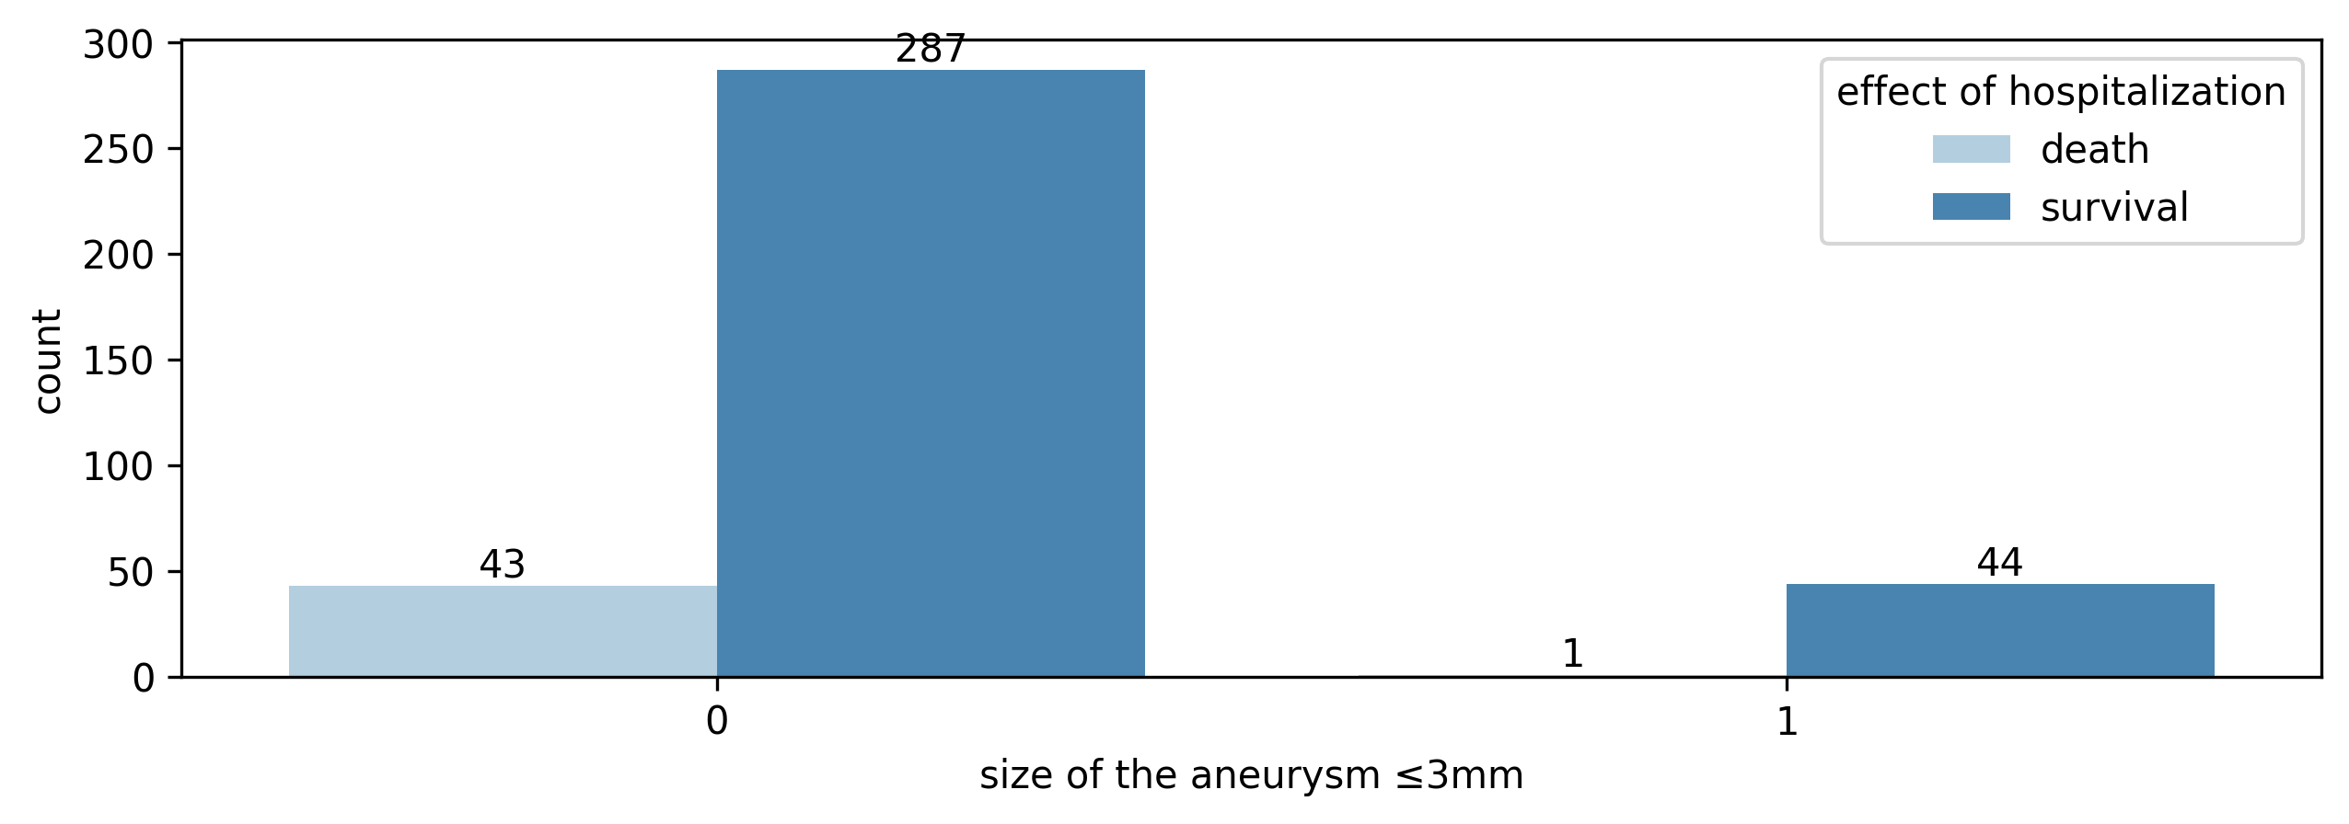

| **size of the aneurysm ≤3mm** | **0** | **1** |
| --- | --- | --- |
| **effect of hospitalization** |  |  |
| **death** | 43 (13.03%) | 1 (2.22%) |
| **survival** | 287 (86.97%) | 44 (97.78%) |

| **effect of hospitalization** | **death** | **survival** |
| --- | --- | --- |
| **size of the aneurysm ≤3mm** |  |  |
| **0** | 42.500000 | 287.500000 |
| **1** | 1.500000 | 43.500000 |

**Test G**

|  | **chi2** | **dof** | **pval** | **cramer** |
| --- | --- | --- | --- | --- |
| **log-likelihood** | 4.540279 | 1.000000 | 0.033106 | 0.110034 |

## surgical treatment

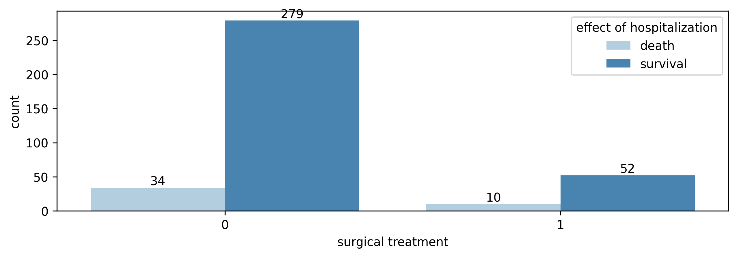

| **surgical treatment** | **0** | **1** |
| --- | --- | --- |
| **effect of hospitalization** |  |  |
| **death** | 34 (10.86%) | 10 (16.13%) |
| **survival** | 279 (89.14%) | 52 (83.87%) |

| **effect of hospitalization** | **death** | **survival** |
| --- | --- | --- |
| **surgical treatment** |  |  |
| **0** | 34.500000 | 278.500000 |
| **1** | 9.500000 | 52.500000 |

**Test G**

|  | **chi2** | **dof** | **pval** | **cramer** |
| --- | --- | --- | --- | --- |
| **log-likelihood** | 0.867586 | 1.000000 | 0.351625 | 0.048099 |

# GOS

## age

|  | **r** | **p-val** |
| --- | --- | --- |
| **spearman** | -0.269808 | 0.000000 |

## gender

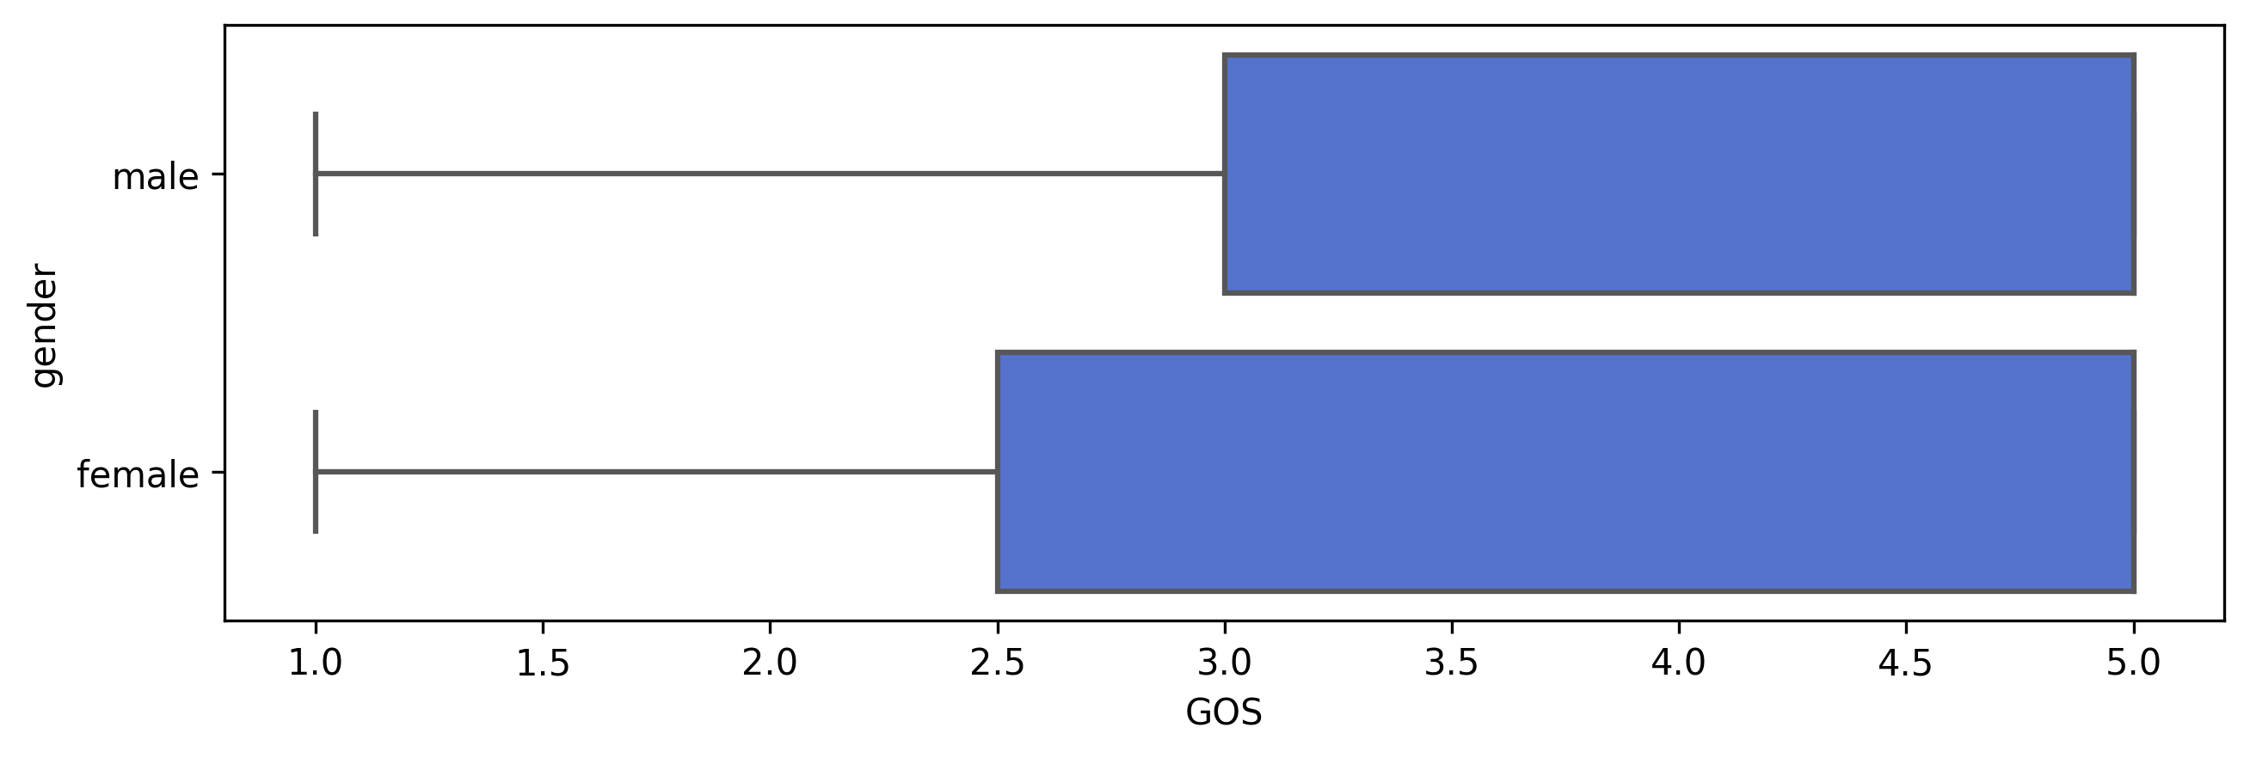

**Mann-Whitney U test**

|  | **U-val** | **alternative** | **p-val** | **RBC** | **CLES** |
| --- | --- | --- | --- | --- | --- |
| **MWU** | 16406.000000 | two-sided | 0.420400 | -0.046001 | 0.523000 |

## localization of ruptured aneurysms

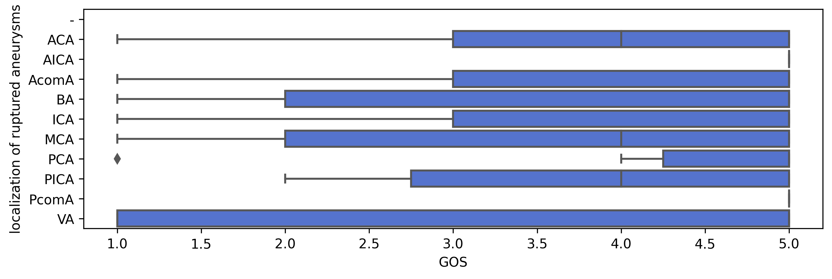

**Kruskal H test**

|  | **ddof1** | **H** | **p-unc** |
| --- | --- | --- | --- |
| **Kruskal** | 9 | 13.768172 | 0.130814 |

## multiple aneurysms

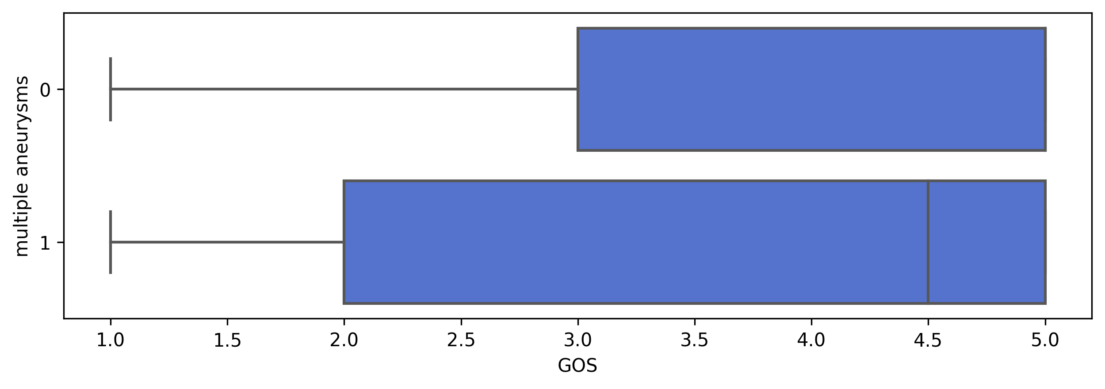

**Mann-Whitney U test**

|  | **U-val** | **alternative** | **p-val** | **RBC** | **CLES** |
| --- | --- | --- | --- | --- | --- |
| **MWU** | 6425.500000 | two-sided | 0.540634 | -0.056131 | 0.528065 |

## GCS admission

|  | **r** | **p-val** |
| --- | --- | --- |
| **spearman** | 0.652378 | 0.000000 |

## Rankin on the day of admission

|  | **r** | **p-val** |
| --- | --- | --- |
| **spearman** | -0.696300 | 0.000000 |

## Hunt Hess scale - admission

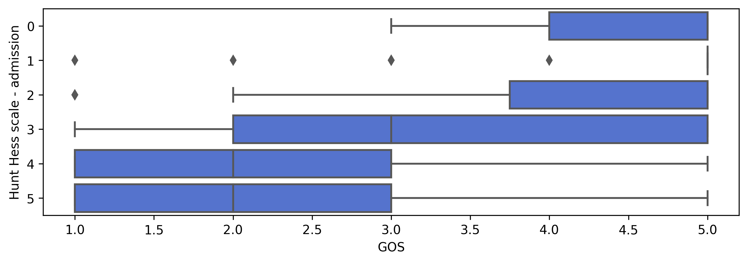

**Kruskal H test**

|  | **ddof1** | **H** | **p-unc** |
| --- | --- | --- | --- |
| **Kruskal** | 5 | 156.597165 | 0.000000 |

## size of the aneurysm ≥7mm

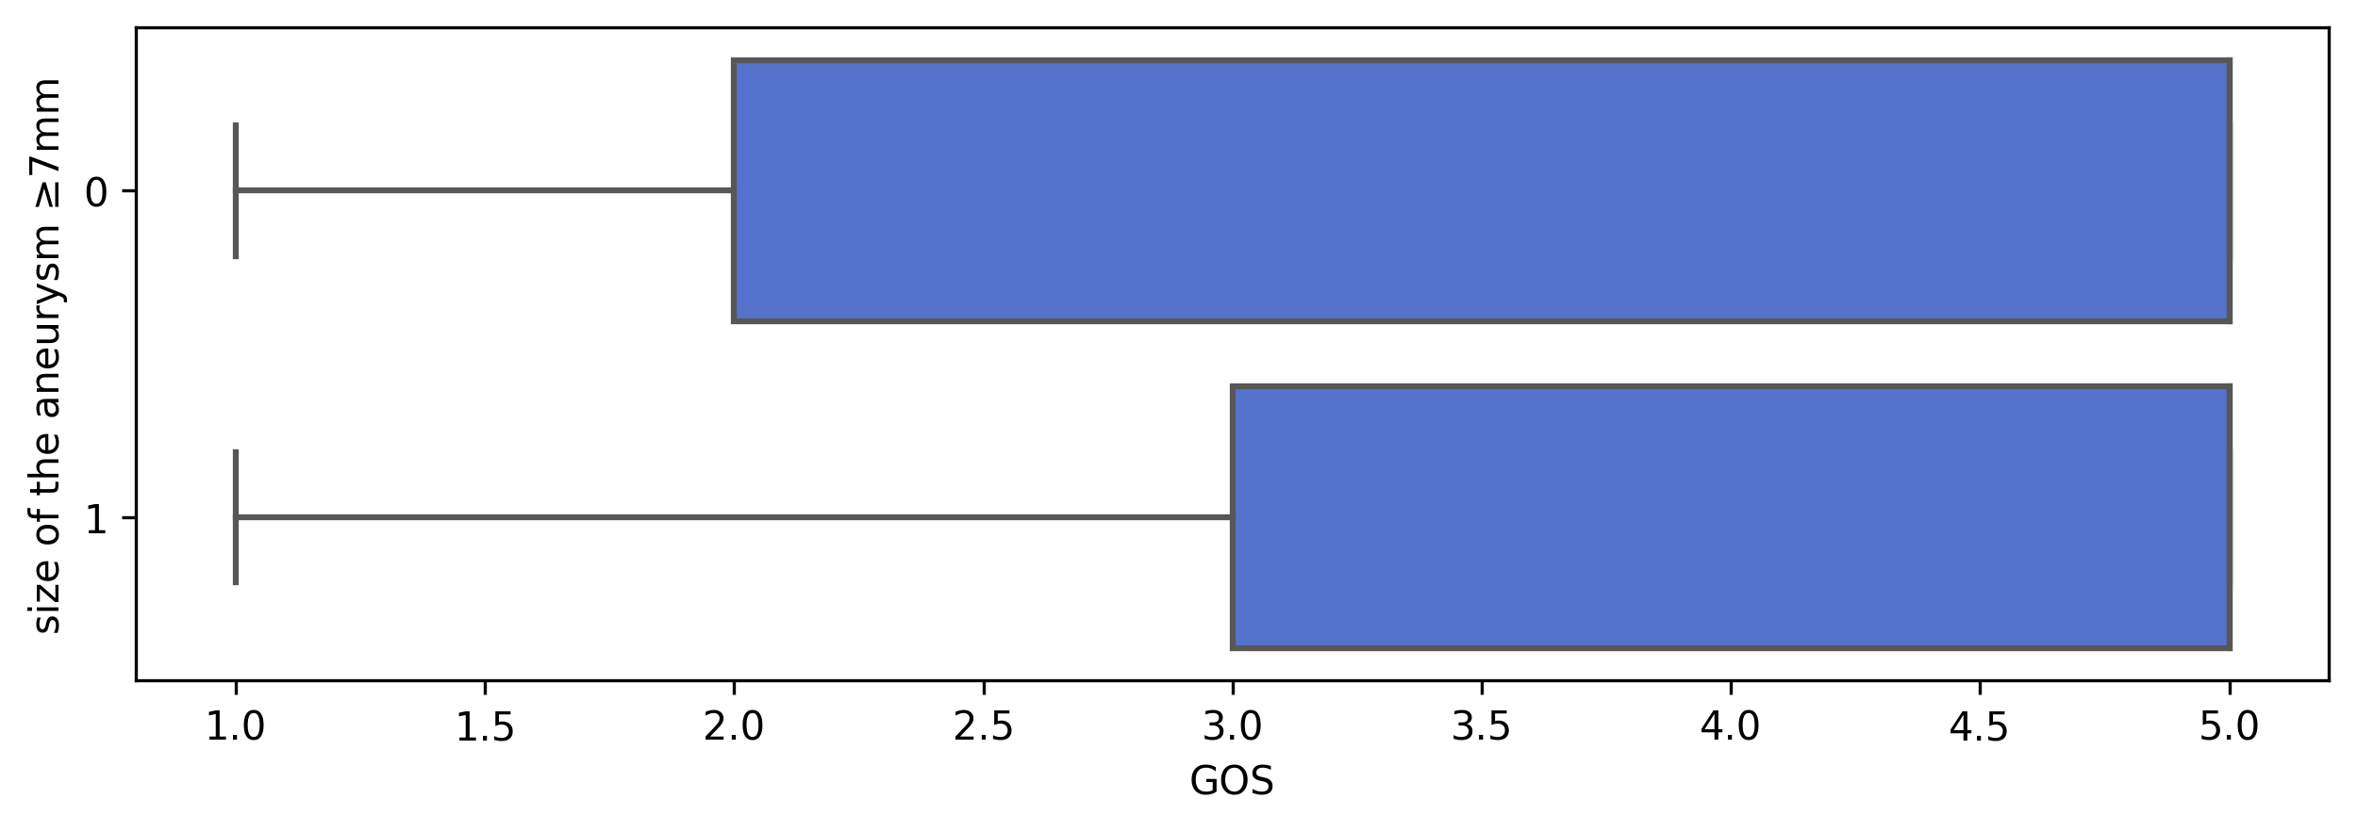

**Mann-Whitney U test**

|  | **U-val** | **alternative** | **p-val** | **RBC** | **CLES** |
| --- | --- | --- | --- | --- | --- |
| **MWU** | 17402.000000 | two-sided | 0.542251 | -0.033588 | 0.516794 |

## size of the aneurysm <7mm

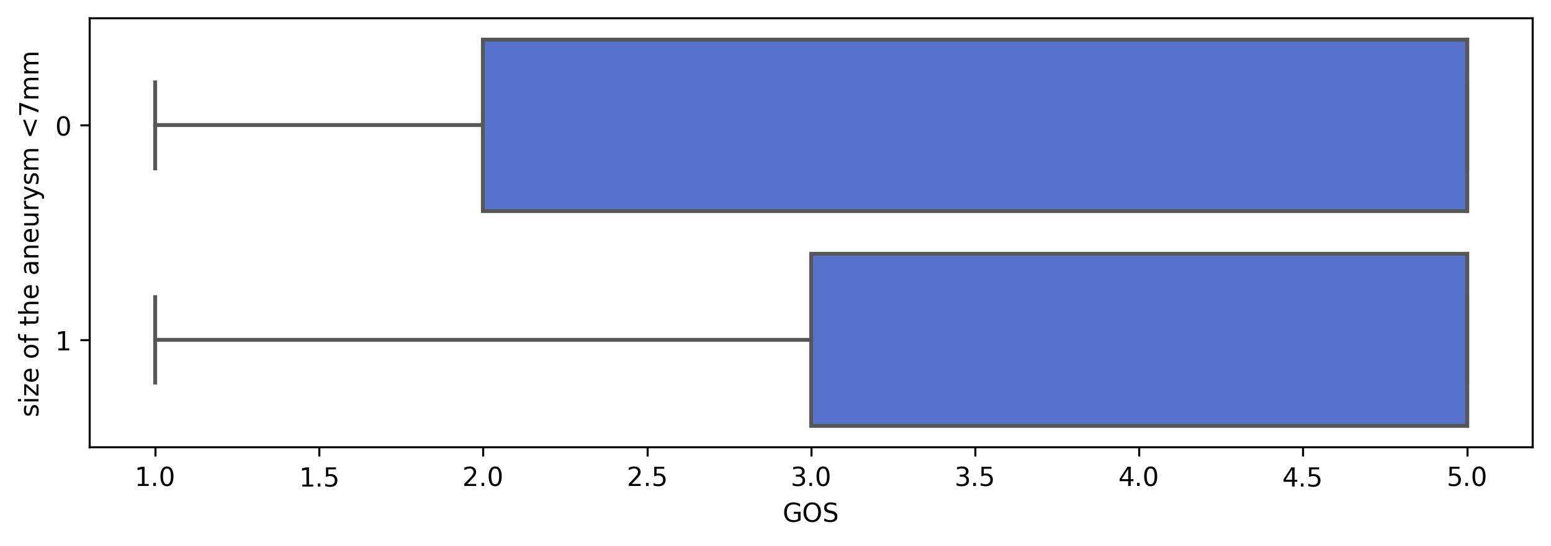

**Mann-Whitney U test**

|  | **U-val** | **alternative** | **p-val** | **RBC** | **CLES** |
| --- | --- | --- | --- | --- | --- |
| **MWU** | 11398.000000 | two-sided | 0.139129 | 0.094247 | 0.452877 |

## size of the aneurysm <5mm

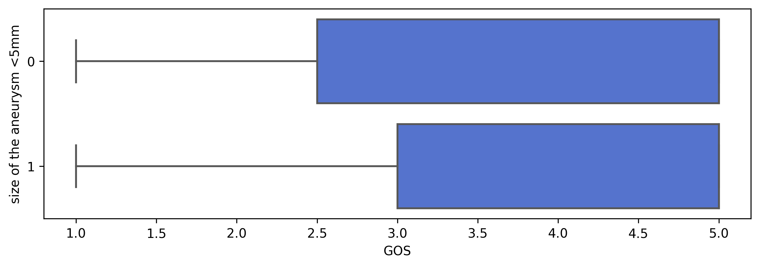

**Mann-Whitney U test**

|  | **U-val** | **alternative** | **p-val** | **RBC** | **CLES** |
| --- | --- | --- | --- | --- | --- |
| **MWU** | 5568.000000 | two-sided | 0.508349 | 0.061441 | 0.469279 |

## size of the aneurysm ≤3mm

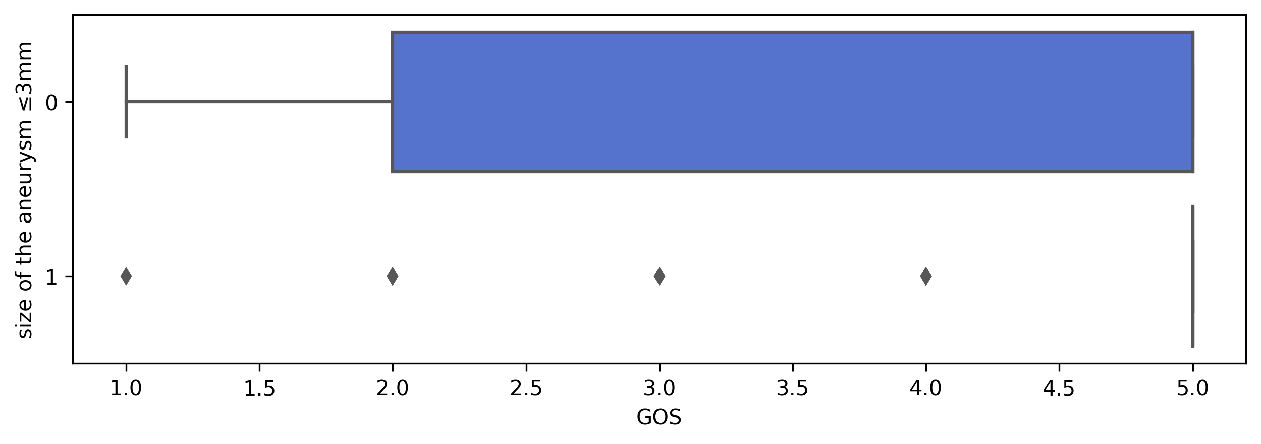

**Mann-Whitney U test**

|  | **U-val** | **alternative** | **p-val** | **RBC** | **CLES** |
| --- | --- | --- | --- | --- | --- |
| **MWU** | 5451.000000 | two-sided | 0.001505 | 0.263627 | 0.368186 |

## surgical treatment

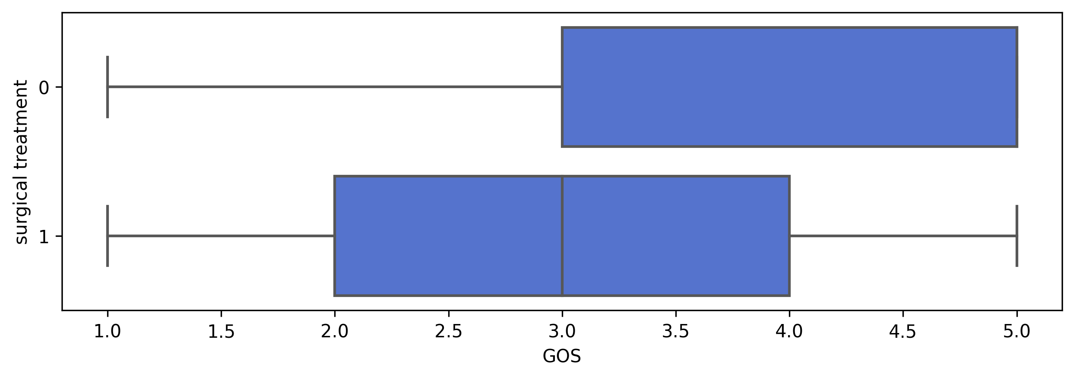

**Mann-Whitney U test**

|  | **U-val** | **alternative** | **p-val** | **RBC** | **CLES** |
| --- | --- | --- | --- | --- | --- |
| **MWU** | 13358.000000 | two-sided | 0.000000 | -0.381100 | 0.690550 |

## number of aneurysms

|  | **r** | **p-val** |
| --- | --- | --- |
| **spearman** | 0.258605 | 0.000000 |