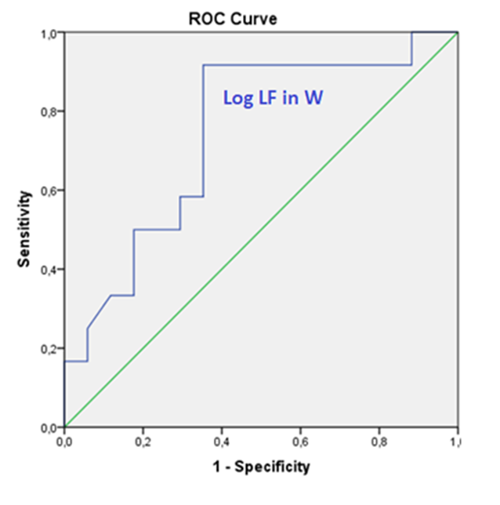
A)
B)
 |  |  | AUC |  | Std. Error |  | p-value
Wakefulness | LF(ms²) | .75 |  | .1 |  | .024
 | logLF | .74 |  | .1 |  | .028
 | HF(ms²) | .62 |  | .11 |  | .288
 | logHF | .64 |  | .11 |  | .191
 | LF/HFratio | .71 |  | .1 |  | .063
NREM | LF(ms²) | .48 |  | .11 |  | .894
 | logLF | .5 |  | .11 |  | .965
 | HF(ms²) | .42 |  | .11 |  | .452
 | logHF | .42 |  | .11 |  | .452
 | LF/HFratio | .56 |  | .11 |  | .611
REM | LF(ms²) | .72 |  | .1 |  | .051
 | logLF | .72 |  | .09 |  | .042
 | HF(ms²) | .54 |  | .11 |  | .723
 | logHF | .51 |  | .11 |  | .965
 | LF/HFratio | .66 |  | .1 |  | .15

D)
C)
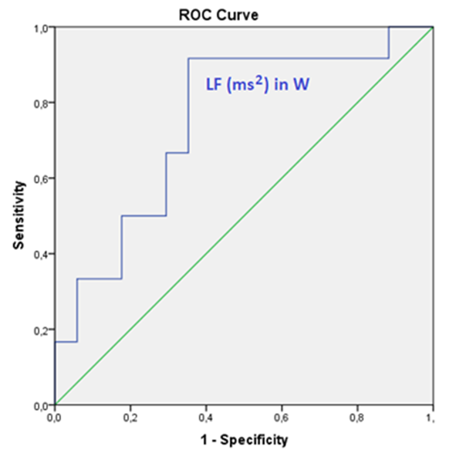
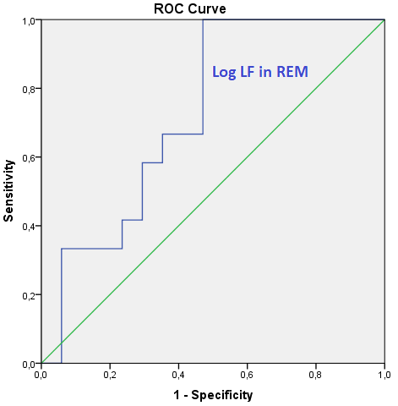

Supplementary Material A - ROC-AUC analysis - Prediction of dysautonomia in the iRBD group using HRV. A) AUC values obtained for each of the used HRV components, after the ROC analysis, with the 3 HRV components having statistically significant AUC values in bold, and with the 2 HRV components which (previously in the study) had the best correlations with total NMSS score underlined. B) ROC curve for log LF during W. C) ROC curve for LF (ms²) during W. D) ROC curve for log LF during REM.
AUC - Area Under the Curve; HF (ms2) - High frequency absolute power; HRV – Heart Rate Variability; iRBD - idiopathic REM sleep behaviour disorder; LF (ms2) - Low Frequency absolute power; Log LF - natural logarithm LF; ; NMSS – Non-motor Symptoms Scale; NREM - Non-Rapid Eye Movement sleep; REM - Rapid Eye Movement sleep; ROC - Receiver operating characteristic curve; W - Wakefulness; Std Error - Standard error

