Supplementary Figure

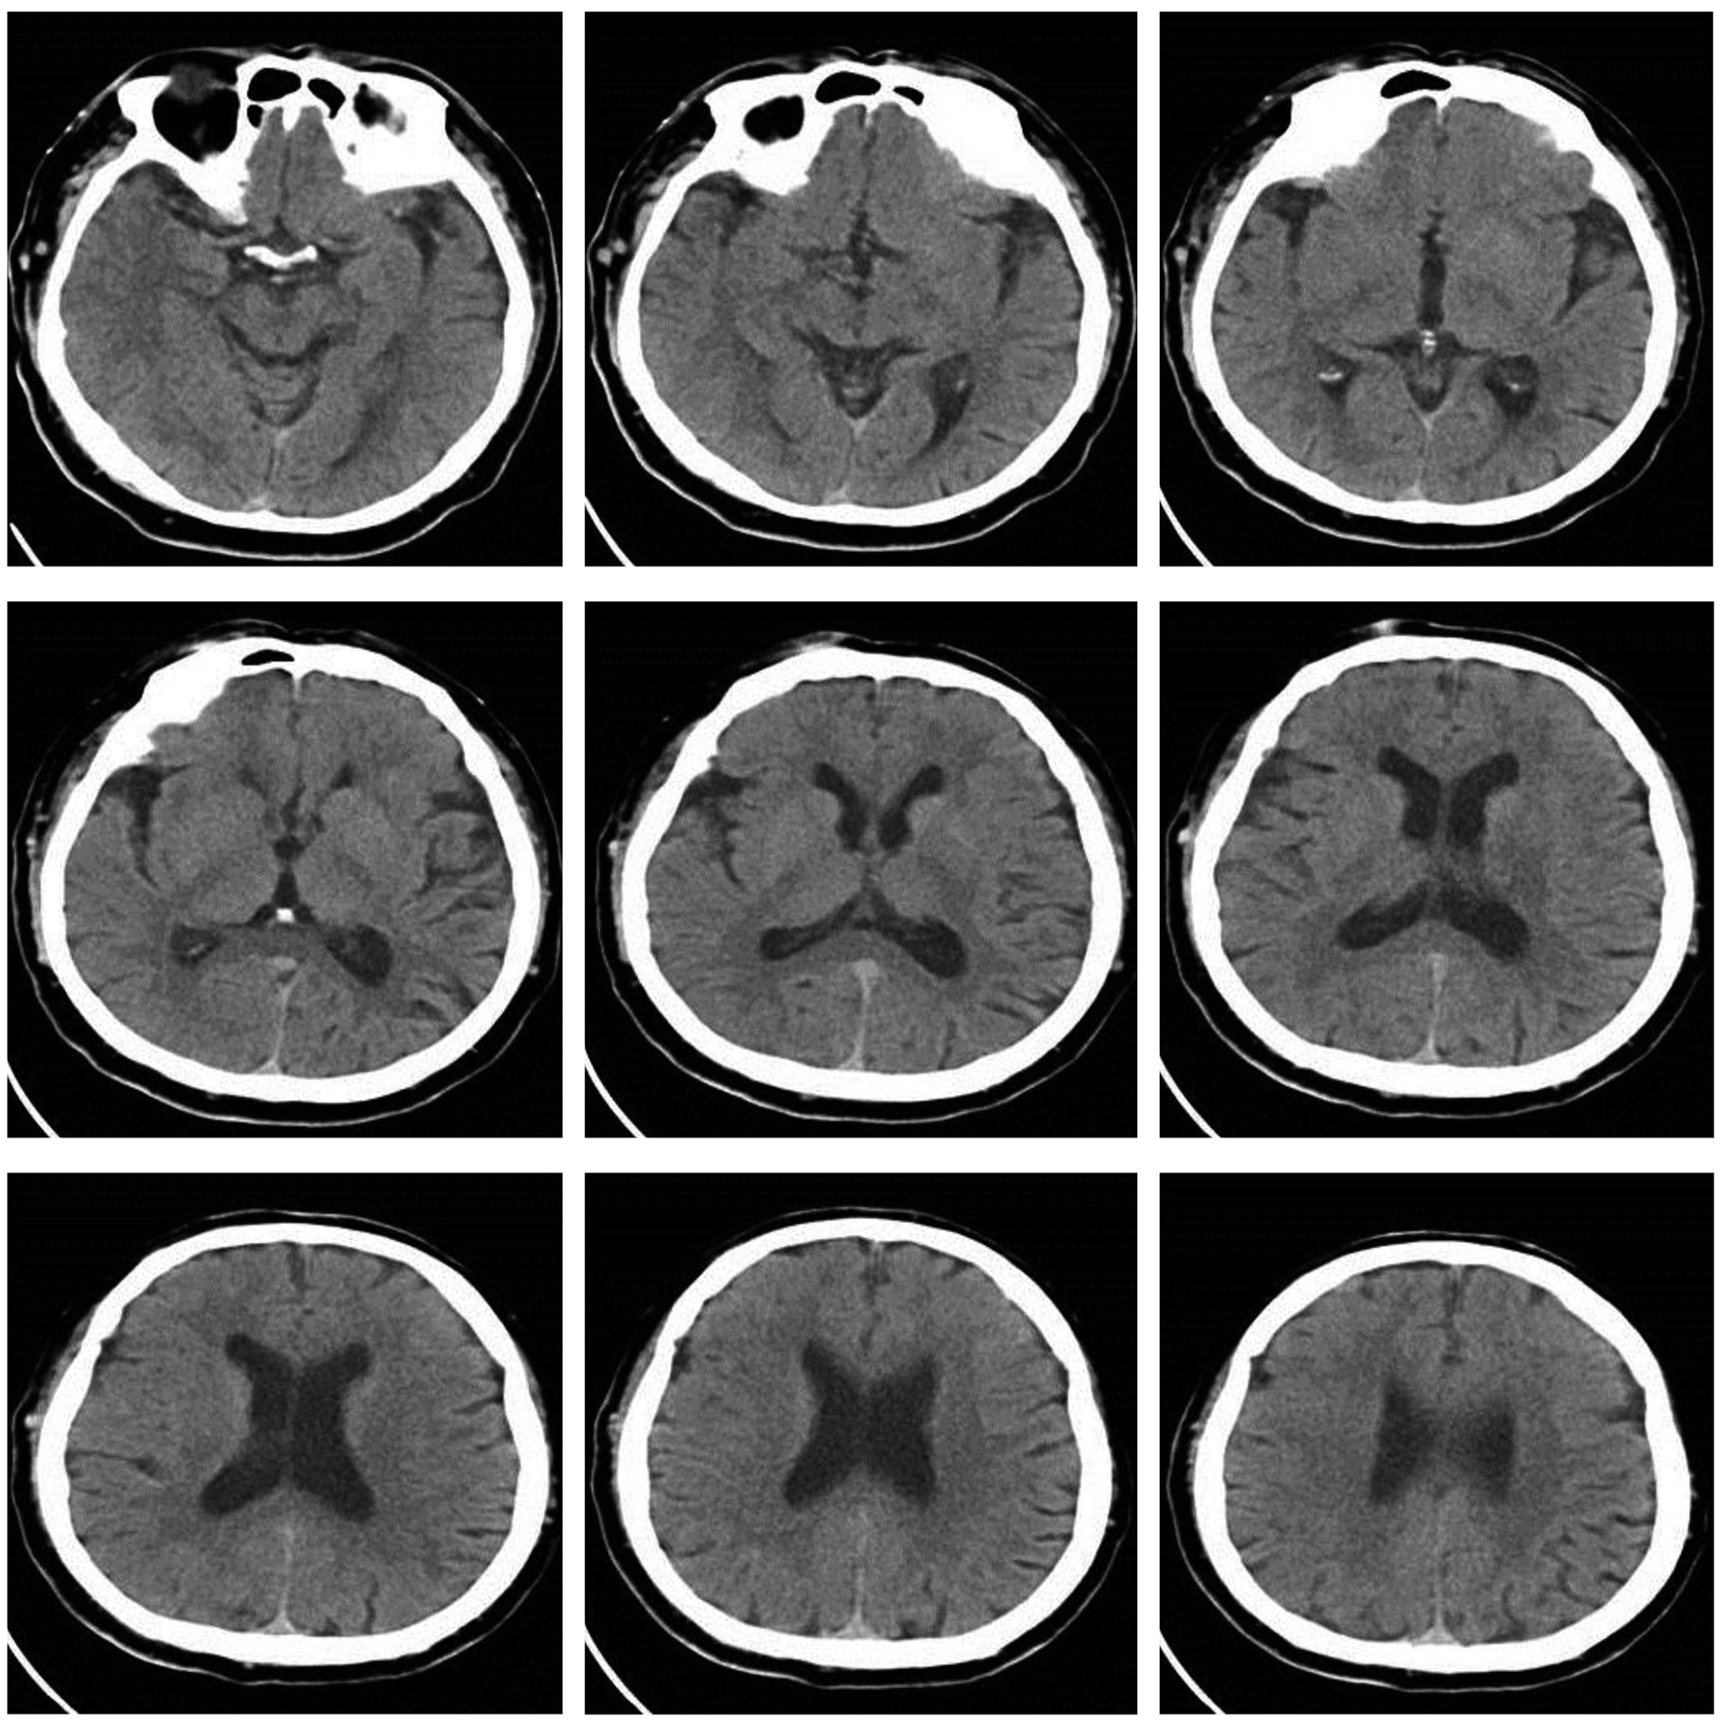
Fig. S1. Unenhanced head CT of the patient prior to the procedure.

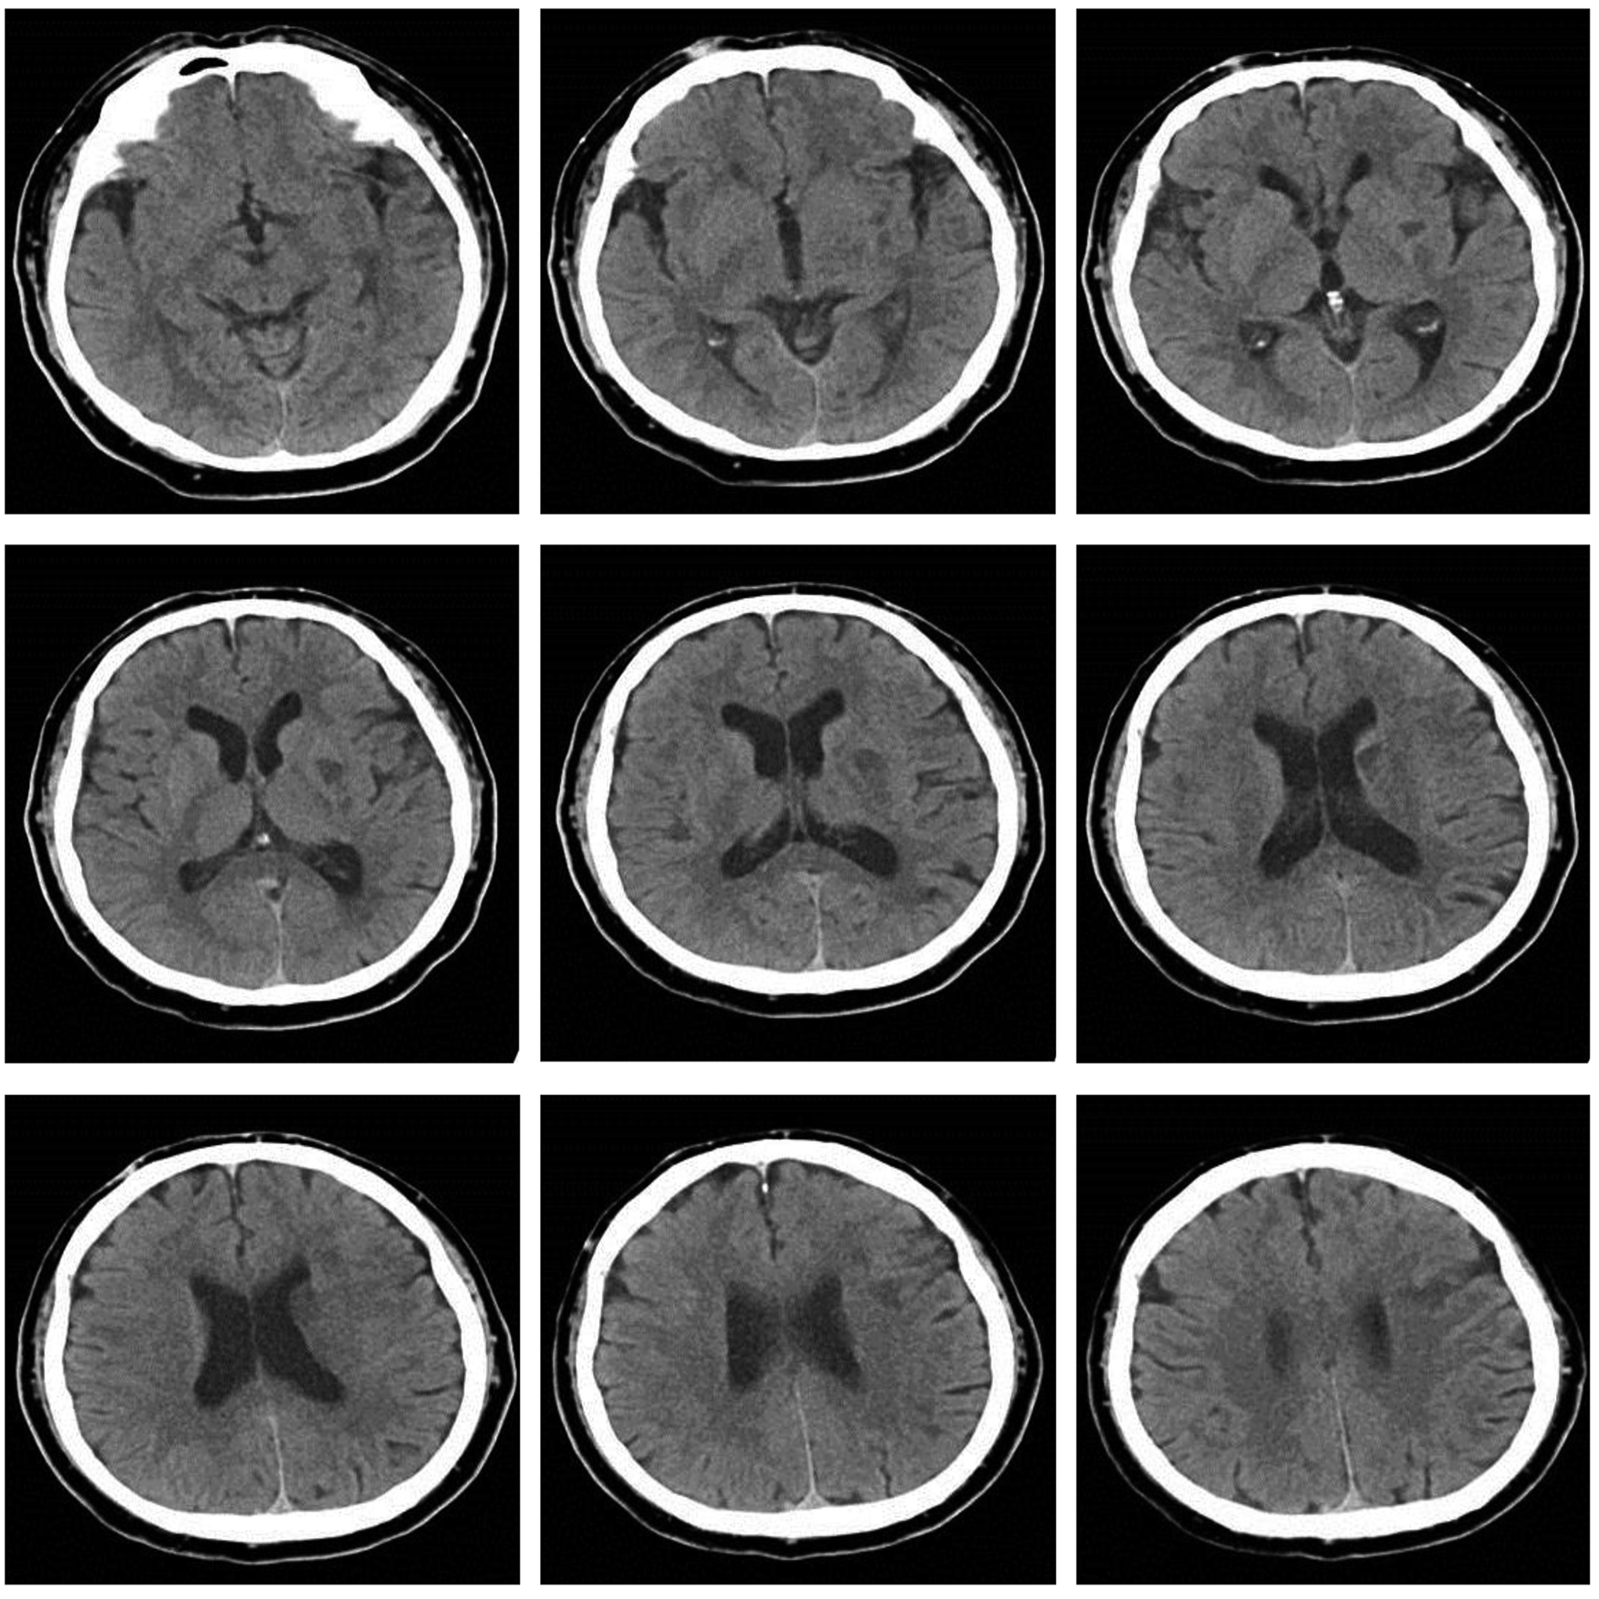
Fig. S2. Head CT one day after the thrombectomy demonstrated scattered new infarcts in the left basal ganglia, as well as left frontal and temporal lobes, and a lack of intracranial hemorrhage.

