**Supplementary Table 1.** Treatment Outcomes in Patients with Eyelid Myoclonia with Absences

| Patient | Medications Tried | Remission at the last follow-up | Current Effective Therapy | Previously Effective Therapy1 |
| --- | --- | --- | --- | --- |
| 1. | CBZ; VPA | yes | VPA | none |
| 2. | LEV; LTG; VPA | yes | VPA | none |
| 3. | LTG; VPA LEV + LTG | yes | LTG | LEV + LTG VPA |
| 4. | ETX + LTG; VPA | yes | ETX + LTG | VPA |
| 5. | LTG; ETX; VPA | no | none | none |

1 — remission for at least 12 months.

CBZ — Carbamazepine; ETX ­— Ethosuximide; VPA ­­— Valproic Acid; LEV — Levetiracetam; LTG ­— Lamotrigine

**Supplementary Table 2**. Treatment regimens at the last follow up-visit

|  |  |
| --- | --- |
| **Monotherapy at the last follow up; n (%)**     LEV     VPA     LTG     CBZ     OXC     ETX     PB | 105 (81.5)  42 (32.3)  32 (24.6)  24 (18.5)  3 (2.3)  2 (1.5)  1 (0.8)  1 (0.8) |
| **Polytherapy at the last follow up; n (%)**  **2 ASMs**          ETX + LTG          ETX + VPA          LEV + LTG          LEV + VPA          LTG + TPM          LTG + VPA          VPA + TPM    **≥ 3 ASMs**  CLZ+LEV+VPA          LEV+VPA+TPM | 23 (17.7)  **21 (16.2)**  1 (0.8)  1 (0.8)  9 (6.9)  3 (2.3)  1 (0.8)  4 (3.1)  2 (1.5)  **2 (1.5)**  1 (0.8)  1 (0.8) |

ASMs — antiseizure medications; CBZ ­— Carbamazepine; CLZ — Clonazepam; ETX —Ethosuximide; LEV — Levetiracetam; LTG — Lamotrigine; OXC — Oxcarbazepine; PB — Phenobarbital; TPM ­— Topiramate; VPA — Valproate

**Supplementary Figure 1.** Comparison of seizure-free rates in patients using valproate versus lamotrigine/levetiracetam/lamotrigine + levetiracetam

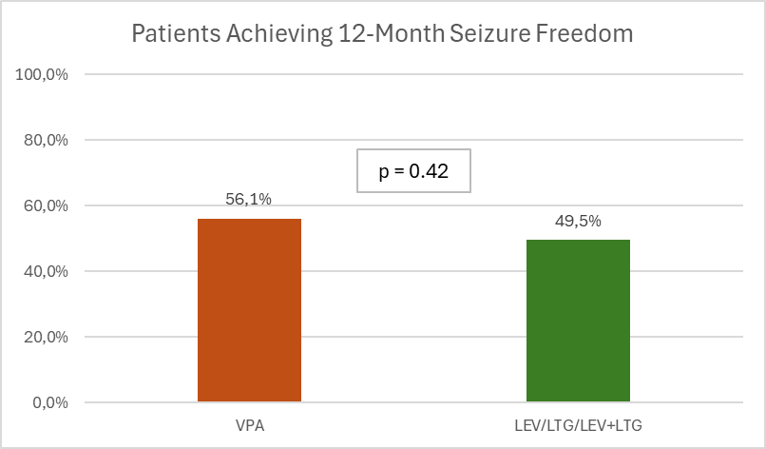

LEV — Levetiracetam; LTG — Lamotrigine; VPA — Valproate

**Supplementary Figure 2.** Seizure outcome at last medical observation according to different   
IGE syndrome

JME — juvenile myoclonic epilepsy; GTCA — epilepsy with generalized tonic-clonic seizures alone; JAE ­— juvenile absence epilepsy; CAE — childhood absence epilepsy