Supplementary material
50 patients with findings that affected the anatomy of the neck were excluded. However we decided to present data from them as a supplement because they may be useful in estimating feasibility of needle cricoidectomy in patients with specific diseases. Based on a small sample (n = 15) enlarged thyroid glands may be an obstacle in performing such a procedure. Median age in this group was 63 (55 - 71.75), 23 pts (46%) were female.
 | SLD [cm] | SLD > 3cm | DR [cm] | DDR < 10%
ALL excluded (n = 50) | 1.24 (0.88 - 2.32) | 5 (10%) | 2.03 (1.73 - 2.36) | 10 (20%)
Enlarged thyroid glands (n = 15) | 2.33 (1.7 - 2.98) | 4 (26.67%) | 2.26 (1.74 - 2.57) | 6 (40%)
Neoplasm of larynx (n = 10) | 0.845 (0.63 - 1.05) | 0 (0%) | 2.27 (1.88 - 2.39) | 1 (10%)
Tracheostomy (n = 7) | 0.93 (0.79 - 1.20) | 0 (0%) | 1.81 (1.6 - 2.01) | 0 (0%)
Abscesses or inflamatory changes (n=2) | 0.89 (0.745 - 1.04) | 0 (0%) | 2.145 (2.0375 - 2.2525) | 0 (0%)
Hemaotoma of neck (n=1) | 1.59 (1.59 - 1.59) | 0 (0%) | 2.34 (2.34 - 2.34) | 0 (0%)
Enlarged lymph nodes / hemaotological neoplasm (n = 15) | 1.33 (0.99 - 2.16) | 1 (6.67%) | 2.03 (2.02 - 2.16) | 3 (20%)
Abbreviations: DR, diameter of the respiratory tract ; DDR, length of device in airways to the diameter of respiratory tract ratio; SLD, surface - ligament distance

Supplementary Figure. Scheme of length of device in airways to the diameter of respiratory tract ratio.
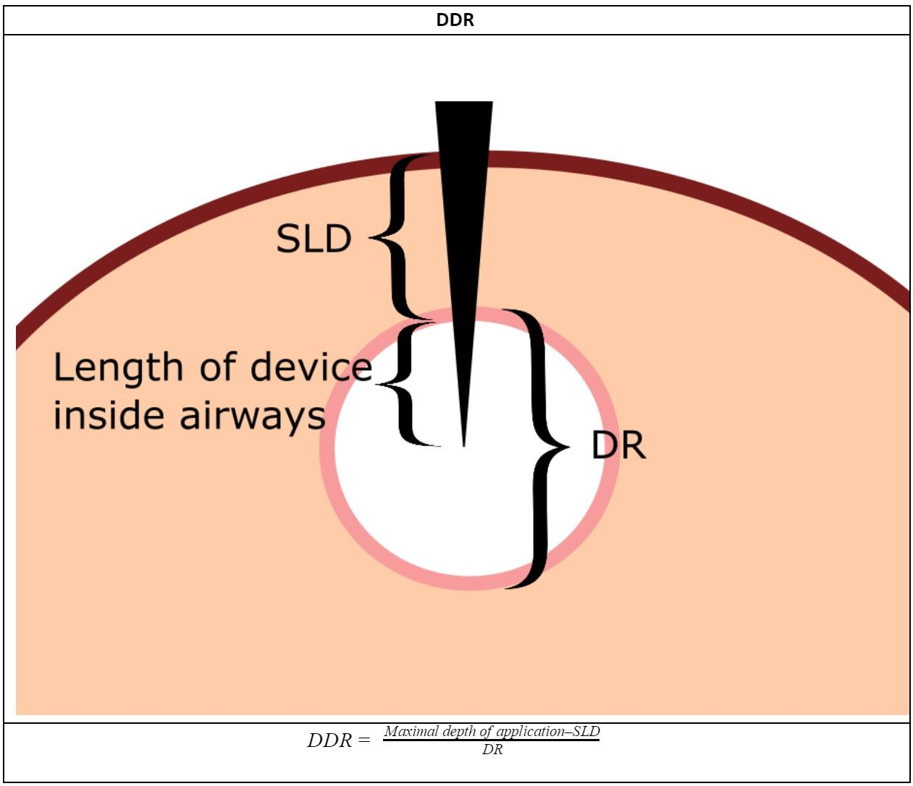
Abbreviations: DR, diameter of the respiratory tract ; DDR, length of device in airways to the diameter of respiratory tract ratio; SLD, surface - ligament distance

