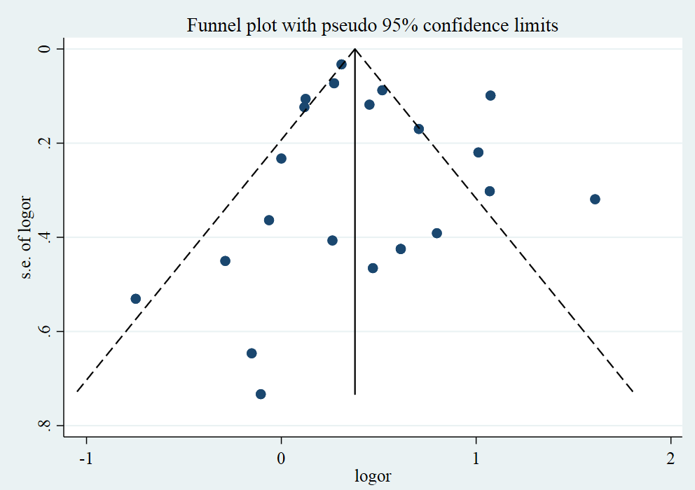
Figure S1: Funnel plot of studies included in the meta-analysis

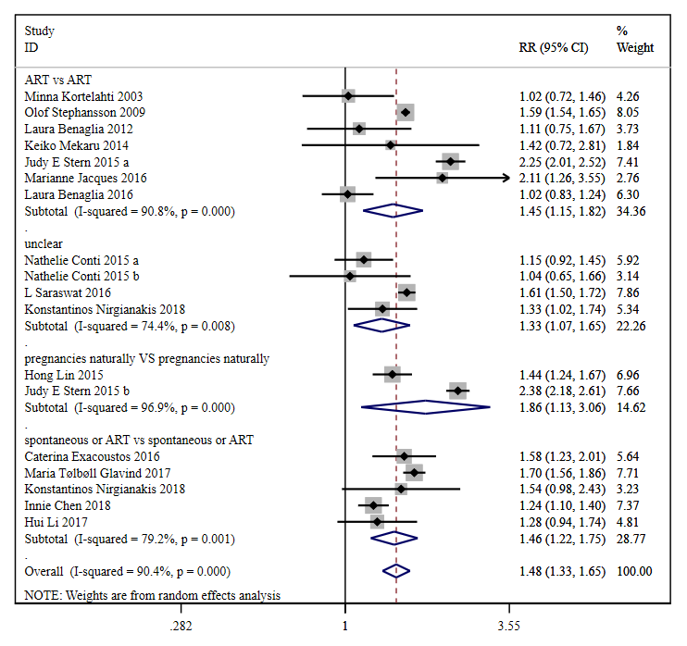
Figure S2. Forest plot for the risk of cesarean section

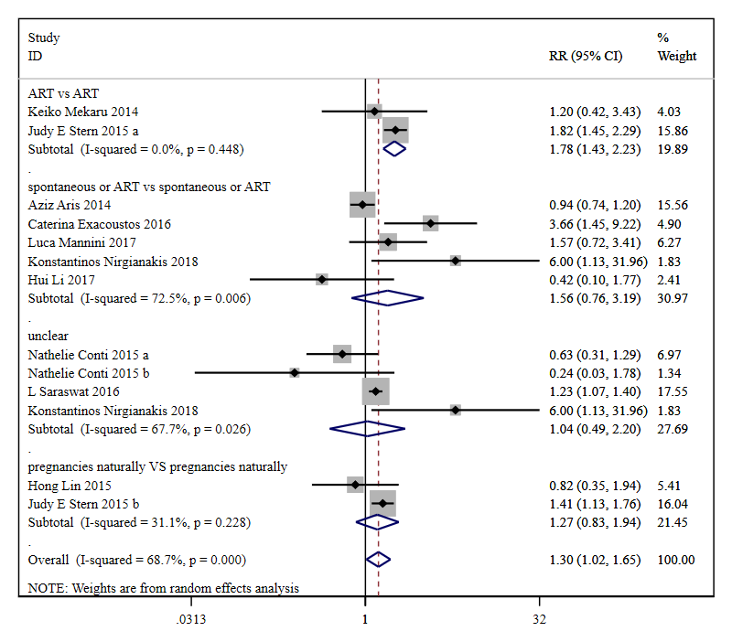
Figure S3. Forest plot for the risk of gestational hypertension

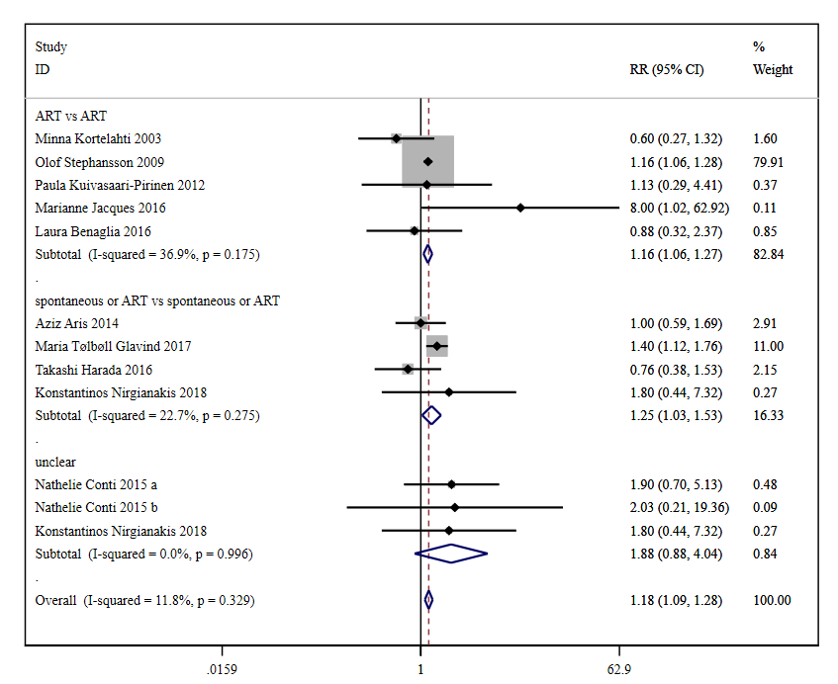
Figure S4. Forest plot for the risk of preeclampsia

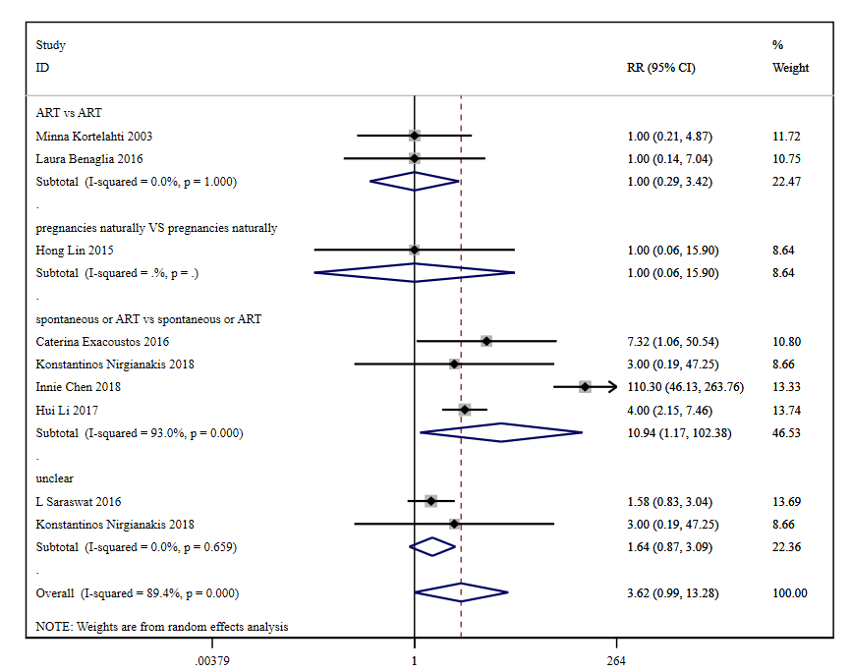
Figure S5. Forest plot for the risk of placental abruption

