# Supplementary material

# Additional information on input parameters

## A.1. Mortality inputs and calculations

Mortality was calculated using the following formula:

-1 * (a – b) * (1/c), where

* a denotes the number of people (per 100 000) who lived to the beginning of the next age range;
* b denotes number of people who lived to the beginning of the considered age range
* c denotes the number of years in the considered range

The calculation was based on the data coming from Life expectancy tables of Poland 2021 [1]. The results are presented in Table A1.

Table A1. Annual all-cause mortality rates for the general population

|  |  |  |
| --- | --- | --- |
| **Age group (years)** | **Males** | **Females** |
| **<1** | 0.00209 | 0.00175 |
| **1-8** | 0.00016 | 0.00012 |
| **9-10** | 0.00009 | 0.00008 |
| **11-12** | 0.00011 | 0.00010 |
| **13-14** | 0.00017 | 0.00013 |
| **15-17** | 0.00034 | 0.00020 |
| **18** | 0.00052 | 0.00024 |
| **19** | 0.00063 | 0.00027 |
| **20-24** | 0.00087 | 0.00029 |
| **25-26** | 0.00108 | 0.00031 |
| **27-29** | 0.00125 | 0.00036 |
| **30-34** | 0.00165 | 0.00051 |
| **35-39** | 0.00241 | 0.00076 |
| **40-44** | 0.00362 | 0.00124 |
| **45-49** | 0.00568 | 0.00212 |
| **50-54** | 0.00908 | 0.00344 |
| **55-59** | 0.01431 | 0.00571 |
| **60-64** | 0.02266 | 0.00976 |
| **65-69** | 0.03465 | 0.01586 |
| **70-74** | 0.04945 | 0.02521 |
| **75-79** | 0.07186 | 0.04090 |
| **80-84** | 0.10828 | 0.07037 |
| **>85** | 1.00000 | 1.00000 |

## A.2. Number of hysterectomies

In Table A2, we present the NFZ statistics for the number of hysterectomies per age group split by DRG codes.

Table A2. The number of hysterectomies in 2020 split by diagnosis related group codes

|  |  |  |  |  |  |  |  |
| --- | --- | --- | --- | --- | --- | --- | --- |
| **Age group** | **Number of procedures by procedure code** | | | | | **Sum** | **Percent of all hysterectiomies** |
| **M11** | **M12** | **M13** | **M20** | **M21** |
| **<1** | 0 | 0 | 0 | 0 | 0 | 0 | 0.00% |
| **1-6** | 0 | 0 | 0 | 0 | 0 | 0 | 0.00% |
| **7-17** | 0 | 0 | 14 | 0 | 0 | 14 | 0.03% |
| **18-40** | 4 | 0 | 264 | 0 | 0 | 268 | 0.65% |
| **41-60** | 327 | 35 | 10 267 | 53 | 2 | 10 684 | 25.74% |
| **61-80** | 2148 | 330 | 17 887 | 365 | 42 | 20 772 | 50.05% |
| **>81** | 2943 | 563 | 4832 | 706 | 112 | 9156 | 22.06% |
| **No data** | 222 | 50 | 241 | 78 | 15 | 606 | 1.46% |
| [2] | | | | | | | |

Percent of female population receiving hysterectomy over the course of 1 year was calculated using the sum of all hysterectomies in a given age range and the population size in the ranges considered by the model. The calculations took into account the fact that the National Health Fund statistics presented results for age ranges wider than those included in the model.

The following formula was used to calculate percent of female population receiving Hysterectomy over the course of 1 year:

a/(b*c), where:

* a denotes the total number of hysterectomies in a given age group reported by NFZ
* b denotes the population size for the age ranges included in the model
* c denotes the number of age ranges included in the model that fall within the corresponding age range presented in NFZ statistics

Table A3. Population size and percent of female population receiving hysterectomy over the course of 1 year

|  |  |  |
| --- | --- | --- |
| **Age group** | **Population size** | **Percent receiving hysterectomy** |
| **<1** | 158 281 | 0.00000 |
| **1-8** | 1 476 064 | 0.00000 |
| **9-10** | 382 753 | 0.00001 |
| **11-12** | 413 238 | 0.00001 |
| **13-14** | 406 953 | 0.00001 |
| **15-17** | 539 521 | 0.00001 |
| **18** | 170 679 | 0.00022 |
| **19** | 172 084 | 0.00022 |
| **20-24** | 934 320 | 0.00004 |
| **25-26** | 419 119 | 0.00009 |
| **27-29** | 707 716 | 0.00005 |
| **30-34** | 1 352 188 | 0.00003 |
| **35-39** | 1 580 374 | 0.00002 |
| **40-44** | 1 529 062 | 0.00175 |
| **45-49** | 1 391 073 | 0.00192 |
| **50-54** | 1 167 265 | 0.00229 |
| **55-59** | 1 161 620 | 0.00230 |
| **60-64** | 1 366 295 | 0.00380 |
| **65-69** | 1 387 413 | 0.00374 |
| **70-74** | 2 958 313 | 0.00176 |
| **75-79** | 739 578 | 0.00702 |
| **80-84** | 739 578 | 0.00619 |
| **>85** | 739 578 | 0.00619 |
| [3] | | |

## A.3. Percent of females receiving a follow-up screening test after abnormal PAP smear diagnosis

According to the information on the prevention program website, approximately 1.5-2% of the PAP smear test results are abnormal [4]. The number of all cytologies performed in 2021 based on the report of the Ministry of Health amounted to 376 791 [5]. Using the value of 2%, the number of abnormal test results was estimated as 7536. The number of women who reported for further diagnostics after receiving abnormal cytological test results in year 2021 was 1698, which is approximately 22.5% of total number of women with abnormal test results.

## A.4. Vaccination coverage rate in females

Parameters and references for vaccination coverage rate adopted in model input are shown in Tables A4 and A5.

Table A4 Vaccination coverage rate in females

|  |  |  |  |
| --- | --- | --- | --- |
| **Year** | **12 year olds** | **13 year olds** | **Source(s)** |
| 1 | 22.0% | 22.0% | Low boundary estimate for EU National Programs (recalculated for half year) |
| 2 | 44.0% | 44.0% | Low boundary estimate for EU National Programs |
| 3 | 57.0% | 57.0% | Max VCR in municipality programs in Poland (published by Polish HTA Agency) |
| 4 | 58.0% | 58.0% | [6]; VCR in Czech Rep after 4 years with two vaccines available |
| 5 | 59.0% | 59.0% | Assumption based on data regarding years 4 and 6+ |
| 6+ | 60.0% | 60.0% | Polish National Oncology Strategy target |

Table A5. Expected vaccination coverage rate in males

|  |  |  |  |
| --- | --- | --- | --- |
| **Year** | **12 year olds** | **13 year olds** | **Reference(s)** |
| 1 | 18.0% | 18.0% | Low boundary estimate for EU National Programs (recalculated for half year) |
| 2 | 35.0% | 35.0% | Low boundary estimate for EU National Programs |
| 3 | 50.0% | 50.0% | Max VCR in municipality programs in Poland (published by Polish HTA Agency) |
| 4 | 58.0% | 58.0% | [6]; VCR in Czech Rep after 4 years with two vaccines available |
| 5 | 59.0% | 59.0% | Assumption based on data regarding years 4 and 6+ |
| 6+ | 60.0% | 60.0% | Polish National Oncology Strategy target |

## A.5. Costs

The costs of the vaccines are based on public tenders and are presented in Table A6 below.

**Table A6. Cost of vaccines**

|  |  |  |  |
| --- | --- | --- | --- |
| **Price** | **Vaccine** | **PLN (EUR)** | **Reference** |
| Listed official price per dose | Gardasil 9 | 486.22 (105.93) | [7] |
| Listed official price per dose | Cervarix | 245.16 (53.41) | [8] |
| Visible contract price | Gardasil 9 | 335.00 (73.00) | [9] |
| Visible contract price | Cervarix | 130.00 (28.33) | [9] |
| Vaccine administration cost per dose | Both vaccines | 29.74 (6.48) | [10] |

Other costs adopted in the model are presented in tables below.

Table A7. Cost per episode of care

|  |  |  |
| --- | --- | --- |
| **Parameter** | **Cost (EUR)** | **Reference(s)** |
| **CIN 1** | 211.34 | [11] |
| **CIN 2** | 285.07 | [11] |
| **CIN 3, CIS** | 285.07 | [11] |
| **Cervical cancer, local disease\*** | 1544.46 | [11] |
| **Cervical cancer, regional disease\*** | 1544.46 | [11] |
| **Cervical cancer, distant disease\*** | 1544.46 | [11] |
| **VaIN 1** | 112.57 | [12] |
| **VaIN 2** | 112.57 | [12] |
| **VaIN 3, CIS** | 112.57 | [12] |
| **Vaginal cancer, local disease\*** | 4530.79 | [11] |
| **Vaginal cancer, regional disease\*** | 4530.79 | [11] |
| **Vaginal cancer, distant disease\*** | 4530.79 | [11] |
| **Vulvar cancer, local disease\*** | 4939.95 | [11] |
| **Vulvar cancer, regional disease\*** | 4939.95 | [11] |
| **Vulvar cancer, distant disease\*** | 4939.95 | [11] |
| CIN – cervical intraepithelial neoplasia; VaIN – Vaginal intraepithelial neoplasia  * Disease stages can be related to the traditional Tumour-Node-Metastasis (TNM) classification system as followed:  - "Local disease" corresponds to stages I and II TNM classification, i.e., localized primary tumour;  - "Regional disease" corresponds to stage III TNM classification system, i.e., metastasis to regional lymph nodes;  - "Distant disease" corresponds to stage IV TNM classification system, i.e., distant metastatic disease. | | |

Table A8. Cost per episode of care

|  |  |  |  |
| --- | --- | --- | --- |
| **Parameter** | **Cost (EUR)** | | **Reference(s)** |
| **Penile cancer, local disease\*** | 495.00 | | [12] |
| **Penile cancer, regional disease\*** | 495.00 | | [12] |
| **Penile cancer, distant disease\*** | 495.00 | | [12] |
| **Anal cancer, local disease\*** | 3909.75 | | [11] |
| **Anal cancer, regional disease\*** | 3909.75 | | [11] |
| **Anal cancer, distant disease\*** | 3909.75 | | [11] |
| **Head & Neck cancer, local disease\*** | 4797.65 | | [12] |
| **Head & Neck cancer, regional disease\*** | 4797.65 | | [12] |
| **Head & Neck cancer, distant disease\*** | 4797.65 | | [12] |
| **Genital warts** | 54.99 | | [11] |
| **Recurrent respiratory papillomatosis** | 2832.33 | | [12] |
|  | |

Table A9 Screening and diagnostic tests (for cervical and vaginal cancers only)

|  |  |  |
| --- | --- | --- |
| **Parameter** | **Cost (EUR)** | **Reference(s)** |
| **Screening (PAP smear) + consultation** | 5.21 | [11] |
| **Colposcopy** | 24.56 | [11] |
| **Biopsy** | 69.23 | [11] |
| CIN – cervical intraepithelial neoplasia; VaIN – Vaginal intraepithelial neoplasia | | |

## A.6. Utilities

Table A10 Health utility values by age and gender for individuals without HPV disease [13]

|  |  |  |
| --- | --- | --- |
| **Age range** | **Men** | **Women** |
| **<1** | 0.967 | 0.959 |
| **1-8** | 0.967 | 0.959 |
| **9-10** | 0.967 | 0.959 |
| **11-12** | 0.967 | 0.959 |
| **13-14** | 0.967 | 0.959 |
| **15-17** | 0.967 | 0.959 |
| **18** | 0.967 | 0.959 |
| **19** | 0.967 | 0.959 |
| **20-24** | 0.967 | 0.959 |
| **25-26** | 0.958 | 0.948 |
| **27-29** | 0.958 | 0.948 |
| **30-34** | 0.958 | 0.948 |
| **35-39** | 0.942 | 0.934 |
| **40-44** | 0.942 | 0.934 |
| **45-49** | 0.910 | 0.887 |
| **50-54** | 0.91 | 0.887 |
| **55-59** | 0.851 | 0.861 |
| **60-64** | 0.851 | 0.861 |
| **65-69** | 0.837 | 0.793 |
| **70-74** | 0.837 | 0.793 |
| **75-79** | 0.74 | 0.715 |
| **80-84** | 0.740 | 0.715 |
| **>85** | 0.740 | 0.715 |
|  | | |

# Additional results

Table B1. Estimated cumulative cost of HPV-related diseases at the population level (discounted, in EUR)

|  |  |  |  |
| --- | --- | --- | --- |
|  | Considered vaccination alternative | | % reduction when using 9v vs 2v |
|  | 2v | 9v |
| **Cervical** | | | |
| Cancer | 76 495 853 | 75 317 545 | 1.5 |
| CIN 1 | 49 738 823 | 39 006 462 | 21.6 |
| CIN 2/3 | 64 309 887 | 55 514 346 | 13.7 |
| **Vaginal** | | | |
| Cancer | 5 475 243 | 5 422 257 | 1.0 |
| VAIN 1 | 0 | 0 | 99.8 |
| VAIN 2/3 | 0 | 0 | 100.0 |
| **Vulvar** | | | |
| Cancer | 7 261 414 | 7 212 609 | 0.7 |
| VIN 1 | 0 | 0 | - |
| VIN 2/3 | 0 | 0 | - |
| **Genital Warts and HPV 6/11-related CIN 1** | | | |
| CIN 1 | 87 815 332 | 67 105 132 | 23.6 |
| CIN 2/3 | 9 872 735 | 7 561 476 | 23.4 |
| Genital Warts (male) | 11 859 022 | 9 375 656 | 20.9 |
| Genital Warts (female) | 17 984 116 | 13 643 840 | 24.1 |
| **Anal** | | | |
| Cancer (male) | 4 857 931 | 4 847 334 | 0.2 |
| Cancer (female) | 11 390 174 | 11 367 223 | 0.2 |
| **Penile Cancer** | 543 147 | 536 217 | 1.3 |
| **RRP** | 83 730 834 | 68 410 707 | 18.3 |
| **Total Disease Costs** | 431 334 511 | 365 320 805 | 15.3 |
| Costs are discounted a 5% annual rate. Percentages are rounded to nearest 0.1%. | | | |

Table B2. Estimated quality-adjusted life year (QALY) gains when comparing 9v vs 2v vaccine per 100,000 individuals per disease type

|  |  |
| --- | --- |
| Disease type | QALY gain |
| Cervical | 50.47 |
| Vaginal | 0.43 |
| Vulvar | 0.54 |
| Genital warts | 66.14 |
| Anal | 0.28 |
| Penile | 0.48 |
| RRP | 44.96 |
| Total | 163.30 |

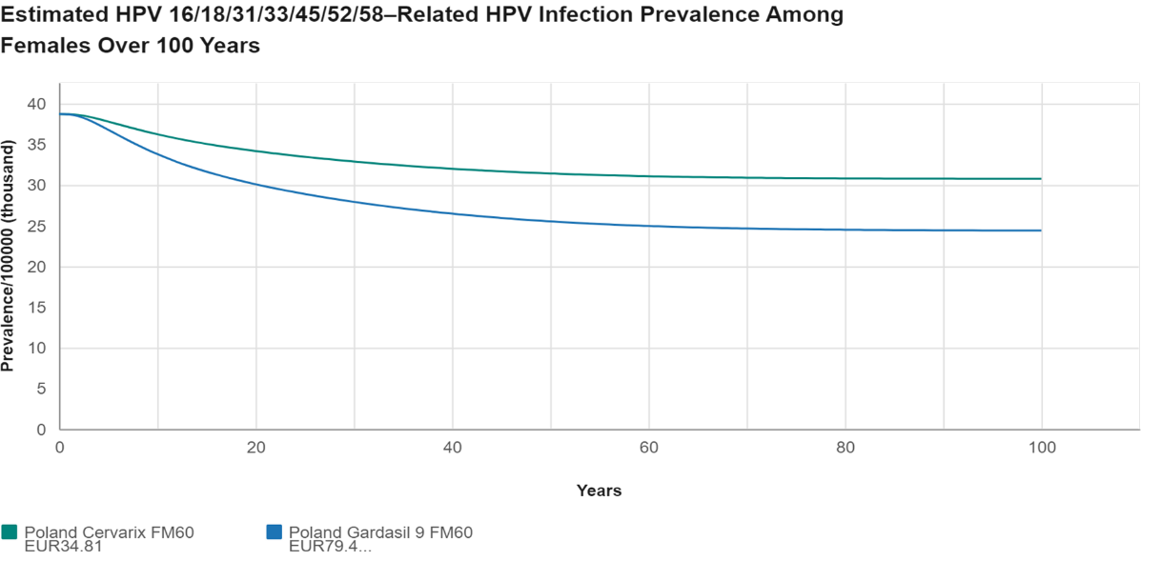

Fig. B1. The estimated HPV infection prevalence among females

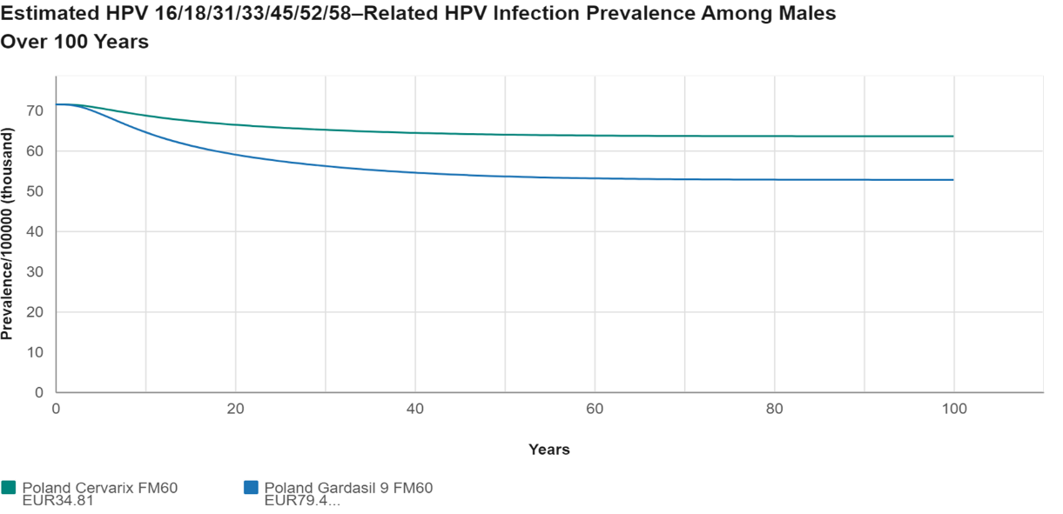

Fig. B2. The estimated HPV infection prevalence among males

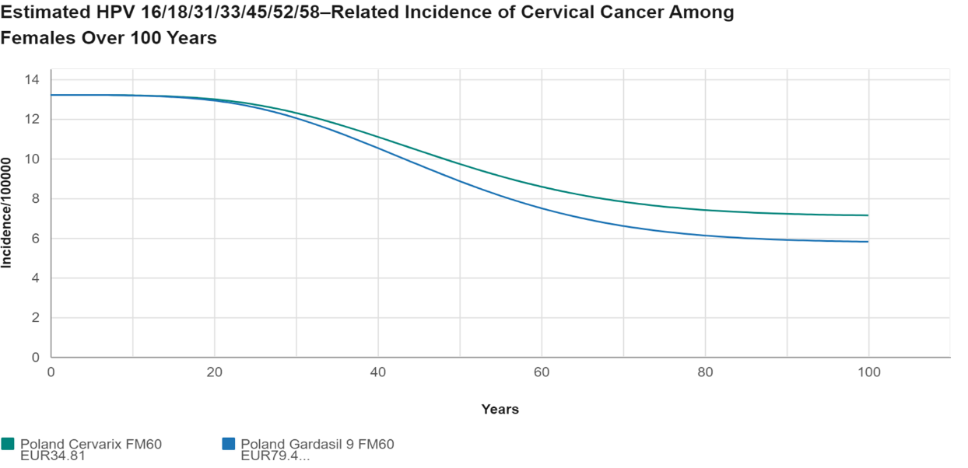

Fig. B3. The estimated HPV-related incidence of cervical cancer among females

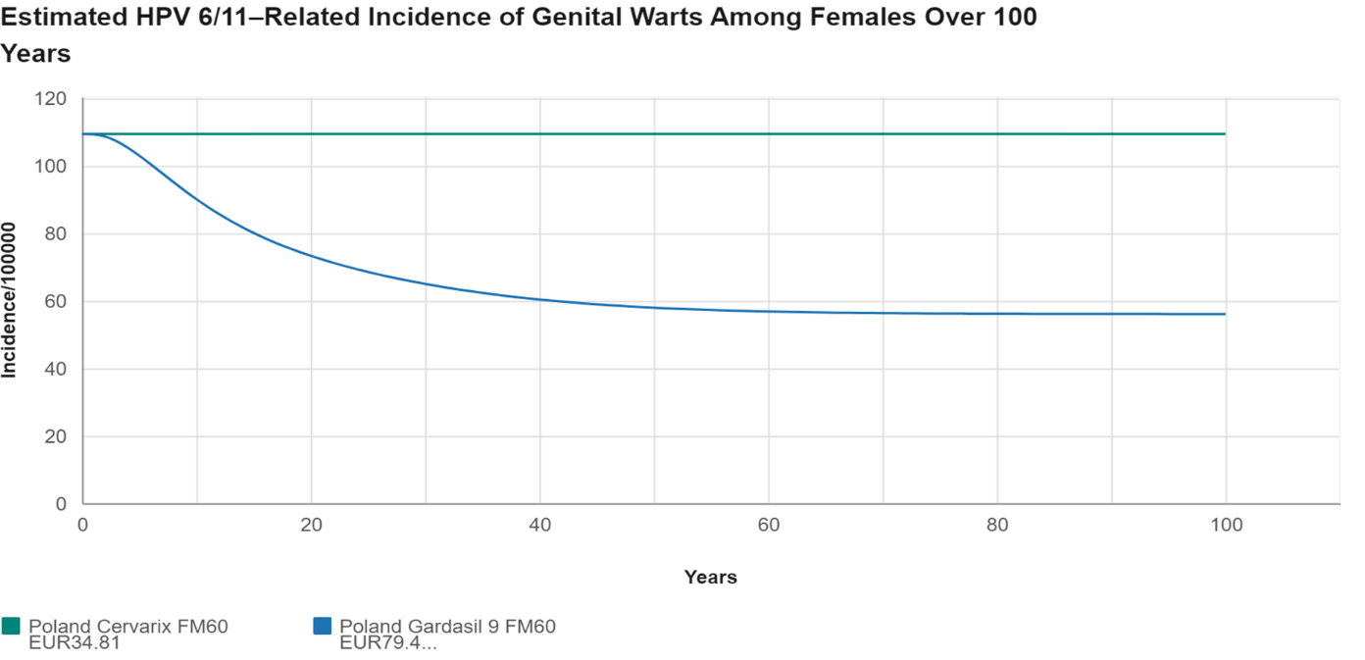

Fig. B4. The estimated HPV-related incidence of genital warts among females

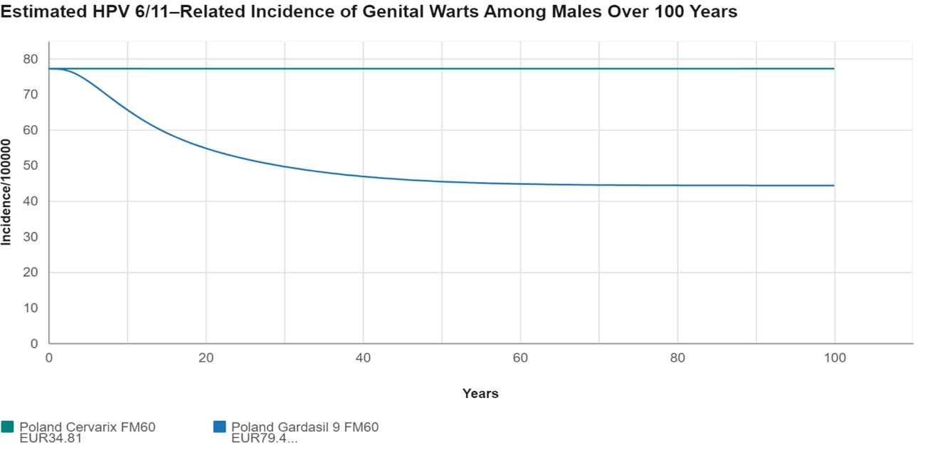

Fig. B5. The estimated HPV-related incidence of genital warts among males

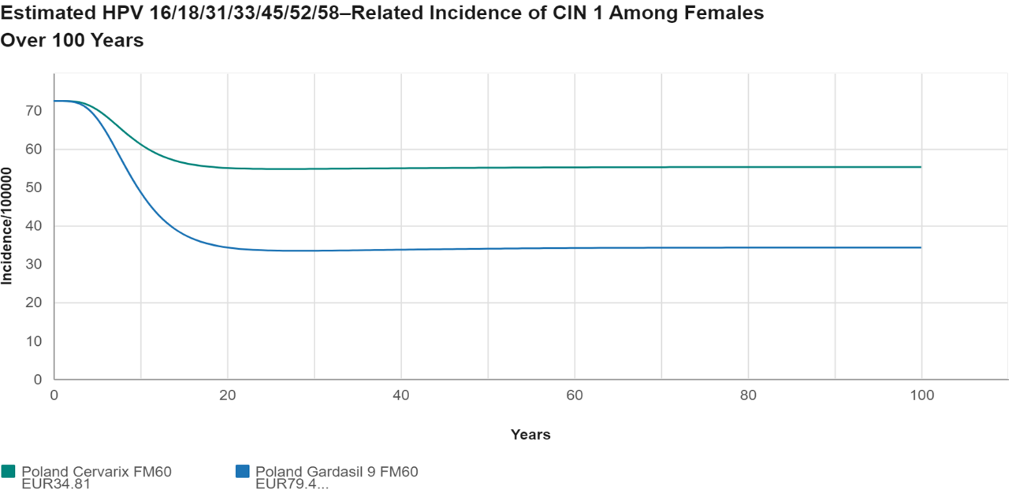

Fig. B6. The estimated HPV 16/18/31/33/45/52/58-related incidence of CIN 1 among females

# References for Supplementary Material

1. Statistics Poland, Demographic Survey Department. Life expectancy tables of Poland 2021. Statistics Poland, 2022.
2. 2020 Statistics for procedures with codes M11, M12, M13, M20 and M21, https://statystyki.nfz.gov.pl/Benefits/1a (access: 27.12.2023).
3. Statistics Poland, Demographic Department. Population. Size and structure and vital statistics in Poland by territorial division in 2021. As of 31 December. Statistics Poland, 2022.
4. https://pacjent.gov.pl/program-profilaktyczny/profilaktyka-raka-szyjki-macicy (access: 27.12.2023).
5. Ministerstwo Zdrowia. Narodowa Strategia Onkologiczna Sprawozdanie za rok 2021. https://www.gov.pl/web/zdrowie/narodowa-strategia-onkologiczna-nso (access: 27.12.2023).
6. Nguyen-Huu NH, Thilly N, Derrough T, et al. Human papillomavirus vaccination coverage, policies, and practical implementation across Europe. Vaccine. 2019; 38(6):1315–1331.
7. https://dziennikmz.mz.gov.pl/legalact/2023/28/ (access: 11.01.2024)
8. https://www.gov.pl/web/zdrowie/obwieszczenie-ministra-zdrowia-z-dnia-20-kwietnia-2023-r-w-sprawie-wykazu-lekow-srodkow-spozywczych-specjalnego-przeznaczenia-zywieniowego-oraz-wyrobow-medycznych-na-1-maja-2023-r (access: 11.01.2024)
9. https://zzpprzymz.ezamawiajacy.pl/pn/zzpprzymz/demand/notice/public/89998/details?folder=0002& (access: 11.01.2024)
10. https://baw.nfz.gov.pl/NFZ/document/1810/Zarzadzenie-78_2023_DSOZ (access: 11.01.2024)
11. Analiza ekonomiczna Szczepionka przeciw wirusowi brodawczaka ludzkiego Cervarix® w profilaktyce zmian przednowotworowych narządów płciowych i odbytu (szyjki macicy, sromu, pochwy i odbytu) oraz raka szyjki macicy i raka odbytu. Pracownia HTA. 2021. https://bipold.aotm.gov.pl/assets/files/zlecenia_mz/2021/041/AW/41_AW_OT.4230.6.2021_Cervarix_AE.pdf (access: 27.12.2023).
12. Order No. 21/2023/DSOZ of the President of the National Health Fund of 31.01. 2023. https://baw.nfz.gov.pl/NFZ/document/1669/Zarzadzenie-21_2023_DSOZ (access: 27.12.2023).
13. Golicki D Niewada M. EQ-5D-5L Polish population norms. Arch Med Sci. 2017; 13(1): 191–200.