Schematic diagrams of retrocaval ureter

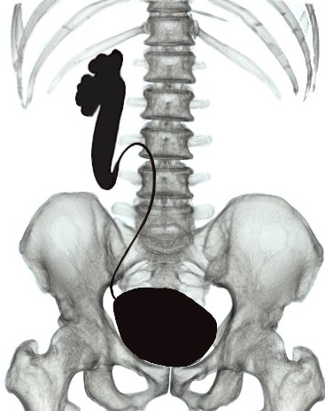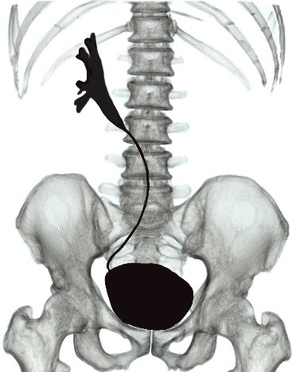

A: Low type (S shaped deformity) B: High type(Sickle shaped deformity)

