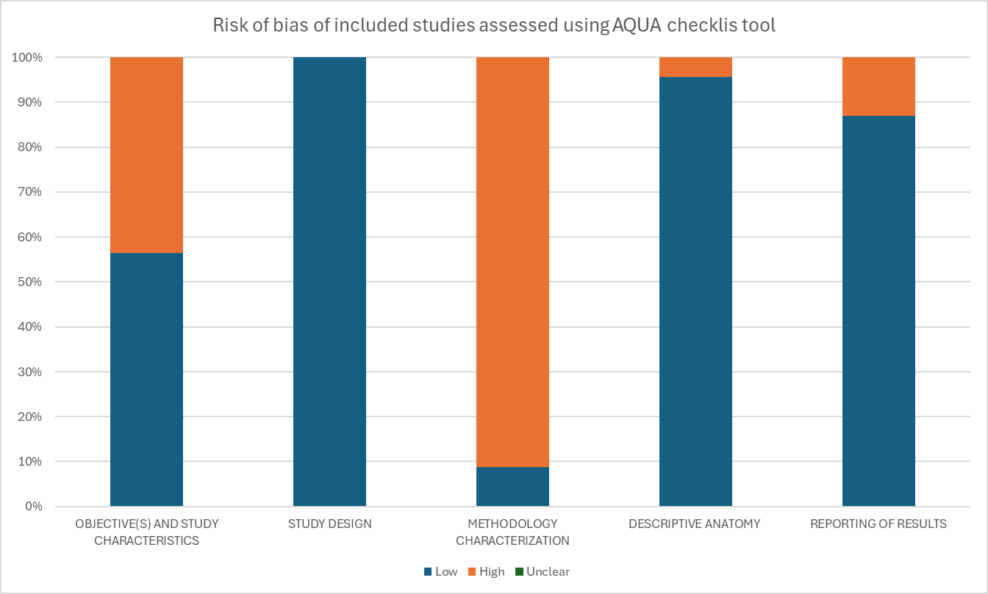

**Supplementary Figure 1.** Risk of bias of included studies assessed using AQUA checklist tool.