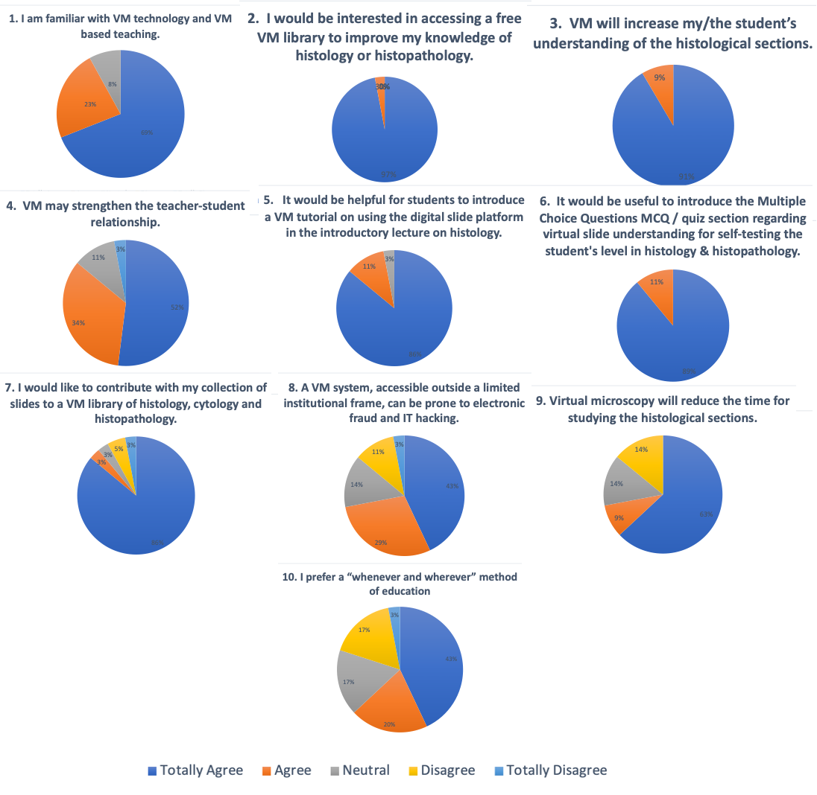

Supplementary Figure 1. Answers provided by the experts on the questionnaire used in the mapping research strategy.

