Supplementary Information

Supplementary Table
Primer sequences for qPCR and RT-PCR
List gene name with accession ID number, forward and reverse primer sequences for qPCR and RT-PCR, size of PCR products.

Amplicon | Forward primer (5’ – 3’) | Reverse primer (5’ – 3’) | Product Size (bp) | ID
GADPH | ATTTGGCTACAGCAACAGGGT | GTTTGGAGGCCCTACCCTCA | 389 | NM_001034034
CXCL12 | TGAGCTACAGATGCCCATGC | CATCTCGAGGTGGCAGATAAC | 304 | NM_001113174
CXCR4 | ATGCAAGGCAGTCCATGTCA | TGGAACACAACCACCCACAA | 276 | NM_174301.3

Supplementary Figure
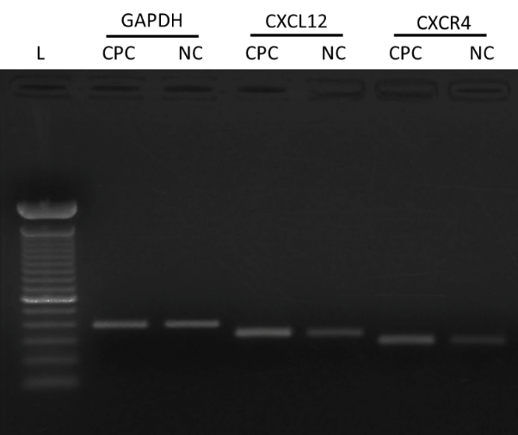
Agarose Gel Electrophoresis of RT-PCR GADPH was used as reference gene. Gene expression of CXCL12 and CXCR4 in CPC and NC was shown in Electrophoresis. L – 100 bp DNA ladder.

