Supplementary Data Figure S1. Bias risk map

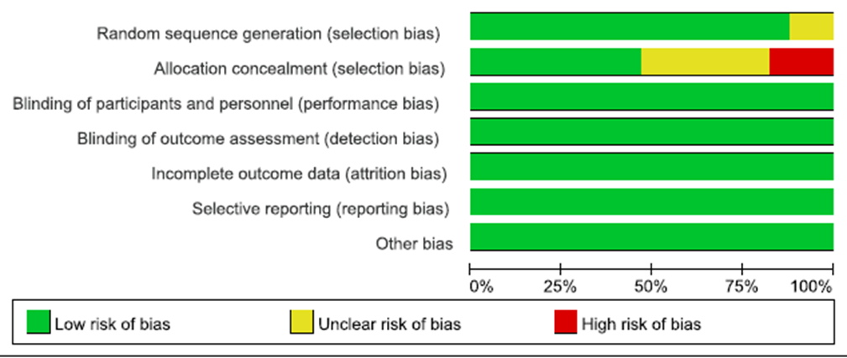
Supplementary Data Figure S2. Bias summary risk

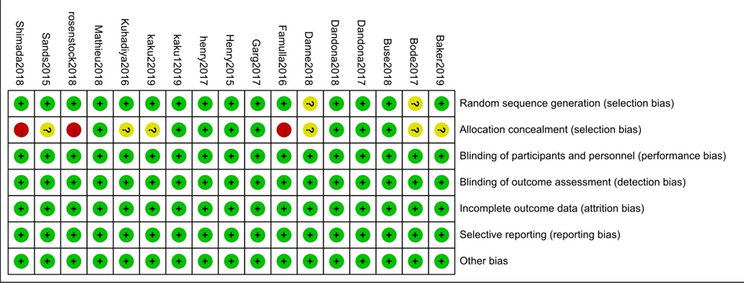
Supplementary Data Figure S3. Linear correlation between HbA1C levels and follow-up time. (Regression coefficient 1.003; p = 0.013)
