Systematic review and meta-analysis of intravenous and topical tranexamic acid in reducing blood loss in knee arthroplasty

Supplementary Digital File

CONTENT:
Figure S1. A summary table of review authors' judgements for each risk of bias item for each randomized study. 2
Figure S2. A plot of the distribution of review authors' judgements across randomized studies for each risk of bias item. 3
Figure S3. A summary table of review authors' judgements for each risk of bias item for each non-randomized study. 3
Figure S4. A plot of the distribution of review authors' judgements across non-randomized studies for each risk of bias item. 3
Figure S5. Forest plot of operative time among IV-TXA and T-TXA groups. 4
Figure S6. Forest plot of length of hospital stay among IV-TXA and T-TXA groups. 4

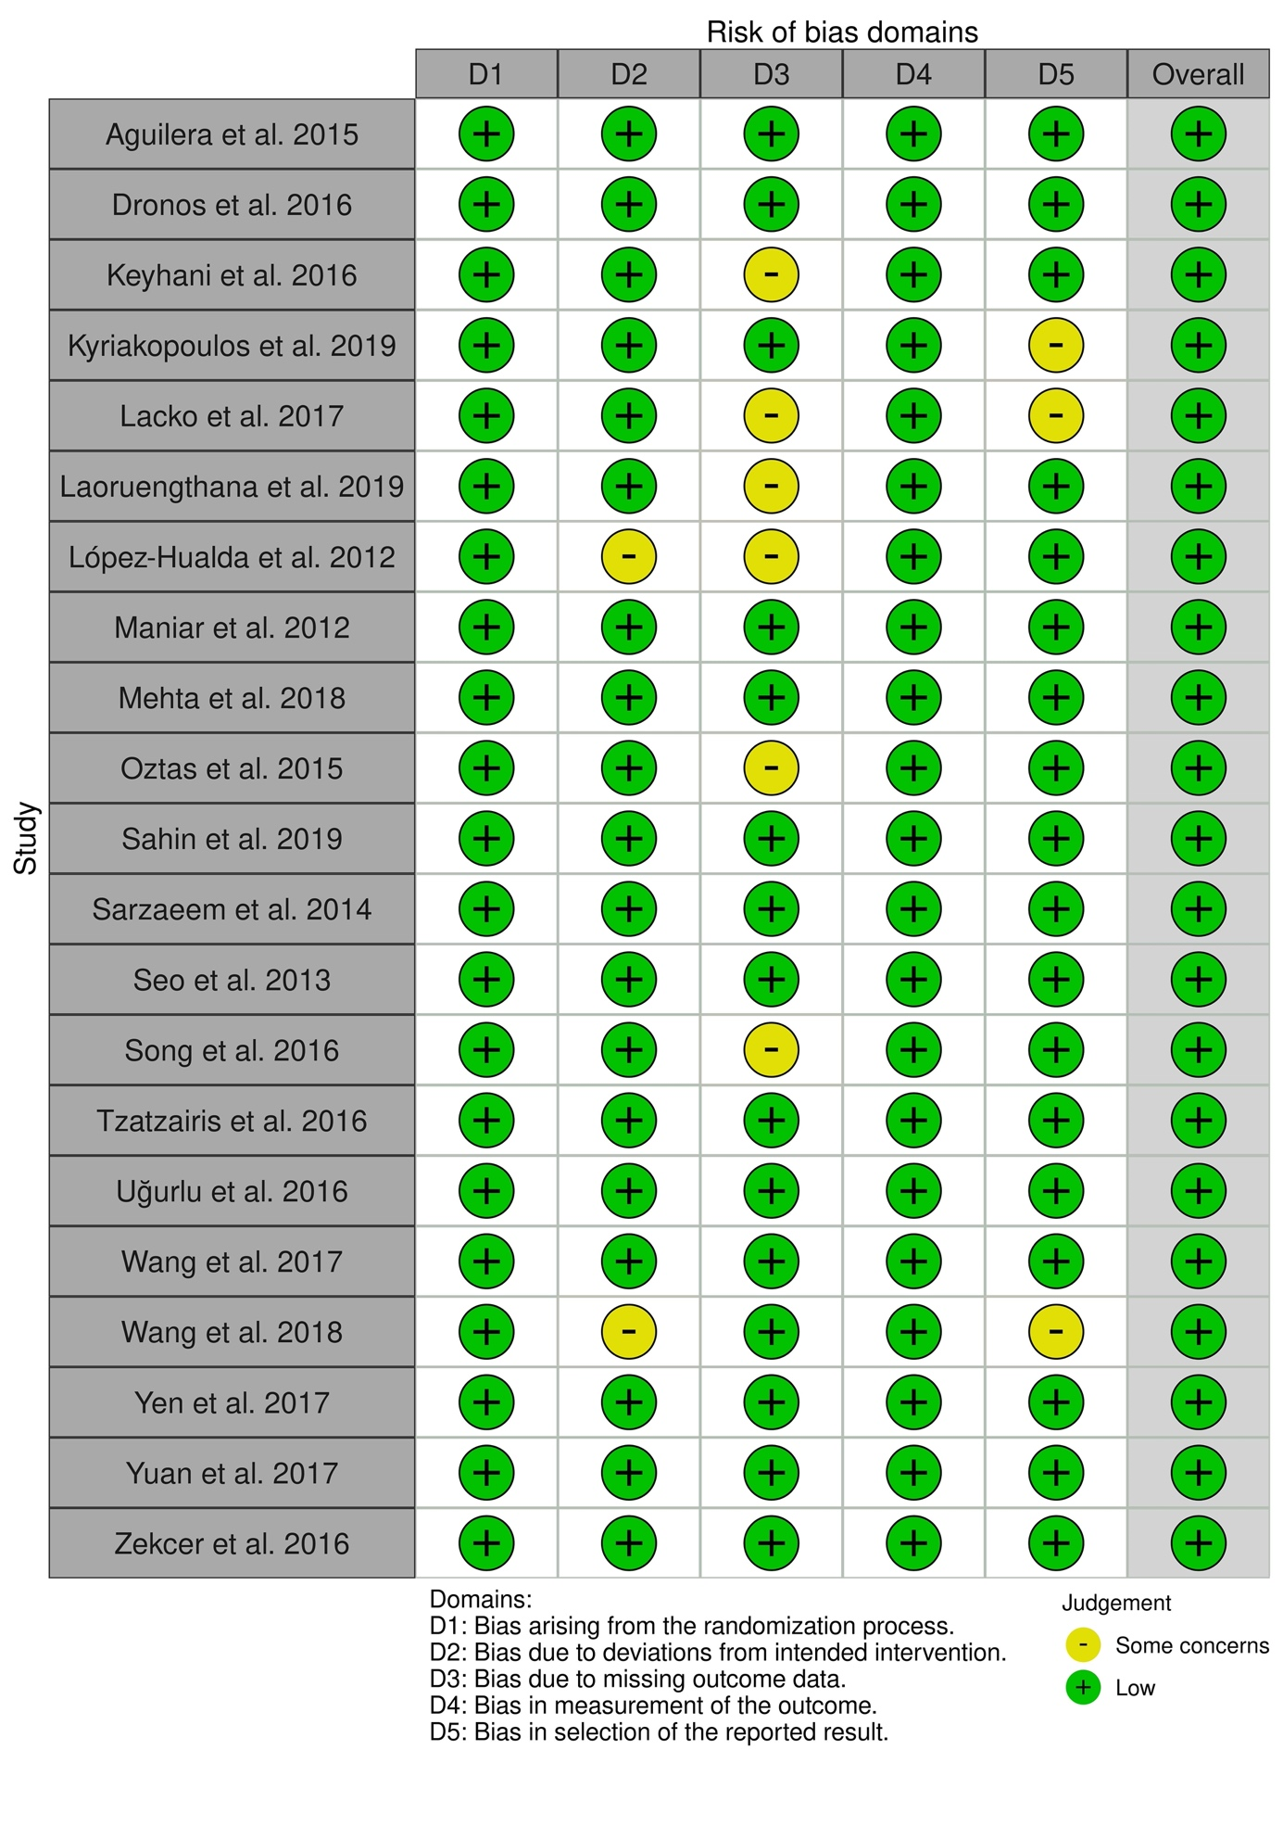

Figure S1. A summary table of review authors' judgements for each risk of bias item for each randomized study.

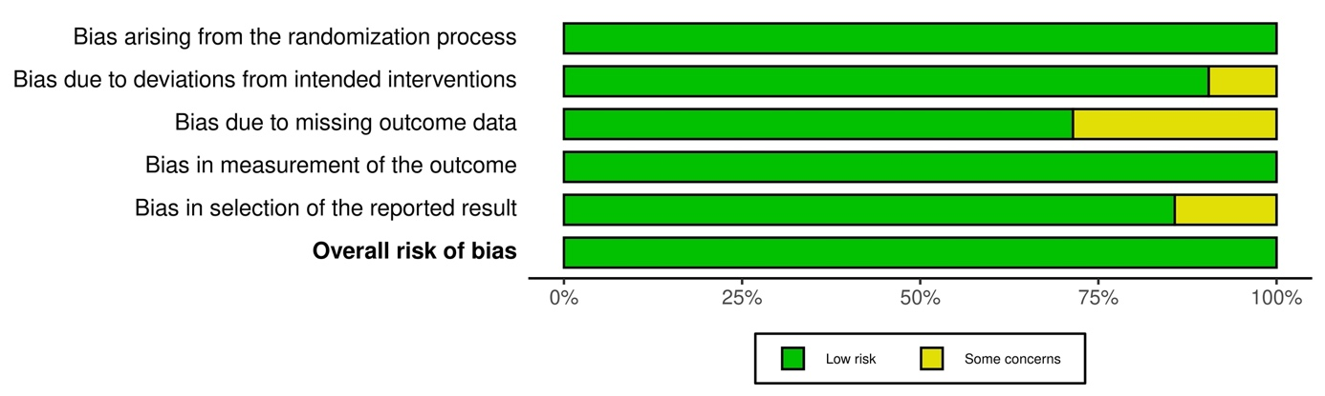

Figure S2. A plot of the distribution of review authors' judgements across randomized studies for each risk of bias item.

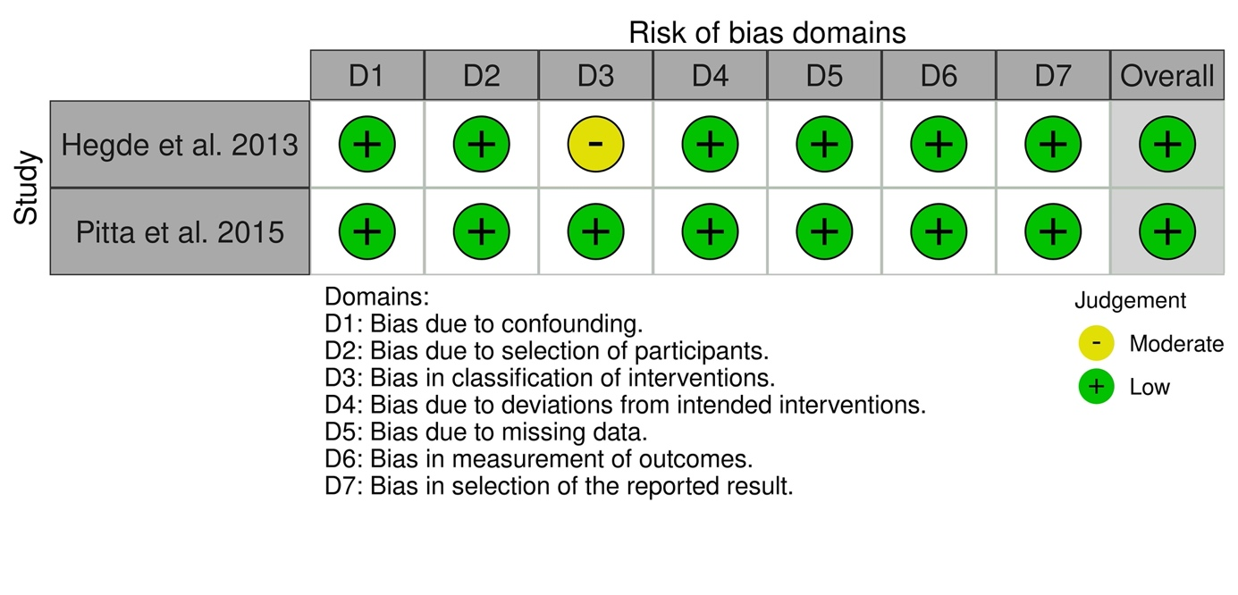

Figure S3. A summary table of review authors' judgements for each risk of bias item for each non-randomized study.

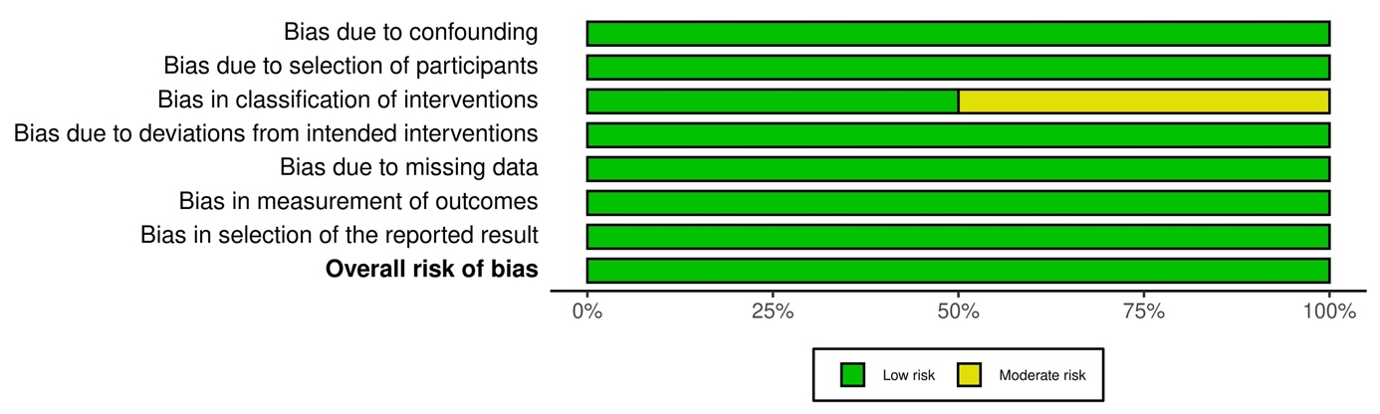

Figure S4. A plot of the distribution of review authors' judgements across non-randomized studies for each risk of bias item.

Figure S5. Forest plot of operative time among IV-TXA and T-TXA groups. The centre of each square represents the weighted standard mean differences for individual trials, and the corresponding horizontal line stands for a 95% confidence interval. The diamonds represent pooled results.

Figure S6. Forest plot of length of hospital stay among IV-TXA and T-TXA groups. The centre of each square represents the weighted standard mean differences for individual trials, and the corresponding horizontal line stands for a 95% confidence interval. The diamonds represent pooled results.

