Supplementary Material

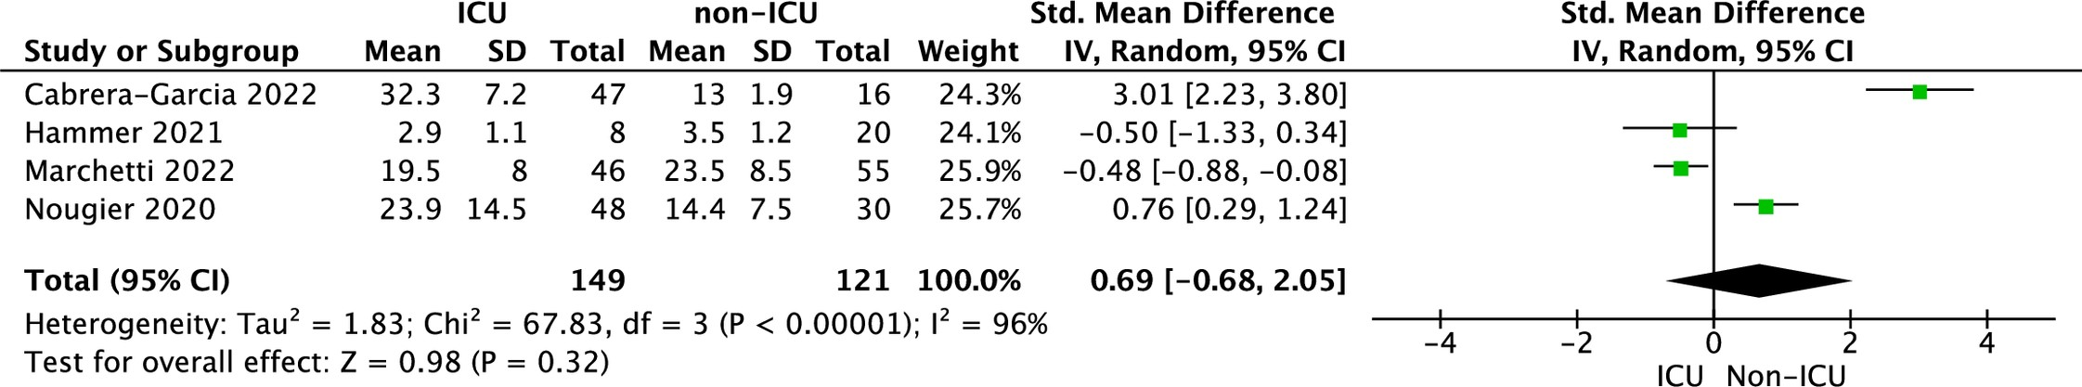
Figure S1. Forest plot of tPA levels among COVID-19 ICU vs non-ICU patients. The center of each square represents the standardized mean differences for individual trials, and the corresponding horizontal line stands for a 95% confidence interval. The diamonds represent pooled results

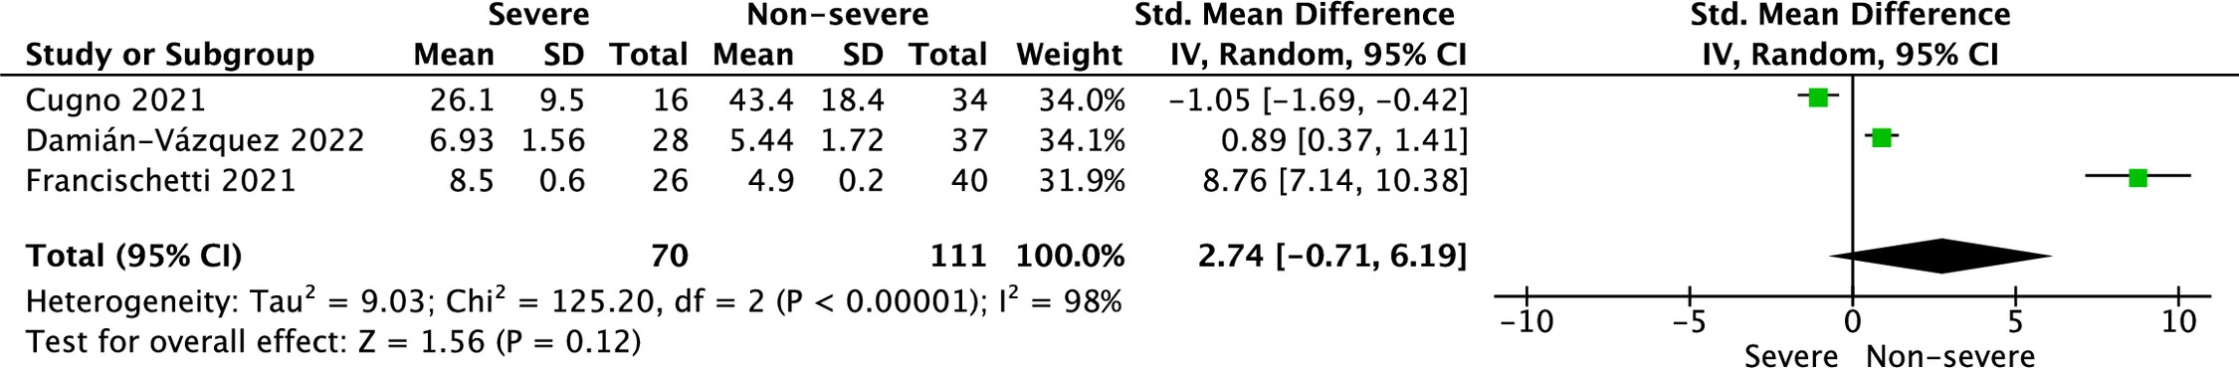
Figure S2. Forest plot of tPA levels among COVID-19 severe vs non-severe patients. The center of each square represents the standardized mean differences for individual trials, and the corresponding horizontal line stands for a 95% confidence interval. The diamonds represent pooled results

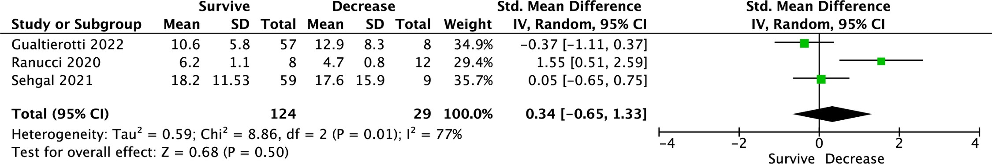
Figure S3. Forest plot of tPA levels among COVID-19 surviving vs desceased patients. The center of each square represents the standardized mean differences for individual trials, and the corresponding horizontal line stands for a 95% confidence interval. The diamonds represent pooled results

