SUPPLEMENTARY DATA

Efficacy and safety of bioresorbable scaffolds in patients with coronary bifurcation lesions: a systematic review and meta-analysis

List of Supporting Information Content
File S1. Search strategy of Embase.
Table S1. Newcastle-Ottawa Quality Assessment Form for Cohort Study
Table S2. Quality assessment of case series studies
Table S3. Summary of GRADE evidence quality evaluation
Figure S1. The funnel plots of all outcomes.
Figure S2. Sensitivity analysis of TLR (A) and MACE (B) at 6-month follow-up.
Figure S3. ACS subgroup analysis for MI, definite or probable ST and cardiac death at 1-year follow-up.
Figure S4. DM subgroup analysis for MI, definite or probable ST and cardiac death at 1-year follow-up.
Figure S5. ACS subgroup analysis for TLR and TVR at 1-year follow-up.
Figure S6. DM subgroup analysis for TLR, MACE and TVR at 1-year follow-up.

Search strategy (Embase)
#1 'coronary bifurcation lesion'/exp
#2 'coronary bifurcation lesion*':ab,ti
#3 'coronary artery bifurcation lesion*':ab,ti
#4 'bifurcation lesion*':ab,ti
#5 'bifurcation coronary lesion*':ab,tiR
#6 'coronary bifurcation':ab,ti
#7 'coronary artery bifurcations':ab,ti
#8 #1 OR #2 OR #3 OR #4 OR #5 OR #6 OR #7
#9 'bioresorbable scaffold'/exp
#10 'bioresorbable vascular stent'/exp
#11 'bioresorbable vascular stent*':ab,ti
#12 'bioresorbable vascular scaffold*':ab,ti
#13 'bioresorbable scaffold*':ab,ti
#14 'everolimus-eluting bioresorbable scaffold*':ab,ti
#15 'coronary bioresorbable scaffold*':ab,ti
#16 'bioabsorbable stent*':ab,ti
#17 'bioresorbable coronary scaffold*':ab,ti
#18 'absorb bioresorwbable vascular scaffold*':ab,ti
#19 'novel sirolimus-eluting bioresorbable scaffold*':ab,ti
#20 'the neovas sirolimus-eluting bioresorbable scaffold*':ab,ti
#21 #9 OR #10 OR #11 OR #12 OR #13 OR #14 OR #15 OR #16 OR #17 OR #18 OR #19 OR #20
#22 #8 AND #21
#22 AND 'article'/it

S1 Table. Newcastle-Ottawa Quality Assessment Form for Cohort Study
Study | Kawamoto et al. 2015
Selection
1) Representativeness of the exposed cohort | ★
2) Selection of the non-exposed cohort | ★
3) Ascertainment of exposure | ★
4) Demonstration that outcome of interest was not present at start of study | ☆
Comparability
Comparability of cohorts on the basis of the design or analysis controlled for confounders | ★★
Outcome
1) Assessment of outcome | ★
2) Was follow-up long enough for outcomes to occur | ★
3) Adequacy of follow-up of cohorts | ★
Note: A study can be given a maximum of one star for each numbered item within the Selection and Outcome categories. A maximum of two stars can be given for Comparability.
Thresholds for converting the Newcastle-Ottawa scales to AHRQ standards (good, fair, and poor):
Good quality: 3 or 4 stars in selection domain AND 1 or 2 stars in comparability domain AND 2 or 3 stars in outcome/exposure domain
Fair quality: 2 stars in selection domain AND 1 or 2 stars in comparability domain AND 2 or 3 stars in outcome/exposure domain
Poor quality: 0 or 1 star in selection domain OR 0 stars in comparability domain OR 0 or 1 stars in outcome/exposure domain

S2 Table. Quality assessment of case series studies
Study | 1ª | 2^{b} | 3^{c} | 4^{d} | 5e | 6^{f} | 7^{g} | 8^{h} | 9^{i} | 10^{j} | Overall appraisal
De Paolis et al. 2016 | Y | Y | Y | U | Y | Y | Y | Y | NA | Y | Include
Elabbassi et.al. 2019 | Y | Y | Y | Y | N | Y | Y | Y | NA | Y | Include
Grundeken et al. 2015 | N | Y | Y | Y | Y | Y | Y | Y | NA | Y | Include
Holck et al. 2019 | Y | Y | Y | U | N | Y | Y | Y | NA | Y | Include
Naganuma et al. 2017 | Y | U | Y | Y | Y | Y | Y | Y | NA | Y | Include
Ojeda et al. 2016 | Y | U | Y | Y | N | Y | Y | Y | NA | Y | Include
Paradies et al. 2018 | Y | Y | Y | Y | N | Y | Y | Y | NA | Y | Include
Suárez et al. 2016 | Y | Y | Y | Y | N | Y | Y | Y | NA | Y | Include
Tanaka^{①} et al. 2016 | Y | U | Y | Y | N | Y | Y | Y | NA | Y | Include
Tanaka^{②} et al. 2016 | N | Y | Y | Y | U | Y | Y | Y | NA | Y | Include
Wiebe et al. 2016 | Y | Y | Y | Y | Y | Y | Y | Y | NA | Y | Include
ª Were there clear criteria for inclusion in the case series?
^{b} Was the condition measured in a standard, reliable way for all participants included in the case series?
^{c} Were valid methods used for identification of the condition for all participants included in the case series?
^{d} Did the case series have consecutive inclusion of participants?
^{e} Did the case series have complete inclusion of participants?
^{f} Was there clear reporting of the demographics of the participants in the study?
^{g} Was there clear reporting of clinical information of the participants?
^{h} Were the outcomes or follow up results of cases clearly reported?
^{i} Was there clear reporting of the presenting site(s)/clinic(s) demographic information?
^{j} Was statistical analysis appropriate?
Y=Yes, N=No, U=Unclear, NA=Not applicable
S3 Table. Summary of GRADE evidence quality evaluation
Bioresorbable scaffolds for coronary bifurcation lesions
Patient or population: patients with coronary bifurcation lesions
Settings:
Intervention: Bioresorbable scaffolds
Outcomes | Illustrative comparative risks* (95% CI) |  | Relative effect  (95% CI) | No of Participants  (studies) | Quality of the evidence  (GRADE) | Comments
 | Assumed risk | Corresponding risk
 | Control | Bioresorbable Stents
target lesion revascularization  interventional angiography  Follow-up: median 12 months | Medium risk population¹ |  | proportion 4.35  (3.07 to 5.62) | 974  (8 studies) | ⊕⊝⊝⊝  very low^{2,3,4,5}
 | 49 per 1000¹ | 213 per 1000  (150 to 275)
target lesion revascularization  interventional angiography  Follow-up: median 6 months | Medium risk population¹ |  | proportion 4.43  (2.83 to 6.94) | 468  (5 studies) | ⊕⊝⊝⊝  very low^{2,3,4,5,6}
 | 37 per 1000² | 164 per 1000  (105 to 257)
major adverse cardiovascular events  interventional angiography and clinical observation  Follow-up: median 12 months | Medium risk population¹ |  | proportion 6.91  (4.97 to 8.86) | 645  (6 studies) | ⊕⊝⊝⊝  very low^{2,5,7}
 | 77 per 1000¹ | 534 per 1000  (384 to 685)
target vessel revascularization  interventional angiography  Follow-up: median 12 months | Medium risk population |  | proportion 4.8  (2.43 to 7.17) | 491  (6 studies) | ⊕⊝⊝⊝  very low^{2,5,7}
 | 71 per 1000 | 342 per 1000  (173 to 511)
myocardial infarction  creatine kinase myocardial band (CK-MB) levels  Follow-up: median 12 months | Medium risk population¹ |  | proportion 1.93  (0.6 to 3.26) | 1114  (9 studies) | ⊕⊝⊝⊝  very low^{2,5,7}
 | 28 per 1000¹ | 53 per 1000  (17 to 90)
probable or definate scaffold thrombosis  interventional angiography  Follow-up: median 12 months | Medium risk population |  | proportion 1.61  (0.81 to 2.42) | 974  (8 studies) | ⊕⊝⊝⊝  very low^{2,5,7}
 | 20 per 1000¹ | 32 per 1000  (16 to 48)
cardiac death  Clinical observation  Follow-up: median 12 months | Medium risk population |  | proportion 0.45  (0 to 0.91) | 974  (8 studies) | ⊕⊝⊝⊝  very low^{2,5,7}
 | 8 per 1000¹ | 3 per 1000  (0 to 7)
major adverse cardiovascular events  interventional angiography and clinical observation  Follow-up: median 6 months | Medium risk population¹ |  | porpulation 5.36  (2.23 to 8.49) | 212  (5 studies) | ⊕⊝⊝⊝  very low^{2,4,5,8,9}
 | 37 per 1000¹ | 198 per 1000  (83 to 314)
*The basis for the assumed risk (e.g. the median control group risk across studies) is provided in footnotes. The corresponding risk (and its 95% confidence interval) is based on the assumed risk in the comparison group and the relative effect of the intervention (and its 95% CI).
CI: Confidence interval;
GRADE Working Group grades of evidence
High quality: Further research is very unlikely to change our confidence in the estimate of effect.
Moderate quality: Further research is likely to have an important impact on our confidence in the estimate of effect and may change the estimate.
Low quality: Further research is very likely to have an important impact on our confidence in the estimate of effect and is likely to change the estimate.
Very low quality: We are very uncertain about the estimate.
¹ No control group
² Part of the studies were case series without control group
³ Some are small sample studies.
⁴ No direct comparison with previous stents, such as druge-eluting stents or metal stent
⁵ The number of events less than 300
⁶ ABSORB bioresorable scaffolds were used for all studies, one of the study was combined with Tryton stent.
⁷ Patients, interventions and outcomes are basically the same
⁸ Different stents were used in studies, four of them were ABSORB stent and one of them is Desolve 150 stent
⁹ The number of total population in analysis is less than 400.

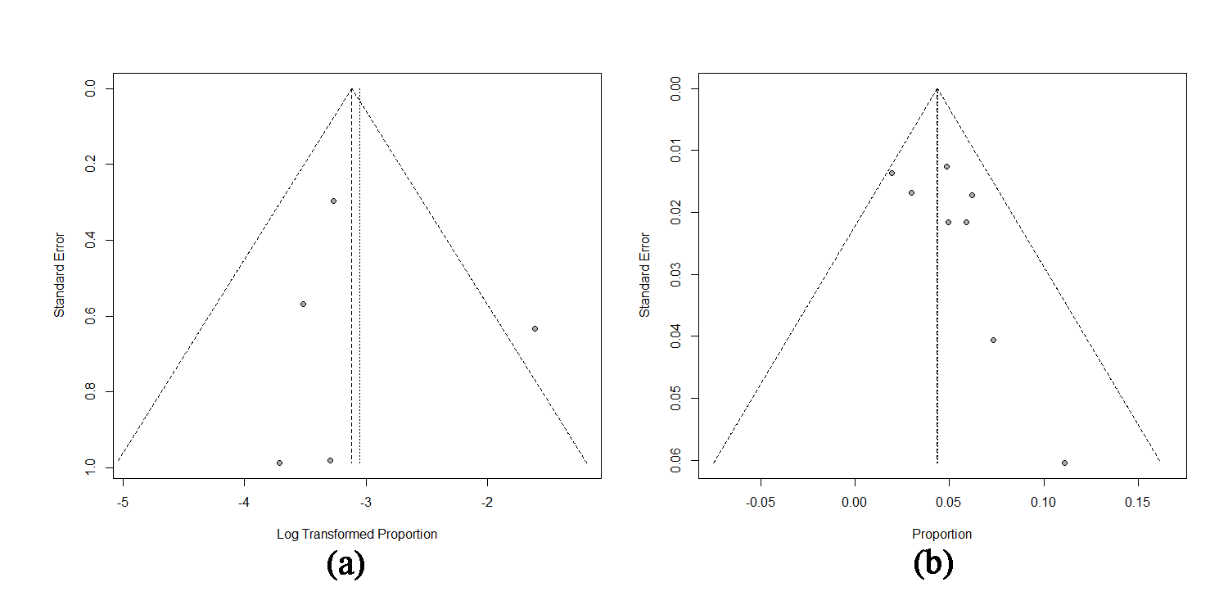
Figure S1. The funnel plots of TLR outcomes.
(a) TLR at 6-month followed up; (b) TLR at 1-year followed up.

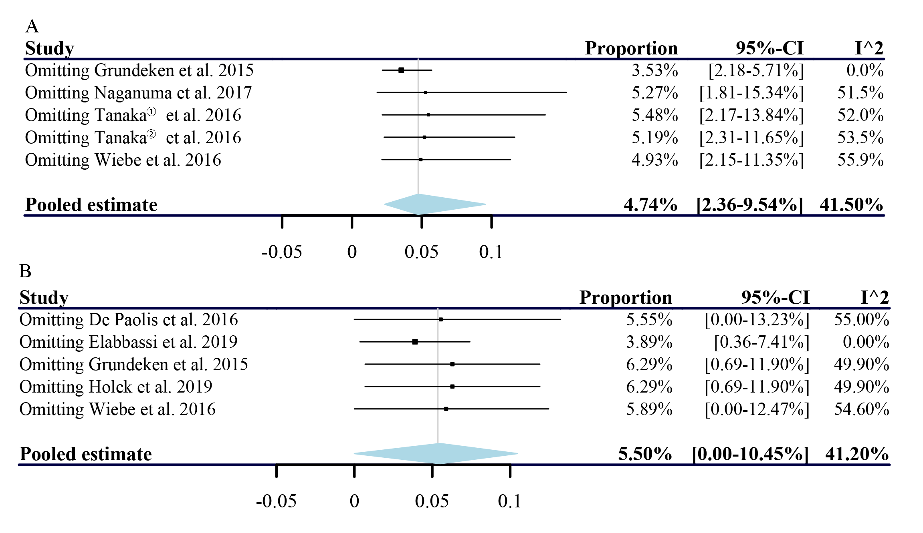
Figure S2. Sensitivity analysis of TLR (A) and MACE (B) at 6-month follow-up.

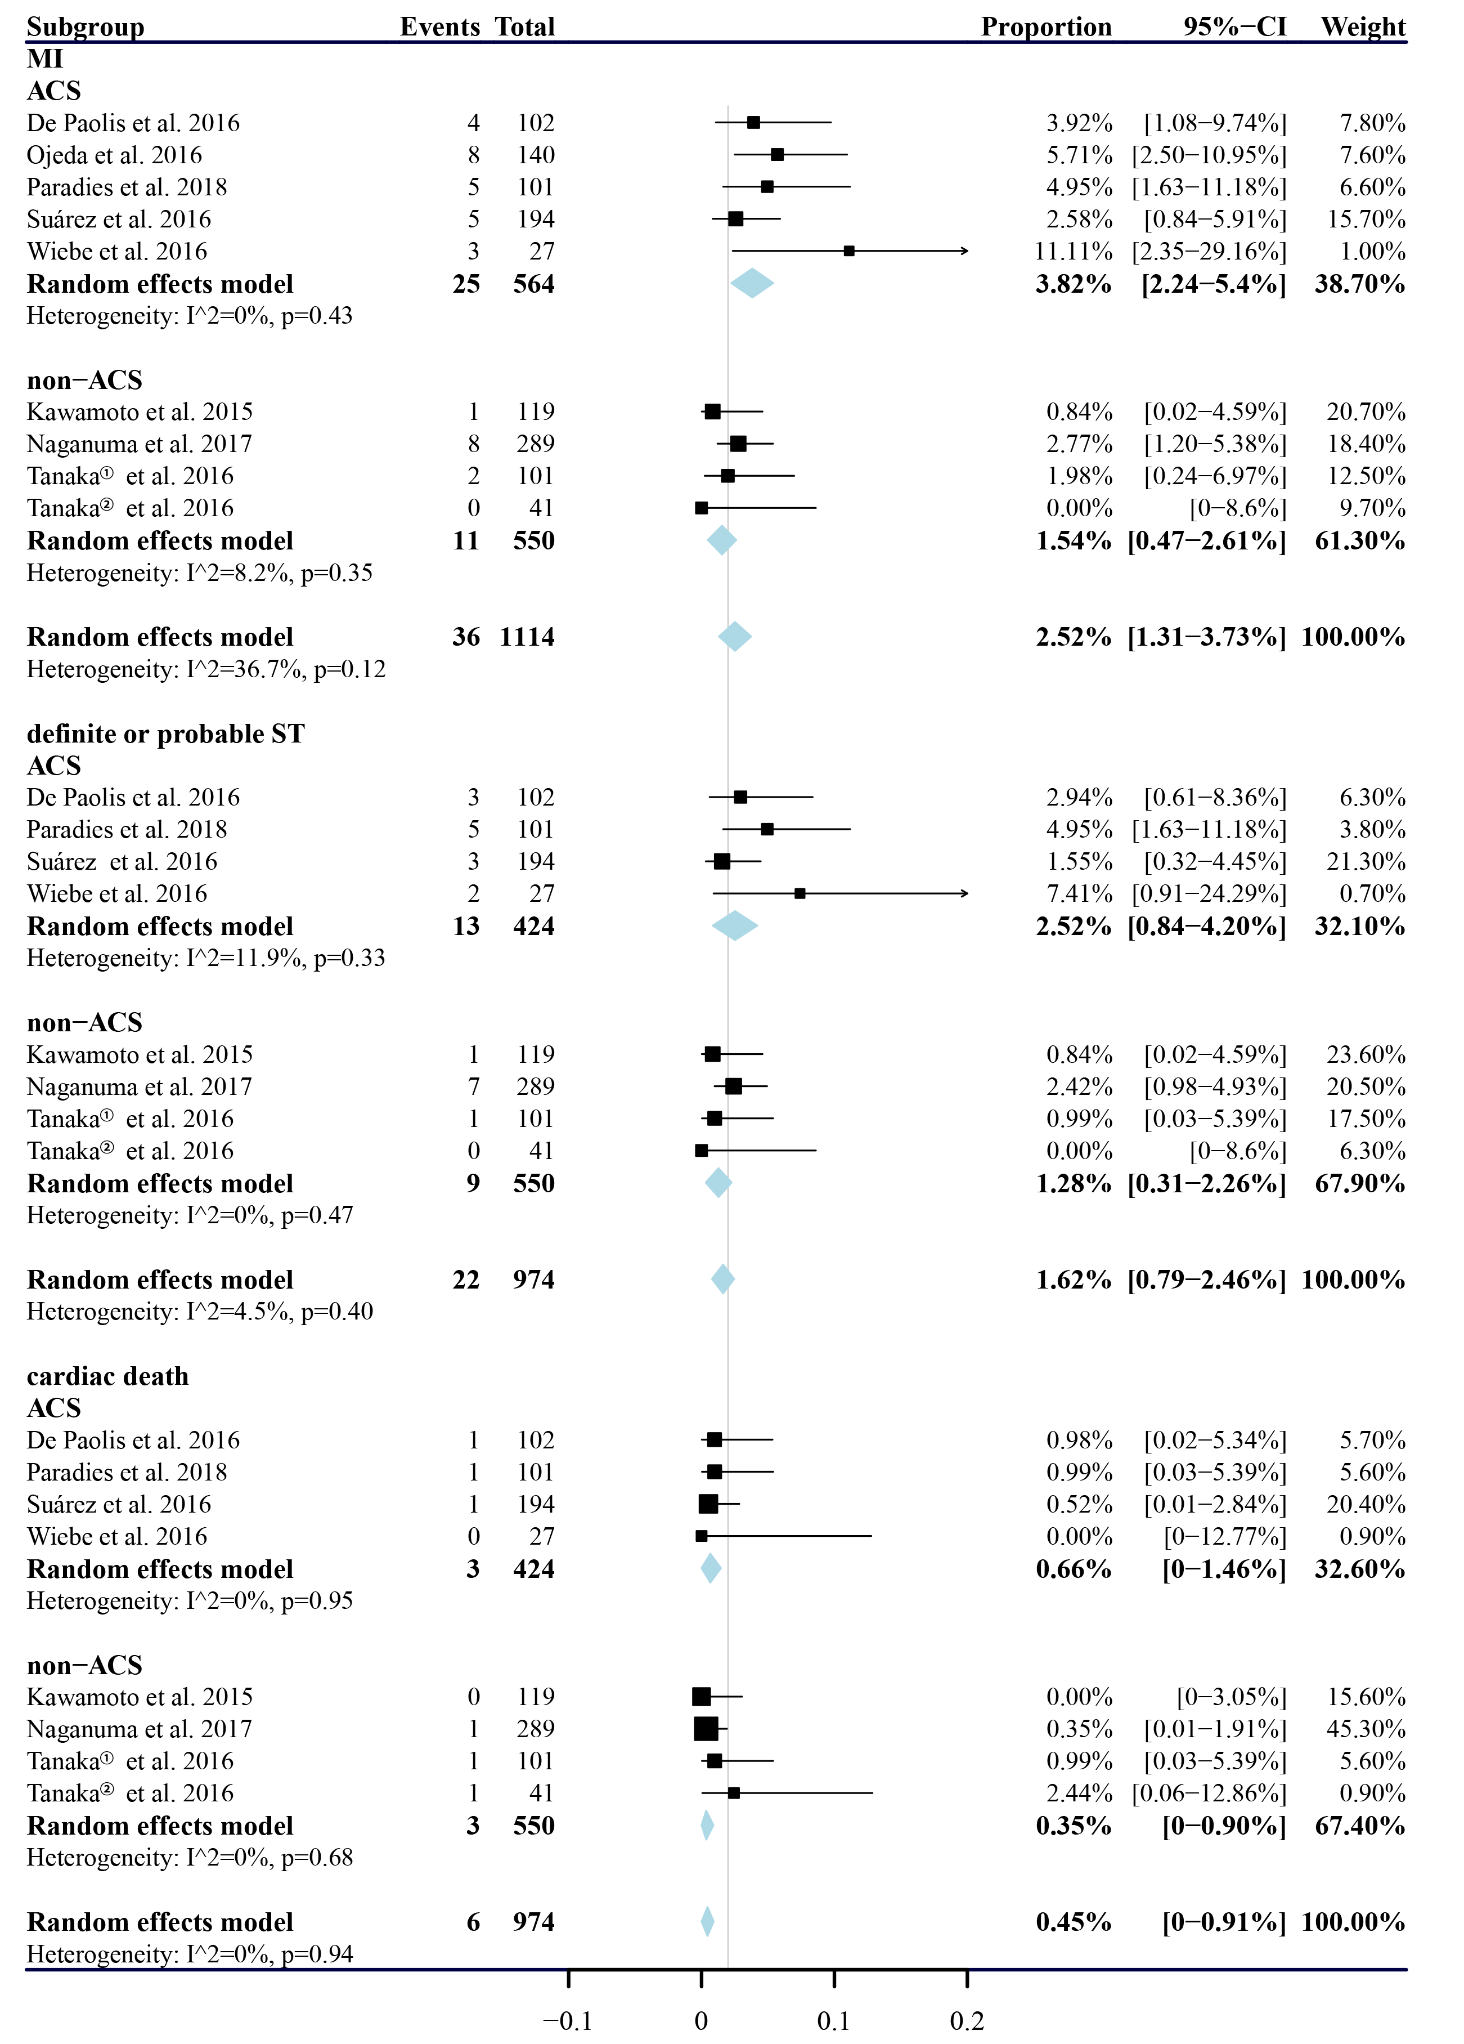
Figure S3. ACS subgroup analysis for MI, definite or probable ST and cardiac death at 1-year follow-up.

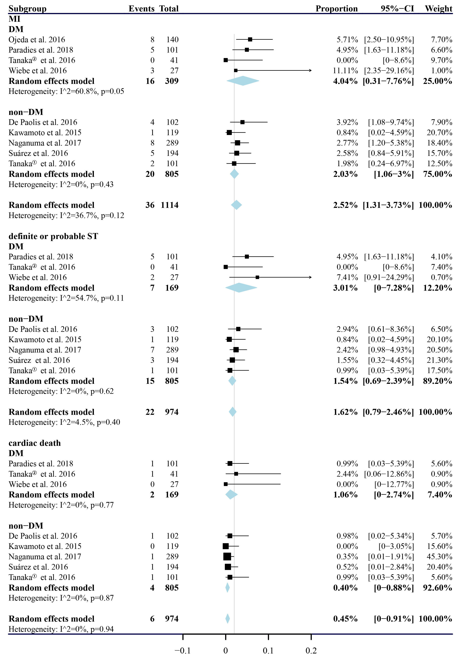
Figure S4. DM subgroup analysis for MI, definite or probable ST and cardiac death at 1-year follow-up.
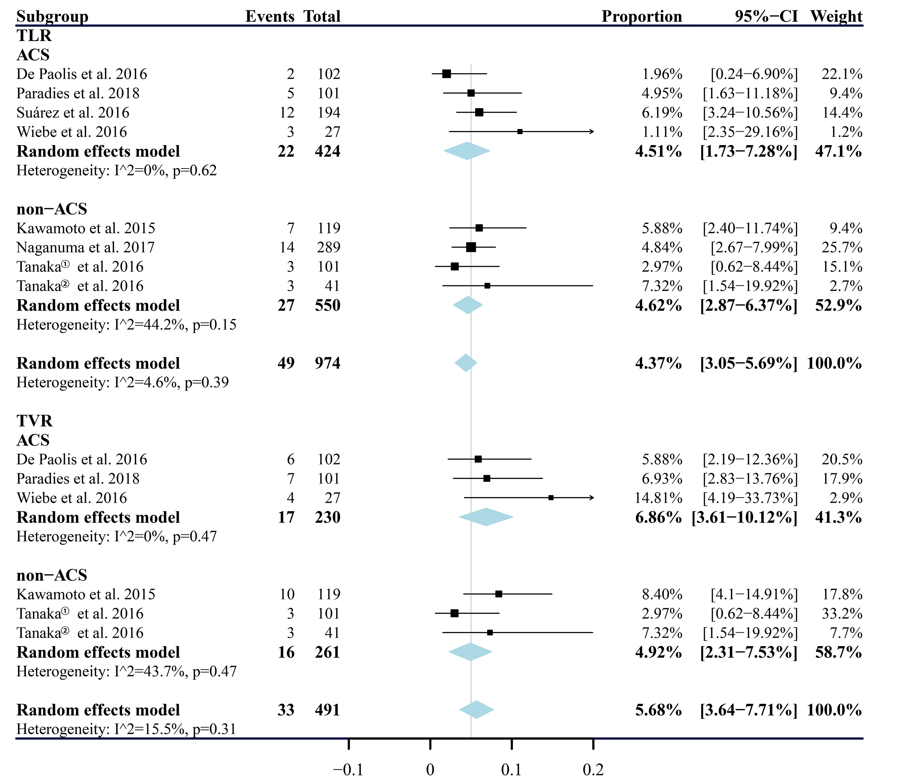
Figure S5. ACS subgroup analysis for TLR and TVR at 1-year follow-up.
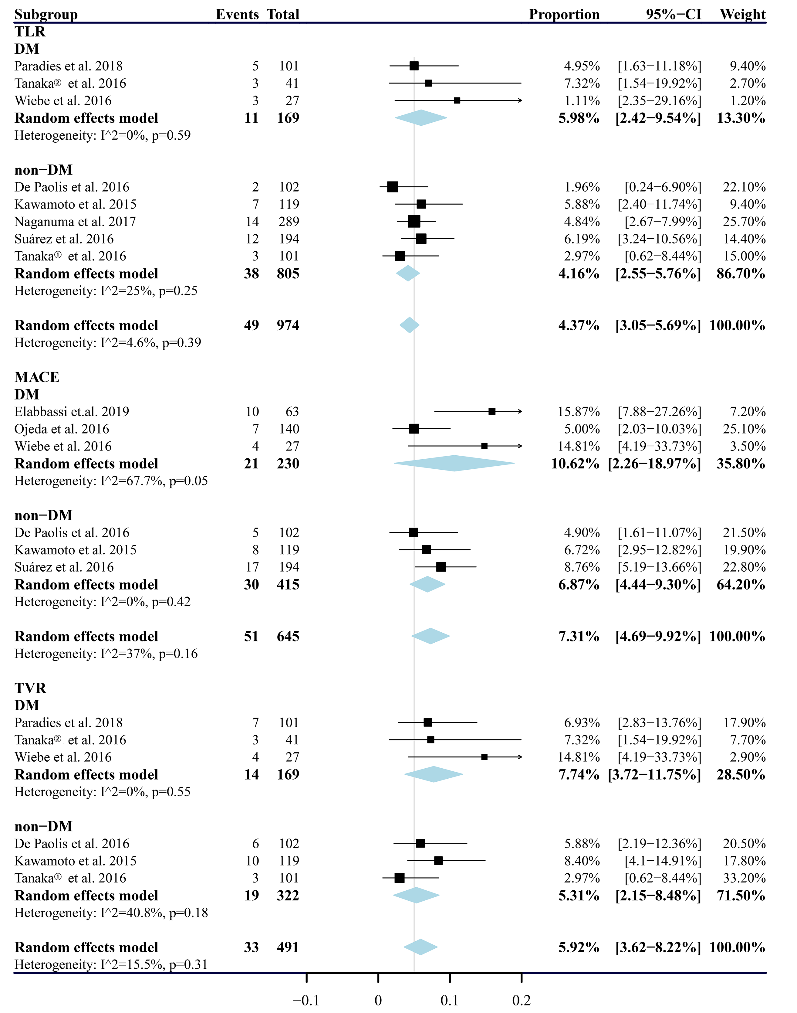
Figure S6. DM subgroup analysis for TLR, MACE and TVR at 1-year follow-up.

