SUPPLEMENTAL MATERIALS

Figure S1: Association between lymphocyte count and adjusted hazard ratio for mortality based on restricted cubic spline model, according to coronary presentation

Figure S2: Survival probability according to lymphocyte count and red cell distribution width

Figure S1: Association between lymphocyte count and adjusted hazard ratio for mortality based on restricted cubic spline model, according to coronary presentation

ACS, acute coronary syndrome; HR, hazard ratio; NSTEMI, non-ST segment elevation myocardial infarction; STEMI, ST segment elevation myocardial infarction; UAP, unstable angina pectoris

Figure S2: Survival probability according to lymphocyte count and red cell distribution width

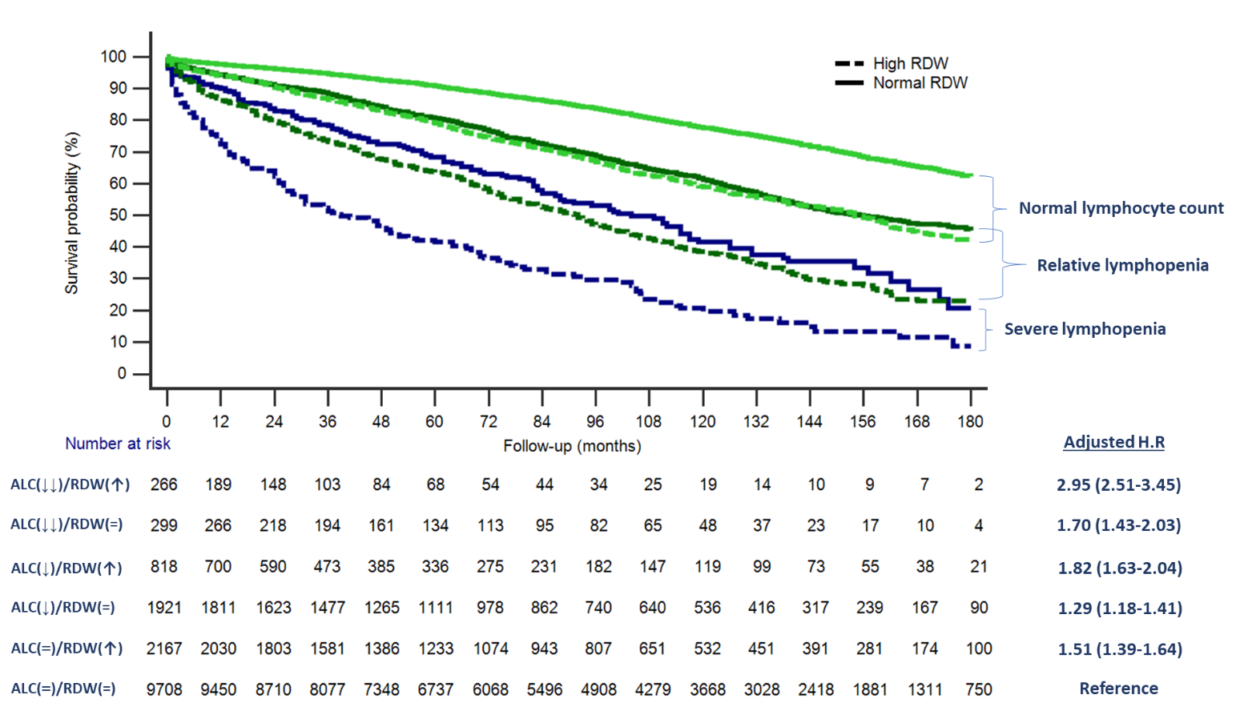

Normal lymphocyte count > 1500 /μL ; Relative lymphopenia 1000-1500 /μL ; Severe lymphopenia <1000 /μL
ALC, absolute lymphocyte count; HR, hazard ratio; RDW, red cell distribution width: High >14.5%; Normal ≤14.5%
Adjusted for age, gender, ethnicity, hypertension, hyperlipidemia, smoking, diabetes, chronic kidney disease, obesity, cancer, COPD, heart failure, PVD, previous myocardial infarction, acute coronary syndrome.

