SUPPLEMENTARY FIGURES
Supplementary Figure S1. Safety end points associated with the use of GLP-1 agonists. RRs for gastrointestinal events, pancreatitis, pancreatic cancer, and retinopathy.
Supplementary Figure S2. Safety end points associated with the use of SGLT-2 inhibitors. RRs for genital infection, urinary tract infection, amputation, bone fracture, and diabetic ketoacidosis.
Supplementary Figure S3. HRs for composite of cardiovascular death, non-fatal MI, or non-fatal stroke stratified by classes of GLP-1 agonists.

Supplementary Figure S1. Safety end points associated with the use of GLP-1 agonists. RRs for gastrointestinal events, pancreatitis, pancreatic cancer, and retinopathy.

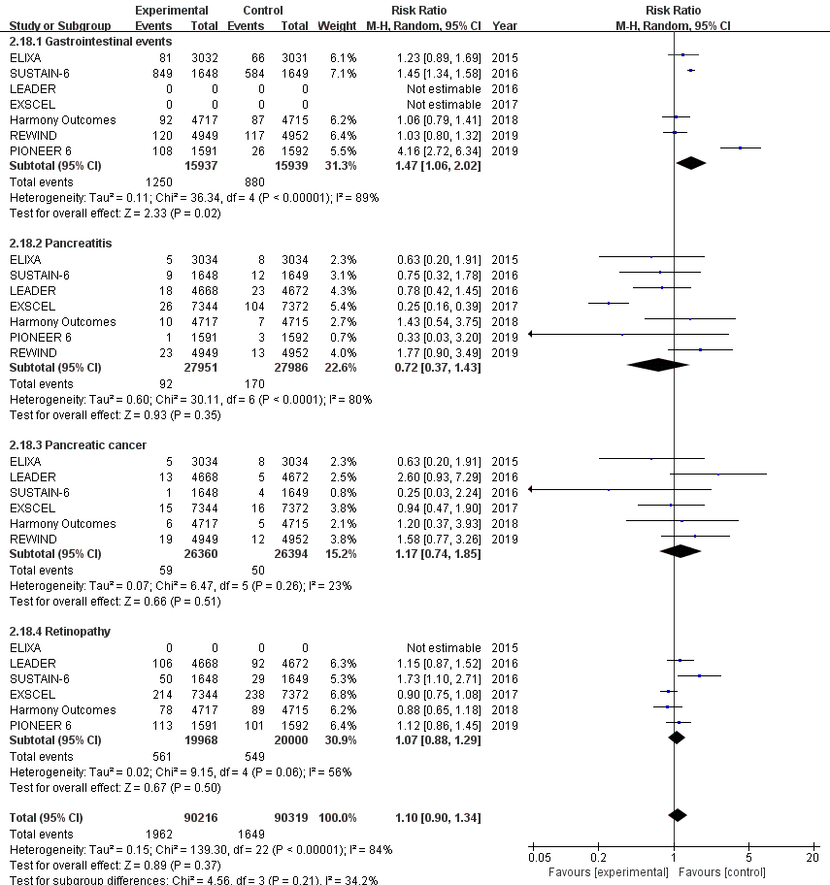

Supplementary Figure S2. Safety end points associated with the use of SGLT-2 inhibitors. RRs for genital infection, urinary tract infection, amputation, bone fracture, and diabetic ketoacidosis.

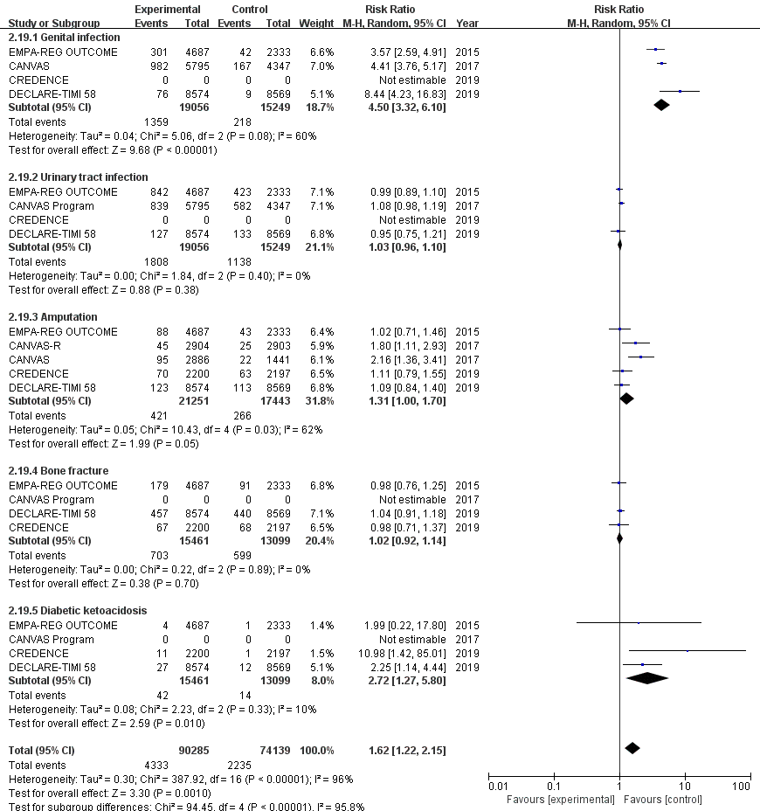
Supplementary Figure S3. HRs for composite of cardiovascular death, non-fatal MI, or non-fatal stroke stratified by classes of GLP-1 agonists.
