EFFICACY AND SAFETY OF HYPERTONIC SALINE SOLUTIONS FLUID RESUSCITATION ON HYPOVOLEMIC SHOCK: A SYSTEMATIC REVIEW AND META-ANALYSIS OF RANDOMIZED CONTROLLED TRIALS

Supplementary Digital File 1

Characteristics of included studies including inclusion and exclusion criteria 2
Adverse events while using hypertonic saline/dextran solutions versus isotonic fluid solutions 5
Adverse events while using hypertonic saline solutions versus isotonic fluid solutions 6
Blood laboratory parameters characteristics while using hypertonic fluid solutions versus isotonic fluid solutions 7
Systolic Blood Pressure while using hypertonic fluid solutions versus isotonic fluid solutions 8
Evaluation of bias in all included studies across the various domains. Green, red, and yellow circles indicate low, high, and unclear risk of bias, respectively 9
Summary of the risk of bias among the included studies 10
PRISMA checklist 11

Characteristics of included studies including inclusion and exclusion criteria

Study | Inclusion criteria | Exclusion criteria | Primary outcome | 28- to 30-days survival
 |  |  |  | Hypertonic group | Control group | Odds Ratio (95% CI)
Alpar et al. 2004 | Patients admitted to the major injuries unit | NS | Hemodynamic measurements and urine output | NS | NS | NS
Bulger et al. 2008 | Blunt trauma, age older than 17 years (or adult size if age was unknown), at least 1 prehospital SBP measurement less than or equal to 90 mm Hg, and being transported directly to a single level I trauma center from the site of injury | Ongoing cardiopulmonary resuscitation, isolated penetrating trauma, known or suspected pregnancy, and receipt of more than 2000 mL of crystalloid before availability of study fluid | The incidence of ARDS within 28 days after injury | 78 (70.9) | 77 (77.8) | 0.70 (0.37, 2.30)
Bulger et al. 2011 | 15 years or older and had out-of-hospital systolic blood pressure (SBP) 70 mm Hg or less or 71 to 90 mm Hg with a concomitant heart rate (HR) 108 beats or less per minute | Known or suspected pregnancy, age less than 15 years, out-of-hospital cardiopulmonary resuscitation, administration of more than 2000 mL crystalloid, colloid, or blood products before enrollment, severe hypothermia (<28◦C), drowning or asphyxia due to hanging, burns more than 20% total body surface area, isolated penetrating head injury, inability to obtain intravenous access, time of dispatch call received to study intervention more than 4 hours, and known prisoners, Interfacility transfers patients. | 28-day survival rate | 351 (73.3) | 279 (74.2) | 1.02 (0.70, 1.49)
Cooper et al. 2004 | Trauma patients with: coma due to blunt head trauma, a Glasgow Coma Scale (GCS) score17 of less than 9 (range, 3-15), and hypotension (SBP <100 mm Hg) including multisystem trauma | Patients with penetrating trauma, younger than 18 years, were pregnant, had no intravenous access, had a serious pre- morbid disease on a medical identification bracelet, had peripheral edema, were in close proximity to receiving hospital (scoop and run), had absent sinus rhythm, or cardiac arrest. | Neurological function at 6 months, measured by the ex- tended Glasgow Outcome Score (GOSE). | 63 (55.3) | 57 (49.6) | 1.26 (0.75, 2.11)
DuBose et al. 2010 | Trauma ICU patients receiving 5% HTS within 1 hour of admission to the hospital | NS | NS | NS | NS | NS
Holcroft et al. 1987 | SBP of 70mmHg or les, or who had required resuscitative solutions in volumes exceeding 6 liters were considered for inclusion if they: (1) were 18 years of age or older; (2) had been injured no longer than 6 hours previously; (3) had received at least 2 units of blood; (4) had received at least 15 mL/kg of crystalloid solutions during the previous hour; and (5) were likely to require at least 15mL/kg for the next hour to maintain blood pressure and urine output | NS | 1-day survival, Improved SBP | NS | NS | NS
Holcroft et al. 1989 | Hypotensive trauma patients in ED (SBP < 80) | NS | 30-day survival | 20(68.9) | 12 (38.7) | 3.52 (1.21, 10.24)
Mattox et al. 1991 | (1)16years of age or older, (2) victim of penetrating or blunt trauma with in the last hour before randomization, and (3) initial field systolic blood pressure of 90 mmHg or less | (1) initial trauma score equal or less than 2, (2) revised trauma score equal or less than 1, (3) pregnancy, (4) history of seizures, coagulopathy, liver or renal disease, or (5) patients in whom medical antishock trousers were applied. | Survival at 24 hours and 30 days | NS | NS | NS
Morrison et al. 2011 | Age ≥ 16; Initial assessment of Glasgow Coma Scale ≤ 8; Blunt traumatic mechanism of injury | Known pregnancy; Primary injury penetrating; Vital signs absent before randomization; Previous intravenous therapy ≥ 50 mL; Time interval between arrival at scene and intravenous access exceeds 4 h; Amputation above wrist or ankle; Any burn (thermal, chemical, electrical, radiation); Suspected environmental hypothermia; Asphyxia (strangulation, hanging, choking, suffocation, drowning); Fall from height ≤ 1 m or ≤ 5 stairs | survival at 30 days | 35 (70.0) | 42 (73.7) | 0.83 (0.36, 1.94)
Rizoli et al. 2006 | Patients with sustained blunt trauma, were 16 years of age or older, had at least one recorded episode of hypotension (systolic blood pressure ≤90 mm Hg) with clear evidence of blood loss (external or internal including thorax, abdomen, or retroperitoneum | Refused to participate, were admitted ≥6 hours after injury, were without vital signs, pregnant, or had stigmata of chronic disease | Changes in immune/inflammatory markers, including neutrophil activation, monocyte subset redistribution, cytokine production, and neuroendocrine changes | NS | NS | NS
Vassar et al. 1991 | (1) SBP of 100 mmHg or less (at any time before arriving in the hospital’s emergency department), (2) palpable peripheral pulse or sinus complex on electrocardiography, (3) age 18 years or older | Pregnant or chronically debilitated with severe hepatic, renal, cardiac, or neurologic disease, as indicated by Medic Alert tags or by physical findings, such as peripheral edema | Survival rate | NS | NS | NS
Vassar et al. 1993 (1) | Trauma patient with SBP fell to 90mmHg or less at any time during transport. | Were asytstolic or were undergoing CPR; lacked a sinus complex on electrocardiogram; appeared to be less than 18 years of age; were seen more than 2 hours from the time of injury; were pregnant; were known to have a history seizures or a bleeding disorder; appeared to have pre-existing hepatic, cardiac or renal disease, as indicated by ascites or peripheral edema; were injured as a result of burn; had a blood pressure of more than 90mmHf by the time that IV access was established; or lacked of IV access. | Survival rate | NS | NS | NS
Vassar et al. 1993 (2) | Trauma patients with SBP less than 90 mmHg | Patients undergoing CPR, SBP of 90mmHg or more, >2hours from injury when infusion started, vital signs when infusion started not recorded, <200mL of test solution administrated | Survival rate | NS | NS | NS
Younes et al. 1992 | Age > 18 years, admitted with hemorrhagic hypovolemia (SBP<80mmHg) with a palpable pulse or positive electrocardiogram, nonpregnant, and with no previous history of cardiac or metabolic diseases. | Not meet inclusion criteria | Mean arterial pressure | NS | NS | NS
Younes et al. 2002 | Patients treated for hemorrhagic hypovolemia and required blood volume expansion | Patients under the age of 16 years, pregnant, or had cardiac or renal failure prior to their acute hemorrhagic episode or arrived with cardiac arrest (absence of palpable pulse or electrical activity on EKG). | Survival rate
Legend: ICU = Intensive Care Unit; ED = Emergency Department; NS = Not specified; SBP = Systolic blood pressure; CPR = Cardiopulmonary resuscitation;

Adverse events while using hypertonic saline/dextran solutions versus isotonic fluid solutions

Type of adverse event | Number of trials | Total numer of patients | Percentage of adverse event |  | OR (95%CI) | P value | I², statistic, %
 |  |  | HSD | NS
Nosocomial inections
Pneumonia | 2 | 568 | 0.7% | 1.1% | 0.65 (0.13, 3.34) | 0.61 | 0%
ARDS | 1 | 422 | 0.0% | 0.9% | 0.20 (0.01, 4.15) | 0.30 | -
Blood stream infection | 2 | 805 | 6.7% | 6.1% | 1.14 (0.64, 2.02) | 0.67 | 0%
Urinary tract infection | 2 | 805 | 6.4% | 7.8% | 0.88 (0.50, 1.53) | 0.65 | 47%
Wound infection | 2 | 805 | 6.1% | 4.0% | 1.44 (0.75, 2.76) | 0.28 | 0%
Intra-abdominal abcess | 2 | 631 | 1.6% | 0.3% | 3.49 (0.57, 21.54) | 0.18 | 11%
Sinustis | 1 | 209 | 1.0% | 0.0% | 2.73 (0.11, 67.69) | 0.54 | -
Pseudomembranous colitis | 1 | 209 | 1.0% | 0.0% | 2.73 (0.11, 67.69) | 0.54 | -
Line infection | 1 | 209 | 1.0% | 0.0% | 2.73 (0.11, 67.69) | 0.54 | -
Sepsis | 1 | 422 | 0.0% | 1.4% | 0.14 (0.01, 2.74) | 0.20 | -
Other | 1 | 209 | 1.0% | 0.0% | 2.73 (0.11, 67.69) | 0.54 | -
One or more nosocomial infections | 2 | 805 | 21.8% | 21.9% | 1.05 (0.74, 1.48) | 0.79 | 0%
Noninfectious complications
Acute renal failure | 2 | 568 | 0.7% | 1.1% | 0.65 (0.13, 3.34) | 0.61 | 0%
Abdominal compartment syndrome | 1 | 209 | 3.6% | 8.1% | 0.43 (0.13, 1.47) | 0.18 | -
Cardiac arrest | 2 | 568 | 1.0% | 1.5% | 0.71 (0.17, 2.88) | 0.63 | 2%
Myocardial infarction | 2 | 568 | 0.7% | 1.1% | 0.65 (0.13, 3.34) | 0.61 | 0%
Cerebral infarction | 1 | 209 | 0.9% | 0.0% | 2.73 (0.11, 67.69) | 0.54 | -
Dead bowel | 1 | 359 | 0.0% | 0.6% | 0.32 (0.01, 7.79) | 0.48 | -
Deep vein thrombolysis | 1 | 209 | 0.9% | 7.0% | 0.12 (0.01, 1.00) | 0.05 | -
Pulmonary embolism | 2 | 568 | 0.3% | 1.1% | 0.39 (0.06, 2.70) | 0.34 | 0%
Coagulopathy | 1 | 359 | 0.9% | 0.0% | 2.73 (0.11, 67.69) | 0.54 | -
Legend: HSD = Hypertonic saline/dextran; NS = Normotonic/isotonic saline; OR = Odds Ratio; CI = Confidence interval

Adverse events while using hypertonic saline solutions versus isotonic fluid solutions

Type of adverse event | Number of trials | Total numer of patients | Percentage of adverse event |  | OR (95%CI) | P value | I², statistic, %
 |  |  | HS | NS
Nosocomial inections
Pneumonia | 2 | 844 | 12.6% | 12.7% | 1.03 (0.68, 1.56) | 0.88 | 0%
ARDS | NR | NR | NR | NR
Blood stream infection | 1 | 632 | 7.8% | 6.4% | 1.24 (0.67, 2.30) | 0.49 | -
Urinary tract infection | 1 | 632 | 5.9% | 7.7% | 0.74 (0.39, 1.42) | 0.37 | -
Wound infection | 1 | 632 | 5.5% | 3.5% | 1.62 (0.75, 3.50) | 0.22 | -
Intra-abdominal abcess | NR | NR | NR | NR | - | - | -
Sinustis | NR | NR | NR | NR | - | - | -
Pseudomembranous colitis | NR | NR | NR | NR | - | - | -
Line infection | NR | NR | NR | NR | - | - | -
Sepsis | NR | NR | NR | NR | - | - | -
Other | 1 | 212 | 6.9% | 5.4% | 1.30 (0.42, 4.02) | 0.64 | -
One or more nosocomial infections | 1 | 632 | 24.6% | 23.7% | 2.05 (0.73, 1.53) | 0.79 | -
Noninfectious complications
Acute renal failure | 1 | 212 | 1.0% | 2.7% | 0.36 (0.04, 3.52) | 0.38 | -
Abdominal compartment syndrome | NR | NR | NR | NR | - | - | -
Cardiac arrest | NR | NR | NR | NR | - | - | -
Myocardial infarction | 1 | 212 | 1.98% | 4.5% | 0.43 (0.08, 2.26) | 0.32 | -
Cerebral infarction | 1 | 212 | 7.9% | 5.4% | 1.51 (0.50, 4.50) | 0.46 | -
Dead bowel | NR | NR | NR | NR | - | - | -
Legend: HS = Hypertonic saline; NS = Normotonic/isotonic saline; OR = Odds Ratio; CI = Confidence interval; NR = Not reported

Blood laboratory parameters characteristics while using hypertonic fluid solutions versus isotonic fluid solutions

Type of laboratory parameter | Number of trials | Total numer of patients | MD (95%CI) | P value | I², statistic, %
Hematocrit  HSD  HS  Total | 4  2  5 | 998  176  1057 | -0.03 (-0.03, -0.02)  -0.01 (-0.03, 0.01)  -0.02 (-0.03, -0.01) | <0.001  0.24  <0.001 | 0%  0%  0%
Hemoglobin  HSD  HS  Total | 2  2  2 | 757  787  869 | -1.07 (-1.44, -0.70)  -0.65 (-1.0, -0.30)  -0.72 (-1.06, -0.38) | <0.001  <0.001  <0.001 | 0%  0%  0%
Serum sodium  HSD  HS  Total | 6  3  7 | 1532  722  1843 | 6.24 (4.06, 8.43)  5.73 (-0.82, 12.27)  6.38 (4.04, 8.71) | <0.001  0.09  <0.001 | 92%  97%  94%
INR  HSD  HS  Total | 2  1  2 | 805  632  1061 | 0.12 (-0.00, 0.25)  0.16 (-0.02, 0.34)  0.13 (0.02, 0.25) | 0.06  0.09  0.02 | 0%  -  0%
pH  HSD  HS  Total | 3  2  4 | 804  189  699 | 0.00 (-0.02, 0.02)  0.05 (0.01, 0.08)  0.01 (-0.01, 0.03) | 0.78  0.004  0.37 | 40%  30%  67%
Platelet count  HSD  HS  Total | 2  1  2 | 382  169  467 | -21.25 (-37.35, -5.14)  -12.00 (-35.82, 11.82)  -17.48 (-32.60, -2.36) | 0.01  0.32  0.02 | 6%  -  0%
Prothrombin time  HSD  HS  Total | 2  1  2 | 363  169  448 | 0.14 (-0.70, 0.98)  0.00 (-2.39, 2.39)  0.33 (-0.51, 1.17) | 0.38  1.0  0.45 | 0%  -  0%
Legend: HSD = Hypertonic saline/dextran; HS = Hypertonic saline; MD = Mean difference; CI = Confidence interval

Systolic Blood Pressure while using hypertonic fluid solutions versus isotonic fluid solutions

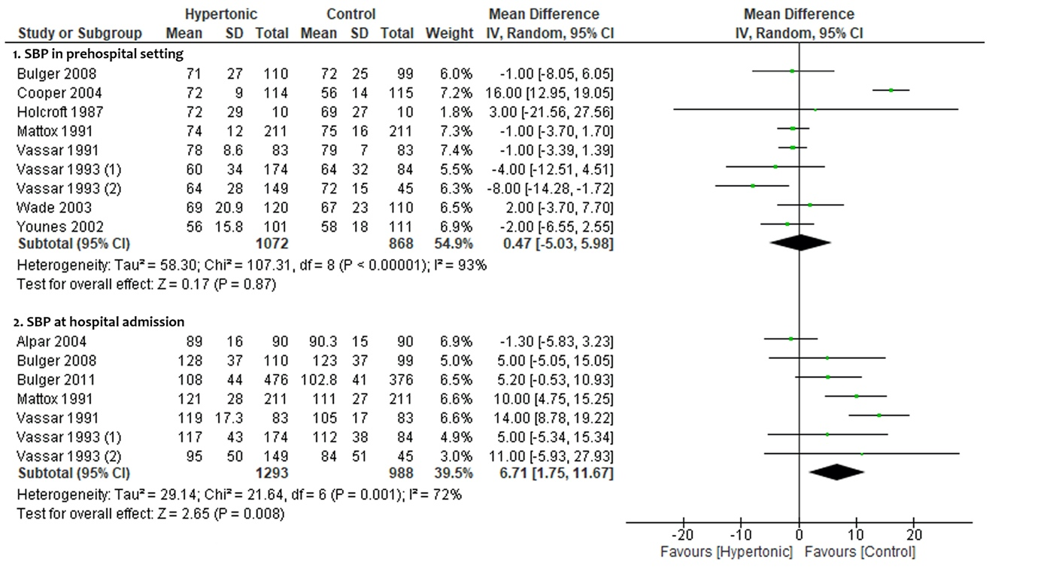

Evaluation of bias in all included studies across the various domains. Green, red, and yellow circles indicate low, high, and unclear risk of bias, respectively

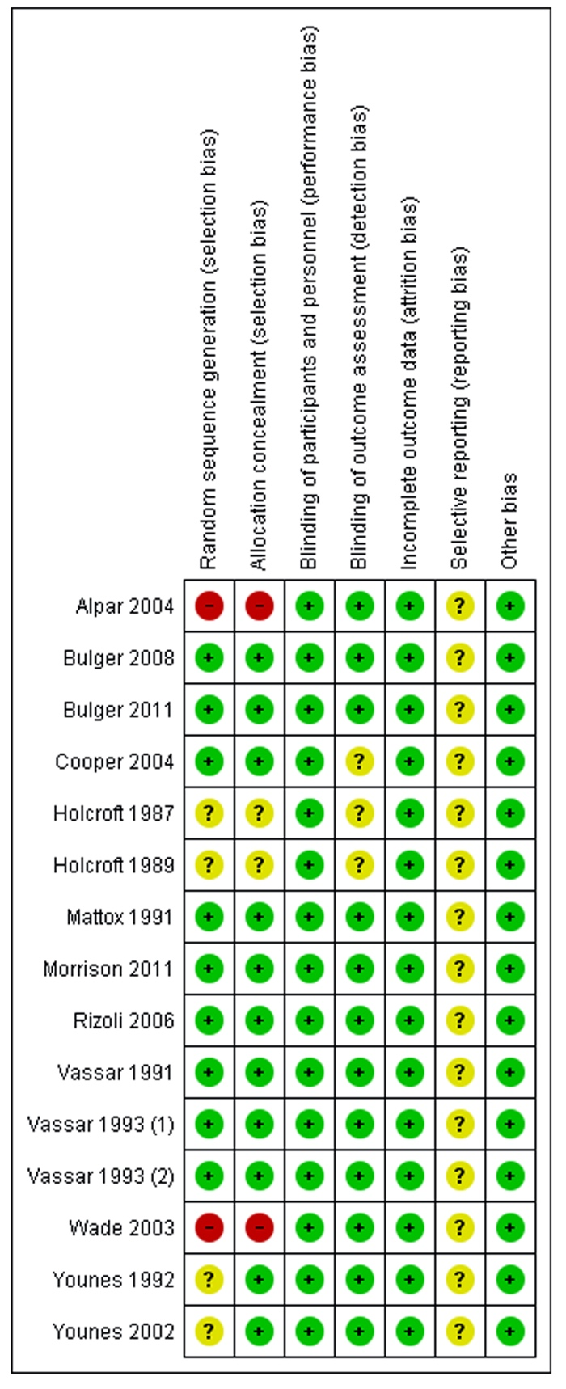

Summary of the risk of bias among the included studies

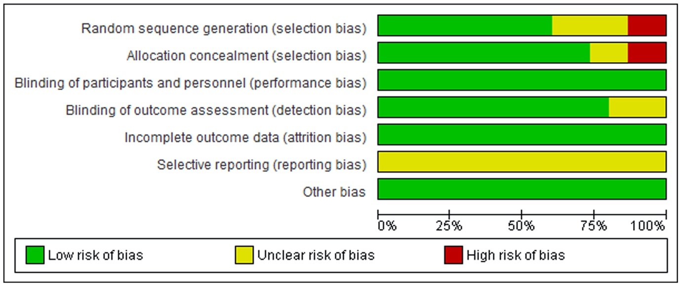

PRISMA checklist

Section/topic | # | Checklist item | Reported on page #
TITLE
Title | 1 | Identify the report as a systematic review, meta-analysis, or both. | 1
ABSTRACT
Structured summary | 2 | Provide a structured summary including, as applicable: background; objectives; data sources; study eligibility criteria, participants, and interventions; study appraisal and synthesis methods; results; limitations; conclusions and implications of key findings; systematic review registration number. | 2
INTRODUCTION
Rationale | 3 | Describe the rationale for the review in the context of what is already known. | 3
Objectives | 4 | Provide an explicit statement of questions being addressed with reference to participants, interventions, comparisons, outcomes, and study design (PICOS). | 4
METHODS
Protocol and registration | 5 | Indicate if a review protocol exists, if and where it can be accessed (e.g., Web address), and, if available, provide registration information including registration number. | 4
Eligibility criteria | 6 | Specify study characteristics (e.g., PICOS, length of follow-up) and report characteristics (e.g., years considered, language, publication status) used as criteria for eligibility, giving rationale. | 4,5
Information sources | 7 | Describe all information sources (e.g., databases with dates of coverage, contact with study authors to identify additional studies) in the search and date last searched. | 4,5
Search | 8 | Present full electronic search strategy for at least one database, including any limits used, such that it could be repeated. | 4,5
Study selection | 9 | State the process for selecting studies (i.e., screening, eligibility, included in systematic review, and, if applicable, included in the meta-analysis). | 5
Data collection process | 10 | Describe method of data extraction from reports (e.g., piloted forms, independently, in duplicate) and any processes for obtaining and confirming data from investigators. | 5,6
Data items | 11 | List and define all variables for which data were sought (e.g., PICOS, funding sources) and any assumptions and simplifications made. | 5,6
Risk of bias in individual studies | 12 | Describe methods used for assessing risk of bias of individual studies (including specification of whether this was done at the study or outcome level), and how this information is to be used in any data synthesis. | 6
Summary measures | 13 | State the principal summary measures (e.g., risk ratio, difference in means). | 6
Synthesis of results | 14 | Describe the methods of handling data and combining results of studies, if done, including measures of consistency (e.g., I²) for each meta-analysis. | 6

Risk of bias across studies | 15 | Specify any assessment of risk of bias that may affect the cumulative evidence (e.g., publication bias, selective reporting within studies). | 6
Additional analyses | 16 | Describe methods of additional analyses (e.g., sensitivity or subgroup analyses, meta-regression), if done, indicating which were pre-specified. | 6,7
RESULTS
Study selection | 17 | Give numbers of studies screened, assessed for eligibility, and included in the review, with reasons for exclusions at each stage, ideally with a flow diagram. | 7
Study characteristics | 18 | For each study, present characteristics for which data were extracted (e.g., study size, PICOS, follow-up period) and provide the citations. | 7,8
Risk of bias within studies | 19 | Present data on risk of bias of each study and, if available, any outcome level assessment (see item 12). | 10
Results of individual studies | 20 | For all outcomes considered (benefits or harms), present, for each study: (a) simple summary data for each intervention group (b) effect estimates and confidence intervals, ideally with a forest plot. | 8,9
Synthesis of results | 21 | Present results of each meta-analysis done, including confidence intervals and measures of consistency. | 8,9
Risk of bias across studies | 22 | Present results of any assessment of risk of bias across studies (see Item 15). | 10
Additional analysis | 23 | Give results of additional analyses, if done (e.g., sensitivity or subgroup analyses, meta-regression [see Item 16]). | 9
DISCUSSION
Summary of evidence | 24 | Summarize the main findings including the strength of evidence for each main outcome; consider their relevance to key groups (e.g., healthcare providers, users, and policy makers). | 10
Limitations | 25 | Discuss limitations at study and outcome level (e.g., risk of bias), and at review-level (e.g., incomplete retrieval of identified research, reporting bias). | 11,12
Conclusions | 26 | Provide a general interpretation of the results in the context of other evidence, and implications for future research. | 12
FUNDING
Funding | 27 | Describe sources of funding for the systematic review and other support (e.g., supply of data); role of funders for the systematic review. | 12

