Supplementary appendix

Long-term follow-up after CRT-optimization in a real world setting: A single-center cohort study
Raphael Korach¹, Peter C. Kahr¹, Frank Ruschitzka¹,
Jan Steffel¹, Andreas J. Flammer¹*, Stephan Winnik¹*

¹ University Heart Center, Cardiology, University Hospital Zurich, Zurich, Switzerland
*Equal contribution

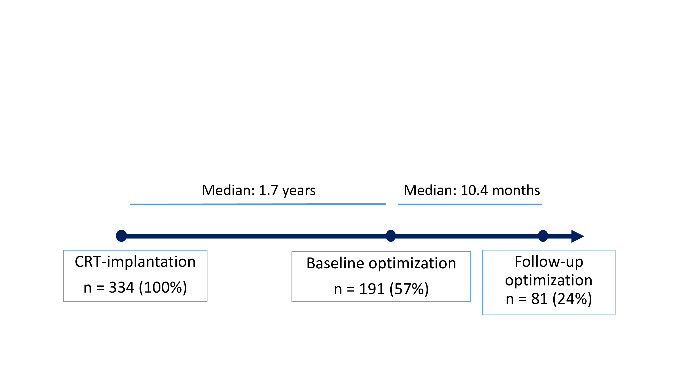
Supplementary figure 1: Flow-chart of patients with echocardiography and 12-lead ECG based optimization after CRT-implantation and consecutive follow-up visit.

Supplementary table 1.
 | Control group (n=16) | Intervention group (n=59) | p-value
Biventricular pacing (%)  (mean ± SD) | 94.5 ± 6.8 | 97.5 ± 4.0 | 0.022*
Biventricular pacing  0 – 90 %  90 – 95 %  95 – 97 %  > 97 % | 3/16 (19%)  1/16 (6%)  5/16 (31%)  7/16 (44%) | 3/59 (5%)  4/59 (7%)  6/59 (10%)  46/59 (78%) | 0.031*

Supplementary table 1. Biventricular pacing rate at follow-up after exclusion of 6 patients with atrial fibrillation and intact atrioventricular conduction.

