SUPPLEMENTARY MATERIALS

Table 1: Overall outcomes at five-year-FU

Figure 1: ROC curve: Independent predictors for secondary endpoint: Baseline creatinine, baseline MVG and baseline sPAP

Figure 2: Cox regression analysis: Combined independent baseline predictors for primary endpoint: Baseline sPAP>45 mmHg, baseline MVG>1,5mmHg and baseline creatinine>2mg/dl)

Figure 3: Kaplan-Meier curve: All-cause mortality in groups during the follow-up (sMR: secondary mitral regurgitation, pMR: primary mitral regurgitation)

Figure 4: Kaplan-Meier curve: Cumulative incidence of Re-dos in groups including surgical and interventional therapies (sMR: secondary mitral regurgitation, pMR: primary mitral regurgitation)

Table 1: Overall outcomes at five-year-FU
 | sMR | pMR | p-Value
MR≤II, % | 91 | 86.4 | 0.9
Functional NYHA class >II, % | 34.6 | 33.3 | 0.6
Mortality, % | 19 | 10 | 0.05
Interventional failure, % | 3.1 | 8.6 | 0.04
Re-Clipping, % | 6.8 | 4.7 | 0.1
Mitral valve surgery, % | 0.6 | 1.9 | 0.08
Other interventions, % | 1.8 | 0.9 | 0.2
MR: Mitral regurgitation; NYHA: New York Heart Association

Figure 1: ROC curve: Independent predictors for secondary endpoint

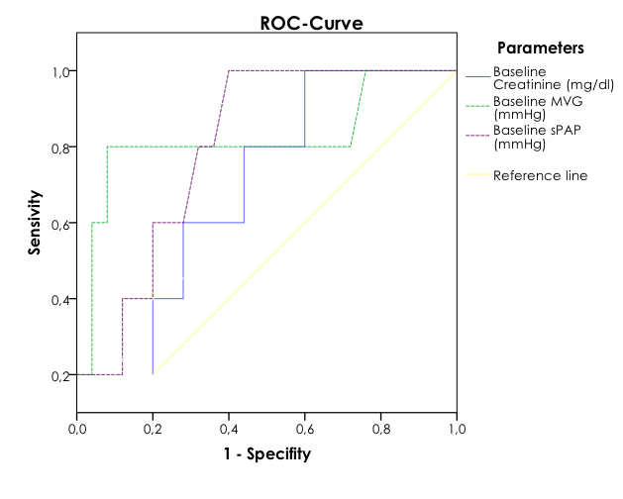

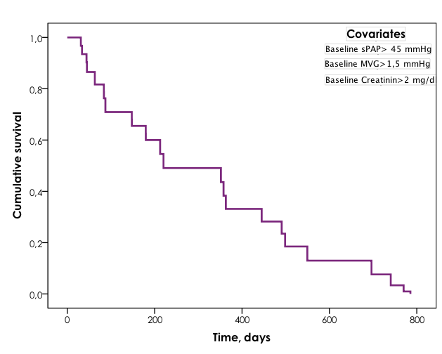
Figure 2: Cox regression analysis: Combined independent predictors for primary endpoint

Figure 3: Kaplan-Meier curve: All-cause mortality in groups during the follow-up (sMR: secondary mitral regurgitation, pMR: primary mitral regurgitation)

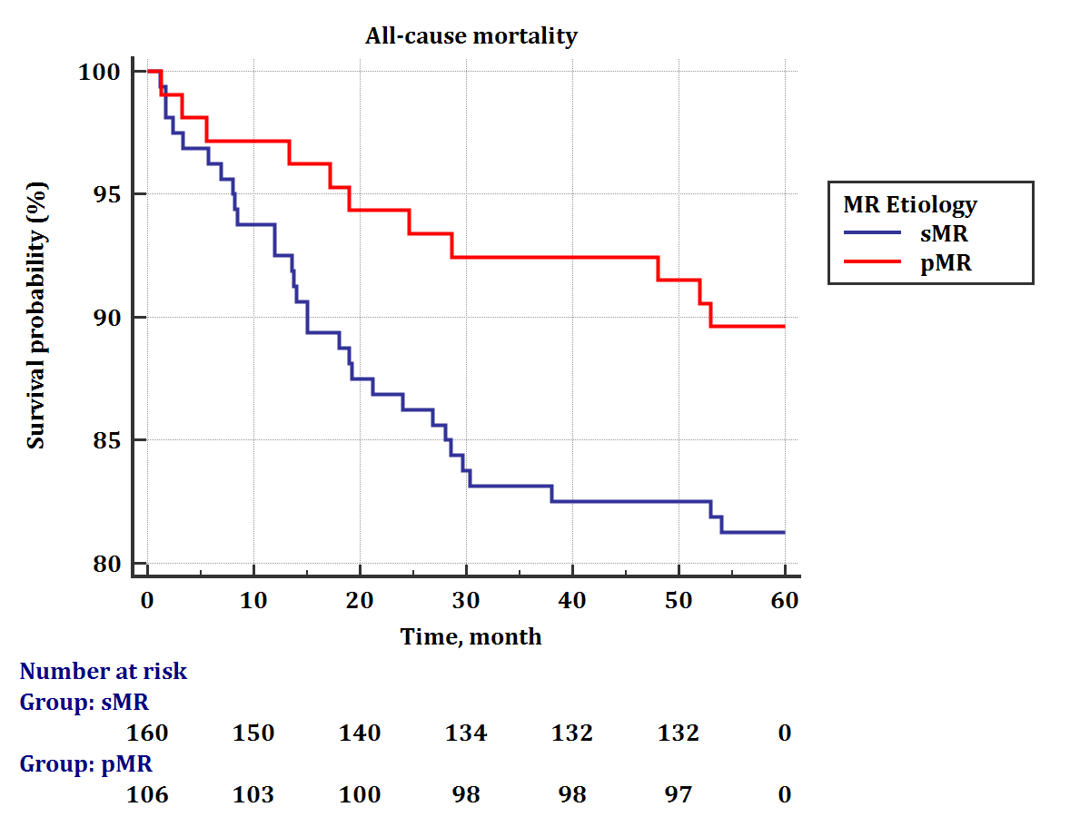

Figure 4: Kaplan-Meier curve: Cumulative incidence of Re-dos in groups including surgical and interventional therapies (sMR: secondary mitral regurgitation, pMR: primary mitral regurgitation)
