Supplementary material
Temporal evolution of liver function parameters predicts clinical outcome in chronic heart failure patients (Bio-SHiFT Study)
Dominika Klimczak-Tomaniak ^{a,b}, Karolina Andrzejczyk* ª, Sabrina Abou Kamar ª, Sara Baart^{c}, Nick van Bovenª, K. Martijn Akkerhuisª, Alina Constantinescuª, Kadir Caliskanª, Suat Simsek^{d}, Tjeerd Germans^{e,} Jan van Ramshorst^{e}, Jasper Brugtsª, Marek Kuch^{b}, Victor Umans^{e}, Eric Boersma PhDª, Isabella Kardys MD PhDª
- Department of Cardiology, Erasmus MC, University Medical Center Rotterdam, the Netherlands
- Department of Cardiology, Hypertension and Internal Medicine, Medical University of Warsaw, Warsaw, Poland
- Department of Biostatistics, Erasmus MC, University Medical Center Rotterdam, the Netherlands
- Department of Internal Medicine, Northwest Clinics, Alkmaar, the Netherlands
- Department of Cardiology, Northwest Clinics, Alkmaar, the Netherlands
* equal contribution

Corresponding author: Isabella Kardys, MD PhD; Erasmus MC, University Medical Center Rotterdam, Department of Cardiology, room NA-316, P.O. Box 2040, 3000 CA Rotterdam, the Netherlands; T +31650032051; E-mail i.kardys@erasmusmc.nl

Supplementary figures

Supplementary methods

Text S1. Definitions used for endpoints
We used the International Classification of Disease-10th revision (ICD-10), from the World Health Organization, to assign the fatal endpoints(1). Cardiac death was defined as death from MI or other ischemic heart disease (ICD-10: codes I20-I25), death from other heart disease including HF (codes I30-I45 and I47-I52), sudden cardiac death (code I46), sudden death undefined (code R96) or unwitnessed or ill-described death (codes R98, R99). Hospitalization for acute or worsened HF was defined as a hospitalization for an exacerbation of HF symptoms, in combination with two of the following: BNP or NT-proBNP > 3x upper limit of normal, signs of worsening HF, such as pulmonary rales, raised jugular venous pressure or peripheral oedema, increased dose or intravenous administration of diuretics, or administration of positive inotropic agents(2).

Text S2. Standard biomarker measurements
Plasma NT-proBNP was analyzed using an electrochemiluminescence immunoassay (lower limit of detection, LLD 5 ng/L, Elecsys 2010; Roche Diagnostics, Indianapolis, IN). Cardiac troponin T was also measured using an electrochemiluminescence immunoassay (LLD 3 ng/L, Elecsys 2010 immunoassay analyzer; Roche Diagnostics, Indianapolis, IN). CRP was analyzed using an immunoturbidimetric assay (LLD 0.3 mg/L, Roche Hitachi 912 chemistry analyzer; Roche, Basel, Switzerland). Creatinine was determined by a colorimetric test by the Jaffe’s reaction in undiluted plasma (LLD: 0,14 mg/dl). All coefficients of variation of these four biomarkers were below 5%.

Text S3. Power calculation and missing data
The current investigation comprised 250 patients, of whom 66 reached the primary end point. For baseline measurements, these numbers are sufficient to detect odds ratios around 2 for the upper quintile of a biomarker associated with the end point (α error .05, power of 80%) when comparing cases with noncases. For repeated measurements, power is further enhanced. Based on input parameters derived from the benchmark blood biomarker NT-proBNP, and using 500 simulations, we calculated that using 3 measurements per person, a difference in change of NT-proBNP level over time of 10 pmol/L per month can be demonstrated between cases and non-cases (α-error 0.05, power of 80%). This difference is very small in clinical terms, demonstrating that the study has high statistical power.
Data on all variables were complete, except for systolic blood pressure patients and chronic heart failure duration which were missing in <5%. These missing values were imputed using the patients’ clinical and outcome data.

Figure S1. Inclusion and exclusion criteria

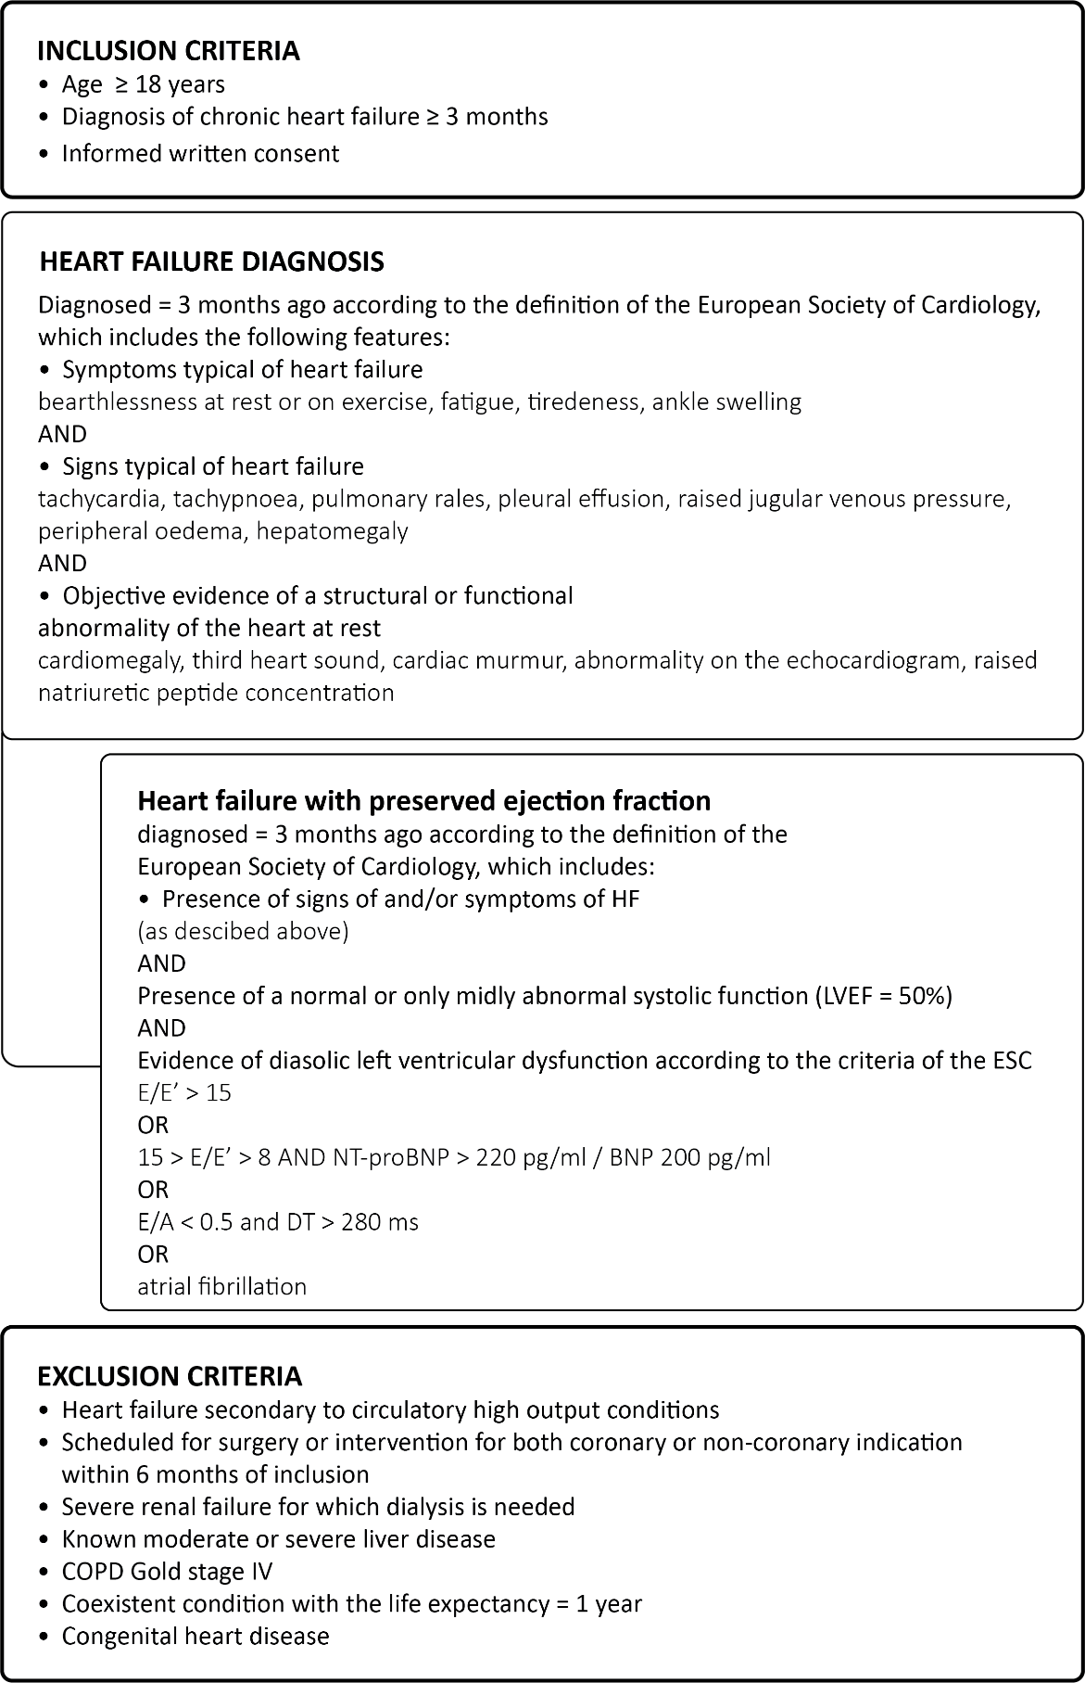

Supplementary Tables
Table S1. Univariable Cox model for the primary, composite endpoint.

Baseline variable | HR (95% CI) | P value
Age (per 10 years) | 1.23 (0.99; 1.52) | 0.054
Male gender | 1.38 (0.76; 2.49) | 0.28
NYHA class III or IV | 2.98 (1.83; 4.85) | <0.001
Duration of CHF | 1.06 (1.02; 1.10) | 0.001
DM | 1.85 (1.14; 3.00) | 0.013
AF | 1.50 (0.92; 2.43) | 0.098
SBP (per 10 mmHg) | 0.85 (0.75; 0.97) | 0.014
eGFR (per 20 ml/min/1.73 m²) | 0.84 (0.67; 1.05) | 0.135
NT-proBNP (per doubling) | 1.83 (1.55; 2.17) | <0.001
hs-TnT (per doubling) | 1.80 (1.50; 2.17) | <0.001

