Supplementary Appendix
Effect of delayed hospitalization on 3-year clinical outcomes according to renal function in patients with non-ST-segment elevation myocardial infarction
Running title: Delayed hospitalization in NSTEMI and CKD

Yong Hoon Kim^{1,*}, Ae-Young Her^{1,*}, Seung-Woon Rha², Cheol Ung Choi², Byoung Geol Choi³, Ji Bak Kim², Soohyung Park², Dong Oh Kang², Ji Young Park⁴, Sang-Ho Park⁵, Myung Ho Jeong⁶
Supplementary Online Contents
Supplementary Table S1. Baseline characteristics of the STD <24 hours and STD ≥24 hours groups before and after PSM
Supplementary Table S2. Independent predictors for MACCE and mortality
Supplementary Figure S1. Subgroup analysis for MACCE in the CKD and non-CKD groups

.

Supplementary Table S1. Baseline characteristics of the STD <24 hours and STD ≥24 hours groups before and after PSM.
Variables | Entire patients, n = 4,513 |  |  |  |  | PSM patients, n = 2,274
 | STD <24 hours  (n = 3,272, Group A+C) | STD ≥24 hours  (n = 1,241, Group B+D) | p value | SD |  | STD <24 hours  (n = 1,137) | STD ≥24 hours  (n = 1,137) | p value | SD
Male, n (%) | 2,461 (75.2) | 826 (66.6) | < 0.001 | 1.90 |  | 776 (68.2) | 779 (68.5) | 0.928 | -0.07
Age, years | 63.1 ± 11.9 | 66.2 ± 11.9 | < 0.001 | -2.61 |  | 65.6 ± 11.5 | 65.9 ± 11.9 | 0.545 | -0.26
LVEF, % | 54.5 ± 10.2 | 53.4 ± 11.3 | 0.003 | 1.02 |  | 53.8 ± 10.7 | 53.7 ± 11.2 | 0.828 | 0.09
BMI, kg/m² | 24.2 ± 3.2 | 24.0 ± 3.3 | 0.206 | 0.62 |  | 24.1 ± 3.3 | 24.1 ± 3.2 | 0.943 | 0.03
SBP, mmHg | 136.7 ± 26.7 | 133.6 ± 24.0 | < 0.001 | 1.22 |  | 133.0 ± 25.2 | 133.9 ± 24.0 | 0.344 | -0.36
DBP, mmHg | 82.0 ± 15.7 | 80.2 ± 14.2 | < 0.001 | 1.33 |  | 80.2 ± 15.0 | 80.3 ± 14.2 | 0.816 | 0.07
DTB, hours | 13.2 (3.8-25.0) | 16.7 (3.9-25.8) | 0.001 | -1.18 |  | 15.1 (4.4-27.6) | 16.4 (3.9-26.0) | 0.835 | -0.08
Atypical chest pain, n (%) | 412 (12.6) | 266 (21.4) | < 0.001 | -2.36 |  | 204 (17.9) | 209 (18.4) | 0.828 | -0.13
Dyspnea, n (%) | 729 (22.3) | 365 (29.4) | < 0.001 | -1.63 |  | 315 (27.7) | 300 (26.4) | 0.509 | 0.29
EKG on admission
Q-wave, n (%) | 458 (14.0) | 233 (18.0) | 0.001 | -1.09 |  | 204 (17.9) | 194 (17.1) | 0.619 | 0.21
ST-segment depression, n (%) | 754 (23.0) | 232 (18.7) | 0.002 | 1.06 |  | 215 (18.9) | 216 (19.0) | 0.957 | 0.20
T wave inversion, n (%) | 635 (19.4) | 300 (24.2) | 0.001 | -1.16 |  | 269 (23.7) | 271 (23.8) | 0.961 | -0.03
Atrial fibrillation, n (%) | 126 (3.9) | 50 (4.0) | 0.796 | -0.05 |  | 36 (3.2) | 45 (4.0) | 0.365 | -0.43
Killip class 1I/III, n (%) | 447 (13.7) | 223 (18.0) | < 0.001 | -1.17 |  | 188 (16.5) | 183 (16.1) | 0.820 | 0.10
First medical contact
EMS, n (%) | 403 (12.3) | 46 (3.7) | < 0.001 | 3.21 |  | 43 (3.8) | 46 (4.0) | 0.829 | -0.10
Non-PCI center, n (%) | 1,654 (50.6) | 720 (58.0) | < 0.001 | -1.49 |  | 646 (56.8) | 658 (57.9) | 0.641 | -0.22
PCI center, n (%) | 1,215 (37.1) | 475 (38.3) | 0.491 | -0.25 |  | 448 (39.4) | 433 (38.1) | 0.547 | 0.27
Hypertension, n (%) | 1,678 (51.3) | 704 (56.7) | 0.001 | -1.08 |  | 618 (54.4) | 635 (55.8) | 0.500 | -0.28
Diabetes mellitus, n (%) | 930 (28.4) | 426 (34.3) | < 0.001 | -1.27 |  | 394 (34.7) | 378 (33.2) | 0.507 | 0.32
Dyslipidemia, n (%) | 413 (12.6) | 141 (11.4) | 0.264 | 0.37 |  | 139 (12.2) | 132 (11.6) | 0.698 | 0.18
Previous MI, n (%) | 219 (6.7) | 84 (6.8) | 0.947 | -0.04 |  | 74 (6.5) | 73 (6.4) | 0.932 | 0.04
Previous PCI, n (%) | 328 (10.0) | 108 (8.7) | 0.194 | 0.45 |  | 102 (9.0) | 99 (8.7) | 0.883 | 0.10
Previous CABG, n (%) | 22 (0.7) | 11 (0.9) | 0.438 | -0.22 |  | 9 (0.8) | 11 (1.0) | 0.823 | -0.21
Previous HF, n (%) | 38 (1.2) | 18 (1.5) | 0.452 | -0.26 |  | 13 (1.1) | 16 (1.4) | 0.709 | -0.27
Previous stroke, n (%) | 178 (5.4) | 86 (6.9) | 0.065 | -0.62 |  | 86 (7.6) | 76 (6.7) | 0.463 | 0.35
Current smokers, n (%) | 1,269 (38.8) | 387 (31.2) | < 0.001 | 1.60 |  | 362 (31.8) | 369 (32.5) | 0.754 | -0.15
Peak CK-MB, mg/dL | 27.3 (7.2-92.2) | 12.0 (4.6-40.5) | < 0.001 | 1.18 |  | 17.0 (5.5-59.3) | 12.2 (4.6-41.9) | 0.740 | 0.01
Peak troponin-I, ng/mL | 11.1 (2.2-23.0) | 5.5 (1.4-21.6) | < 0.001 | 2.09 |  | 6.1 (1.5-21.6) | 5.5 (1.3-21.6) | 0.306 | 0.42
Blood glucose, mg/dL | 159.4 ± 74.5 | 151.7 ± 75.9 | < 0.001 | 1.02 |  | 151.2 ± 61.8 | 152.1 ± 76.4 | 0.735 | 0.13
Total cholesterol, mg/dL | 180.7 ± 43.8 | 177.2 ± 44.0 | 0.015 | 0.79 |  | 175.8 ± 44.6 | 177.2 ± 44.0 | 0.439 | -0.32
Triglyceride, mg/L | 134.2 ± 116.7 | 129.2 ± 90.9 | 0.127 | 0.48 |  | 125.6 ± 93.7 | 129.9 ± 91.9 | 0.252 | -0.46
HDL cholesterol, mg/L | 43.2 ± 11.2 | 41.8 ± 11.1 | < 0.001 | 1.26 |  | 42.2 ± 11.1 | 42.0 ± 11.2 | 0.615 | 0.18
LDL cholesterol, mg/L | 114.2 ± 36.2 | 112.2 ± 35.7 | 0.091 | 0.55 |  | 111.5 ± 36.3 | 112.2 ± 35.9 | 0.646 | -0.19
GRACE risk score | 130.0 ± 39.8 | 134.4 ± 39.2 | < 0.001 | -1.11 |  | 133.7 ± 38.7 | 133.3 ± 38.8 | 0.796 | 0.10
>140, n (%) | 1100 (33.6) | 521 (42.0) | < 0.001 | -1.74 |  | 444 (39.1) | 447 (39.3) | 0.932 | -0.04
Discharge medications, n (%)
Aspirin, n (%) | 3,254 (99.4) | 1,227 (98.9) | 0.039 | 0.54 |  | 1,130 (99.4) | 1,129 (99.3) | 0.896 | 0.12
Clopidogrel, n (%) | 2,331 (71.2) | 931 (75.0) | 0.011 | -0.86 |  | 822 (72.3) | 843 (74.1) | 0.344 | -0.41
Ticagrelor, n (%) | 627 (19.2) | 203 (16.4) | 0.031 | 0.73 |  | 209 (18.4) | 193 (17.0) | 0.410 | 0.37
Prasugrel, n (%) | 314 (9.6) | 107 (8.6) | 0.330 | 0.35 |  | 106 (9.3) | 101 (8.9) | 0.771 | 0.14
BBs, n (%) | 2,823 (86.3) | 1,049 (84.5) | 0.139 | 0.51 |  | 973 (85.6) | 969 (85.2) | 0.859 | 0.11
ACEI or ARBs, n (%) | 2,732 (83.5) | 1,020 (82.2) | 0.306 | 0.34 |  | 951 (83.6) | 938 (82.5) | 0.502 | 0.29
Statin, n (%) | 3,127 (95.6) | 1,180 (95.1) | 0.473 | 0.24 |  | 1,078 (94.8) | 1,079 (94.9) | 0.924 | -0.04
Anticoagulant, n (%) | 59 (1.8) | 37 (3.0) | 0.020 | -0.78 |  | 33 (2.9) | 28 (2.5) | 0.604 | 0.25
Infarct-related artery
Left main, n (%) | 88 (2.7) | 43 (3.5) | 0.166 | -0.46 |  | 41 (3.6) | 39 (3.4) | 0.820 | 0.11
LAD, n (%) | 1,408 (43.0) | 523 (42.1) | 0.613 | 0.18 |  | 488 (42.9) | 486 (42.7) | 0.932 | 0.04
LCx, n (%) | 866 (26.5) | 284 (22.9) | 0.014 | 0.84 |  | 255 (22.4) | 261 (23.0) | 0.802 | -0.14
RCA, n (%) | 910 (27.8) | 391 (31.5) | 0.015 | -0.81 |  | 353 (31.0) | 351 (30.9) | 0.964 | 0.02
Treated vessel
Left main, n (%) | 134 (4.1) | 67 (5.4) | 0.063 | -0.61 |  | 62 (5.5) | 59 (5.2) | 0.852 | 0.13
LAD, n (%) | 1,872 (57.2) | 732 (59.0) | 0.296 | -0.36 |  | 669 (58.8) | 671 (59.0) | 0.932 | -0.04
LCx, n (%) | 1,263 (38.6) | 469 (37.8) | 0.631 | 0.16 |  | 413 (36.3) | 424 (37.3) | 0.664 | -0.21
RCA, n (%) | 1,204 (36.8) | 508 (40.9) | 0.011 | -0.84 |  | 463 (40.7) | 457 (40.2) | 0.831 | 0.10
Extent of CAD
1-vesssel disease, n (%) | 1,498 (45.8) | 510 (41.1) | 0.005 | 0.95 |  | 490 (43.1) | 478 (42.0) | 0.641 | 0.22
2-vessel disease, n (%) | 1,092 (33.4) | 430 (34.6) | 0.418 | -0.25 |  | 388 (34.1) | 392 (34.5) | 0.895 | -0.08
≥3-vessel disease, n (%) | 682 (20.8) | 301 (24.3) | 0.014 | -0.84 |  | 259 (22.8) | 267 (23.5) | 0.728 | -0.17
ACC/AHA type B2/C lesions | 2,751 (84.1) | 1,046 (84.3) | 0.981 | -0.05 |  | 961 (84.5) | 957 (84.2) | 0.863 | 0.08
Pre-PCI TIMI flow grade 0/1 | 1,292 (39.5) | 477 (38.4) | 0.539 | 0.23 |  | 437 (38.4) | 425 (37.4) | 0.634 | 0.21
GP IIb/IIIa inhibitor | 281 (8.6) | 110 (8.9) | 0.767 | -0.10 |  | 97 (8.5) | 98 (8.6) | 0.940 | -0.04
Transradial approach | 1,647 (50.3) | 694 (55.9) | 0.001 | -0.11 |  | 641 (56.4) | 624 (54.9) | 0.499 | -0.06
IVUS/OCT, n (%) | 828 (25.3) | 315 (25.4) | 0.969 | -0.02 |  | 280 (24.6) | 288 (25.3) | 0.735 | -0.16
FFR, n (%) | 76 (2.3) | 31 (2.5) | 0.743 | -0.13 |  | 31 (2.7) | 27 (2.4) | 0.690 | 0.19
Drug-eluting stents*
ZES, n (%) | 818 (25.0) | 272 (21.9) | 0.032 | 0.73 |  | 248 (21.8) | 259 (22.8) | 0.614 | -0.24
EES, n (%) | 1,706 (52.1) | 657 (52.9) | 0.640 | -0.16 |  | 598 (52.6) | 594 (52.2) | 0.900 | 0.08
BES, n (%) | 653 (20.0) | 282 (22.7) | 0.044 | -0.66 |  | 267 (23.5) | 257 (22.6) | 0.654 | 0.21
Others, n (%) | 95 (2.9) | 30 (2.4) | 0.417 | 0.31 |  | 24 (2.1) | 27 (2.4) | 0.777 | -0.20
Stent diameter (mm) | 3.08 ± 0.42 | 3.07 ± 0.42 | 0.303 | 0.24 |  | 3.07 ± 0.42 | 3.07 ± 0.42 | 0.880 | 0.06
Stent length (mm) | 29.5 ± 13.7 | 30.2 ± 15.1 | 0.124 | -0.16 |  | 29.7 ± 13.8 | 30.2 ± 15.1 | 0.352 | -0.35
Number of stents | 1.20 ± 0.45 | 1.22 ± 0.47 | 0.206 | -0.43 |  | 1.20 ± 0.46 | 1.22 ± 0.47 | 0.426 | 0.43
Values are means ± standard deviation or median (interquartile range) or numbers and percentages. The p values for continuous data were obtained from the unpaired t-test. The p values for categorical data were obtained from the chi-square or Fisher’s exact test. STD - symptom-to-door time; PSM – propensity-score matched; SD – standardized mean difference; CKD - chronic kidney disease; LVEF - left ventricular ejection fraction; BMI - body mass index; SBP - systolic blood pressure; DBP - diastolic blood pressure; DTB - door-to-balloon time; EKG - electrocardiogram; EMS - emergency medical service; PCI - percutaneous coronary intervention; MI - myocardial infarction; CABG - coronary artery bypass graft; HF - heart failure; CK-MB - creatine kinase myocardial band; eGFR - estimated glomerular filtration rate; HDL - high-density lipoprotein; LDL- low-density lipoprotein; GRACE - Global Registry of Acute Coronary Events; BBs - beta-blockers; ACEIs - angiotensin converting enzyme inhibitors; ARBs - angiotensin receptor blockers; LAD - left anterior descending coronary artery; LCx - left circumflex coronary artery; RCA - right coronary artery; CAD - coronary artery disease; ACC/AHA - American College of Cardiology/American Heart Association; TIMI - Thrombolysis In Myocardial Infarction; GP - glycoprotein; IVUS - intravascular ultrasound; OCT - optical coherence tomography; FFR - fractional flow reserve; ZES - zotarolimus-eluting stent; EES - everolimus-eluting stent; BES - biolimus-eluting stent. * Drug-eluting stents were composed of ZES (Resolute Integrity stent; Medtronic, Inc., Minneapolis, MN), EES (Xience Prime stent, Abbott Vascular, Santa Clara, CA; or Promus Element stent, Boston Scientific, Natick, MA), and BES (BioMatrix Flex stent, Biosensors International, Morges, Switzerland; or Nobori stent, Terumo Corporation, Tokyo, Japan).
Supplementary Table S2. Independent predictors for MACCE and mortality.
 | MACCE
 | CKD |  |  |  | Non-CKD |  |  |  | Total
 | Unadjusted |  | Adjusted |  | Unadjusted |  | Adjusted |  | Unadjusted |  | Adjusted
Variables | HR (95% CI) | p value | HR (95% CI) | p value | HR (95% CI) | p value | HR (95% CI) | p value | HR (95% CI) | p value | HR (95% CI) | p value
STD, <24h vs. ≥24 h | 1.065 (0.806 - 1.408) | 0.656 | 1.185 (0.886 - 1.584) | 0.252 | 1.061 (0.839 - 1.341) | 0.622 | 1.147 (0.903 - 1.457) | 0.261 | 1.013 (0.847 - 1.211) | 0.888 | 1.162 (0.966 - 1.397) | 0.111
Male | 1.134 (0.868 - 1.481) | 0.357 | 1.296 (0.973 - 1.726) | 0.076 | 1.090 (0.861 - 1.381) | 0.472 | 1.083 (0.834 - 1.408) | 0.549 | 1.124 (0.943 - 1.339) | 0.191 | 1.182 (0.974 - 1.434) | 0.090
Age, ≥65 years | 1.553 (1.320 - 1.828) | <0.001 | 1.029 (0.732 - 1.446) | 0.066 | 1.424 (1.163 - 1.745) | 0.001 | 1.176 (0.913 - 1.515) | 0.209 | 1.552 (1.319 - 1.827) | < 0.001 | 1.110 (0.907 - 1.359) | 0.310
LVEF, <50% | 1.516 (1.171 - 1.964) | 0.002 | 1.329 (1.008 - 1.754) | 0.044 | 1.451 (1.162 - 1.811) | 0.001 | 1.282 (1.018 - 1.615) | 0.035 | 1.615 (1.400 - 1.947) | < 0.001 | 1.307 (1.096 - 1.559) | 0.003
Atypical chest pain | 1.645 (1.256 - 2.154) | <0.001 | 1.508 (1.129 - 2.015) | 0.005 | 1.379 (1.036 - 1.836) | 0.028 | 1.159 (0.855 - 1.570) | 0.342 | 1.739 (1.438 - 2.104) | < 0.001 | 1.322 (1.075 - 1.626) | 0.008
Dyspnea | 1.361 (1.049 - 1.765) | 0.020 | 1.086 (0.815 - 1.448) | 0.572 | 1.386 (1.096 - 1.752) | 0.006 | 1.243 (0.971 - 1.591) | 0.085 | 1.557 (1.312 - 1.846) | 0.175 | 1.162 (0.964 - 1.402) | 0.116
EMS use (-) | 1.177 (0.806 - 1.719) | 0.398 | 1.113 (0.757 - 1.638) | 0.586 | 1.118 (0.799 - 1.564) | 0.001 | 1.081 (0.771 - 1.516) | 0.653 | 1.189 (0.926 - 1.528) | < 0.001 | 1.098 (0.852 - 1.415) | 0.468
Hypertension | 1.387 (1.014 - 1.898) | 0.041 | 1.310 (0.948 - 1.811) | 0.716 | 1.275 (1.041 - 1.562) | 0.019 | 1.159 (0.934 - 1.437) | 0.180 | 1.501 (1.273 - 1.769) | < 0.001 | 1.211 (1.014 - 1.446) | 0.035
Diabetes mellitus | 1.497 (1.151 - 1.947) | 0.003 | 1.335 (1.032 - 1.779) | 0.029 | 1.280 (1.021 - 1.605) | 0.033 | 1.170 (0.928 - 1.476) | 0.185 | 1.594 (1.354 - 1.876) | < 0.001 | 1.248 (1.049 - 1.486) | 0.013
Dyslipidemia | 1.168 (0.771 - 1.769) | 0.464 | 1.168 (0.766 - 1.780) | 0.470 | 1.140 (0.824 - 1.577) | 0.428 | 1.110 (0.798 - 1.542) | 0.536 | 1.150 (0.890 - 1.485) | 0.285 | 1.140 (0.880 - 1.477) | 0.322
Current smoker | 1.314 (0.937 - 1.841) | 0.113 | 1.290 (0.899 - 1.851) | 0.166 | 1.187 (0.963 - 1.463) | 0.109 | 1.032 (0.814 - 1.307) | 0.796 | 1.372 (1.153 - 1.633) | < 0.001 | 1.125 (0.926 - 1.367) | 0.236
DTB | 1.001 (0.999 - 1.003) | 0.305 | 1.000 (0.998 - 1.002) | 0.416 | 0.999 (0.995 - 1.002) | 0.433 | 0.998 (0.994 - 1.001) | 0.167 | 1.001 (0.999 - 1.002) | 0.308 | 0.999 (0.997 - 1.001) | 0.420
GRACE risk score >140 | 1.297 (0.973 - 1.728) | 0.076 | 1.067 (0.766 - 1.486) | 0.703 | 1.520 (1.226 - 1.884) | < 0.001 | 1.198 (0.932 - 1.540) | 0.159 | 1.744 (1.487 - 2.047) | < 0.001 | 1.147 (0.938 - 1.403) | 0.181
Multivessel disease | 1.650 (1.223 - 2.226) | 0.001 | 1.481 (1.094 - 2.006) | 0.011 | 1.643 (1.331 - 2.029) | < 0.001 | 1.516 (1.223 - 1.878) | < 0.001 | 1.768 (1.490 - 2.097) | < 0.001 | 1.503 (1.262 - 1.790) | < 0.001
CKD vs. Non-CKD |  |  |  |  |  |  |  |  | 1.992 (1.690 - 2.348) | < 0.001 | 1.404 (1.161 - 1.696) | < 0.001
 | All-cause death |  |  |  | Cardiac death |  |  |  | Non-cardiac death
 | Unadjusted |  | Adjusted |  | Unadjusted |  | Adjusted |  | Unadjusted |  | Adjusted
Variables | HR (95% CI) | p value | HR (95% CI) | p value | HR (95% CI) | p value | HR (95% CI) | p value | HR (95% CI) | p value | HR (95% CI) | p value
STD, <24h vs. ≥24 h | 1.305 (0.974 - 1.748) | 0.075 | 1.052 (0.778 - 1.422) | 0.742 | 1.626 (1.112 - 2.377) | 0.012 | 1.135 (0.767 - 1.681) | 0.526 | 1.038 (0.650 - 1.656) | 0.876 | 1.359 (0.841 - 2.196) | 0.210
Male | 1.486 (1.114 - 1.980) | 0.007 | 1.245 (0.914 - 1.698) | 0.165 | 1.659 (1.135 - 2.425) | 0.009 | 1.103 (0.730 - 1.665) | 0.642 | 1.286 (0.827 - 2.001) | 0.264 | 1.453 (0.907 - 2.328) | 0.120
Age, ≥65 years | 4.477 (3.146 - 6.370) | < 0.001 | 2.393 (1.588 - 3.607) | < 0.001 | 4.025 (2.546 - 6.362) | < 0.001 | 1.855 (1.085 - 3.171) | 0.024 | 5.170 (2.970 - 9.000) | < 0.001 | 3.363 (1.779 - 6.358) | < 0.001
LVEF, <50% | 3.426 (2.597 - 4.519) | < 0.001 | 2.045 (1.520 - 2.751) | < 0.001 | 4.779 (3.257 - 7.012) | < 0.001 | 2.756 (1.829 - 4.153) | < 0.001 | 2.291 (1.513 - 3.469) | < 0.001 | 1.433 (0.921 - 2.230) | 0.111
Atypical chest pain | 3.213 (2.410 - 4.284) | < 0.001 | 1.779 (1.294 - 2.444) | < 0.001 | 3.194 (2.172 - 4.697) | < 0.001 | 1.481 (0.968 - 2.265) | 0.071 | 3.237 (2.102 - 4.984) | < 0.001 | 2.248 (1.398 - 3.615) | 0.001
Dyspnea | 2.170 (1.639 - 2.872) | < 0.001 | 1.003 (0.730 - 1.379) | 0.983 | 2.629 (1.815 - 3.808) | < 0.001 | 1.118 (0.734 - 1.702) | 0.605 | 1.686 (1.092 - 2.604) | 0.019 | 1.154 (0.708 - 1.882) | 0.566
EMS use (-) | 1.168 (0.757 - 1.803) | 0.483 | 1.059 (0.682 - 1.644) | 0.799 | 1.105 (0.545 - 1.891) | 0.962 | 1.112 (0.592 - 2.088) | 0.742 | 1.407 (0.766 - 2.584) | 0.271 | 1.251 (0.675 - 2.317) | 0.447
Hypertension | 1.545 (1.162 - 2.055) | 0.003 | 1.084 (0.799 - 1.470) | 0.605 | 1.934 (1.302 - 2.874) | 0.001 | 1.154 (0.756 - 1.763) | 0.506 | 1.185 (0.781 - 1.799) | 0.424 | 1.411 (0.904 - 2.202) | 0.130
Diabetes mellitus | 1.884 (1.428 - 2.485) | < 0.001 | 1.227 (0.913 - 1.649) | 0.175 | 2.014 (1.391 - 2.915) | < 0.001 | 1.156 (0.780 - 1.715) | 0.471 | 1.732 (1.140 - 2.631) | 0.010 | 1.320 (0.845 - 2.062) | 0.223
Dyslipidemia | 1.778 (1.051 - 3.007) | 0.032 | 1.493 (0.878 - 2.542) | 0.139 | 2.145 (0.998 - 4.609) | 0.050 | 1.868 (0.863 - 4.043) | 0.113 | 1.456 (0.704 - 3.009) | 0.311 | 1.174 (0.563 - 2.449) | 0.669
Current smoker | 2.008 (1.446 - 2.789) | < 0.001 | 1.117 (0.778 - 1.603) | 0.549 | 1.872 (1.215 - 2.884) | 0.004 | 1.054 (0.652 - 1.704) | 0.830 | 2.202 (1.327 - 3.653) | 0.002 | 1.355 (0.782 - 2.346) | 0.279
DTB | 1.003 (1.001 - 1.004) | < 0.001 | 1.001 (0.999 - 1.003) | 0.332 | 1.003 (1.001 - 1.005) | 0.002 | 1.001 (0.999 - 1.003) | 0.422 | 1.002 (1.000 - 1.005) | 0.089 | 1.001 (0.998 - 1.004) | 0.629
GRACE risk score >140 | 4.521 (3.339 - 6.120) | < 0.001 | 1.648 (1.144 - 2.375) | 0.007 | 5.109 (3.365 - 7.756) | < 0.001 | 1.659 (0.998 - 2.760) | 0.051 | 3.911 (2.513 - 6.085) | < 0.001 | 1.629 (0.967 - 2.746) | 0.067
Multivessel disease | 1.809 (1.344 - 2.435) | < 0.001 | 1.252 (0.924 - 1.696) | 0.148 | 2.058 (1.367 - 3.099) | 0.001 | 1.362 (0.897 - 2.069) | 0.147 | 1.552 (1.005 - 2.397) | 0.048 | 1.129 (0.724 - 1.761) | 0.591
CKD vs. Non-CKD | 4.223 (3.198 - 5.577) | < 0.001 | 2.106 (1.537 - 2.886) | < 0.001 | 5.543 (3.777 - 8.134) | < 0.001 | 2.646 (1.713 - 4.085) | < 0.001 | 3.043 (2.013 - 4.601) | < 0.001 | 1.595 (1.002 - 2.539) | 0.047
MACCE - major adverse cardiac and cerebrovascular events; HR - hazard ratio; CI - confidence interval; STD - symptom-to-door time; LVEF - left ventricular ejection fraction; EMS - emergency medical service; DTB - door-to-balloon time; GRACE - Global Registry of Acute Coronary Events; CKD - chronic kidney disease.

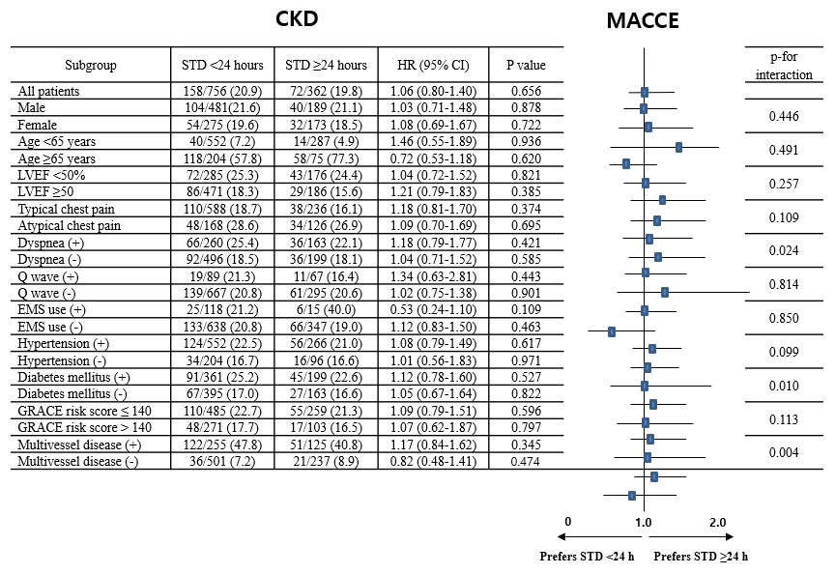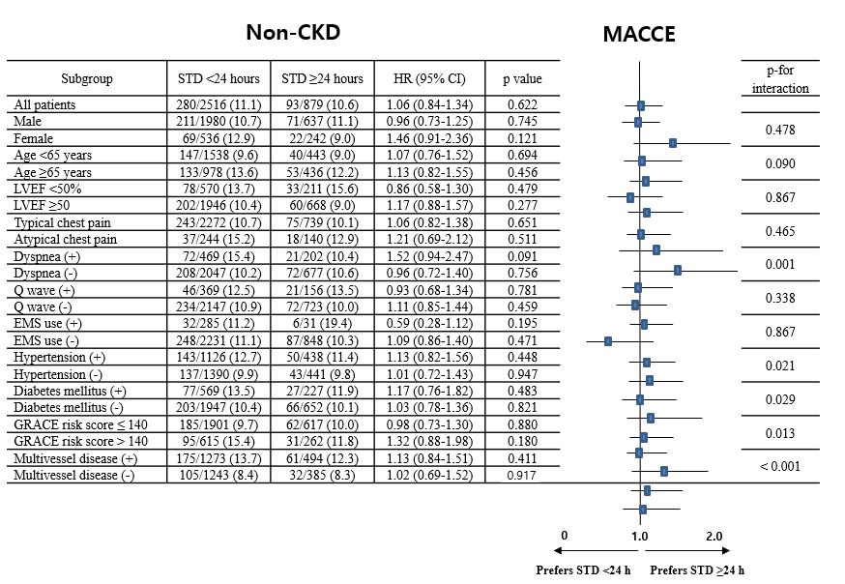
Supplementary Figure S1. Subgroup analysis for MACCE in the CKD and non-CKD groups. MACCE - major adverse cardiac and cerebrovascular events; CKD - chronic kidney disease; STD - symptom-to-door time; HR - hazard ratio; CI - confidence interval; LVEF - left ventricular ejection fraction; GRACE - Global Registry of Acute Coronary Events.

