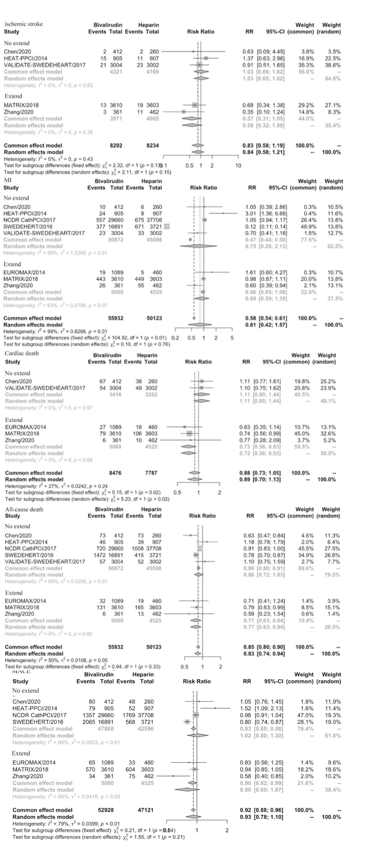
Supplementary Figure 1:
Pooled relative risks of MACE, cardiac death, MI, ischemic stroke, and ST in the post PCI bivalirudin infusion subgroup of patients using bivalirudin vs. heparin during procedure. MACE, main adverse clinical events; MI, myocardial infarction; ST, stent thrombosis.

Supplementary Figure 2:
Pooled relative risks of NACE, MACE, all-cause death, stroke, MI, ST, and major bleeding in patients receiving bivalirudin vs. heparin in the RCT subgroup. Major bleeding was defined as a bleeding event of Bleeding Academic Research Consortium (BARC) type 2, 3, and 5 or BARC 3 and 5 according to included studies. NACE, net adverse clinical events; MACE, main adverse cardiac events; MI, myocardial infarction; ST, stent thrombosis.

