Automatic computation of PCDA flow velocity
The automatic computation of coronary blood flow consists of the following procedures, including vessel segmentation, vessel extraction of centrelines and length calculation, derivation of length/time curve, fitting a straight line to the length/time curve and calculation of flow velocity.

1. Vessel segmentation based on the improved U-Net
The U-Net deep convolutional neural network (CNN) structure was widely used for medical image segmentation with four down-sampling layers originally, for processing of the input feature maps [1]. Due to the slender morphological characteristics of coronary arteries, the traditional architecture can hardly achieve satisfactory segmentation performance. In order to optimize the segmentation of the vessel, two additional down-sampling layers were implemented on the U-Net structure to enlarge the receptive field and thus avoid discontinuity of detected centrelines. Furthermore, the number of feature maps per layer was reduced to accelerate the computation speed [2]. This novel model is based on the improved U-Net, as is shown in Figure 1.
For the training process, a combination of dice and focal losses was used as the loss function [3, 4]. The Adam optimization algorithm [5] was used to facilitate CNN convergence, preventing overfitting. Model performance was evaluated by 5-fold cross-validation using evaluation metrics of dice similarity index, precision, recall, and F1 score. Good segmentation performance had been achieved with mean Dice coefficient values 0.780 ± 0.007, 0.722 ± 0.005, and 0.758 ± 0.003 for left anterior descending arteries, left circumflex arteries, and right coronary arteries, respectively [2].

Figure 1. The structure of the improved deep-learning U-Net for vessel segmentation ^{[2]}

2. Vessel extraction of centerlines and length calculation
The trained CNN model automatically segmented the vessel and subsequently delineated the vessel contour and centrelines. The length of the vessel was calculated for each frame according to the length of the segmentation centreline, using skeletonization [6] and a fast marching algorithm [7].

3. Derivation of length/time curve
Taking into account the frame rate, the real curve of vessel length variation over time (length/time curve) could be easily derived and subsequently smoothed by the Bezier curve [8].

4. Fitting a straight line to the length/time curve
The point with the half of Bezier curve maximum length was selected as the central point. Starting from the central point, the start and end frame of key frames were found on both sides and should be located in 10% and 90% of the maximum length, respectively. The key frames were selected between the start and end frame. In the key frames area, the original values of the real vessel length - time curve were applied, and a straight line was fitted to the length/time curve during the phase of contrast injection, using the least-square method (https://www.cuemath.com/data/least-squares/) (Figure 2).

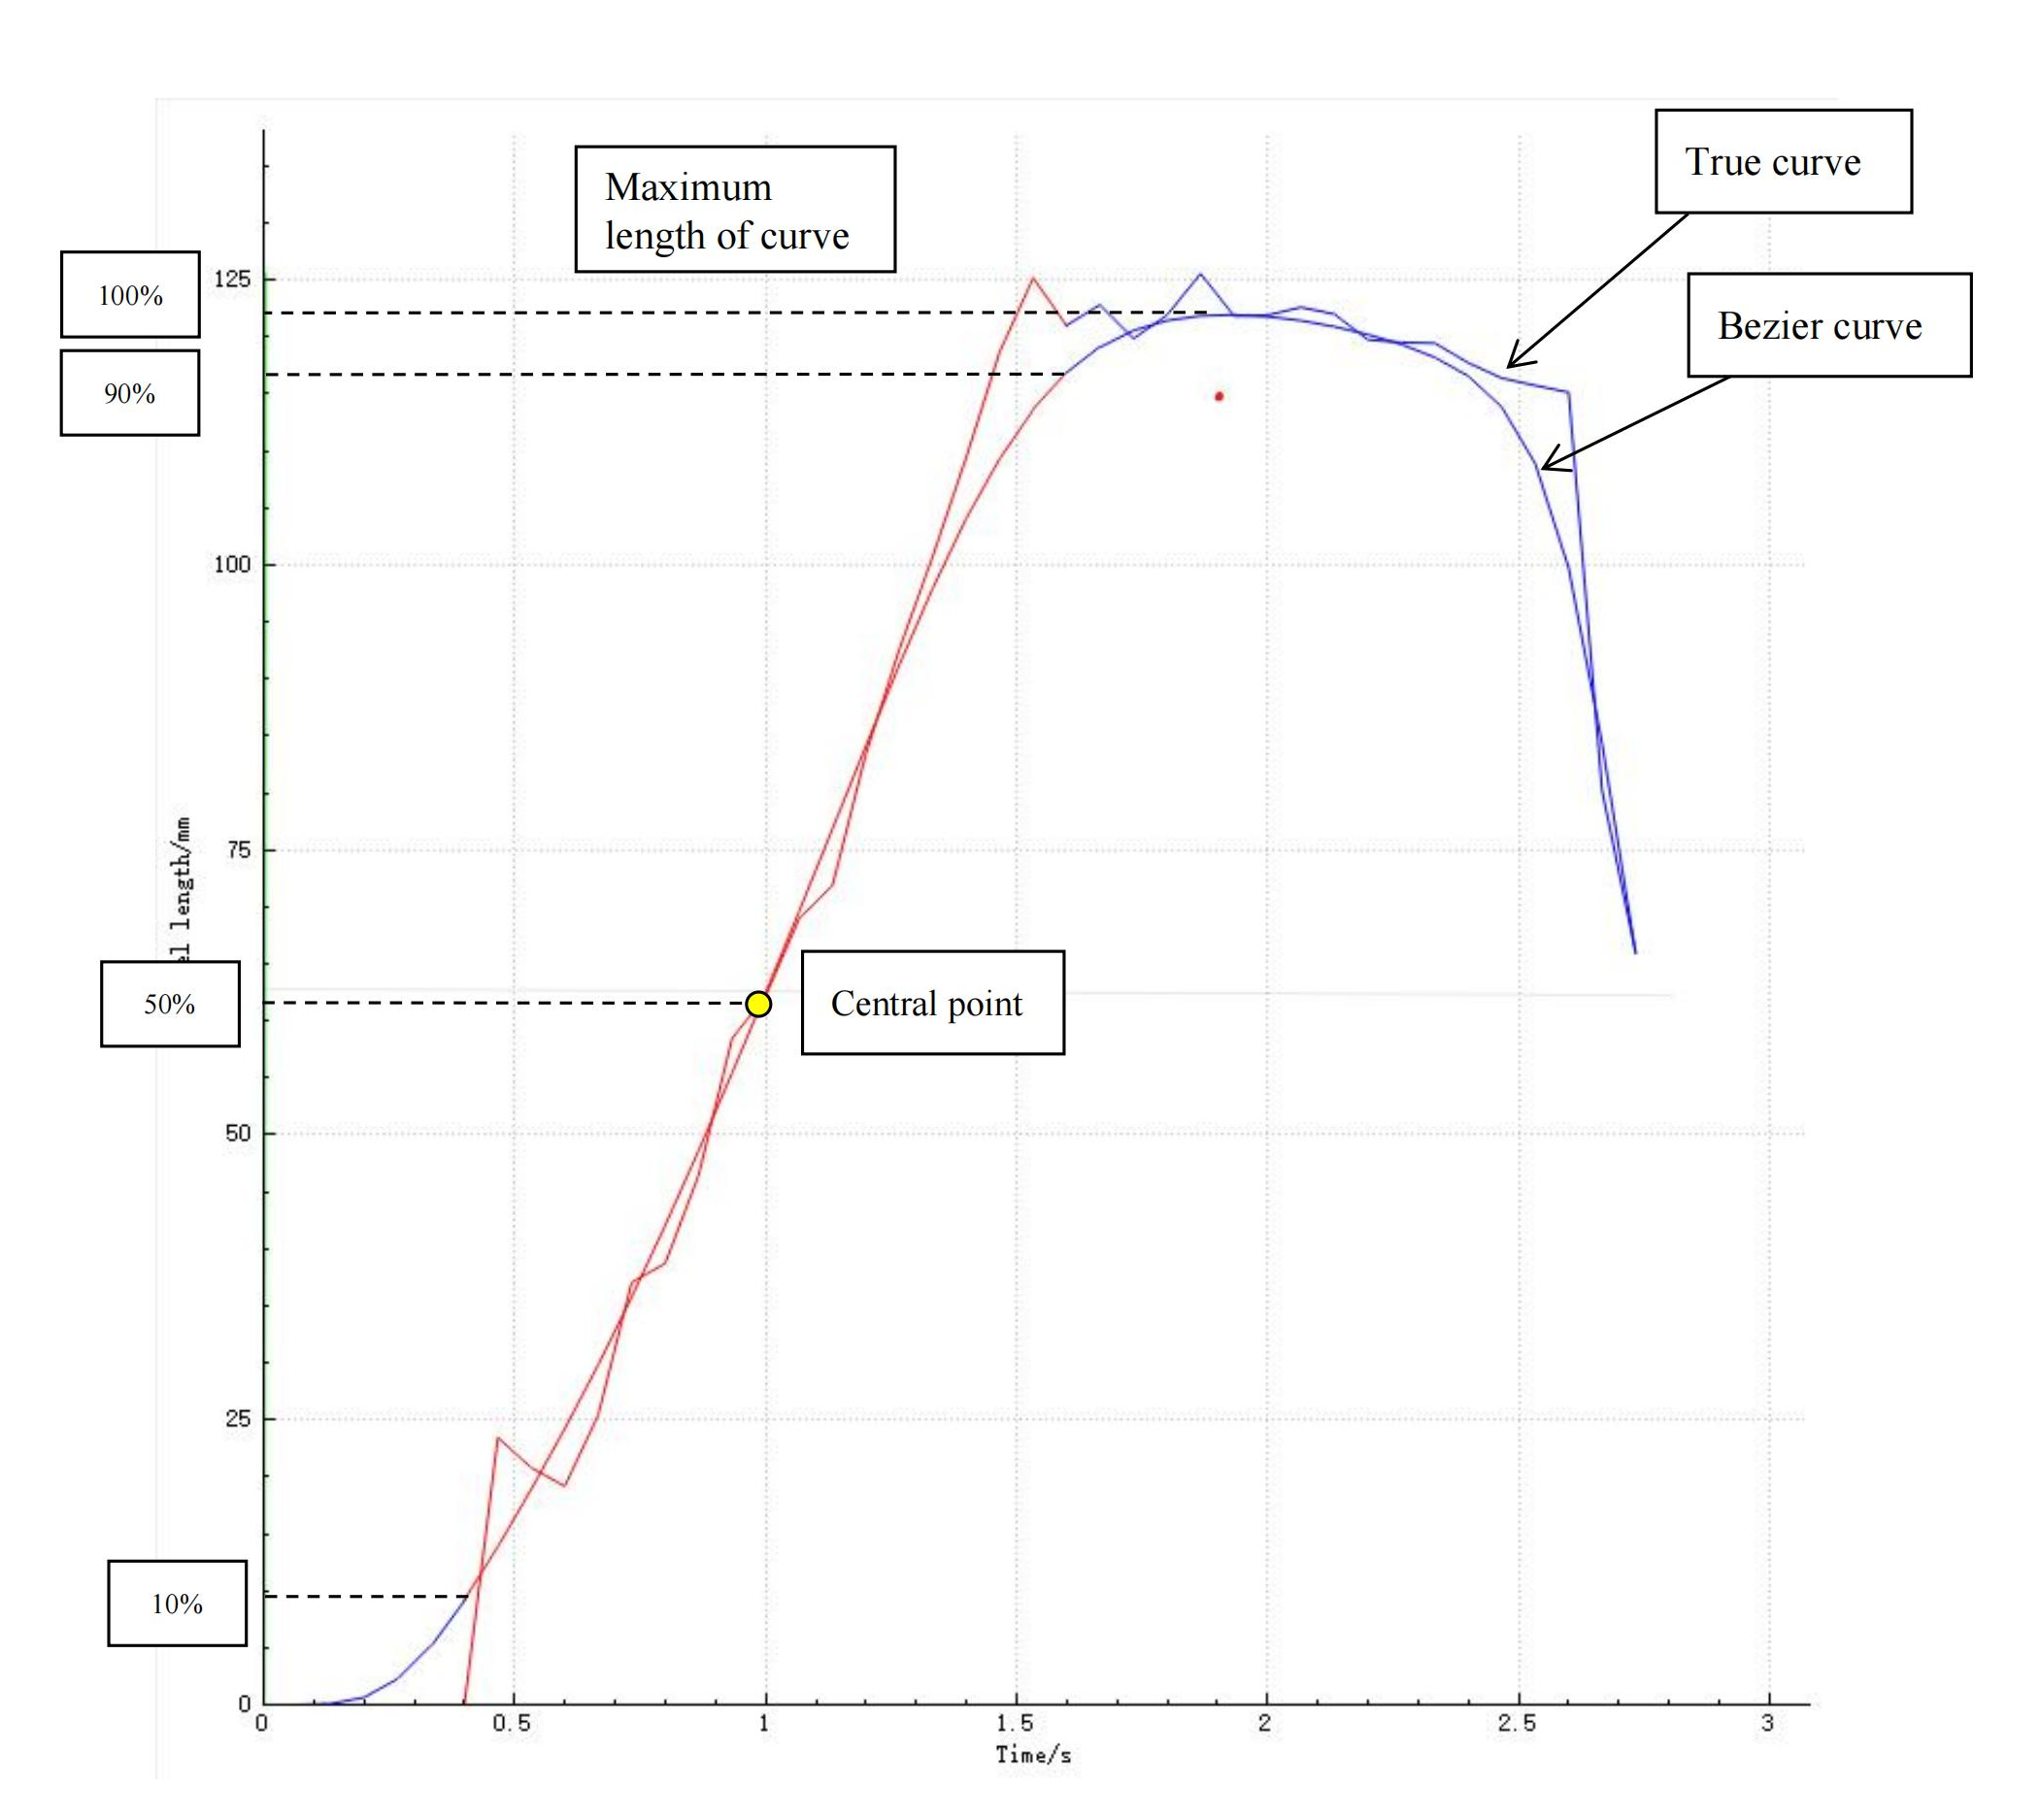
Figure 2. The vessel length/time curve

5. Calculate flow velocity
The flow velocity could be calculated then by fitting a straight line to the real length/time curve during the phase of contrast injection [2]. The slope of the fitting curve defined the rate of length change over time, hence the flow velocity in that coronary artery [2, 9, 10].

A fitting coefficient of the real length/time curve ≥ 0.90 was considered acceptable. Flow velocities pre-PCI (V_{pre}) and post-PCI (V_{post}) were automatically calculated following the same methodology.

References
- Ronneberger O, Fischer P, Brox T. U-Net: Convolutional Networks for Biomedical Image Segmentation. arXiv:1505.04597 [cs] 2015. Available at: http://arxiv.org/abs/1505.04597. Accessed November 1, 2020.
- Zhao Q, Li C, Chu M, Gutiérrez-Chico JL, Tu S. Angiography-based coronary flow reserve: The feasibility of automatic computation by artificial intelligence. Cardiol J 2021.
- Milletari F, Navab N, Ahmadi SA. V-Net: Fully Convolutional Neural Networks for Volumetric Medical Image Segmentation. 2016 Fourth International Conference on 3D Vision (3DV). 2016.
- Lin TY, Goyal P, Girshick R, et al. Focal Loss for Dense Object Detection. 2017 IEEE International Conference on Computer Vision (ICCV). 2017: 2980–2988.
- Kingma DP, Ba J. Adam: A method for stochastic optimization. arXiv preprint arXiv. 2014; 14126980.
- Zhang TY, Suen CY. A fast parallel algorithm for thinning digital patterns. Commun. ACM 1984;27:236–239.
- Sethian JA. A fast marching level set method for monotonically advancing fronts. Proceedings of the National Academy of Sciences 1996;93:1591–1595.
- Bartels RH, Beatty JC, Barsky BA. "Bézier Curves." Ch. 10 in An Introduction to Splines for Use in Computer Graphics and Geometric Modelling. San Francisco, CA: Morgan Kaufmann, 1998; 211-245.
- Zhang Y, Zhang S, Westra J, et al. Automatic coronary blood flow computation: validation in quantitative flow ratio from coronary angiography. Int J Cardiovasc Imaging 2019;35:587–595.
- Werner GS, Lang K, Kuehnert H, Figulla HR. Intracoronary verapamil for reversal of no-reflow during coronary angioplasty for acute myocardial infarction. Catheter Cardiovasc Interv 2002;57:444–451.

