Supplement 2

Supplement to: Ion channel inhibition with amiodarone or verapamil in symptomatic hospitalized nonintensive care COVID-19 patients: The ReCOVery-SIRIO randomized trial

Contents
Suppl. Table 1. Association between biomarkers other than CRP and platelet count and mortality. 2
Suppl. Table 2. Tested predictors for variable selection by cluster analysis. 3
Suppl. Table 3. Adverse events. 4
Suppl. Figure 1. CRP levels at 7,10 and 15 days stratified by presence (red) or absence (violet) of clinical improvement. 5
Suppl. Figure 2. Cluster plot with 4 phenotypes. 6

Suppl. Table 1. Association between biomarkers other than CRP and platelet count and mortality.
Biomarker | Death (Yes) | Death (No) | P value
Plasma D-dimer (ng/ml) | 753 (500-946) | 665 (443-700) | 0.03
WBC count day 7 (x10³/mcL) | 8.13±4.81 | 8.91±3.50 | 0.48
WBC count day 10 (x10³/mcL) | 10.40±4.52 | 10.33±4.11 | 0.96
WBC count day 15 (x10³/mcL) | 11.96±4.67 | 10.46±4.49 | 0.47
Lymphocyte count (x10³/mcL) | 0.75 (0.46-1.27) | 1.02 (0.77-1.45) | 0.08
Serum hs-cTroponin I day 7 (ng/ml) | 0.23 (0.006-0.30) | 0.007 (0.004-0.017) | 0.18
Serum hs-cTroponin I day 10 (ng/ml) | 0.30(0.005-0.41) | 0.008 (0.004-0.014) | 0.36
Serum hs-cTroponin I day 15 (ng/ml) | 0.15 (0.007-0.23) | 0.009 (0.005-0.018) | 0.16
Serum MB-CK (IU/L) | 1.14 (0.50-2.12) | 1.79 (0.86-3.40) | 0.10
Serum ALT (IU/L) | 27.15 (23-47.3) | 30 (20.70-52.6) | 0.88
Values are median (IQR) or mean+SD. ALT=alanine aminotransferase, CK=creatine kinase, CRP=C-reactive protein, hs-c=high sensitivity-cardiac, MB, myocardium brain, WBC=white blood cell.

Suppl. Table 2. Tested predictors for variable selection by cluster analysis.
Peak serum C-reactive protein | Blood lymphocyte count
Nadir blood platelet count | Serum creatinine
Serum ALT | Serum AST
Hs troponin I | Plasma D-dimer
Blood platelet count | Serum Creatine kinase
Serum C-reactive protein | WBC count
PO2/FIO2 | Diabetes mellitus
Cancer | Chronic obstructive pulmonary disease
Age | Sex
Cardiovascular disease | Body mass index
Serum MB-creatine kinase | Aspirin
Statins | ACE-inhibitors
Antidiabetic medications | Diuretics
Fever | Dyspnoea
Headache | NEWS2 score
Fatigue | Systolic blood pressure
Chest pain | Diastolic blood pressure
Pulse rate | Hydroxychloroquine
Ritonavir | Lopinavir
Azithromycin | Remdesivir
Convalescent plasma | Supplemental oxygen
Heparin | ECMO
Invasive mechanical ventilation

Suppl. Table 3. Adverse events.
 | Amiodarone  (n = 71) | Verapamil  (n = 72) | Usual care  (n = 72) | P
Ventricular tachiarrhythmia, n (%) | 0 (0) | 0 (0) | 0 (0) | 1
Atrioventricular II or III degree block, n (%) | 0 (0) | 0 (0) | 1 (1) | 0.66
Bradyarrhythmia (<40 bpm), n (%) | 1 (1) | 0 (0) | 3 (4) | 0.13
Supraventricular tachiarrhythmia, n (%) | 4 (6) | 2 (3) | 0 (0) | 0.08
Atrial fibrillation, n (%) | 0 (0) | 0 (0) | 1 (1) | 1
Other serious event, n (%) | 1 (1) | 3 (4) | 1 (1) | 1
Corrected QT interval at 15 days (ms), mean ±SD | 407.59±32.66 | 415.22±29.74 | 414.46± 32.80 | 0.90

Suppl. Figure 1. CRP levels at 7,10 and 15 days stratified by presence (red) or absence (violet) of clinical improvement.
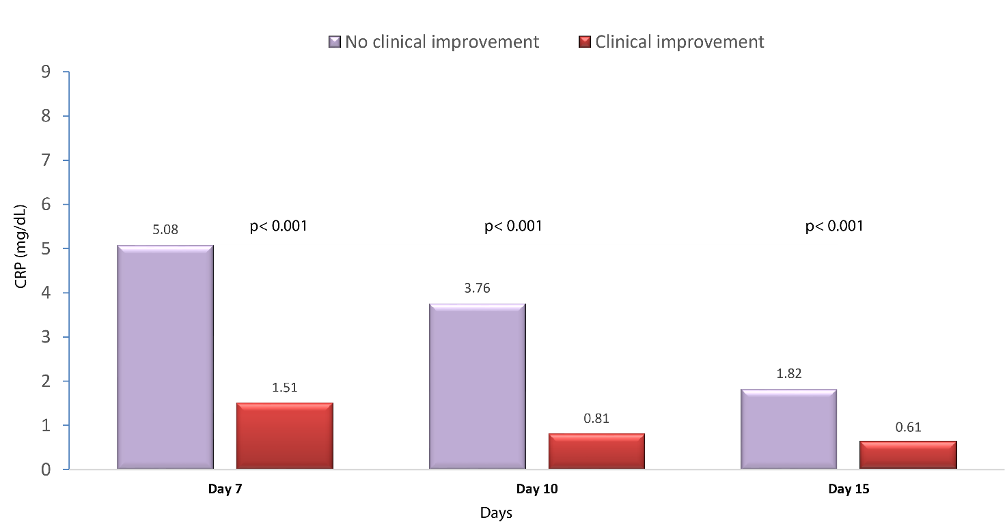

Suppl. Figure 2. Cluster plot with 4 phenotypes.
