Statins and the risk of pancreatic cancer: A systematic review and meta-analysis of 2,797,186 patients

Supplementary Digital File

CONTENT:
Figure S1. A summary table of review authors' judgements for each risk of bias item for each randomized study. 2
Figure S2. A plot of the distribution of review authors' judgements across randomized studies for each risk of bias item. 2
Figure S3. A summary table of review authors' judgements for each risk of bias item for each non-randomized study. 3
Figure S4. A plot of the distribution of review authors' judgements across non-randomized studies for each risk of bias item. 4
Table S1. Study characteristics. 4

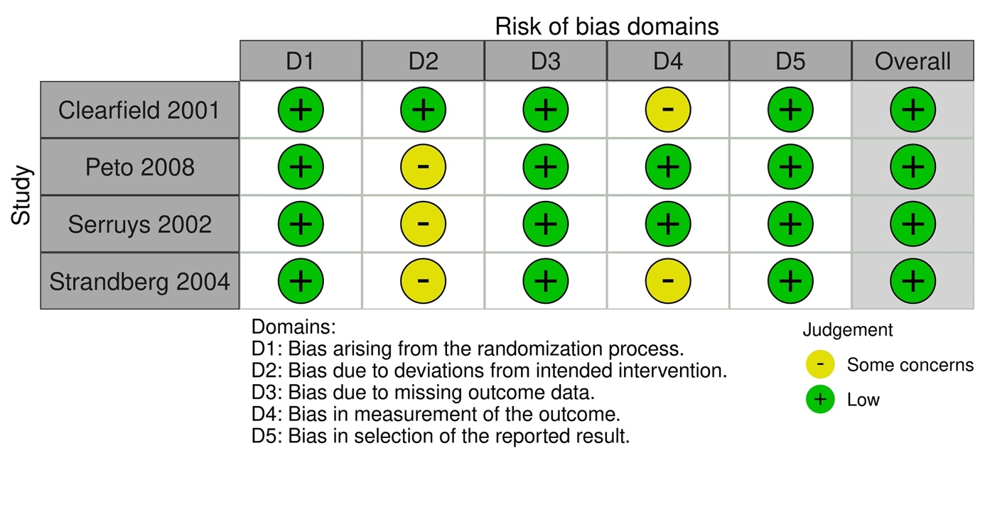

Figure S1. A summary table of review authors' judgements for each risk of bias item for each randomized study.

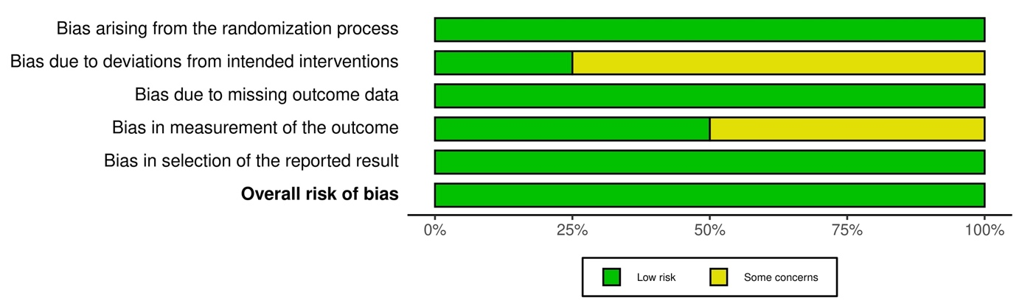

Figure S2. A plot of the distribution of review authors' judgements across randomized studies for each risk of bias item.

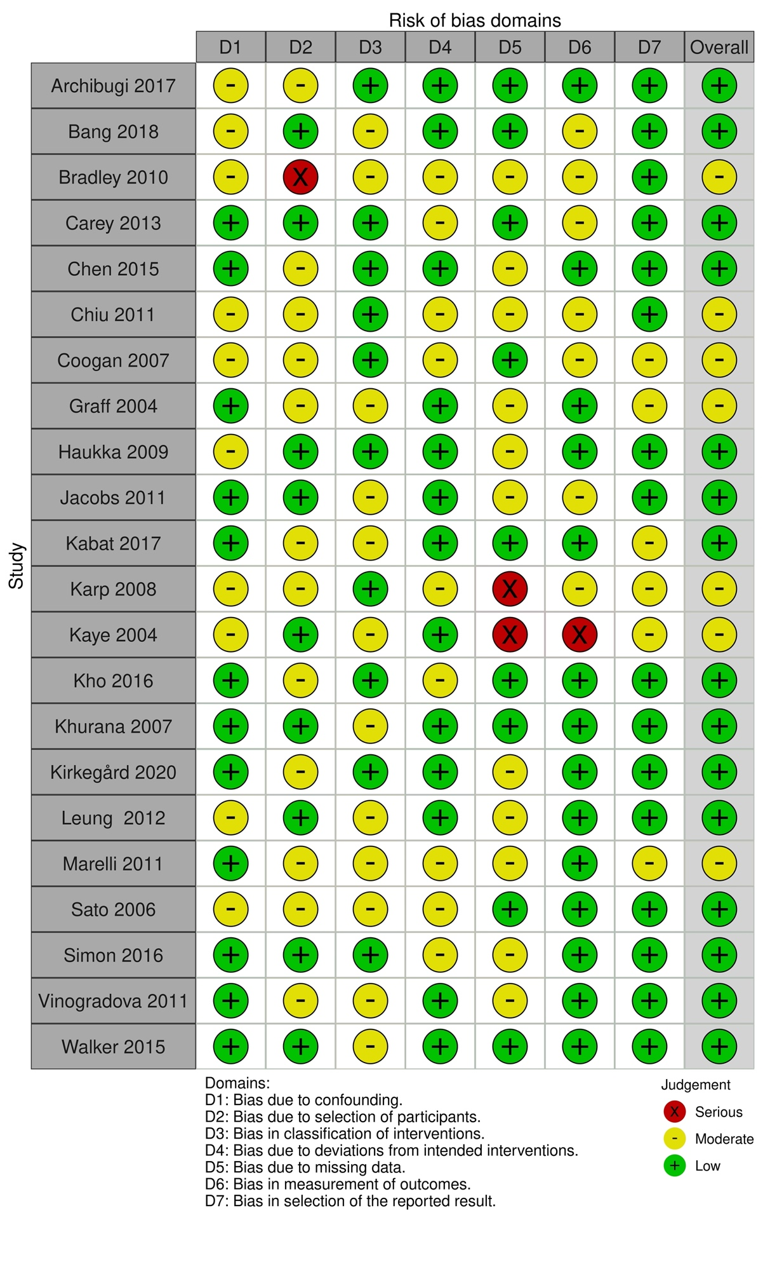

Figure S3. A summary table of review authors' judgements for each risk of bias item for each non-randomized study.

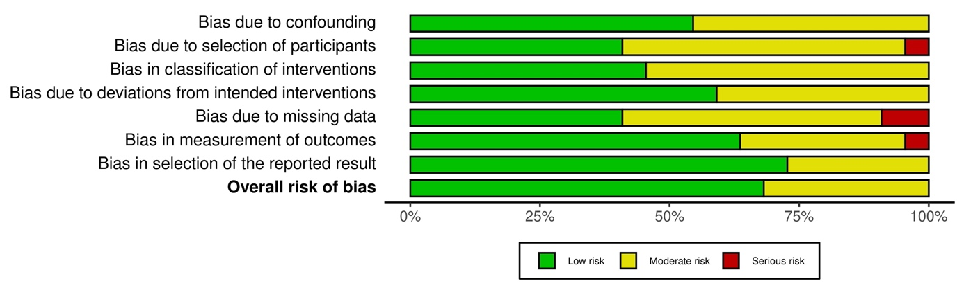

Figure S4. A plot of the distribution of review authors' judgements across non-randomized studies for each risk of bias item.

Table S1. Study characteristics.
Study | Country | Study design | No. | Age | Sex, male | No. of PCC
Archibugi et al. 2017 | Italy | CCS | 1,224 | 68±11.8 | 627 (51.2%) | 408 (33.3%)
Bang et al. 2018 | Denmark | CCS | 4,807 | 53.1±12.7 | 3,107 (64.6%) | 117 (2.4%)
Bradley et al. 2010 | UK | CCS | 9,095 | 57.3 ± 9.8 | 4,884 (53.7%) | 1,141 (12.5%)
Carey et al. 2013 | UK | CCS | 756 | 65.9±4.3 | 377 (49.9%) | 252 (33.3%)
Chen et al. 2015 | Taiwan | RS | 1,140,617 | 57.5±13.5 | 607,215 (53.2%) | 2,341 (0.2%)
Chiu et al. 2011 | Taiwan | CCS | 950 | 68.8 ±10.4 | 520 (54.7%) | 190 (20.0%)
Clearfield et al. 2001 | USA | RCT | 997 | 63 ± 5 | NS | 2 (0.2%)
Coogan et al. 2007 | USA | CCS | 8,813 | NS | 4,170 (47.3%) | 4,913 (55.7%)
Graff et al. 2004 | Netherlands | CCS | 20,105 | NS | 9,785 (48.7%) | 186 (0.9%)
Haukka et al. 2009 | Finland | CCS | 472,481 | NS | NS | 1,898 (0.4%)
Jacobs et al. 2011 | USA | CCS | 133,255 | NS | NS | 495 (0.4%)
Kabat et al. 2017 | USA | CCS | 18,281 | 65.3 ± 7.1 | NS | 156 (0.9%)
Karp et al. 2008 | Canada | RS | 30,076 | 69 ± 13.1 | 18,312 (60.9%) | 38 (0.1%)
Kaye et al. 2004 | USA | CCS | 18,088 | NS | 9,110 (50.4%) | 65 (0.4%)
Kho et al. 2016 | Australia | CCS | 1,175 | 63.6 ± 9.9 | 708 (60.3%) | 522 (44.4%)
Khurana et al. 2007 | USA | CCS | 483,733 | NS | NS | 475 (0.1%)
Kirkegård et al. 2020 | Denmark | CCS | 8,311 | NS | 5,498 (66.2%) | 153 (1.8%)
Leung et al. 2012 | Taiwan | CCS | 34,205 | 58.3 ± 4.7 | 16,150 (47.2%) | 6,841 (20.0%)
Marelli et al. 2011 | USA | CCS | 362,767 | 62.4 ± 9.5 | 191,744 (52.9%) | 69 (0.02%)
Peto et al. 2008 | UK | CCS | 22,490 | NS | NS | 16 (0.1%)
Sato et al. 2006 | Japan | CCS | 263 | NS | 215 (81.7%) | 1(0.4%)
Serruys et al. 2002 | Netherlands | RCT | 1,617 | 60 ± 9.9 | 1,406 (87.0%) | 3(0.2%)
Simon et al. 2016 | USA | CCS | 161,806 | NS | NS | 385 (0.2%)
Strandberg et al. 2004 | Finland | RCT | 4,444 | NS | 3,617 (81.4%) | 19 (0.4%)
Vinogradova et al. 2011 | UK | CCS | 450,379 | NS | 216,549 (48.1%) | 14,768 (3.3%)
Walker et al. 2015 | USA | CCS | 1,405 | NS | 704 (50.1%) | 536 (38.1%)
Legend: CCS = case-control study; NS = not specified; RCT = randomized controlled trial; Retrospective study; RS = retrospective study; PCC = pancreatic cancer case.

