Supplementary Materials
Supplementary Table 1. Baseline characteristics of study population by average on-treatment systolic BP categories (n=9,983).
 | Overall  (n=9,983) | Average systolic blood pressure during follow-up, mmHg
 |  | <110  (n=1,362) | 110 to 119  (n=2,100) | 120 to 129 (n=2,520) | ≥130  (n=4,001) | p value
Demographic
Age, (years) | 63 (54, 73) | 65 (55, 75) | 63 (53, 73) | 63 (53, 73) | 63 (54, 72) | <0.001
Male, n (%) | 7,569 (75.8) | 1,011 (74.2) | 1,633 (77.8) | 1,928 (76.5) | 2,997 (74.9) | 0.034
Body mass index, (kg/m²) | 24.1 (22.1, 26.0) | 23.4 (21.3, 25.0) | 23.8 (21.9, 25.8) | 24.0 (22.2, 26.0) | 24.2 (22.5, 26.4) | <0.001
Smoking, n (%) |  |  |  |  |  | 0.009
Never | 3,761 (38.6) | 514 (38.7) | 749 (36.5) | 931 (37.6) | 1,567 (40.3)
Former | 1,904 (19.5) | 229 (17.2) | 404 (19.7) | 498 (20.1) | 773 (19.9)
Current | 4,085 (41.9) | 585 (44.1) | 898 (43.8) | 1049 (42.3) | 1,553 (39.9)
Clinical
Hospital stays, (days) | 5 (4, 7) | 6 (5, 8) | 6 (4, 7) | 5 (4, 7) | 5 (4, 7) | <0.001
Symptom to door time, (hours) | 3.8 (1.5, 13.4) | 3.2 (1.3, 11.2) | 3.5 (1.6, 12.4) | 4.0 (1.6, 14.2) | 3.9 (1.6, 13.9) | 0.001
Killip classification, n (%) |  |  |  |  |  | <0.001
Ⅰ | 8,298 (83.1) | 983 (72.2) | 1,766 (84.1) | 2,166 (86.0) | 3,383 (84.6)
Ⅱ | 830 (8.4) | 106 (7.8) | 176 (8.4) | 212 (8.4) | 336 (8.4)
Ⅲ | 613 (6.1) | 108 (7.9) | 126 (6.0) | 126 (5.0) | 253 (6.3)
Ⅳ | 242 (2.4) | 165 (12.1) | 32 (1.5) | 16 (0.6) | 29 (0.7)
GRACE risk score, n (%)* |  |  |  |  |  | <0.001
Low | 1,067 (10.7) | 14 (1.0) | 71 (3.4) | 172 (6.8) | 810 (20.2)
Intermediated | 2,945 (29.5) | 202 (14.8) | 576 (27.4) | 841 (33.4) | 1,326 (33.1)
High | 5,971 (59.8) | 1,146 (84.1) | 1,453 (69.2) | 1,507 (59.8) | 1,865 (46.6)
Previous heart failure, n (%) | 112 (1.1) | 22 (1.6) | 23 (1.1) | 16 (0.6) | 51 (1.3) | 0.026
Previous MI, n (%) | 699 (7.0) | 124 (9.1) | 179 (8.5) | 167 (6.6) | 229 (5.7) | <0.001
Previous ischemic stroke, n (%) | 543 (5.5) | 70 (5.1) | 102 (4.9) | 148 (5.9) | 223 (5.6) | 0.435
Previous ICH, n (%) | 50 (0.5) | 6 (0.4) | 11 (0.5) | 11 (0.4) | 22 (0.6) | 0.912
Hypertension, n (%) | 4,982 (49.9) | 522 (38.3) | 891 (42.4) | 1,211 (48.1) | 2,358 (58.9) | <0.001
Diabetes mellitus, n (%) | 2,708 (27.1) | 329 (24.2) | 516 (24.6) | 683 (27.1) | 1,180 (29.5) | <0.001
Dyslipidemia, n (%) | 1,164 (11.7) | 133 (9.8) | 229 (10.9) | 297 (11.8) | 505 (12.6) | 0.023
Chronic kidney disease, n (%) | 1,777 (17.8) | 294 (21.6) | 363 (17.3) | 364 (14.4) | 756 (18.9) | <0.001
Myocardial infarction, n (%) |  |  |  |  |  | <0.001
NSTEMI | 5,031 (50.4) | 508 (37.3) | 934 (44.5) | 1,309 (51.9) | 2,280 (57.0)
STEMI | 4,952 (49.6) | 854 (62.7) | 1,166 (55.5) | 1,211 (48.1) | 1,721 (43.0)
Multivessel disease, n (%) | 4,545 (45.5) | 600 (44.1) | 938 (44.7) | 1,115 (44.2) | 1,892 (47.3) | 0.037
Anterior wall infarction, n (%) | 4,864 (48.7) | 554 (40.7) | 968 (46.1) | 1,252 (49.7) | 2,090 (52.2) | <0.001
LVEF <40% in hospital, n (%) | 998 (10.0) | 238 (17.5) | 219 (10.4) | 198 (7.9) | 343 (8.6) | <0.001
Atrial fibrillation in hospital, n (%) | 189 (1.9) | 41 (3.0) | 48 (2.3) | 37 (1.5) | 63 (1.6) | 0.001
Hemodynamics at admission
Systolic BP, (mmHg) | 130 (114, 150) | 100 (90, 106) | 115 (110, 120) | 130 (120, 140) | 153 (140, 169) | <0.001
Diastolic BP, (mmHg) | 80 (70, 90) | 60 (58, 70) | 70 (66, 80) | 80 (73, 90) | 90 (80, 100) | <0.001
Heart rate, (beats/mins) | 77 (66, 88) | 72 (60, 86) | 75 (64, 84) | 76 (68, 87) | 79 (69, 90) | <0.001
Hemodynamics at discharge
Systolic BP, (mmHg) | 110 (100, 120) | 100 (96, 110) | 110 (100, 115) | 110 (100, 120) | 120 (110, 130) | <0.001
Diastolic BP, (mmHg) | 70 (60, 75) | 60 (60, 70) | 62 (60, 70) | 70 (60, 72) | 70 (63, 80) | <0.001
Heart rate, (beats/mins) | 70 (64, 76) | 70 (64, 78) | 70 (64, 76) | 70 (64, 76) | 70 (64, 77) | 0.312
Cardiac enzyme, peak level
Troponin I, (ng/mL) | 19 (4, 50) | 27 (9, 73) | 23 (5, 58) | 18 (3, 47) | 13 (3, 41) | <0.001
CK-MB, (ng/mL) | 52 (10, 169) | 90 (20, 235) | 63 (12, 194) | 52 (10, 163) | 36 (8, 137) | <0.001
Medication†
Antiplatelet agents, n (%) | 9,983 (100.0) | 1362 (100.0) | 2,100 (100.0) | 2,520 (100.0) | 4,001 (100.0) | 1.000
Beta‒blockers, n (%) | 8,734 (87.5) | 1,113 (81.7) | 1,807 (86.0) | 2,225 (88.3) | 3,589 (89.7) | <0.001
≥25 % of optimal dose, n (%) | 1,353 (15.5) | 103 (9.2) | 217 (12.0) | 296 (13.3) | 737 (20.5) | <0.001
ACE inhibitors or ARBs, n (%) | 8,324 (83.4) | 1,050 (77.1) | 1,692 (80.6) | 2,094 (83.1) | 3,488 (87.2) | <0.001
Statins, n (%) | 9,534 (95.5) | 1,278 (93.8) | 2,005 (95.5) | 2,423 (96.2) | 3,828 (95.7) | 0.009
Moderate to high intensity, n (%) | 9,387 (98.4) | 1,243 (97.3) | 1,967 (98.1) | 2,392 (98.7) | 3,780 (98.7) | 0.001
Calcium channel blockers, n (%) | 610 (6.1) | 34 (2.5) | 76 (3.6) | 124 (4.9) | 376 (9.4) | <0.001
The data are presented as the number (%), and median (interquartile interval). Non-parametric continuous variables as assessed by the Kolmogorov-Smirnov method and were analyzed by Mann-Whitney U test.
Abbreviation: ACE, angiotensin converting enzyme inhibitor; ARB, angiotensin Ⅱ receptor blocker; BP, blood pressure; ICH, intracranial hemorrhage; LVEF, left ventricular ejection fraction; MI, myocardial infarction
* GRACE risk score classification: 108≥: low, 109-140: intermediate, >140: high
† Defined as a prescription at hospital discharge after acute coronary syndrome.
Supplementary Table 2. Baseline procedure-related profiles based on the revascularization strategies in multivessel disease (n=4,545).
 | Overall  (n=4,545) | Complete revascularization  (n=1,235) | Incomplete  revascularization  (n=456) | IRA-Only revascularization  (n=2,854) | p value
Culprit lesion profile |  |  |  |  | <0.001
Left main artery, n (%) | 409 (9.0) | 175 (14.2) | 63 (13.8) | 171 (6.0)
LAD, n (%) | 1,475 (32.4) | 333 (27.0) | 143 (31.4) | 999 (35.0)
LCX, n (%) | 932 (20.5) | 324 (26.2) | 98 (21.5) | 510 (17.9)
RCA, n (%) | 1,729 (38.1) | 403 (32.6) | 152 (33.3) | 1,174 (41.1)
Type B2/C lesion*, n (%) | 536 (11.8) | 151 (12.2) | 59 (12.9) | 326 (11.4) | 0.556
Pre-PCI TIMI flow, n (%) |  |  |  |  | <0.001
0 | 1,962 (43.2) | 434 (35.1) | 153 (33.6) | 1,375 (48.2)
1 | 536 (11.8) | 156 (12.6) | 62 (13.6) | 318 (11.1)
2 or 3 | 2,047 (45.0) | 645 (52.2) | 241 (52.9) | 1,161 (40.7)
Overall lesion |  |  |  |  | <0.001
2-Vessel disease, n (%) | 2,898 (63.8) | 978 (79.2) | 44 (9.6) | 1,876 (65.7)
3-Vessel disease, n (%) | 1,647 (36.2) | 257 (20.8) | 412 (90.4) | 978 (34.3)
Timing of non-IRA PCI |  |  |  |  | 0.203†
Immediate during index procedure, n (%) | 1,033 (22.7) | 767 (62.1) | 266 (58.3) | -
The data are presented as the number (%).
Abbreviation: IRA, infarct-related artery; LAD, left anterior descending artery; LCX, left circumflex artery; PCI, percutaneous coronary intervention; RCA, right coronary artery; TIMI, Thrombolysis in Myocardial infarction
* Type B2 or C lesions according to American College of Cardiology/American Heart Association classification.
† p-value between complete revascularization and incomplete revascularization.

Supplementary Figure 1. Forest plots of cox regression analysis for the clinical outcomes by multivessel disease (A) and single-vessel disease (B) of systolic BP during a 3-year follow-up period.
Abbreviations: BP, blood pressure
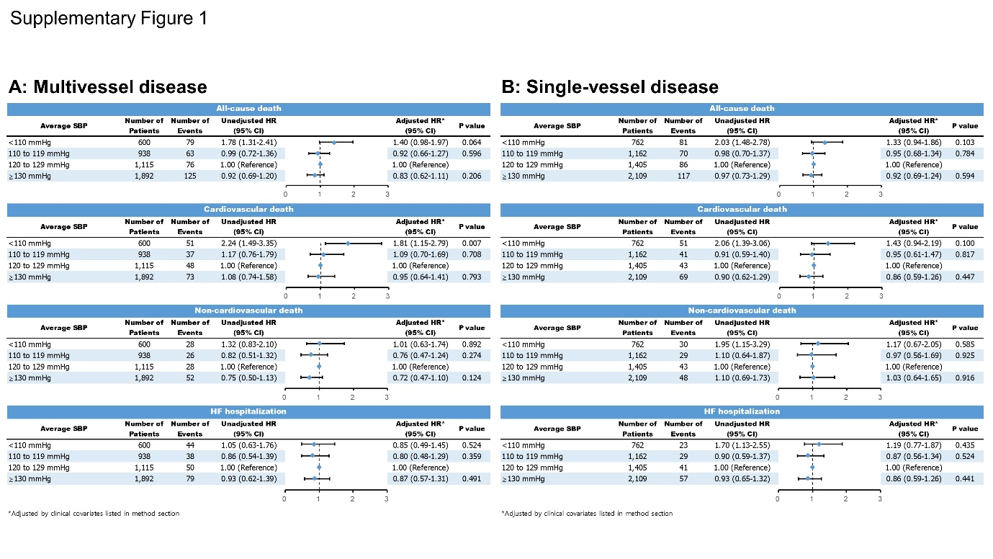

Supplementary Figure 2. Sensitivity analysis: Restricted cubic spline model of all-cause death or hospitalization for HF in patients with multivessel disease (A) and single-vessel disease (B) during a 3-year follow-up according to baseline BP. The dashed black horizontal lines indicate a hazard ratio of 1 and the painted areas indicate the 95% confidence interval (red line: diastolic BP, blue line: systolic BP).
Abbreviations: BP, blood pressure; HF, heart failure
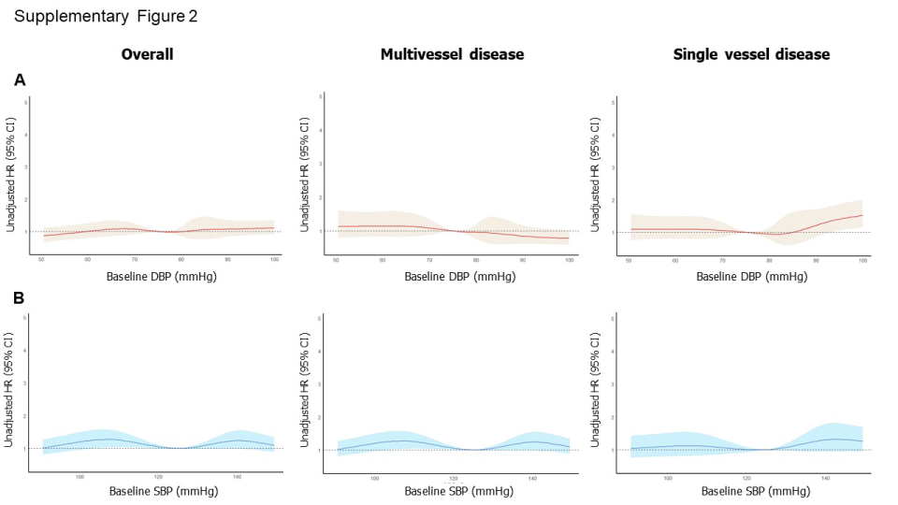

Supplementary Figure 3. Forest plots of cox regression analysis for the clinical outcomes by complete revascularization (A) and incomplete revascularization (B) of multivessel disease during a 3-year follow-up period.
