SUPPLEMENTARY MATERIAL

Supplementary Figure 1. NVT’s Allegra valve. 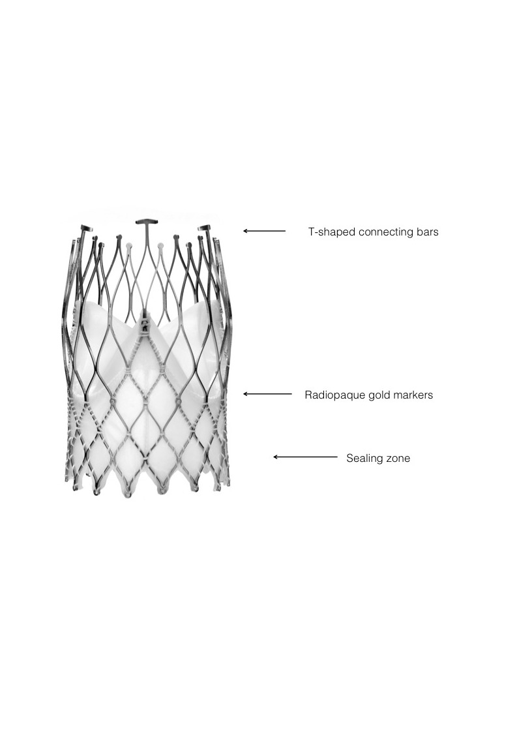

Supplementary Figure 2. Flow chart of the study.

