SUPPLEMENTAL METHODS

Biochemical data
Serum cardiac troponin I concentrations were assessed by two independent CLIA-approved laboratories at the University of Louisville and KentuckyOne Health Jewish Hospitals. The Ortho Vitros 5600 assay was used to assess cardiac troponin I in subjects enrolled at the University of Louisville Hospital. For this assay, a 99% cutoff level for a healthy population was 0.035 ng/mL and had a coefficient of variance below 10% at this level. Troponin levels < 0.035 ng/mL were considered non-elevated. This assay’s FDA-approved package insert further defined 0.12 ng/mL as the most efficient (more specific) cutoff point for the diagnosis of acute MI with this assay. Troponin levels >0.12 ng/mL were considered elevated, and levels from 0.035–0.12 ng/mL were considered non-diagnostic for the purposes of the present study.
The Beckman Access assay was used to assess cardiac troponin I in subjects enrolled at KentuckyOne Jewish Hospitals. For this assay, a 99% cutoff level for a healthy population was 0.04 ng/mL, but the results did not achieve a coefficient of variance below 10% until 0.06 ng/mL. Troponin levels < 0.04 ng/mL were considered non-elevated. This assay further defined 0.5 ng/mL as the most efficient (more specific) cutoff point for the diagnosis of acute MI. Troponin levels > 0.5 ng/mL were considered elevated, and levels from 0.04–0.5 ng/mL were considered non-diagnostic for this study.

Primary endpoints
This evaluation was accomplished by comparing the frequencies of angiographic characteristics in outcome Group 1 (lesions with histologically confirmed thrombus) versus Not-Group 1 (all lesions without histologically confirmed thrombus); outcome Group 2 (lesions with highly probable coronary thrombus) versus Not-Group 2 (all lesions not highly probable of having a coronary thrombus) and outcome Group 3 (lesions highly unlikely to have a coronary thrombus) versus Not-Group 3 (all lesions not highly unlikely to have a coronary thrombus).
The ability of an angiographic characteristic to differentiate between outcome groups (and hence its ability to identify the lesion types) was assessed by determining model-estimated odds ratios, sensitivity, and specificity. Since the angiographic characteristics represented a binary response variable, the logit link function was used in this modeling. Also, because the characteristics considered are lesion-specific, both the vessel and the subject represented significant sources of correlation between responses. Thus, model coefficients were estimated using generalized estimating equations (GEE), assuming a compound symmetry correlation structure [1]. Characteristics that could not be determined were considered missing data, to reflect clinical practice. It should be emphasized that if a clinician were unable to determine the presence or absence of an angiographic characteristic, the failure of the angiographic assessment to produce a result would not have influenced the diagnosis.

SUPPLEMENTAL TABLES
Supplemental Table 1. Definitions for study diagnoses.
Diagnoses | Definitions
Acute myocardial infarction (MI) | Must satisfy ALL:  - Symptoms consistent with acute ischemia lasting > 10 min in the last 24 hours  - ST-segment depression/elevation in ≥ 2 continuous ECG leads – OR – elevated cardiac troponin
Stable coronary artery disease (CAD) | Must satisfy ALL:  - Clinically stable  - Presenting for an elective catheterization to evaluate for stable CAD  - No recent revascularization attempts

APPENDIX FIGURES
Supplemental Figure 1. Coronary angiographic assessment scoring sheet.
Angiographic Characteristic | Score
Vessel (LM, LAD, LCx, RCA, Graft)
[All vessels must be assigned to one of the above listed vessel types. Note: ramus is considered part of LAD territory]
Graft Type (vein, LIMA, RIMA, gastro-epiploic, radial, other)
Graft #1 destination (LM, LAD, LCx, RCA, Graft)
Graft #2 destination (LM, LAD, LCx, RCA, Graft)
Graft #3 destination (LM, LAD, LCx, RCA, Graft)
Total number of lesions in this vessel
[Individual lesion must be in a distinct vessel branch or separated by ≥ 3 cm of normal vessel (< 10 stenosis) to constitute a separate lesion]
Lesion number (29-Segment Model) [2]
Stenosis by visual inspection (%) | 0 | 10 | 25 |  |  |  | 50 |  | 75 |  | 95 |  | 100
Collaterals supplying territory of this vessel | Yes |  |  |  |  | No |  |  | Undetermined
Ambrose Morphology Score [3, 4] | Simple |  | Complex |  |  |  |  |  |  | Undetermined
TIMI Flow Grade [5] | 3 |  |  | 2 |  |  |  | 1 |  |  |  | 0
TIMI MPG [5, 6] | 3 |  |  | 2 |  |  |  | 1 |  |  |  | 0
Spherical, ovoid, or irregular intramural filling defect, surrounded on 3 sides by contrast medium, just distal to or within a coronary stenosis [7] | Present |  |  |  | Absent |  |  |  |  | Undetermined
Abrupt vessel cutoff with persistence of contrast [8] | Present |  |  |  | Absent |  |  |  |  | Undetermined
Intraluminal staining [9] | Present |  |  |  | Absent |  |  |  |  | Undetermined
Any intracoronary filling defect [4] | Present |  |  |  | Absent |  |  |  |  | Undetermined
Major dissection present (spiral dissection or a dissection with > 50% diameter reduction) [10, 11] | Present |  |  |  | Absent |  |  |  |  | Undetermined
Minor dissection present (linear extraluminal cap in >1 view without luminal compromise) [10, 11] | Present |  |  |  | Absent |  |  |  |  | Undetermined
LM — left main coronary artery; LAD — left anterior descending artery; RCA — right coronary artery; LCx — left circumflex artery

Supplemental Figure 2. Ambrose Scoring System [3, 4]: Coronary Angiography Scoring Definitions and Guidelines.
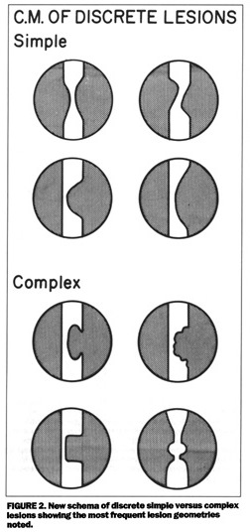  Source: Ambrose J, Israel D. Am J Cardiol, 1991; 68: 78B–84B | Definitions
Complex Lesions (ACS like lesions):
- Irregular ragged borders and intraluminal lucency
- Eccentric, with a narrow neck, overhanging edges or irregular borders
Simple Lesions:
- Stenosis with smooth borders without evidence or any complex features

Supplemental Figure 3. 29-segment coronary artery map with the addition of branch segments of large diagonal or obtuse marginal vessels, and the ramus intermedius branch [2].
Right coronary artery |  |  | 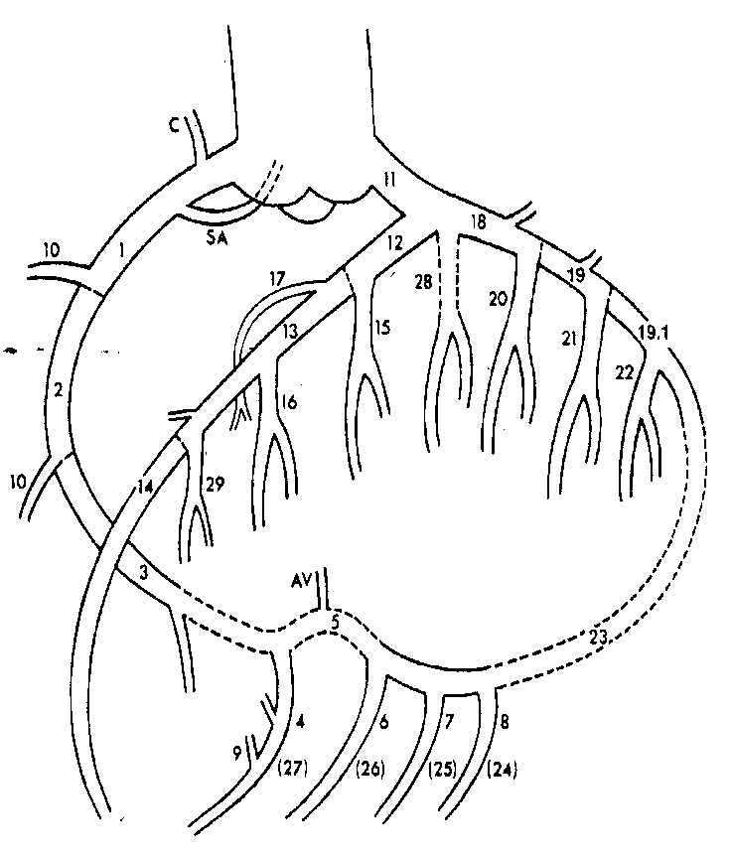
1 | Proximal RCA conduit segment
2 | Mid-RCA conduit segment
3 | Distal RCA conduit segment
4 | RPDA
5 | RPA
6 | First RPL segment
7 | Second RPL segment
8 | Third RPL segment
9 | Inferior septal
10 | AM segment(s)
Left coronary artery
11 | LMCA segment
12 | Proximal LAD segment
13 | Mid-LAD segment
14 | Distal LAD segment
15 | Lateral first diagonal segment
16 | Lateral second diagonal segment
17 | LAD septal perforator segment
18 | Proximal Cx segment
19 | Mid-Cx segment
19.1 | Distal Cx segment
20 | First OM segment
21 | Second OM segment
22 | Third OM segment
23 | Cx AV groove continuation segment
24 | First LPL segment
25 | Second LPL segment
26 | Third LPL segment
27 | LPL descending artery segment
28 | Ramus intermedius
29 | Third diagonal segment
Coronary vessels |  | LMCA |  | LAD | LCx | RCA
Segment numbers corresponding to lesions |  | 11 |  | 12, 13, 14, 15, 16, 17, 28, 29 | 5, 6, 7, 8, 18, 19, 19.1, 20, 21, 22, 23 | 1, 2, 3, 4, 9, 10, 24, 25, 26, 27
AM — acute marginal; CX — circumflex artery; LAD — left anterior descending artery; LMCA — left main coronary artery; LPL — left posterolateral; OM — obtuse marginal; RCA — right coronary artery; RPA — right posterior atrioventricular segment; RPDA — right posterior descending artery; RPL — right posterolateral

SUPPLEMENTAL REFERENCES
1. Lipsitz SR, Kim K, Zhao L. Analysis of repeated categorical data using generalized estimating equations. Statistics Med, 1994; 13: 1149–1163.
2. Protocol for the Bypass Angioplasty Revascularization Investigation (BARI). Circulation, 1991; 84 (Suppl. V): V1–V27.
3. Ambrose JA, Israel DH. Angiography in unstable angina. Am J Cardiol, 1991; 68: 78B–84B.
4. Dangas G, Mehran R, Wallenstein S et al. Correlation of angiographic morphology and clinical presentation in unstable angina. J Am Coll Cardiol, 1997; 29: 519–525.
5. Gibson CM, Cannon CP, Murphy SA et al. Relationship of the TIMI myocardial perfusion grades, flow grades, frame count, and percutaneous coronary intervention to long-term outcomes after thrombolytic administration in acute myocardial infarction. Circulation, 2002; 105: 1909–1913.
6. Gibson CM, Cannon CP, Murphy SA et al. Relationship of TIMI myocardial perfusion grade to mortality after administration of thrombolytic drugs. Circulation, 2000; 101: 125–130.
7. Capone G, Wolf NM, Meyer B, Meister SG. Frequency of intracoronary filling defects by angiography in angina pectoris at rest. Am J Cardiol, 1985; 56: 403–406.
8. Goldstein JA, Demetriou D, Grines CL, Pica M, Shoukfeh M, O’Neill WW. Multiple complex coronary plaques in patients with acute myocardial infarction. New Engl J Med, 2000; 343: 915–922.
9. Zack PM, Ischinger T, Aker UT, Dincer B, Kennedy HL. The occurrence of angiographically detected intracoronary thrombus in patients with unstable angina pectoris. Am Heart J, 1984; 108: 1408–1412.
10. Ambrose JA, Almeida OD, Sharma SK, Dangas G, Ratner DE. Angiographic evolution of intracoronary thrombus and dissection following percutaneous transluminal coronary angioplasty (the Thrombolysis and Angioplasty in Unstable Angina [TAUSA] trial). Am J Cardiol, 1997; 79: 559–563.
11. Ambrose JA, Almeida OD, Sharma SK et al. Adjunctive thrombolytic therapy during angioplasty for ischemic rest angina. Results of the TAUSA Trial. TAUSA Investigators. Thrombolysis and Angioplasty in Unstable Angina trial. Circulation, 1994; 90: 69–77.

