Impact of postdilatation on performance of bioresorbable vascular scaffolds in patients with acute coronary syndrome compared with everolimus-eluting stents: a propensity score-matched analysis from a multicenter “real-world” registry

Yoichi Imori, MD^{1*}; Fabrizio D’Ascenzo, MD^{1,2*#}; Tommaso Gori, MD³; Thomas Münzel, MD³; Ugo Fabrizio, MD⁴; Gianluca Campo, MD⁵; Enrico Cerrato, MD⁶; L. Christian Napp, MD⁷; Mario Iannaccone, MD²; Jelena-R. Ghadri, MD¹; Elycia Kazemian¹; Ronald K Binder, MD¹; Milosz Jaguszewski, MD¹; Adam Csordas, MD¹; Piera Capasso, MD⁴; Simone Biscaglia, MD⁵; Federico Conrotto, MD²; Ferdinando Varbella, MD⁶; Roberto Garbo, MD⁴; Fiorenzo Gaita, MD²; Paul Erne, MD^{8,9}; Thomas F. Lüscher, MD¹; Claudio Moretti, MD²; Antonio H. Frangieh, MD^{1*};Christian Templin, MD, PhD^{1*#}
* contributed equally to this work
¹ University Heart Center, Department of Cardiology, University Hospital Zurich, Switzerland
² Dipartimento di Scienze Mediche, Divisione di Cardiologia, Città della Salute e della Scienza, Turin, Italy
³ Medizinische Klinik und Poliklinik-Kardiologie, Angiologie und Internistische Intensivmedizin, University Medical Center, Mainz, Germany
⁴ Interventional Cardiology Department, San Giovanni Bosco Hospital, Turin, Italy
⁵ Cardiovascular Institute, Azienda Ospedaliero-Universitaria S. Anna, Cona, FE, Italy; Laboratorio per le Tecnologie delle Terapie Avanzate (LTTA) Center, Ferrara, Italy
⁶ Cardiology Department, Ospedale degli Infermi, Rivoli TO, Italy
⁷ Department of Cardiology and Angiology, Hannover Medical School, Hannover, Germany
⁸ Heart Centre Lucerne, Luzerner Kantonsspital, Lucerne, Switzerland
⁹ Department of Cardiology, Klinik St. Anna, Lucerne, Switzerland
Table of Contents

Supplementary Methods ………………………………………………………… 4
Supplementary Figure 1 ………………………………………………………… 5
Supplementary Figure 2 ………………………………………………………… 6
Supplementary Table 1 ………………………………………………………… 7
Supplementary Table 2 ………………………………………………………… 8
Supplementary Table 3 ………………………………………………………… 9
Supplementary Table 4 ………………………………………………………… 10
Supplementary Table 5 ………………………………………………………… 11
Supplementary Table 6 ………………………………………………………… 12

SUPPLEMENTARY METHODS

Leading Study Center

University Heart Center, Department of Cardiology, University Hospital Zurich, Switzerland

Participating Study Centers

Italy:

Dipartimento di Scienze Mediche, Divisione di Cardiologia, Città della Salute e della Scienza, Turin, Italy

Interventional Cardiology Department, San Giovanni Bosco Hospital, Turin, Italy

Cardiovascular Institute, Azienda Ospedaliero-Universitaria S. Anna, Cona, FE, Italy

Laboratorio per le Tecnologie delle Terapie Avanzate (LTTA) Center, Ferrara, Italy

Cardiology Department, Ospedale degli Infermi, Rivoli TO, Italy

Germany:

Medizinische Klinik und Poliklinik-Kardiologie, Angiologie und Internistische Intensivmedizin, University Medical Center, Mainz, Germany

Switzerland:

Heart Centre Lucerne, Luzerner Kantonsspital, Lucerne, Switzerland

Department of Cardiology, Klinik St. Anna, Lucerne, Switzerland

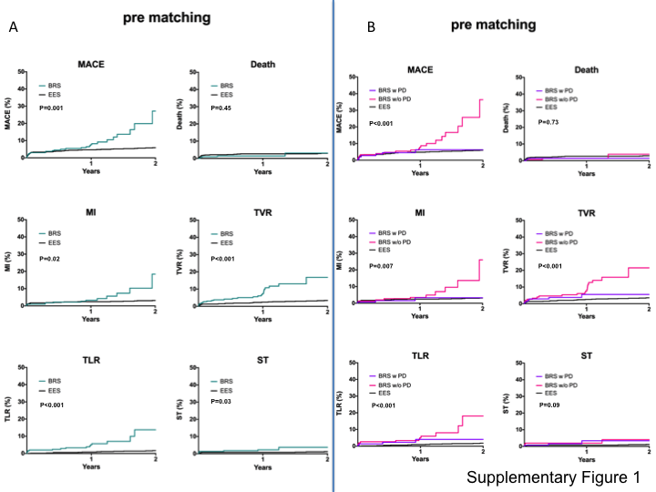

Supplementary Figure 1: Kaplan–Meier survival curves of outcomes in the total study cohort. Comparison between bioresorbable scaffolds and everolimus-eluting stents before and after sensitivity analysis for postdilatation.
BRS, bioresorbable scaffolds; EES, everolimus-eluting stents; MACE, major adverse cardiac events (composite of death, MI, and TLR); MI, myocardial infarction; PD, postdilatation; ST, stent thrombosis; TLR, target lesion revascularization; TVR, target vessel revascularization

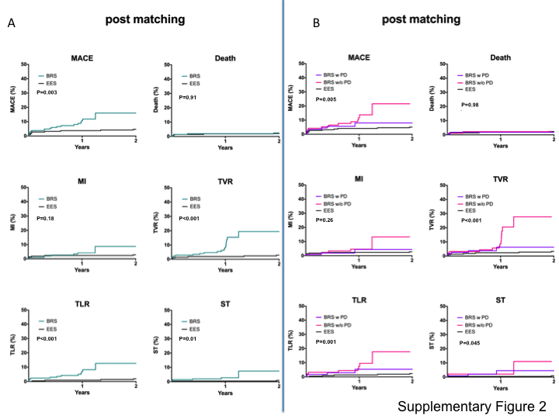

Supplementary Figure 2: Kaplan–Meier survival curves of outcomes in the matched study cohort. Comparison between bioresorbable scaffolds and everolimus-eluting stents before and after sensitivity analysis for postdilatation.
BRS, bioresorbable scaffolds; EES, everolimus-eluting stents; MACE, major adverse cardiac events (composite of death, MI, and TLR); MI, myocardial infarction; PD, postdilatation; ST, stent thrombosis; TLR, target lesion revascularization; TVR, target vessel revascularization

Supplementary Table 1: Outcome at median follow-up. Comparison between bioresorbable scaffolds and everolimus-eluting stents in the total study cohort

 | BRS | EES | p-value
MACE | 27 (8.9) | 44 (5.9) | <0.001
Death | 5 (1.7) | 22 (2.9) | 0.45
MI | 13 (4.3) | 23 (3.1) | 0.02
TLR | 16 (5.3) | 12 (1.6) | <0.001
TVR | 26 (8.6) | 25 (3.3) | <0.001
ST | 7 (2.3) | 9 (1.2) | 0.03
BRS, bioresorbable scaffolds; EES, everolimus-eluting stents; MACE, major adverse cardiac events (composite of death, MI, and TLR); MI, myocardial infarction; ST, stent thrombosis; TLR, target lesion revascularization; TVR, target vessel revascularization

Supplementary Table 2: Outcome at median follow-up. Comparison between bioresorbable scaffolds and everolimus-eluting stents in the matched study cohort

 | BRS | EES | p-value
MACE | 20 (9.3) | 10 (4.7) | 0.003
Death | 4 (1.9) | 5 (2.3) | 0.91
MI | 8 (3.7) | 6 (2.8) | 0.18
TLR | 13 (6.1) | 4 (1.9) | <0.001
TVR | 19 (8.9) | 6 (2.8) | <0.001
ST | 6 (2.8) | 2 (0.9) | 0.01
BRS, bioresorbable scaffolds; EES, everolimus-eluting stents; MACE, major adverse cardiac events (composite of death, MI, and TLR); MI, myocardial infarction; ST, stent thrombosis; TLR, target lesion revascularization; TVR, target vessel revascularization

 | 1: BRS with postdilatation | 2: BRS without postdilatation | 3: EES | p-value (all group) | 1 vs. 2 | 1 vs. 3 | 2 vs. 3
Female gender (%) | 29/148 (19.6) | 39/153 (25.5) | 140/748 (18.7) | 0.16 | - | - | -
Age (years) | 60.0 ± 11.7 | 61.0 ± 12.8 | 62.2 ± 11.6 | 0.18 | - | - | -
Hypertension (%) | 85/148 (57.4) | 96/152 (63.2) | 392/745 (52.6) | 0.05 | >0.999 | 0.96 | 0.06
Diabetes (%) | 15/148 (10.1) | 21/152 (13.8) | 116/748 (15.5) | 0.24 | - | - | -
Hyperlipidemia (%) | 75/148 (50.7) | 48/152 (31.6) | 299/745 (40.1) | 0.003 | 0.003 | 0.07 | 0.17
Smoke (%) | 68/148 (45.9) | 76/152 (50.0) | 325/745 (43.6) | 0.34 | - | - | -
Ejection fraction (%) | 52.5 ± 10.1 | 53.9 ± 9.1 | 53.6 ± 11.3 | 0.55 | - | - | -
STEMI (%) | 63/148 (42.6) | 57/153 (37.3) | 410/748 (54.8) | <0.001 | >0.999 | 0.02 | <0.001
Use of GP III (%) | 4/56 (7.1) | 2/27 (7.4) | 191/746 (25.6) | <0.001 | >0.999 | 0.003 | 0.12
Target Vessel |  |  |  | 0.05 | 0.02 | 0.40 | 0.43
LM | 1/188 (0.5) | 0/167 (0) | 7/699 (1.0)
LAD | 115/188 (61.2) | 78/167 (46.7) | 352/699 (50.4)
LCX | 27/188 (14.4) | 34/167 (20.4) | 136/699 (19.5)
RCA | 42/188 (22.3) | 55/167 (32.9) | 190/699 (27.2)
Graft | 3/188 (1.6) | 0/167 (0) | 14/699 (2.0)
Type C lesion (%) | 88/165 (53.3) | 45/153 (29.4) | 105/274 (38.3) | <0.001 | <0.001 | 0.009 | 0.22
Stent length (mm) | 22.2 ± 5.4 | 18.3 ± 3.8 | 20.0 ± 5.4 | <0.001 | <0.001 | <0.001 | 0.003
Stent diameter (mm) | 3.1 ± 0.4 | 3.1 ± 0.4 | 3.0 ± 0.4 | 0.002 | >0.999 | 0.01 | 0.05
Supplementary Table 3: Baseline characteristics of the total study cohort (prematching) and sensitivity analysis with and without postdilatation

BRS, bioresorbable scaffolds; EES, everolimus eluting stents; GP, glycoprotein; LAD, left anterior descending; LCX, left circumflex artery; LM, left main; RCA, right coronary artery; STEMI, ST-elevation myocardial infarction; p-value: one-way ANOVA or Fisher's exact test (with Bonferroni correction)

 | 1: BRS with postdilatation | 2:BRS without postdilatation | 3: EES | p-value (all group) | 1 vs. 2 | 1 vs. 3 | 2 vs. 3
Female gender (%) | 22/117 (18.8) | 22/95 (23.2) | 42/215 (19.5) | 0.71 | - | - | -
Age (years) | 59.8 ± 12.5 | 59.6 ± 13.5 | 61.5 ± 11.9 | 0.37 | - | - | -
Hypertension (%) | 65/117 (55.6) | 54/95 (56.8) | 117/215 (54.4) | 0.93 | - | - | -
Diabetes (%) | 13/117 (11.1) | 16/95 (16.8) | 36/215 (16.7) | 0.34 | - | - | -
Hyperlipidemia (%) | 53/117 (45.3) | 33/95 (34.7) | 92/215 (42.8) | 0.27 | - | - | -
Smoke (%) | 56/117 (47.9) | 54/95 (56.8) | 89/215 (41.4) | 0.04 | 0.64 | 0.89 | 0.04
Ejection fraction (%) | 51.5 ± 10.2 | 52.3 ± 8.7 | 53.7 ± 11.7 | 0.28 | - | - | -
STEMI (%) | 56/117 (47.9) | 49/95 (51.6) | 97/215 (45.1) | 0.57 | - | - | -
Use of GP III (%) | 2/33 (6.1) | 1/11 (9.1) | 70/213 (32.9) | <0.001 | >0.999 | 0.003 | 0.54
Target Vessel |  |  |  | 0.001 | 0.03 | 0.004 | 0.46
LM | 1/146 (0.7) | 0/99 (0.0) | 5/212 (2.4)
LAD | 94/146 (64.4) | 44/99 (44.4) | 96/212 (45.3)
LCX | 19/146 (13.0) | 20/99 (20.2) | 38/212 (17.9)
RCA | 32/146 (21.9) | 35/99 (35.4) | 65/212 (30.7)
Graft | 0/146 (0.0) | 0/99 (0.0) | 8/212 (3.8)
Type C lesion (%) | 79/134 (59.0) | 31/96 (32.3) | 100/240 (41.7) | <0.001 | <0.001 | 0.005 | 0.41
Stent length (mm) | 22.1 ± 5.5 | 18.5 ± 3.7 | 19.7 ± 5.1 | <0.001 | <0.001 | <0.001 | 0.17
Stent diameter (mm) | 3.1 ± 0.4 | 3.1 ± 0.3 | 3.0 ± 0.4 | 0.01 | >0.999 | 0.10 | 0.03
Supplementary Table 4: Baseline characteristics of the matched study cohort and sensitivity analysis with and without postdilatation

BRS, bioresorbable scaffolds; EES, everolimus eluting stents; GP, glycoprotein; LAD, left anterior descending; LCX, left circumflex artery; LM, left main; RCA, right coronary artery; STEMI, ST-elevation myocardial infarction; p-value: one-way ANOVA or Fisher's exact test (with Bonferroni correction)

 | 1: BRS with PD | 2: BRS without PD | 3: EES | P-value | 1 vs. 2 | 1 vs. 3 | 2 vs. 3
MACE | 7 (4.7) | 19 (12.4) | 44 (5.9) | <0.001 | 0.17 | 0.75 | <0.001
Death | 2 (1.4) | 3 (2.0) | 22 (2.9) | 0.73 | － | － | －
MI | 3 (2.0) | 10 (6.5) | 23 (3.1) | 0.007 | 0.24 | 0.94 | 0.002
TLR | 4 (2.7) | 11 (7.2) | 12 (1.6) | <0.001 | 0.29 | 0.02 | <0.001
TVR | 6 (4.1) | 19 (12.4) | 25 (3.3) | <0.001 | 0.12 | 0.12 | <0.001
ST | 3 (2.0) | 4 (2.6) | 9 (1.2) | 0.09 | － | － | －
Supplementary Table 5: Outcome at median follow-up. Comparison between bioresorbable scaffolds and everolimus-eluting stents in the total study cohort after sensitivity analysis for postdilatation
BRS, bioresorbable scaffolds; EES, everolimus-eluting stents; MACE, major adverse cardiac events (composite of death, MI, and TLR); MI, myocardial infarction; PD, postdilatation; ST, stent thrombosis; TLR, target lesion revascularization; TVR, target vessel revascularization

 | 1: BRS  with PD | 2: BRS  without PD | 3: EES | p-value | 1 vs. 2 | 1 vs. 3 | 2 vs. 3
MACE | 7 (6.0) | 12 (12.6) | 10 (4.7) | 0.005 | 0.31 | 0.23 | 0.001
Death | 2 (1.7) | 2 (2.1) | 5 (2.3) | 0.98 | － | － | －
MI | 3 (2.6) | 5 (5.3) | 6 (2.8) | 0.26 | － | － | －
TLR | 4 (3.4) | 8 (8.4) | 4 (1.9) | 0.001 | 0.33 | 0.06 | <0.001
TVR | 5 (4.3) | 13 (13.7) | 6 (2.8) | <0.001 | 0.13 | 0.13 | <0.001
ST | 3 (2.6) | 3 (3.2) | 2 (0.9) | 0.045 | 0.99 | 0.04 | 0.01
Supplementary Table 6: Outcome at median follow-up. Comparison between bioresorbable scaffolds and everolimus-eluting stents in the matched study cohort after sensitivity analysis for postdilatation

BRS, bioresorbable scaffolds; EES, everolimus-eluting stents; MACE, major adverse cardiac events (composite of death, MI, and TLR); MI, myocardial infarction; PD, postdilatation; ST, stent thrombosis; TLR, target lesion revascularization; TVR, target vessel revascularization

