Table I. General characteristics of asciminib, an allosteric BCR-ABL tyrosine kinase inhibitor, specifically targeting ABL1 myristoyl pocket
Chemical structure | 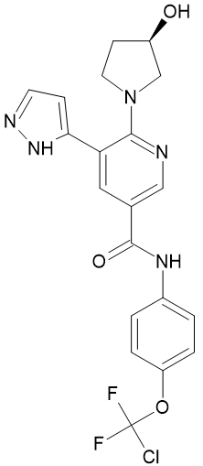
IUAPC name | N-[4-[chloro(difluoro)methoxy]phenyl]-6-[(3R)-3-hydroxypyrrolidin-1-yl]-5-(1H-pyrazol-5-yl)pyridine-3-carboxamide
Molecular formula | C₂₀H₁₈CIF₂N₅O₃
Spectrum of inhibitory activity [43] | Myristoyl pocket of BCR-ABL1
BCR-ABL1 tyrosine kinase inhibitory mode of action | On fusion of ABL1 to BCR, myristoylated N-terminal is lost and ABL1 kinase is activated. By allosterical binding of myristoyl site, asciminib mimics myristate and restores inhibition of BCR-ABL1 kinase activity [47]  After binding to myristoyl pocket of ABL1 kinase domain, asciminib induces an inactive conformational change and inhibits kinase activity [45]
Half-life time (T_{1/2}) [44, 48] | 5.5 h (40 mg/day)  9 hours (200 mg twice a day)
Resistant BCR-ABL1 mutants* [23, 43, 46, 49–51] | Detected in in vitro conditions | Emergence in clinical trials
 | A337V  A344P  P465S  F497F | G109D  Y115N  M244V  V289I  A337V/T  E355G  F359V  E462K  G463D/S  P465S  V468F  S501R  I502L
Oral dose per day | CP — 80 mg/d or 40 mg twice a day, in a case of T315I BCR::ABL1 mutation dosages up to 200 mg twice a day**
Off-target inhibition [44, 48] | Reversible inhibitor of CYP3A4/5, CYP2C8, CYP2C9, CYP2B6, inhibitor of BCRP, Pgp and weak inhibitor of OCT1
*in vitro and in vivo; ** not approved in T315I BCR::ABL1 mutation positive cases in Poland; IUAPC — International Union of Pure and Applied Chemistry; BCRP — breast cancer resistance protein; Pgp — glycoprotein P; OCT1 — organic cation transporter 1

