TKI/drug properties | Imatinib | Nilotinib |  | Dazatinib | Bosutinib | Ponatinib | Asciminib
Chemical structure | 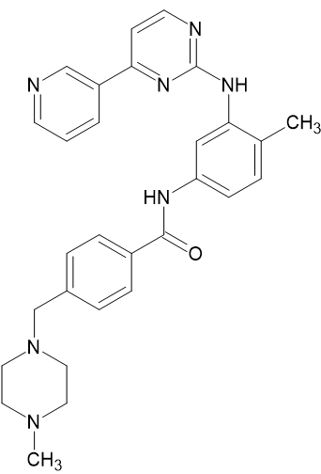 | 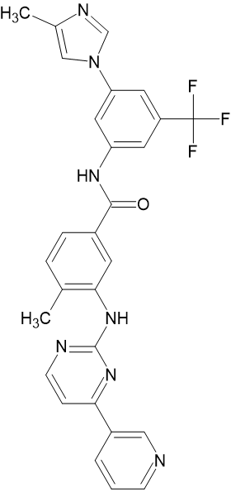 |  | 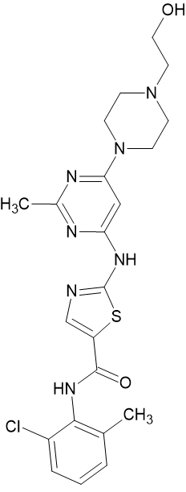 | 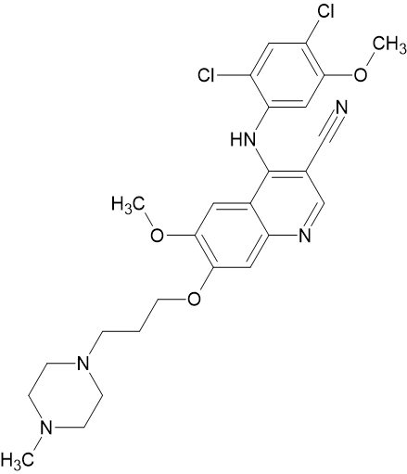 | 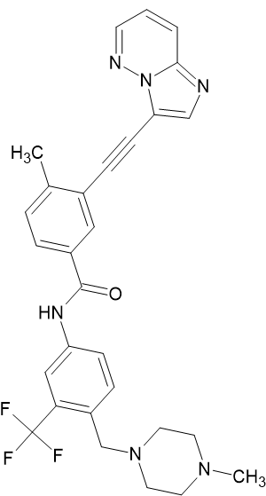 | 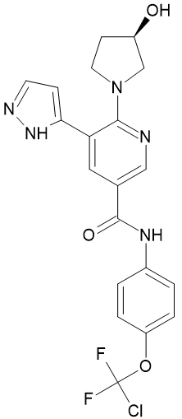
International Union of Pure and Applied Chemistry (IUAPC) name | 4-[(4-methylpiperazin-1-yl)methyl]-N-[4-methyl-3-[(4-pyridin-3-ylpyrimidin-2-yl)amino]phenyl]benzamide | 4-methyl-N-[3-(4-methylimidazol-1-yl)-5-(trifluoromethyl)phenyl]-3-[(4-pyridin-3-ylpyrimidin-2-yl)amino]benzamide |  | N-(2-chloro-6-methylphenyl)-2-[[6-[4-(2-hydroxyethyl)piperazin-1-yl]-2-methylpyrimidin-4-yl]amino]-1,3-thiazole-5-carboxamide | 4-(2,4-dichloro-5-methoxyanilino)-6-methoxy-7-[3-(4-methylpiperazin-1-yl)propoxy]quinoline-3-carbonitrile | 3-(2-imidazo[1,2-b]pyridazin-3-ylethynyl)-4-methyl-N-[4-[(4-methylpiperazin-1-yl)methyl]-3-(trifluoromethyl)phenyl]benzamide | N-[4-[chloro(difluoro)methoxy]phenyl]-6-[(3R)-3-hydroxypyrrolidin-1-yl]-5-(1H-pyrazol-5-yl)pyridine-3-carboxamide
Molecular formula | C29H31N7O | C28H22F3N7O |  | C22H26ClN7O2S | C26H29Cl2N5O3 | C29H27F3N6O | C20H18ClF2N5O3
Spectrum of inhibitory activity | ABL1  ARG  BCR-ABL  KIT  PDGFR  DDR1  NQO2 | ABL1  ARG  BCR-ABL  KIT  PDGFR  DDR1  NQO2 |  | ABL1, ARG, BCR-ABL, KIT, PDGFR, SRC,YES,FYN, LYN, HCK, LCK, FGR, BLK, FRK, CSK,BTK, TEC, BMX, TXK, DDR1, DDR2, ACK, ACTR2B, ACVR2, BRAF, EGFR/ERBB1-5, EPHA8,EPHB1-2, EPHB4, EPHB6, ERBB2, ERBB4,FAK, GAK, GCK, HH498/TNNI3K, ILK, LIMK1-2, MAP2K5, MAP3K1-4, MAP4K1, MAP4K5/KHS1, MAPK11/p38 beta, MAPK14/p38 alpha, MYT1,NLK, PTK6/Brk, QIK, QSK, RAF1, RET, RIPK2, SLK, STK36/ULK, SYK, TAO3, TESK2, TYK2, ZAK [6] | BCR-ABL1, ABL1, SRC, LYN, HCK | ABL1, KIT, PDGFR, SRC family, VEGFR, EGFR, HER2, FLT3, FGFR, and JAK2 [7] | BCR-ABL1 [8]
BCR-ABL tyrosine kinase inhibitory mode of action | Works by binding close to the  ATP binding site, locking it in  a closed or self-inhibited conformation, therefore inhibiting the enzyme activity of the protein semicompetitively [9] [10] | Binds to and stabilizes inactive conformation of kinase domain of Abl protein [11] |  | Binds to ATP-binding site, but extends in opposite direction from imatinib. Binds inactive and active conformation of ABL kinase domain, requires fewer contact points with ABL, and has a greater affinity to ABL kinase domain compared to IM [12, 13] | ATP-competitive inhibitor of Src and Abl tyrosine kinases [14] | Acts as a multikinase inhibitor. Introduction of a triple bond ethynyl linker allowed spanning of bulky T315I isoleucine residue side chain in ATP-binding site, and overcame resistance to prior generation TKIs [15, 16] | Acts as an allosteric inhibitor and engages a vacant pocket at site of kinase domain normally occupied by myristoylated N-terminal of ABL1 — a motif that serves as an allosteric negative regulatory element lost on fusion of ABL1 to BCR  BCR, myristoylated N-terminal is lost and ABL1 kinase is activated. By allosterically binding, to myristoyl site, asciminib mimics myristate and restores inhibition of BCR-ABL1 kinase activity [4]
BCR-ABL tyrosine kinase binding conformation | Inactive | Inactive |  | Active | Both | Inactive | Specifically targeting ABL myristoyl pocket
Half life time (T_{1/2}) | ~20 hours | ~17 hours |  | 3–5 hours | 32.4–41.2 hours enabling daily dose [17] | 24 hours | 5.5 hours (40 mg/d)  9 hours (200 mg bid)
Resistant BCR-ABL KD mutants**  [8, 15, 18–23] | Y253  E255  T315  M244  L248  G250 | Q252  F317  M351  M355  F359  H396 | T315  L248  Y253  E255  F359 | T315  V299  F317 | T315  V299  L248  G250  E255  F317 | E250*  Y253*  E255*  F311 | A337  W464  P465  V468  I502
Oral dose per day | CP 400 mg/d  AP 600 mg/d  BP 800 mg/d | CP 2 × 300 mg  (2nd-line)  2 × 400mg  (1st-line) |  | CP 100 mg/d  AP/BP 140 mg/d | CP 500 mg/d | CP 15–45 mg/d | CP 80 mg/d  or 40 mg bid
Main off-target effect | Hematologic:  - anemia  - neutropenia  - thrombocytopenia  Non-hematologic:  - edema (periorbital and ● peripheral)  - muscle cramps  - musculoskeletal pain  - diarrhea [24] | Hematologic:  - thrombocytopenia  - granulocytopenia  - anemia  Non-hematologic:  - pruritus  - asthenia  Cardiovascular:  - cardiovascular  ischemic adverse events [25, 26] |  | Hematologic:  - thrombocytopenia  - anemia  - neutropenia  Non-hematologic:  - endocrine disorders (gynecomastia, irregular menses, hypoglycemia, hyperglycemia, increased triglyceride and cholesterol levels)  - fluid retention  - nausea, vomiting, diarrhea  Cardiovascular  - pericardial effusion  - pulmonary artery hypertension [27, 28] | Hematologic:  - thrombocytopenia  - neutropenia  Non-hematologic:  - rash  - nausea  - diarrhea  - vomiting  - elevated serum aminotransferases [29] | Hematologic:  - anemia  - thrombocytopenia  - neutropenia  Non-hematologic:  - rash  - elevated serum lipase  - pancreatitis  Cardiovascular  - hypertension  - chest pain [30] | Hematologic:  - thrombocytopenia and/or neutropenia  Non-hematologic:  - hepatic impairment  - asymptomatic amylase and/or lipase elevations  Cardiovascular:  - hypertension  - pericardial effusion  [4, 5, 31]
*Increase in IC50 for ponatinib as a sole anomaly typically not leading to clinical resistance, which is observed in cases of a compound mutation including T315I; **strong resistance is indicated in bold; CP — chronic phase; AP — acceleration phase; BP — blastic phase; bid (bid in die) — twice daily

