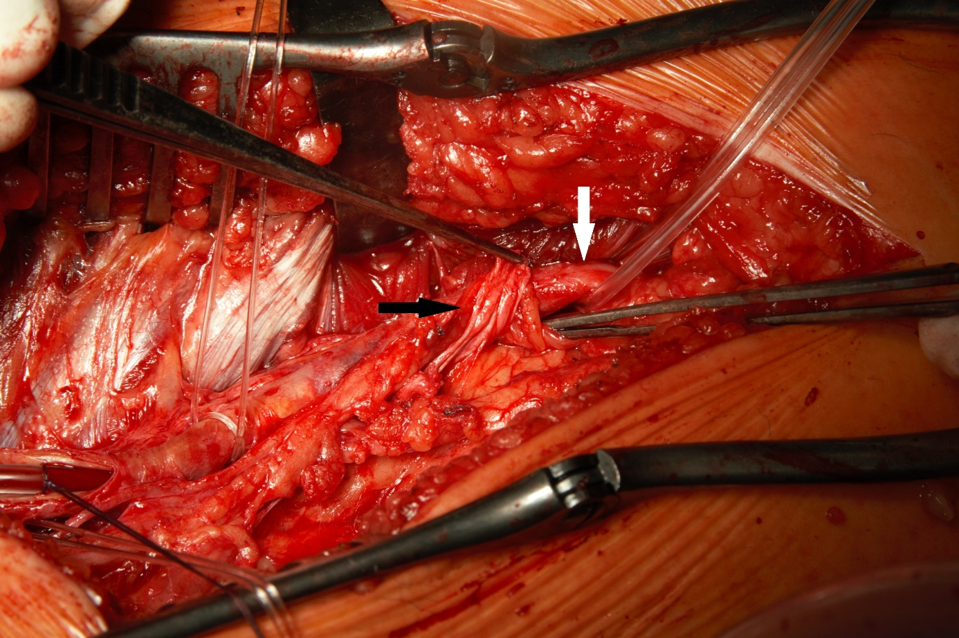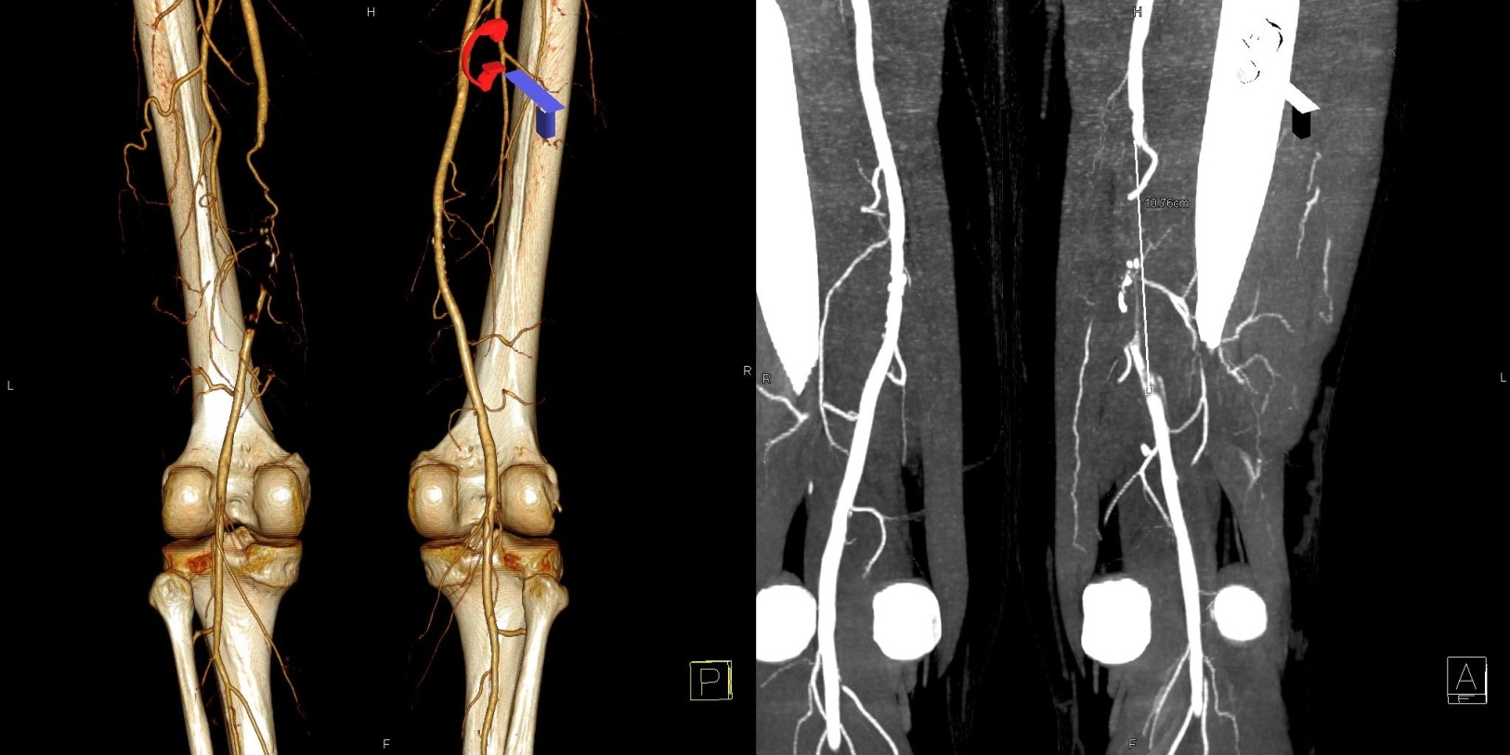

Img 2. The fibromuscular band ( black arrow) - arising from the adductor magnus muscle, overlying, running across and compressing the superficial femoral artery (white arrow).

Img 1. A. Three dimensional reconstruction demonstrates occlusion of the superficial femoral artery – posterior view. B. A Computed Tomography image of the 11 cm occlusion of the artery in question – anterior view.

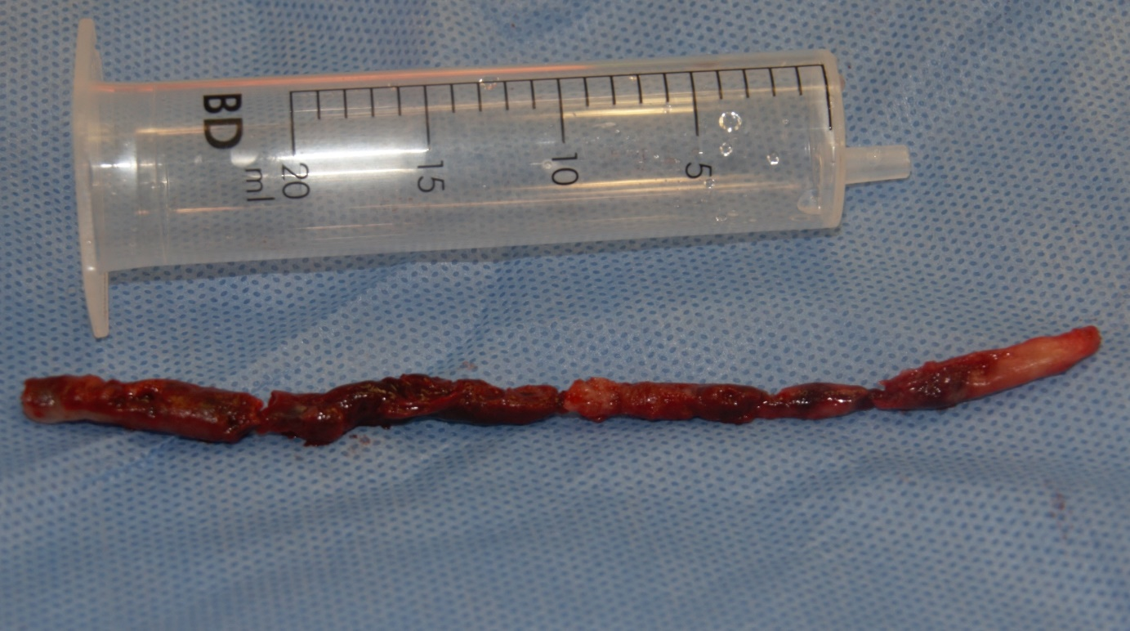

Img 3. The thrombotic material removed from the superficial femoral artery.

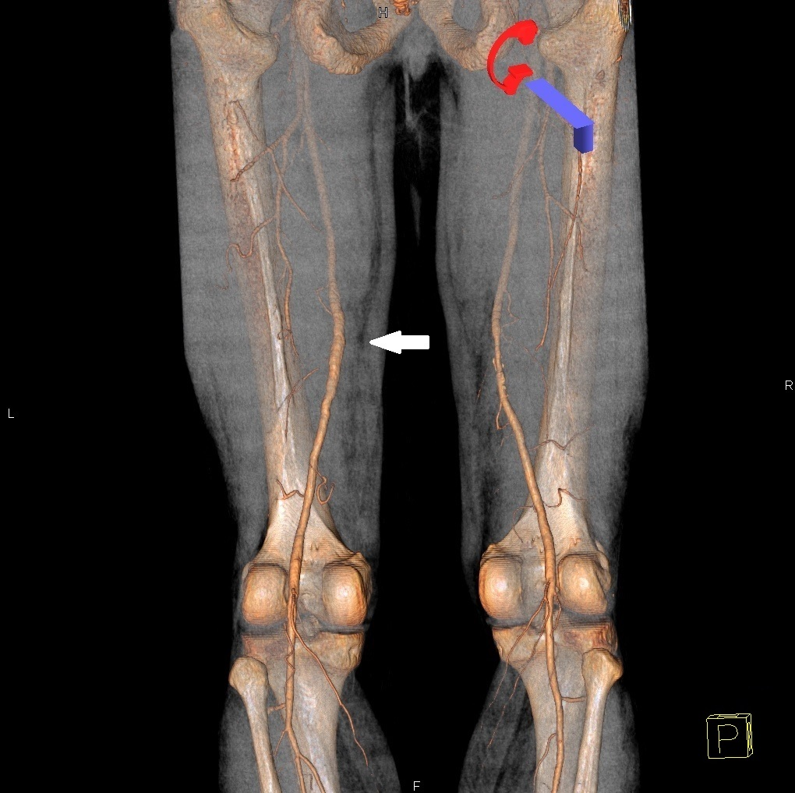

Img 4. A 3 dimensional reconstruction a follow-up computed tomography angiography 6 months after the surgery demonstrates patency and excellent result of the surgical treatment of the right superficial femoral artery (white arrow)- posterior view.