Supplemental figure 1. Risk of bias graph: review of authors’ judgments regarding each risk of bias question presented as percentages across all studies included in the final review.

A. Risk of bias in case control studies (n=20)
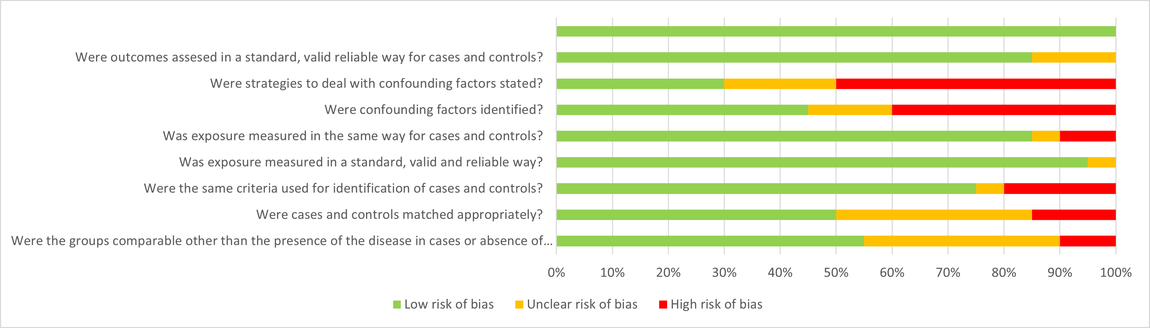

B. Risk of bias in cohort studies (n=9)
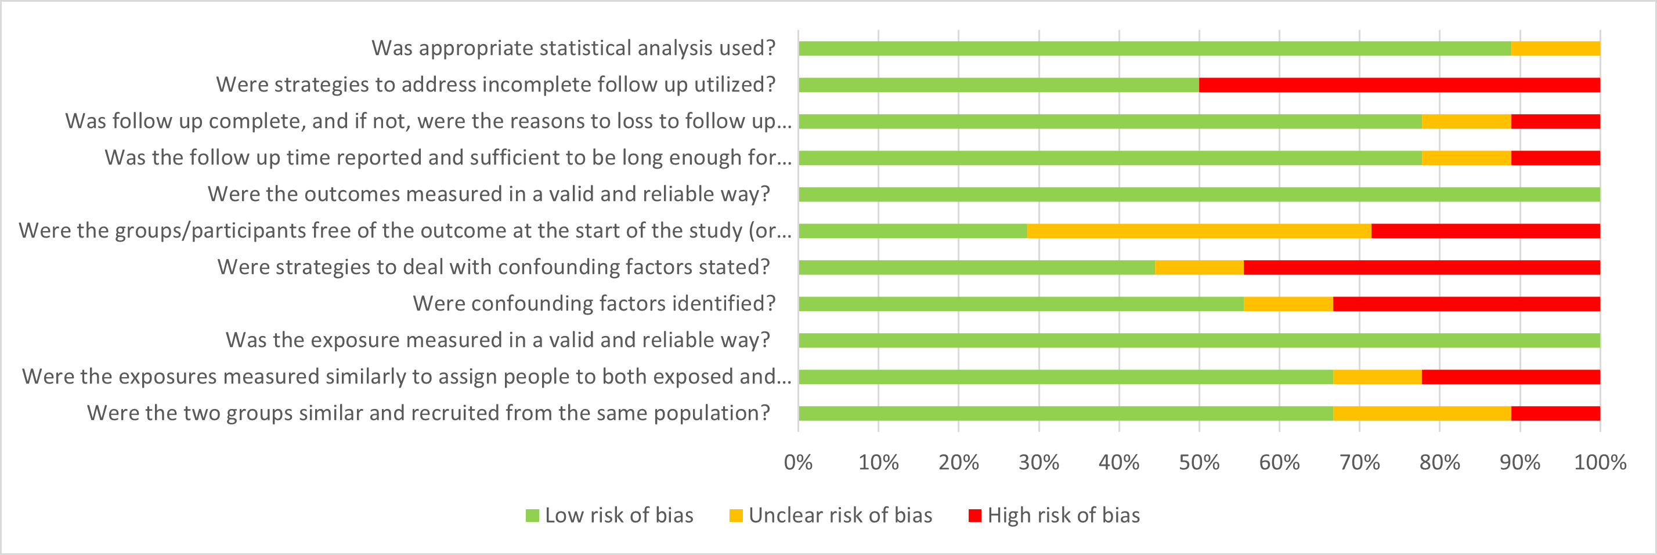

C. Risk of bias in experimental study (n=1)
